




Dear Editor,

Please find a revised copy of our manuscript JoVE58912. We have taken into consideration each comment and answered each point carefully. They are either addressed in the main document (with tracked changes) or detailed in this rebuttal letter.

We would like to thank the editor and both referees for their constructive comment, which have helped us to greatly improve our manuscript.

Finally, the English throughout the article has been copyedited by a professional copyeditor very familiar with scientific English.

Sincerely yours,

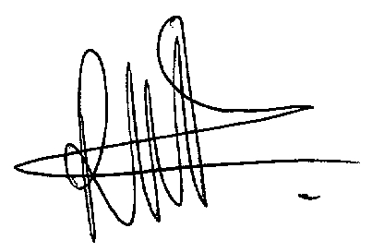

Anne-Karine Bouzier-Sore, PhD.

Editorial comments:
1. Please take this opportunity to thoroughly proofread the manuscript to ensure that there are no spelling or grammar issues.
The English throughout the article has been copyedited by a professional copyeditor very familiar with scientific English.
2. Please spell out each abbreviation the first time it is used.
Done.
3. JoVE cannot publish manuscripts containing commercial language. This includes trademark symbols (™), registered symbols (®), and company names before an instrument or reagent. Please remove all commercial language from your manuscript and use generic terms instead. All commercial products should be sufficiently referenced in the Table of Materials and Reagents. You may use the generic term followed by “(see table of materials)” to draw the readers’ attention to specific commercial names. Examples of commercial sounding language in your manuscript are: Bruker, Surgivet; Harvard Apparatus, 3M Micropore, Terumo, Vibrac, Sanofi, Vetoquinol SA, Ocry Gel, SA Instruments, Bruker BioSpec, Stephen Provencher Inc., etc.
We have followed your recommendations and all references to commercial companies have been removed from the main text.
4. Please revise the protocol text to avoid the use of any personal pronouns (e.g., "we", "you", "our" etc.).
No personal pronoun is now used.
5. Please revise the protocol to contain only action items that direct the reader to do something (e.g., “Do this,” “Ensure that,” etc.). The actions should be described in the imperative tense in complete sentences wherever possible. Avoid usage of phrases such as “could be,” “should be,” and “would be” throughout the Protocol. Any text that cannot be written in the imperative tense may be added as a “Note.” Please include all safety procedures and use of hoods, etc. However, notes should be used sparingly and actions should be described in the imperative tense wherever possible.
We have modified the text accordingly.
6. Lines 84-88: Please move the ethics statement before your numbered protocol steps, indicating that the protocol follows the animal care guidelines of your institution.
The ethics statement is now in the correct place, lines 89-93.
7. Lines 92-105, 3.1, 5.1, 6.1, 7.1, 8.1: The Protocol should contain only action items that direct the reader to do something. Please move the solutions, materials and equipment information to the Materials Table.
This has been done.
8. 5.3: Please describe how to perform MR setting.
MR setting is now described in details throughout the protocol.
9. 6.7: Please specify the dose of atipamezole given to the rat.
Dose is now specified l.101 and 116.
10. Steps 7, 8, and their sub-steps: Software must have a GUI (graphical user interface) and software steps must be more explicitly explained ('click', 'select', etc.). Please add more specific details (e.g. button clicks for software actions, numerical values for settings, etc.).
This has been done (5.4, 6.2, 7.3,7.4, 7.5, 8.2).
11. Please combine some of the shorter Protocol steps so that individual steps contain 2-3 actions and maximum of 4 sentences per step.
This has been done (3.1, 5.1, 7.1).
12. After you have made all the recommended changes to your protocol (listed above), please highlight 2.75 pages or less of the Protocol (including headings and spacing) that identifies the essential steps of the protocol for the video, i.e., the steps that should be visualized to tell the most cohesive story of the Protocol.
Essential steps (corresponding to 2.5 pages) are highlighted in yellow.
13. Please highlight complete sentences (not parts of sentences). Please ensure that the highlighted part of the step includes at least one action that is written in imperative tense. Please do not highlight any steps describing anesthetization and euthanasia.
Highlighted steps are complete sentences.
14. Please include all relevant details that are required to perform the step in the highlighting. For example: If step 2.5 is highlighted for filming and the details of how to perform the step are given in steps 2.5.1 and 2.5.2, then the sub-steps where the details are provided must be highlighted.
All relevant details required for an essential step are also highlighted in yellow, the ones that are not relevant were not highlighted.
15. Figure 5: Please add 1H to the ppm scale. The green square can hardly be seen. Please increase contrast.
This has been done.
16. Figure 7: Please add 1H to the ppm scale.
This has been done.
17. Table of Materials: Please use SI abbreviations for all units (L, mL, µL, h, min, s, etc.) and include a space between all numerical values and their corresponding units (15 mL, 37 °C, 60 s; etc.). Please use the period symbol (.) for the decimal separator.
We carefully check all SI abbreviations.
18. References: Please do not abbreviate journal titles.
Journal titles have been modified.

Reviewers' comments:
Please note that the reviewers raised some significant concerns regarding your method and your manuscript. Please thoroughly address each concern by revising the manuscript or addressing the comment in your rebuttal letter.
Reviewer #1:
Manuscript Summary:
The authors present a protocol for localized MR spectroscopy (MRS) and fMRI during whisker stimulation in rat. MRS and fMRI are performed in different settings. The same anesthetized animal is used, but it needs to be repositioned and the detector is changed.
Overall, the experiments are well motivated in the introduction. However, some relevant literature on MRS in rat, in particular on fMRS, has not been cited and should be included. Regarding the described data analysis of fMRI it is also not clear why fMRI scan proved added value compared to fMRS alone.
The reference "Mullins, P. G. Towards a theory of functional magnetic resonance spectroscopy (fMRS): A meta-analysis and discussion of using MRS to measure changes in neurotransmitters in real time. Scand J Psychol. 59, 91-103 (2018)" and "Stanley, A. J. and Raz, N. Functional magnetic resonance spectroscopy: The "New" MRS for cognitive neuroscience and psychiatry research. Front Psychiatry 9, 16, (2018)" were added. These articles present all studies that have performed fMRS. One study from Mangia and Tkac was also added.

In our study, fMRI was performed only to check that the home-build whisker activator is efficient. This point was not clear enough and the entire manuscript was modified such as the main objective of the study, fMRS, is now clearly stated.
Major Concerns:
1. For fMRI it is described that the air puff system must be switched on at the same time. This sounds as if this could be done manually. However, manual synchronization does not yield scientifically sound results. Fluctuations in timing will make the data useless for analysis. Usually the stimulator is connected to a TTL-port of the Biospec. This must be explained in more detail.
The stimulator is in fact connected to the Biospec via a TTL-port. This point is now clarified.
2. For analysis of fMRI data the tool in Paravision 6 is suggested. This is not adequate. I am not familiar with this tool, but to my knowledge it simply performs a simple statistical test. This may serve to get a first, very rough idea if responses may be detected. For a scientifically sound analysis more complex strategies must be used (eg SPM, AFNI, etc), which is standard in the community.
We agree with the reviewer. As the main objective of fMRI in our study was to check if the barrel cortex was efficiently activated by the whisker stimulation, we used the tool in Paravision 6 (FUNController tool) only to visualize the BOLD signal. This point is now much more clear in the manuscript.
3. A more complex fMRI analysis will also allow for detecting network activations and not just S1BF, as insinuated by the authors. Such activation will be essential to justify performing fMRI in addition to fMRS.
Yes, we agree with the referee. However, the overall goal of the paper was to describe how to perform MRS in an activated brain area. This is the reason why we focused on the S1BF area, which is the most suitable place to perform fMRS in an activated zone with whisker stimulation using a surface coil.
Minor Concerns:
1. Most crucial step to obtain high quality spectra is shimming. This is mentioned but not described in detail. Since this is the most important step, shimming must be described in far more detail.
A much more described section for each MR settings has been added.
2. The LASER sequence it mentioned, but not explained. For the non-expert this may be helpful. Further, the experimental parameters for LASER must be given.
LASER sequence parameters are now added.
3. The magnet does not have a 12-cm bore - it is 20 cm.
We would like to apologize for this mistake. It has been corrected.
4. In Fig 2. arrows pointing at the sail and the tube will be helpful.
Arrows have been added.
Reviewer #2:
Manuscript Summary:
This seems to be largely a proof-of-concept study that demonstrates the ability to measure brain metabolism and BOLD activation resulting from the same stimulus, unilateral whisker stimulation. While the overall demonstration requires implementation of several advanced techniques, it is unclear what new information is gained by the study, from the perspective of the neurobiology of sensation/perception or the perspective of applications of NMR in biomedicine. A potential strength may be the visual demonstration of the equipment and procedures, however the study has not yet reached this stage in the review process. Otherwise, it is simply another demonstration of using MRS to measure in vivo changes in brain metabolism following a stimulus whose neurobiological sequelae are largely already known (i.e. whisker stimulation and barrel cortex activation). Even if the visual demonstration is impressive enough to warrant publication in this journal (whose purpose is largely to visualize experiments), several issues must be addressed.
Major Concerns:
The choice of stimulation is appropriate and the rationale is described adequately. However, it is unclear why a sail needs to be present. The authors state that this "regroups" the whiskers and that this increases the signal. Please explain further.
The barrel cortex, also called S1BF for somatosensory cortex or barrel field, is a region within cortical layer IV that can be observed using cytochrome c oxidase staining (Wong-Riley and Welt, PNAS 1980). One vibrissa is connected to one barrel (as shown in the figure) in which around 19,000 neurons are organized in a column (Felmeyer, Front in Neuroanat 2012). Using a sail allows to stimulate a maximum of vibrissa, and therefore the largest part of the S1BF area, corresponding to approximately the size of the voxel in which MRS is performed.
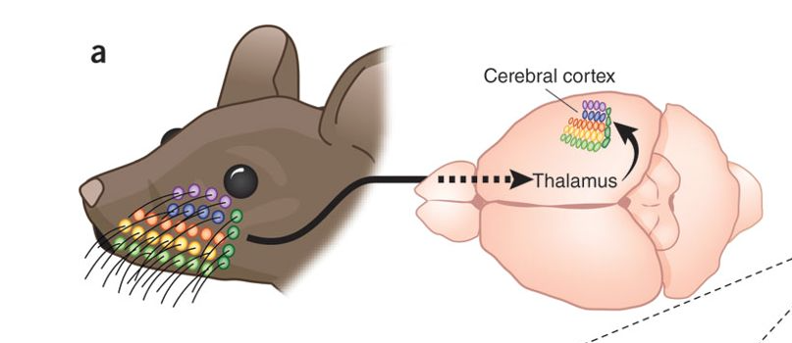
A paragraph explaining why a sail is needed has been added in the text, which explains that if only one or few whiskers are activated, the metabolic changes will occur only in few barrels and therefore the metabolic changes would not be detectable. This text can by found l.326-333 and l.358-359. Using this sail, the entire barrel cortex was activated, as demonstrated by the two following figures. Indeed, S1BF area is around 3-mm depth, and a signal enhancement on the BOLD fMRI was observed on 3 consecutives slices (1-mm thickness), and NOT on the fourth one.

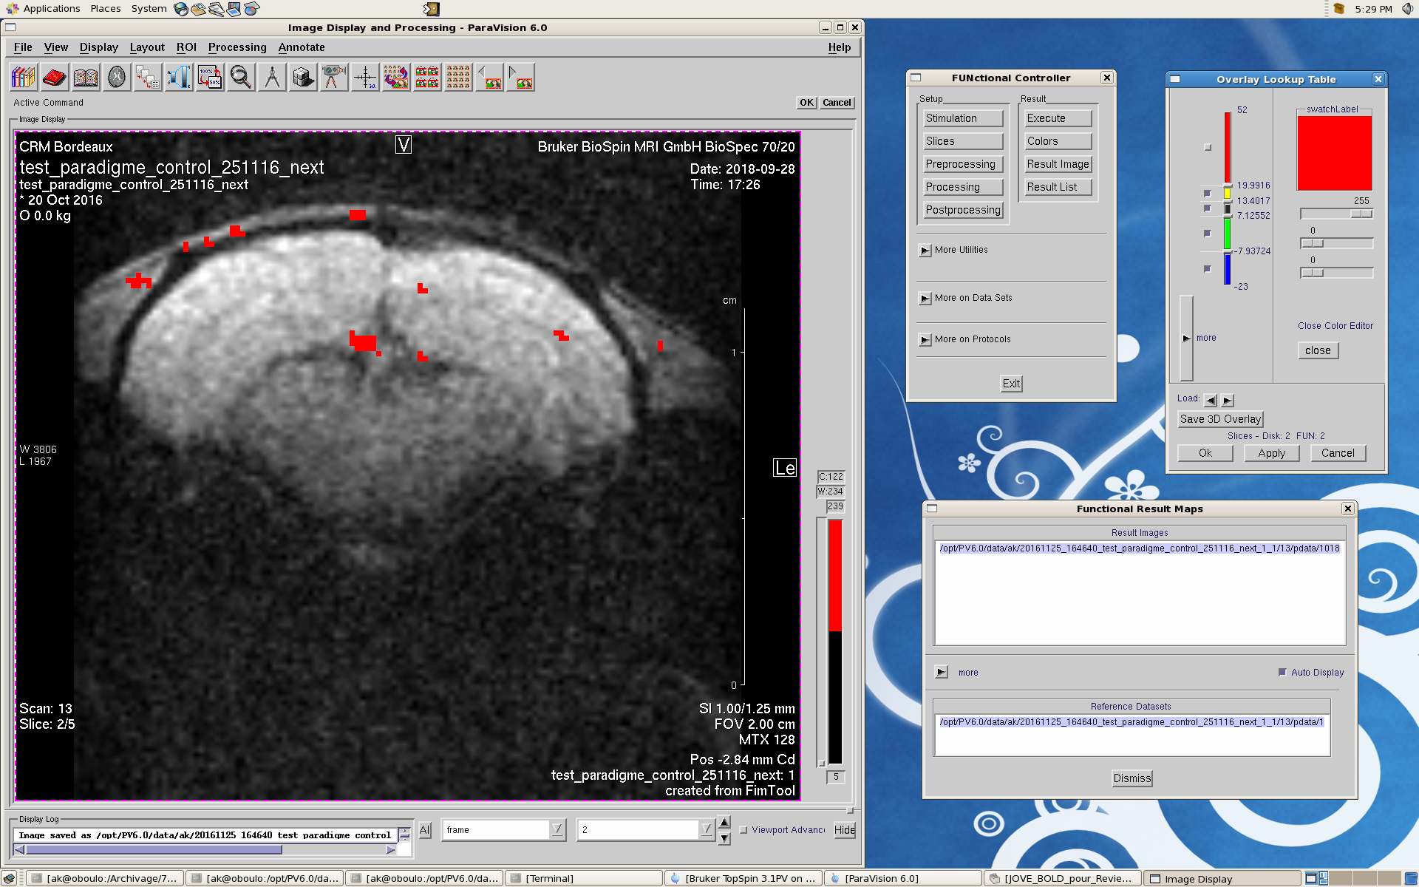
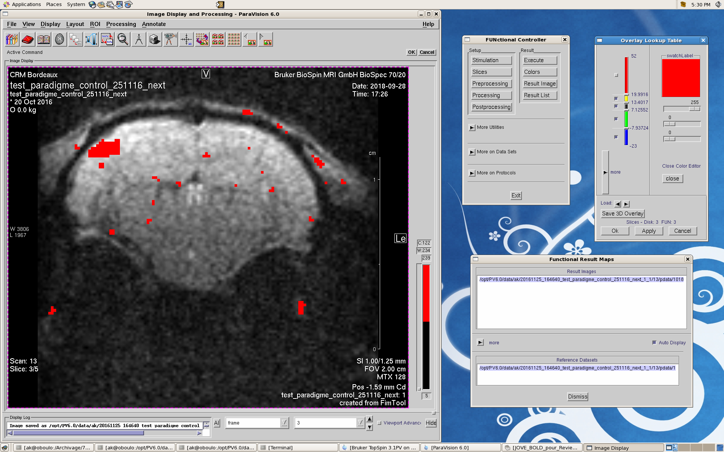
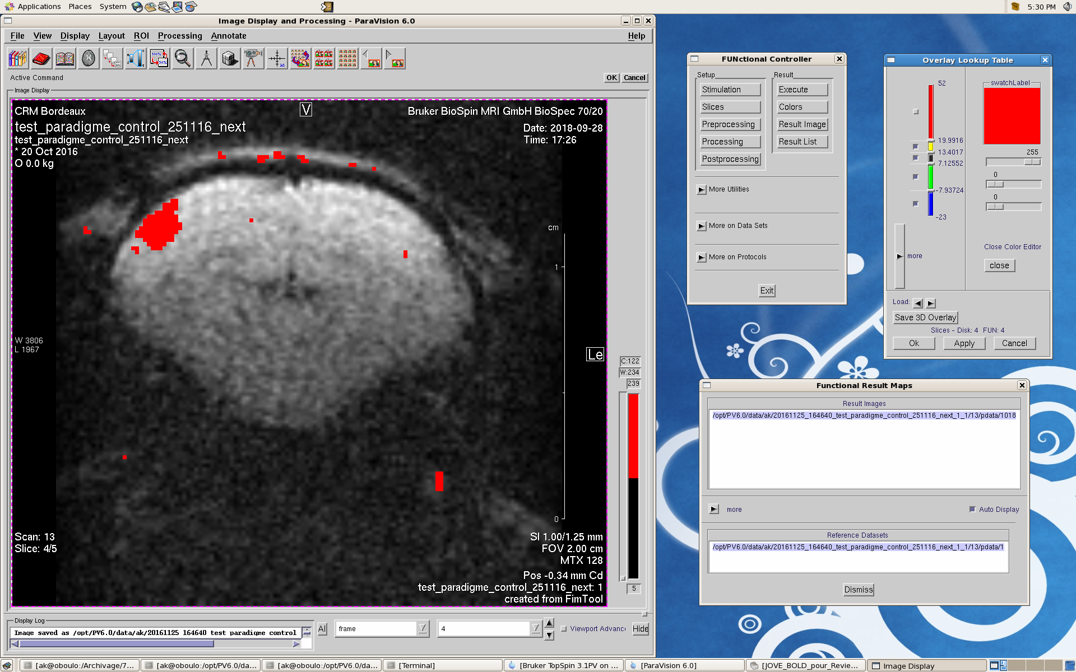
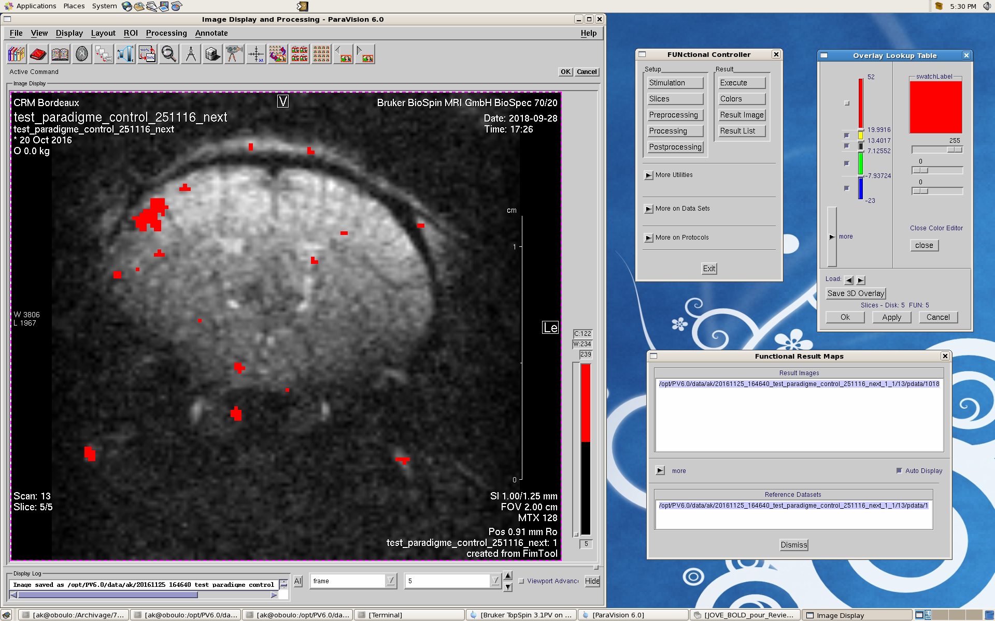
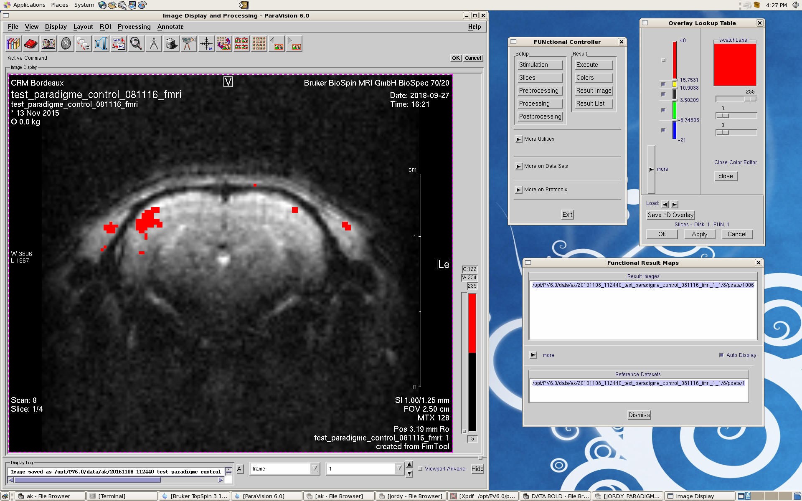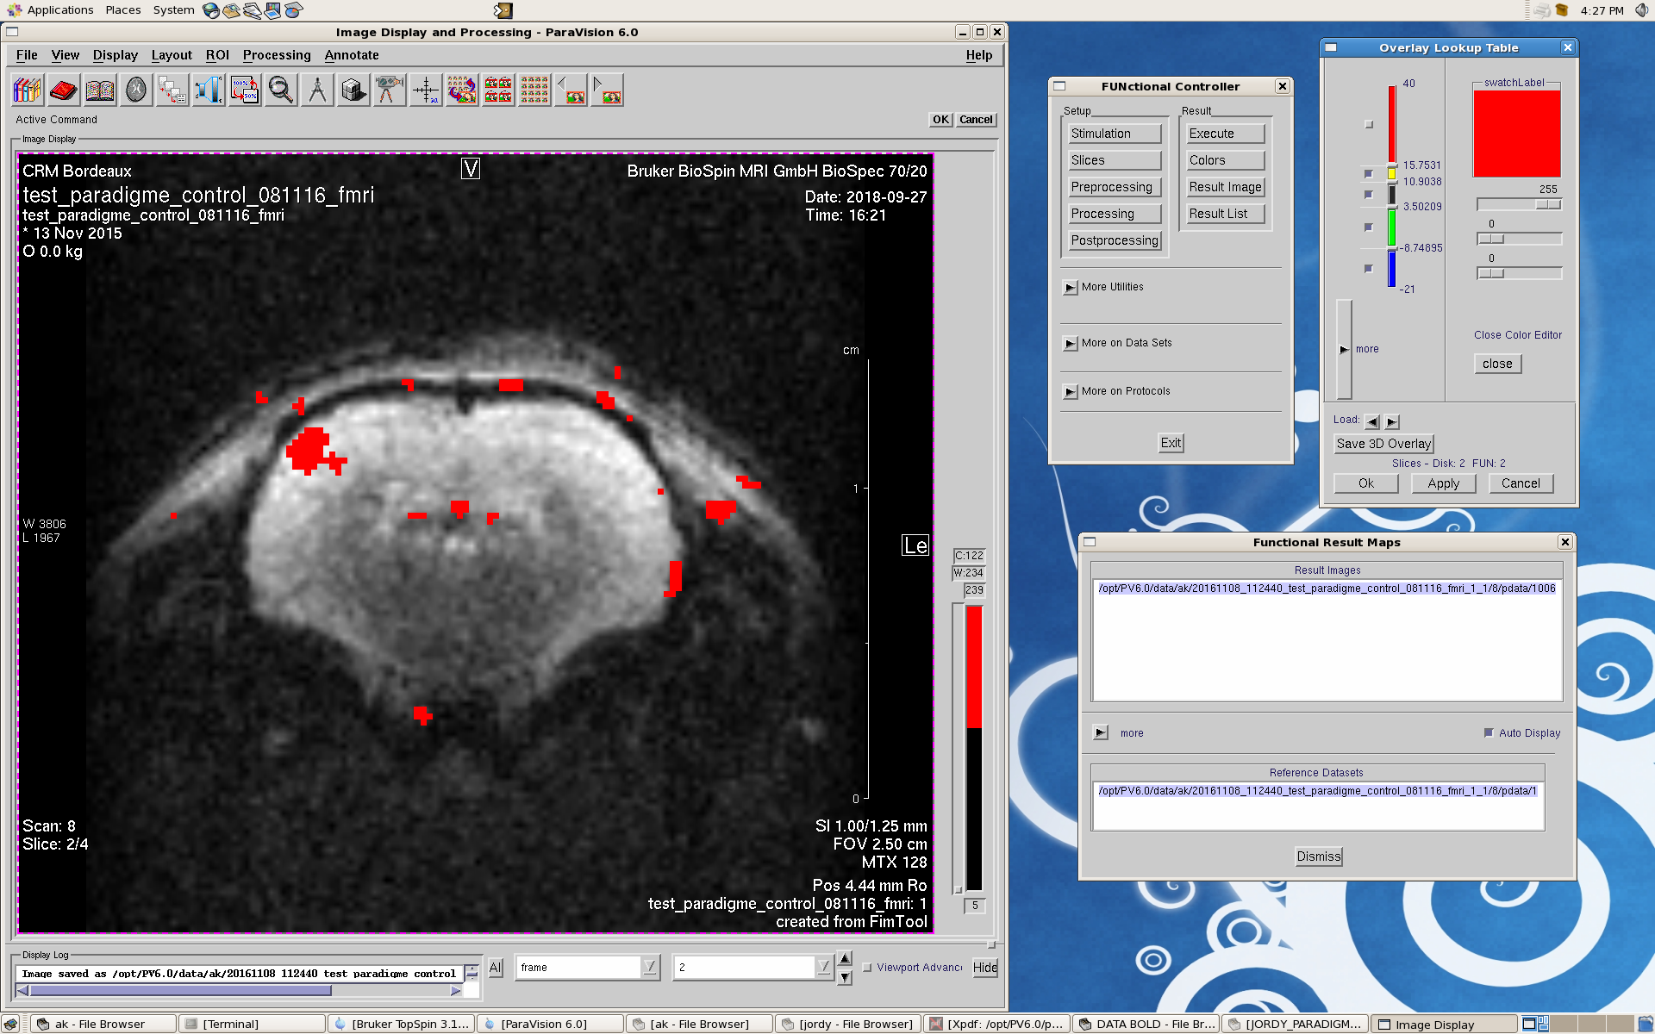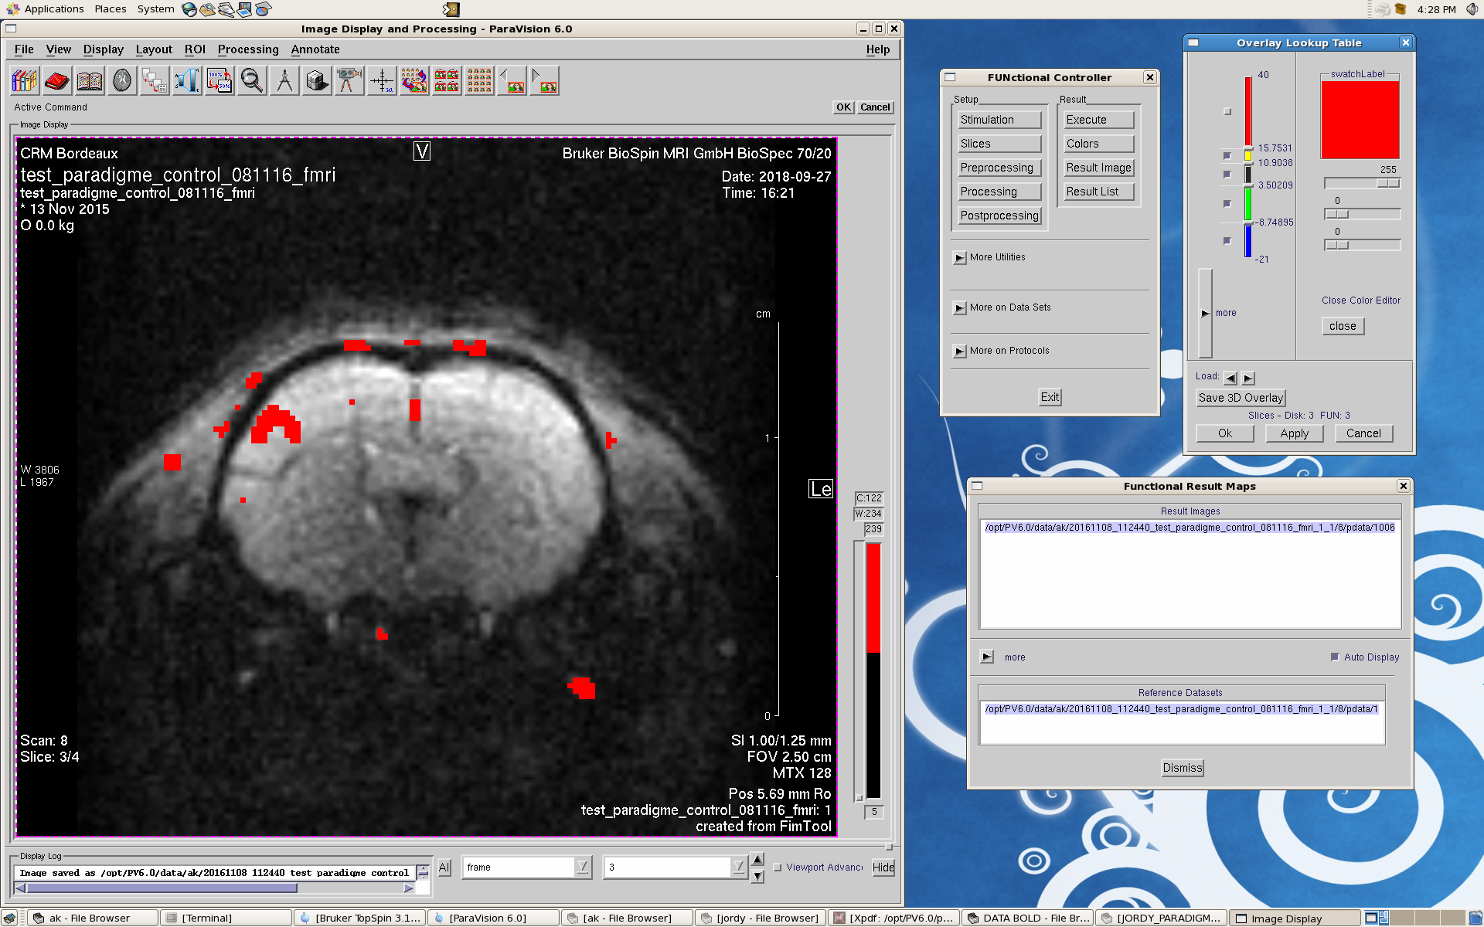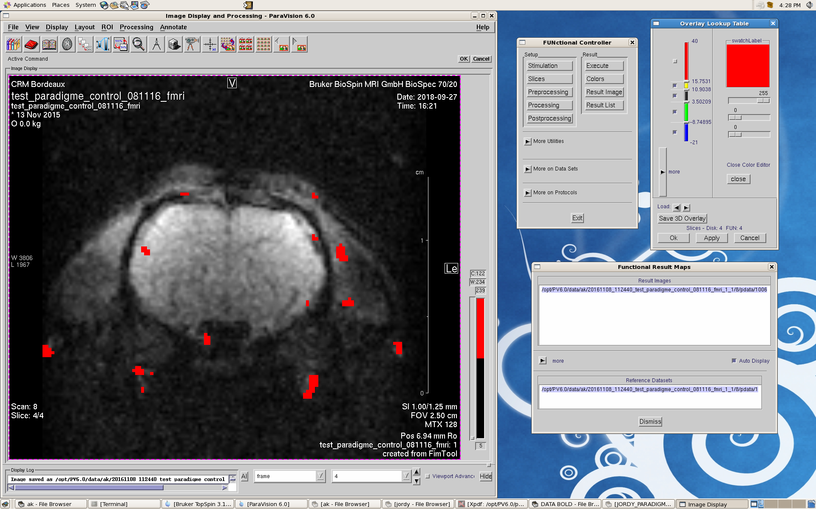

Presentation of results needs considerable work. Statistical analysis seems completely absent from the paper which is unacceptable. Analyses should be presented in the text and also in figures.
*For example, figure 7 shows increase in lactate and decrease in NAA, but it is unclear whether this is representative data from one animal. Please include the data from the entire pool of subjects, along with appropriate statistical analyses.
Presentation of results has been completely changed. Values for 5 additional rats that were scanned recently (only for fMRS) have been also added. Rather than presenting the ratio of lactate during activation/lactate at rest, contents of lactate at rest and during brain activation (quantification relative to phosphocreatine + creatine content) are presented. Paired t-test was performed on these values and the statistical analysis has been added. It is now clearly stated that fMRS was performed in 23 rats, and that Figure 6 presents typical spectra obtained in one rat. Figure 8 has also been added, in which results for each individual rat can be visualized, and which shows that lactate is increasing with brain activation in 22 out of 23 rats.
Here are the details of the statistics that have been performed using the Prism software:

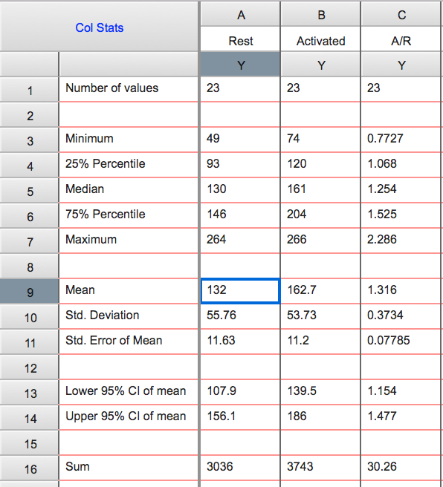
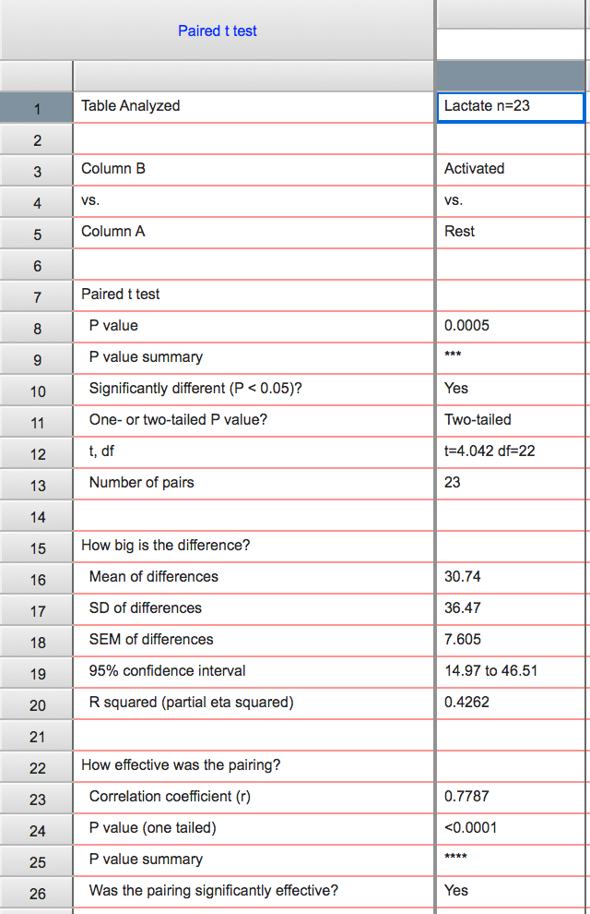

*While figure 6 shows BOLD activation in the contralateral barrel cortex, it seems as if this is data from only 1 animal. Please show all subjects and provide statistical analyses. Also, labels indicating left vs right are needed.
It is now clearly stated in the manuscript that BOLD fMRI was performed in 8 rats and that a signal enhancement was observed in all animals. In our study, fMRI was performed only to check that the home-build whisker activator is efficient. This point was not clear enough and the entire manuscript was modified according to referee's 1 comments such as the main objective of the study, fMRS, is now clearly stated. Therefore, the fMRI section has been shortened. However, to reply to reviewer 2, all BOLD fMRI and statistics are shown in the following figure in this rebuttal letter (ROI1 was located in the activated left S1BF, ROI2 in the contralateral S1BF (at rest) and ROI3 was placed in a non-activated cortex zone, to measure the noise).

Arrows have been added to indicate left and right hemispheres in Figure 6.
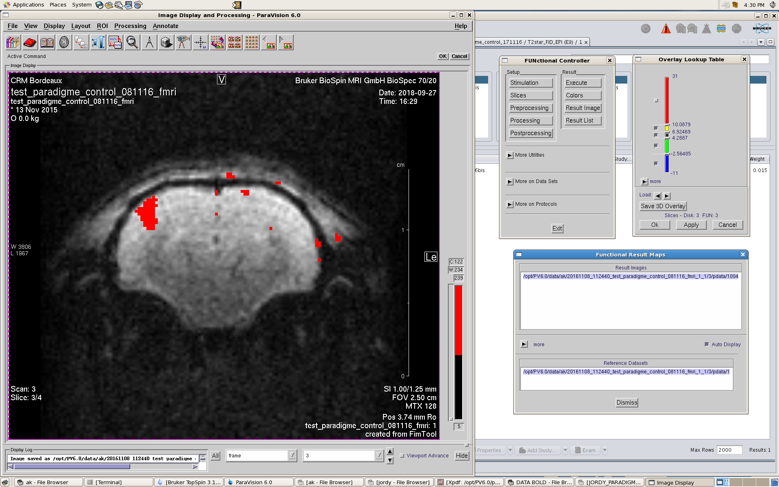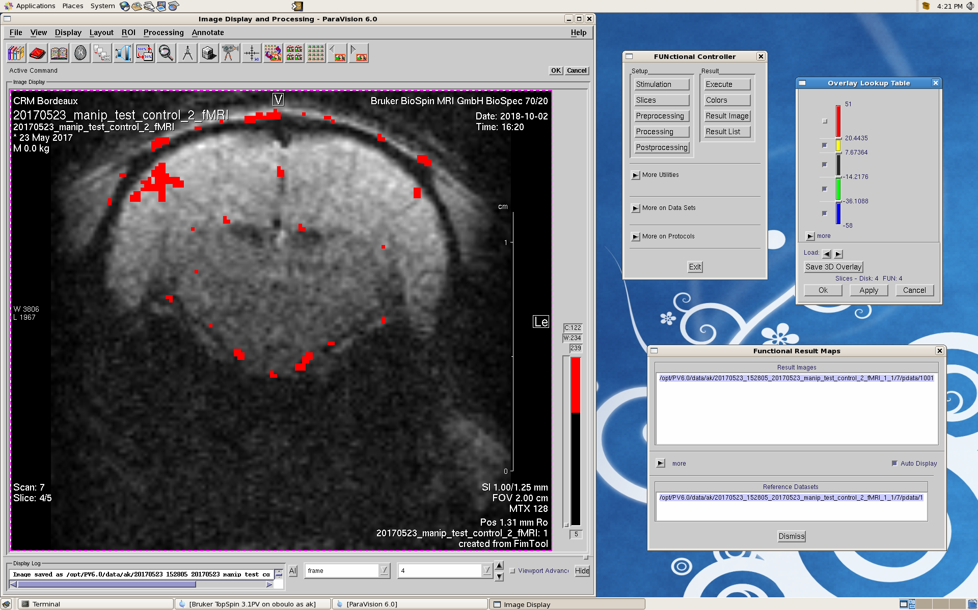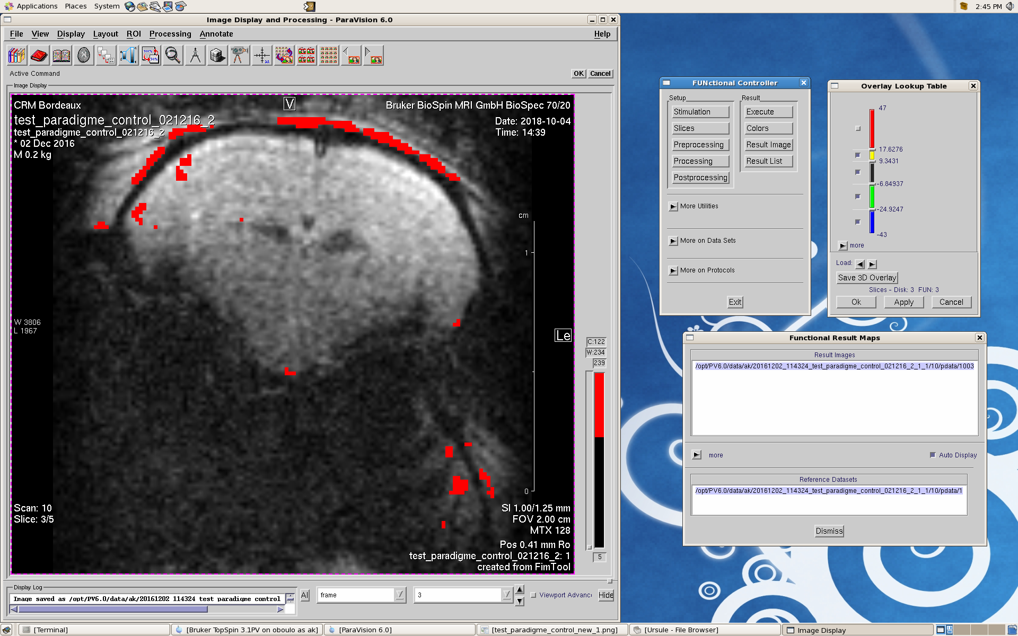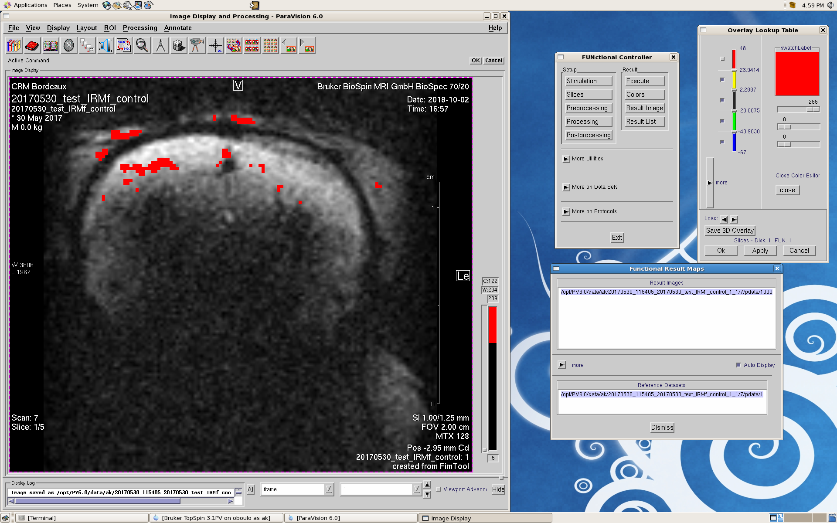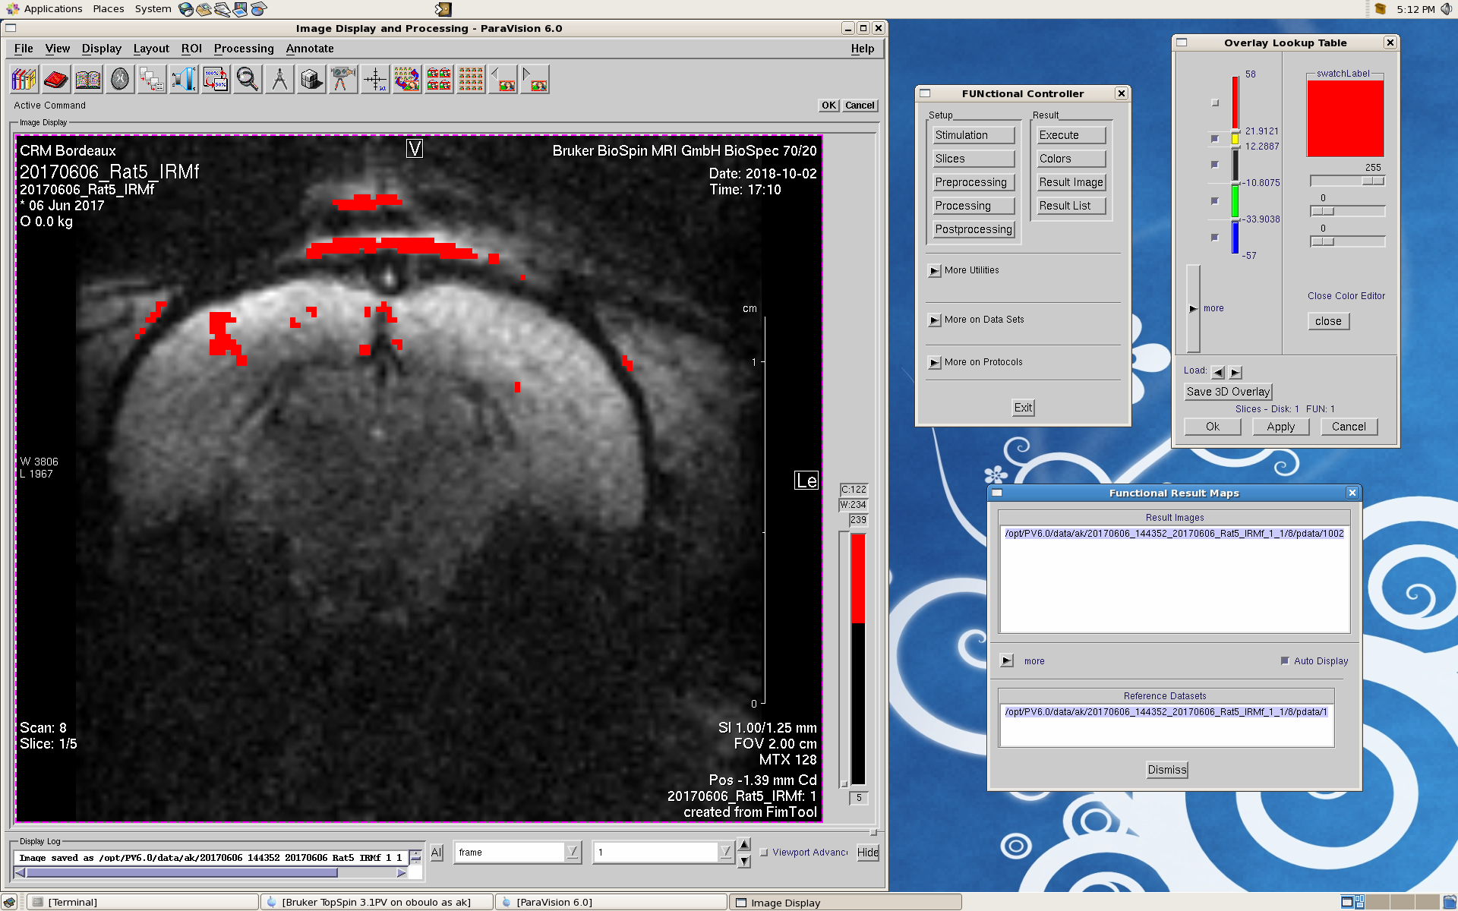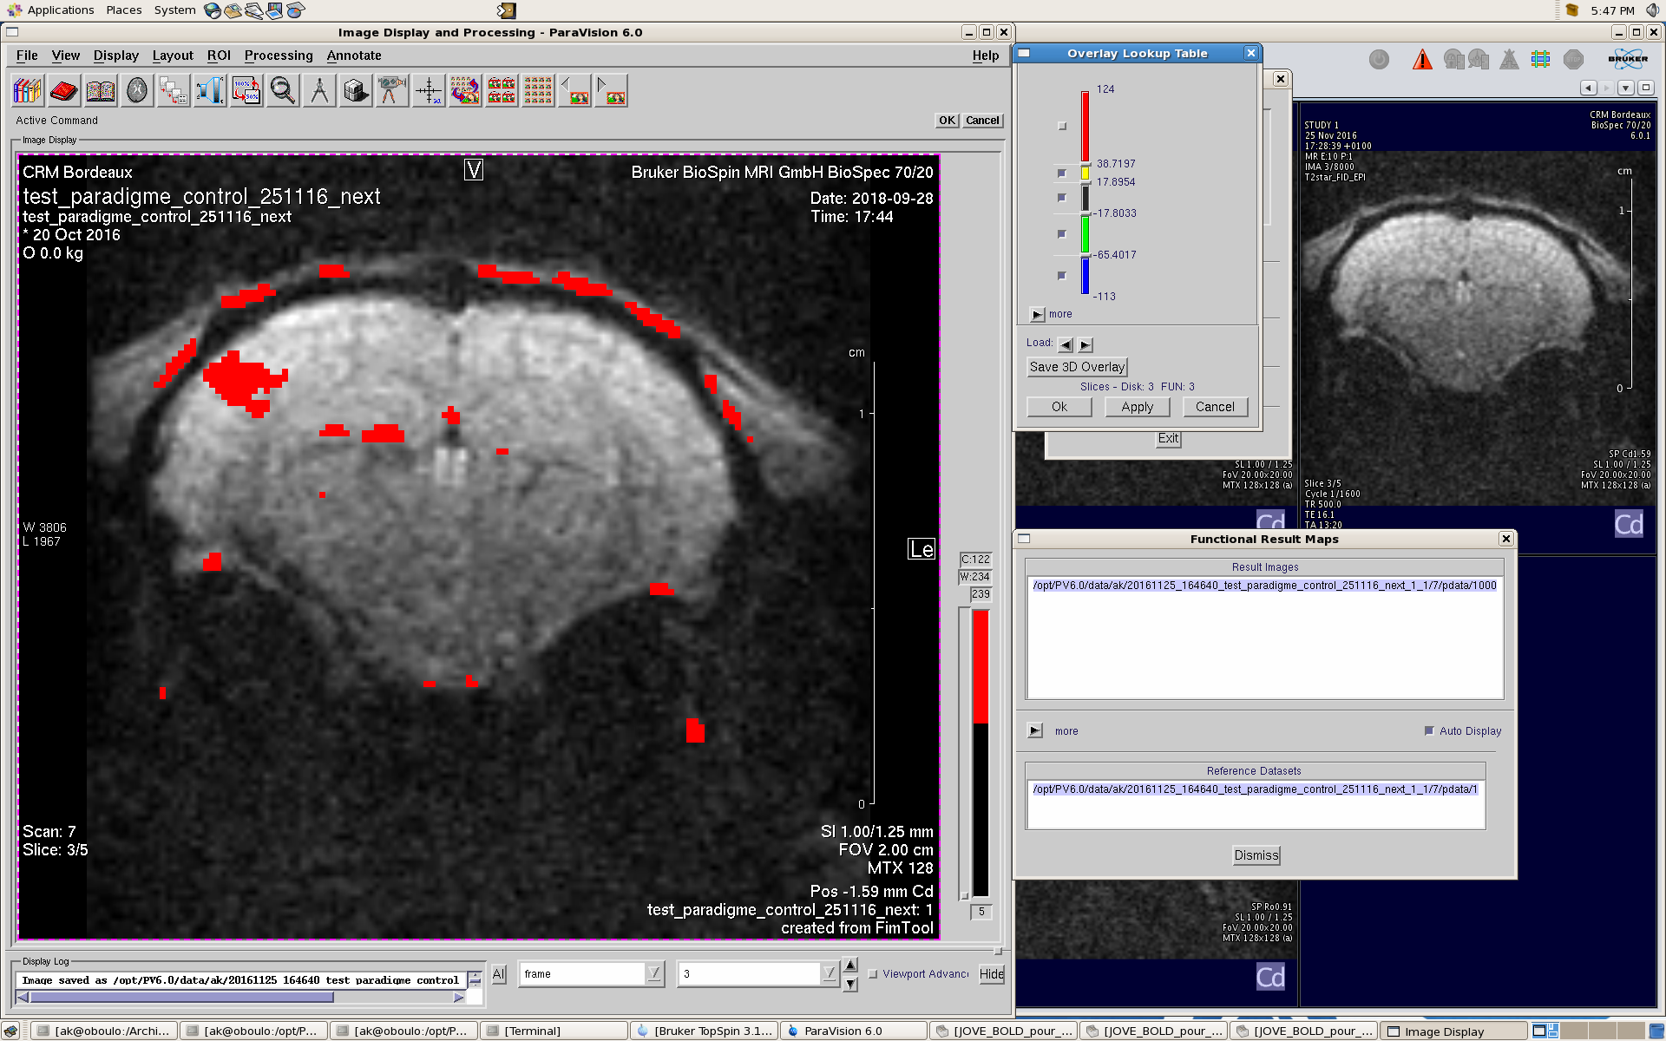

ROI1
ROI2
ROI3

Page 10, line 360: the paragraph is incomplete; the last line trails off with no ending.
We apologize for this mistake. It has been removed.
The authors spend a great deal of the introduction talking about the controversial astrocyte to neuron lactate shuttle, but there is no further discussion of the results and how they contribute to this controversy. This must be addressed.
This point is now discussed l.372-383.

The authors talk about lactate but not about NAA. Please introduce and discuss the changes in NAA.
In the results section, NAA values are presented in more details. It's now clearly stated that NAA decrease was observed on Figure 6, which shows spectra for one rat, but that this variation was not found in all animals and that no statistical variation was found. In the discussion, this point has also been extended l.385-390.
The language/writing needs considerable improvement. As a native English speaker it was difficult to get through the whole manuscript. For example, in the abstract I doubt the authors meant to say that "brain activation is controlled by BOLD fMRI" as BOLD fMRI is simply a tool to measure one proxy of brain activation.
The English throughout the article has been copyedited by a professional copyeditor very familiar with scientific English. We also modified the text and the title. It's now clearly explained that the main goal of the article was to present a way to perform functional MRS and that BOLD fMRI was used only to check that the whisker stimulator was efficient. We hope that the overall interest to perform fMRS is now much more clear in this revised manuscript.

