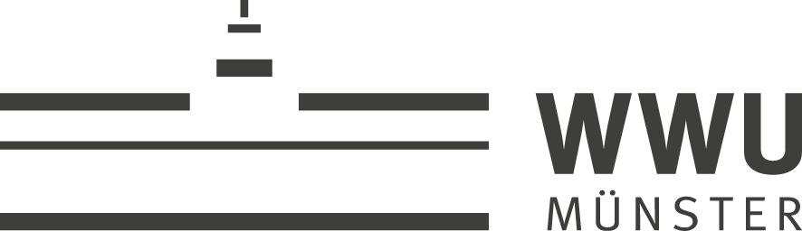
University Hospital Muenster . Department of Neurology . 48129 Münster  JoVE  Ronald Myers  Science Editor | Department of Neurology  Univ.-Prof. Prof. h. c. Dr. med. Heinz Wiendl  Director  with  Institute of Translational Neurology  Univ.-Prof. Dr. med. Dr. rer. nat. Sven Meuth  Dr. med. Tobias Ruck  Albert-Schweitzer-Campus 1, Building A1  48149 Münster  T +49 (0)2 51 - 83 – 41125  F +49 (0)2 51 - 83 - 4 68 12
Münster, 02 August 2018

Dear Dr. Myers,

we would like to thank you again for your invitation to submit our article „Isolation of primary murine skeletal muscle microvascular endothelial cells” for consideration to JoVE.
Microvascular endothelial cells shape the inner wall of muscle capillaries and regulate fundamental processes in the skeletal muscle such as the exchange of fluids and nutrients or immune cell migration.
Therefore, the isolation of primary murine skeletal muscle microvascular endothelial cells is an essential method in muscle research, and thus would be of general interest to a wide audience.

As potential reviewers, we would like to suggest:
- Christoph Kleinschnitz, Universitatsklinikum Essen, Germany, christoph.kleinschnitz@uk-essen.de
- Ralf Gold, University of Bochum, Germany, ralf.gold@ruhr-uni-bochum.de
- Werner Stenzel, Charite Universitatsmedizin Berlin, Germany, werner.stenzel@charite.de
- Tim Magnus, Universitatsklinikum Hamburg-Eppendorf, Germany, t.magnus@uke.de

Please do not hesitate to contact me in case of any additional questions.

Sincerely,

Tobias Ruck, MD

