Submission ID #: 58894

Scriptwriter Name: Bridget Colvin
Project Page Link: http://www.jove.com/files_upload.php?src=17962718

Title: Targeting Gray Rami Communicantes in Selective Chemical Lumbar Sympathectomy

Authors and Affiliations: Wen-Hui Wang¹, Long Zhang^{2,3}, Guo-Xiang Dong², Jun Zhao², and Xuan Li^{2,3}

¹Department of Dermatology, Peking University Third Hospital
²Department of Interventional Radiology and Vascular Surgery, Peking University Third Hospital
³Wound Healing Center, Peking University Third Hospital

Corresponding Author:
Long Zhang
longzh2000@126.com
Tel: 008613041210677

Email addresses for Co-authors: wwh0608@126.com, dongguoxiang18@126.com, zhaojun2568@163.com, xuanli1030@sina.com

PLEASE READ THE INSTRUCTIONS IN THE GRAY BOXES CAREFULLY AND USE TRACK CHANGES WHILE MAKING ANY EDITS TO THE DOCUMENT.

This document has several sections on separate pages, so take care to view each page.

Author Questionnaire:
Authors, please fill out the unanswered questions below.

1. Microscopy: Does your protocol involve video microscopy, such as filming a complex dissection or microinjection technique? (N)
Can you record movies/images using your own microscope camera? (Not applicable.)
If no, JoVE will need to record the microscope images using our scope kit (through a camera port or one of the oculars). Please list the make and model of your microscope here:

2. Does your protocol include software usage? (N)
If yes, we will need you to record using screen recording software to capture the steps. If you use a Mac, QuickTime X also has the ability to record the steps.

3. Which steps from the protocol section below are the most important for viewers to see? Please list 4-6 individual steps using the step numbers listed in this document. This information is important to prepare your Videographer for your shoot. (You do not need to include steps that will be screen captured. Please do not list entire sections.)
Authors, please answer this question with the steps listed here in the Protocol section below for use by the videographer.
Steps 2.5 to 2.7 are most important for viewers to see.

4. What is the single most difficult aspect of this procedure and what do you do to ensure success? Please list 1-2 individual steps using the step numbers listed in this document. (Please do not list entire sections.)
Authors, please answer this question with the steps listed here in the Protocol section below for use by the videographer.
Step 2.5 is the single most difficult aspect of this procedure. To ensure success, 1. The needle tip was positioned at the optimal area, as shown in figure 1. In lateral radiograph, the position is at the cross point of approximately at one-third vertical dividing line of vertebral body, and just beside the middle horizontal dividing line of vertebral body. 2. The contrast spreading can also help to differentiate if it is in the right place or not. If the contrast spreads from optimum area along the psoas major muscle, it is just behind the fascia (figure 2A, selective CLS).
5. Will the filming need to take place in multiple locations? (N)
If yes, how far apart are the locations?

Section - Introduction
Videographer: Interviewee Headshots are required. Take a headshot for each interviewee.

- REQUIRED Interview Statements (Said by you on camera): All interview statements may be edited for length and clarity.

- The total introduction length (i.e., Required and Optional Interview Statements) cannot exceed 150 words.
- Restrict the length of each statement to no more than 30 words.
- Please answer the questions below in full sentences to highlight the significance of your protocol. You will be expected to memorize and deliver these sentences as spoken interview statements during filming.
- Indicate the full name of each author who will give each statement. If only one author is giving the REQUIRED statements, the same author may speak both statements.

Why is your protocol significant? OR What key questions can this method help answer?

  - Zhang, Long: This protocol can guide us to precisely inject the inactivating agents behind the anterior fascia of of psoas major muscle, thus selectively target gray rami communicantes, not sympathetic trunk. ___________(Write your answer here in the form of a spoken statement. Don’t forget to replace “Author Name” with the name of the person who will be speaking the statement on camera).

What is the main advantage of this technique?

  - Zhang, Long: _ Ureteropelvic damage is the most frequently reported serious complication of conventional CLS, although it is relatively rare, it does great harm to the patients and could not be accepted. With selective CLS, comparable therapeutic efficacy could be achieved and the risk of serious complication would be largely reduced.__________(Write your answer here in the form of a spoken statement. Don’t forget to replace “Author Name” with the name of the person who will be speaking the statement on camera)

OPTIONAL Interview Statements: (Said by you on camera) - All interview statements may be edited for length and clarity.

- The following OPTIONAL questions may be answered to provide additional introductory information about your protocol.
- These OPTIONAL statements must be spoken by different authors than those who gave the Required Interview Statements.
- The length of each OPTIONAL statement is restricted to no more than 30 words and contributes to the total introduction length, which cannot exceed 150 words.
- Indicate the full name of each author who will give each OPTIONAL statement.

Do the implications of this technique extend toward the therapy (or diagnosis) of a particular disease, disability, or challenge? How so?

  - Zhang, Long: With selective CLS, the operation could be performed in children, young female patients, and senile patients with high-risk comorbidities if needed.___________(Write your answer here in the form of a spoken statement. Don’t forget to replace “Author Name” with the name of the person who will be speaking the statement on camera).

Are there any specific areas of research that this method could provide insight into?

Can this method be applied to any other systems?

  - Author Name: ___________(Write your answer here in the form of a spoken statement. Don’t forget to replace “Author Name” with the name of the person who will be speaking the statement on camera)

How would you expect an individual who has never performed this technique to struggle?

Do you have any advice to offer to somebody who is trying this technique for the first time?

  - Author Name: ___________ (Write your answer here in the form of a spoken statement. Don’t forget to replace “Author Name” with the name of the person who will be speaking the statement on camera)

Why is visual demonstration of this method critical?

  - Author Name: ___________(Write your answer here in the form of a spoken statement. Don’t forget to replace “Author Name” with the name of the person who will be speaking the statement on camera)

Introduction of Demonstrator (Said by you on camera):

- Please use this statement ONLY if any of the individuals who will be demonstrating the procedure on camera have not given a required or optional Introduction interview statement already.
- Include the full name(s) of the person(s) demonstrating the experiment followed by their title (e.g., technician, post doc, grad student, clinician, etc.)
- Also indicate the full name of the author who will introduce the demonstrator(s).

  - Zhang, Long: Demonstrating the procedure will be _myself________ (name of the person or persons), a vascular surgeon _________ (technician, post doc, grad student) from Peking University Third Hospital. (Add additional mention of demonstrators as necessary).
    - Interview style: Author saying the above
    - The named technician, post doc, student looks up from workbench or desk or microscope and acknowledges the camera.

Ethics title card: (for human subjects or animal work, does not count toward word length total)

  - Procedures involving animal subjects have been approved by the Institutional Animal Care and Use Committee (IACUC) or equivalent body at (insert Institutional Name).
OR
Procedures involving human subjects have been approved by the Institutional Review Board (IRB) at Peking University Third Hospital(insert Institutional Name).

Section - Protocol
- Read through the entire protocol carefully to understand what you will need on the filming day and prepare accordingly.
- The two-digit numbers (e.g. 2.1., 2.2.) represent the “steps” of you protocol and will be read by a professional voiceover talent.
- The three-digit numbers (e.g. 2.1.1., 2.2.2.) represent the “shots” that our videographer will capture at your lab.
- To ensure that your protocol can be filmed in a single work day, the protocol is restricted to 30 steps and/or 60 shots.
- It is critical for a smooth and organized shoot that all materials and work spaces are prepared and labeled (if applicable) in advance.
- Any specimens/samples that require long or overnight incubation steps should be prepared in advance. (i.e. day 0 sample preparation will be filmed on the day of the shoot; day 1 samples should be prepared the day before the shoot so their processing can be filmed on the day of the shoot/after their overnight culture/treatment/etc.)
- Each section must contain a minimum of 3 steps (6 shots), so short sections may be combined.
- Treatment Procedure
  - Before initiating the treatment procedure, confirm the presence of indications and lack of contraindications based on the Patient’s clinical and laboratory results [1-TXT] and obtain written, informed consent from the Patient or the Patient’s representative [2].
    - WIDE: Talent checking Patient chart or lab reports of similar TEXT: See text for inclusion and exclusion criteria
    - MED: Patient giving consent form to Talent
  - To deliver the treatment, ensure that the Patient is in the lateral decubitus position with the side to be treated facing upwards [1] and the lower limbs flexed to make the back as stretched as possible [2].
    - MED: Patient moving so treatment area is facing upwards/Shot of Patient treatment area facing upwards
    - MED: Shot of Patient’s flexed lower limbs/stretched back

  - Disinfect an approximately 30-centimeter area of skin two times at the planned needle puncture site with 2% entoiodine [1] and cover the Patient’s back with surgical towels [2].

    - CU: Site being disinfected
    - MED: Talent placing towels

  - Using lateral fluoroscopy guidance, anesthetize the skin and the entire needle tract with 5-8 mL of 0.5% lidocaine without vasoconstrictors [1-TXT], advancing the needle to the vertebral body surface gradually [2].

    - CU: Needle being inserted/lidocaine being injected TEXT: Puncture point 7-8 cm from dorsomedial line depending on body shape
    - LAB MEDIA: To be provided by Authors: Fluoroscopy movie/image of needle being advanced to vertebral body

  - Position the needle tip in the optimal injection area [1] and use lateral view lumbar X-ray [2-TXT] and 0.5 milliliters of contrast agent to confirm the position of the needle [3].

    - LAB MEDIA: To be provided by Authors: Shot of needle in position
    - LAB MEDIA: To be provided by Authors: X-ray of needle in position TEXT: Optimal injection area at 1/3 dividing line of vertebral body
    - CU: Contrast agent being injected

  - If the contrast agent remains mainly confined to the optimal area with spreading along the psoas major muscle, the needle placement was successful [1].

    - LAB MEDIA: To be provided by Authors: Shot of contrast agent in optimal area/spreading along muscle

  - Inject 2 milliliters of 5% aqueous phenol solution into the injection site [1], adjusting the needle tip direction to ensure that 1 milliliter of phenol spreads toward the Patient’s head [2] and that 1 milliliter spreads toward the Patient’s feet [3].

    - CU: Phenol being injected
    - CU: Needle tip being adjusted toward head OR LAB MEDIA: To be provided by Authors: Needle tip/phenol being adjusted toward head
    - CU: Needle tip being adjusted toward feet OR LAB MEDIA: To be provided by Authors: Needle tip/phenol being adjusted toward feet

  - When all of the phenol has been injected, withdraw the needle from the skin [1] and compress and cover the puncture site with gauze to achieve hemostasis [2].

    - Needle being withdrawn
    - Puncture site being compressed/covered

  - Five minutes after the injection, confirm a satisfactory sympathetic interruption as a rise of at least 2 degrees Celsius in skin temperature [1].

    - MED: Talent checking Patient skin temperature with infrared thermometer

  - If satisfactory interruption is not achieved, perform supplemental injection to another optimal area with a total phenol volume of no larger than 10 milliliters for both sides [1-TXT] and measure the Patient’s skin temperature again [2], calculating the average among the temperature increases in the shin and plantar and dorsal foot [3].

    - MED: Talent loading syringe with phenol TEXT: Inject other side in same manner as necessary
    - CU: Skin temperature being measured
    - CU: Shot of Patient’s foot bottoms similar to Figure 3 or similar representative shot

  - Then encourage the patient to drink water [1] and to ambulate [2].

    - MED: Talent gesturing while Patient drinks water
    - MED: Patient walking/standing up from side of bed

  - Check the patient on the following day for any discomfort, especially in the loin, groin, and thigh [1] and for improvement of symptoms and any signs of primary disease [2].

    - MED: Talent checking Patient discomfort
    - MED: Patient giving a smile of a thumbs up or similar indicator of symptom improvement

  - Then measure the skin temperature again as demonstrated [1-TXT].

    - MED: Talent checking skin temperature TEXT: Follow up w/ patient accordingly

OPTIONAL – Critical Step Statement:
- An OPTIONAL brief statement may be submitted for further elaboration of the best way to perform the required technique for the single most critical step of this procedure.
- If there is no single critical step, then there is no need to fill out this statement.
- This will be an interview style shot interjected after the relevant step within the Protocol section of the video.
- This statement is limited to 30 words or less.
- Please indicate the full name of the Author who will give this statement and the step of the protocol to which the statement pertains using the step numbers from the Protocol section (above).

Fill in the details below based on the instructions above for the “Critical Step Statement”

Author name, Step : (Write your answer here in the form of a spoken statement. Don’t forget to replace “Author Name” with the name of the person who will be speaking the statement on camera)

Section – Results

The Results section is restricted to 200 words of narrative. Please read through the results as presented to make sure that it accurately represents your findings. If you would like to highlight other data, please revise this section accordingly, keeping in mind the word count restriction. Please note that we cannot include narrative without an accompanying visual.

- Results: Representative Gray Rami Communicante Targeting

  - Before injecting the phenol solution, confirm that the needle tip [1] is located within the optimal area [2].

    - LAB MEDIA: Authors: please upload the images from Figure 1B to your project page without the yellow, red or blue lines, green ovals, or needle text: JoVE Video Editor: please emphasize black needle line in at least one image and/or needle text

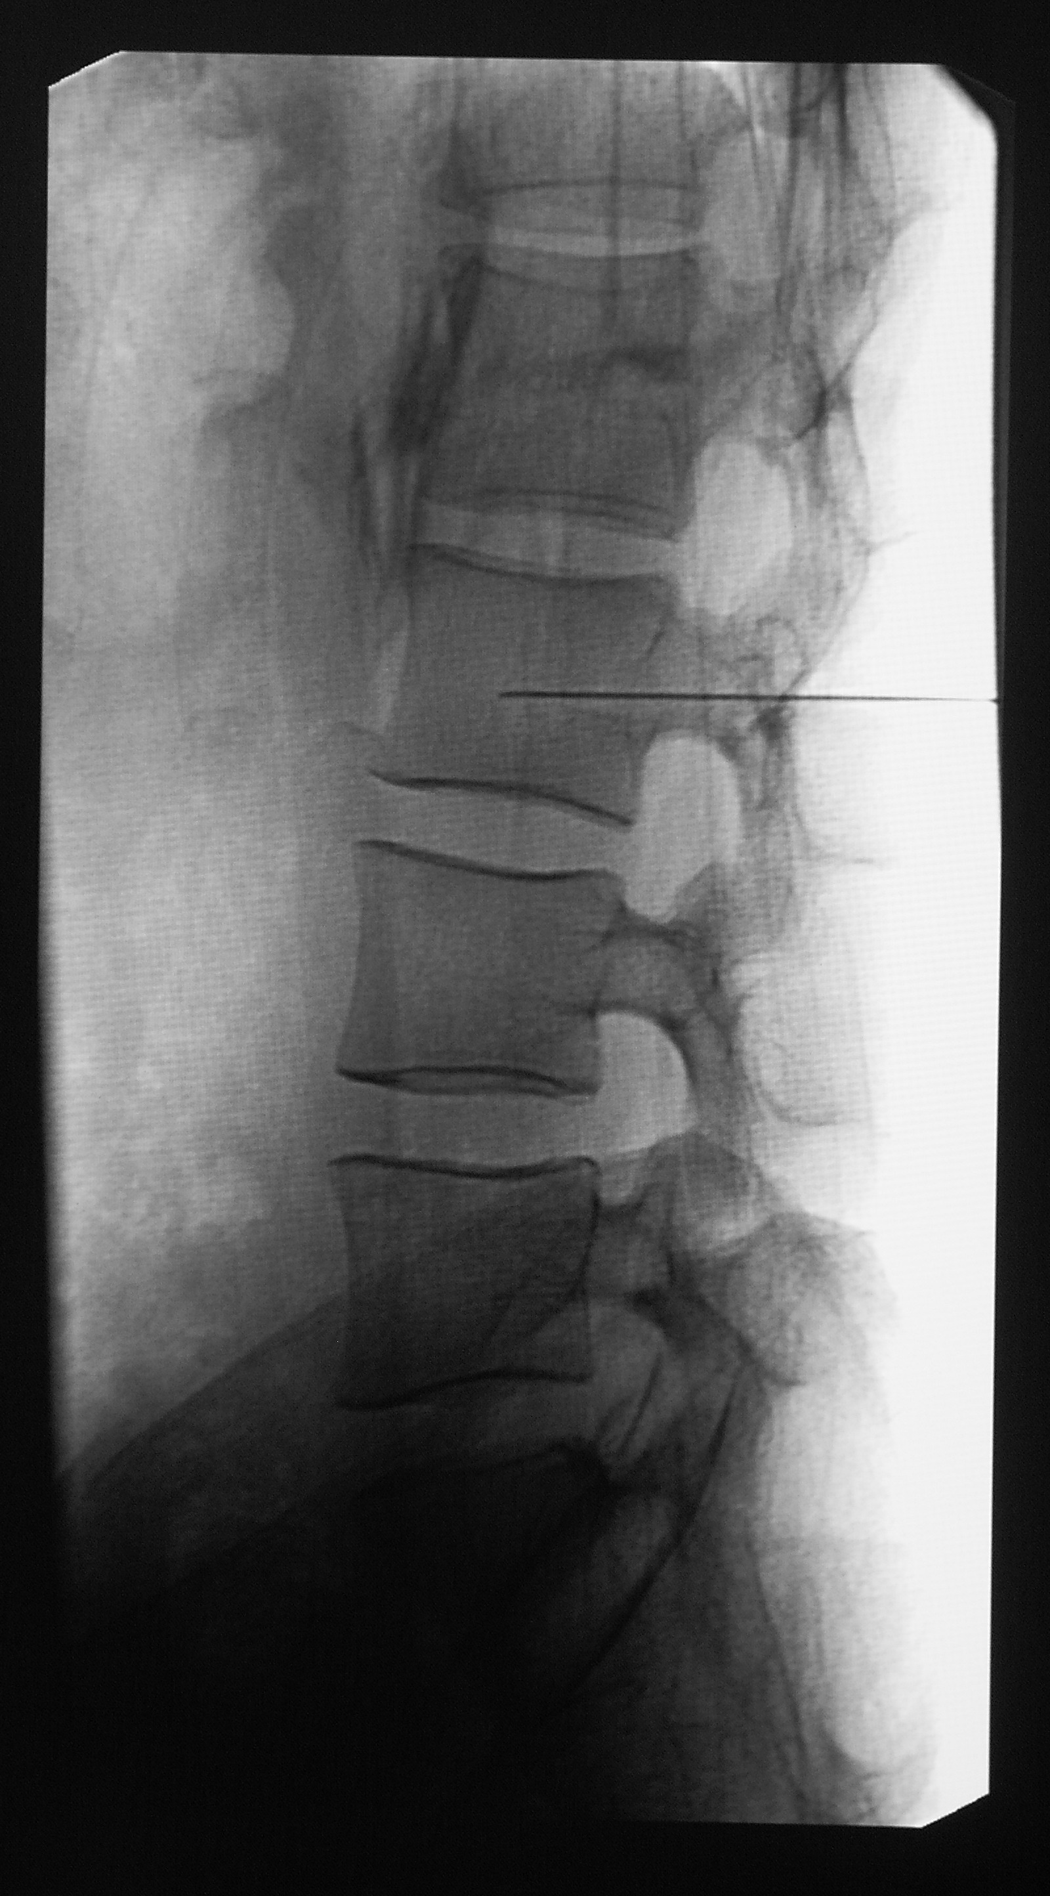

    - LAB MEDIA: Figure 1B: JoVE Video Editor: please emphasize optimal area/add green ovals to right image as in original Figure 1B

  - In selective chemical lumbar sympathectomy, or CLS (C-L-S), the contrast is injected behind the anterior fascia of the psoas major muscle, targeting the gray rami communicantes [1].

    - LAB MEDIA: Figure 2: JoVE Video Editor: please emphasize grey area in left image of left/selective CLS image pair where needle tip is located

  - The expected clinical effects are vasodilation [1], sweat reduction, and pain relief [2].

    - LAB MEDIA: Figure 3: JoVE Video Editor: please emphasize foot/red coloring of foot on left side of image
    - LAB MEDIA: Figure 3

Section - Conclusion
- Conclusion Interview Statements: (Said by you on camera) - All interview statements may be edited for length and clarity.

- Below are questions for statements that can be used to further emphasize the significance of your protocol. At least one statement is required.
- Each statement is limited to 30 words.
- Answer the questions in full sentences, as you will be expected to memorize and deliver the sentences as spoken interview statements during filming.
- Indicate the full name of the author who will give each Conclusion Interview statement.

What is most important thing to remember when attempting this procedure? Please indicate the steps (e.g., 2.4., 2.5.) in the Protocol section this advice correlates to.
  - Zhang, Long: Here we raise the concept of selective CLS, the precise needle tract, accurate evaluation of the contrast spreading are critical in ensuring injection targeting gray rami communicantes.____ (Step: 2.5., 2.6.) (Write your answer here in the form of a spoken statement. Don’t forget to replace “Author Name” with the name of the person who will be speaking the statement on camera)

Following this procedure, what other methods can be performed? What questions would these additional methods answer?
  - Zhang, Long: ____ (Write your answer here in the form of a spoken statement. Don’t forget to replace “Author Name” with the name of the person who will be speaking the statement on camera)

After its development, did this technique pave the way for researchers to explore new questions within a specific scientific field? If so, how?
  - Zhang, Long: With selective CLS, the risk of operation is largely reduced, so the indications for CLS could be widened._____ (Write your answer here in the form of a spoken statement. Don’t forget to replace “Author Name” with the name of the person who will be speaking the statement on camera)

Are any of the reagents or instruments hazardous? If so, please use this interview statement to remind viewers of what precautions they should take.
  - Zhang, Long: The procedures are performed under fluoroscopy guidance, so the radiation protection measures should be taken.___(Write your answer here in the form of a spoken statement. Don’t forget to replace “Author Name” with the name of the person who will be speaking the statement on camera)

Thank you for following the instructions and addressing our questions. We will incorporate your answers/suggestions and send you the finalized script before your shoot. You will also receive detailed shoot preparation instructions in the email accompanying the finalized script.

