Supplemental Information
Table of Contents:
Cost Comparison of Our Method with Commercial and Academic Options
SDS-PAGE of sfGFP Expression in CFPS
Methods for Preparation of an sfGFP Standard Curve
Standard curve for sfGFP on Cytation 5
Methods for T7 RNAP Preparation
Reagent Preparation Instructions
Solution A and B Recipes
CFPS Reaction Setup Guide

Cost Comparison of Our Method with Commercial and Academic Options
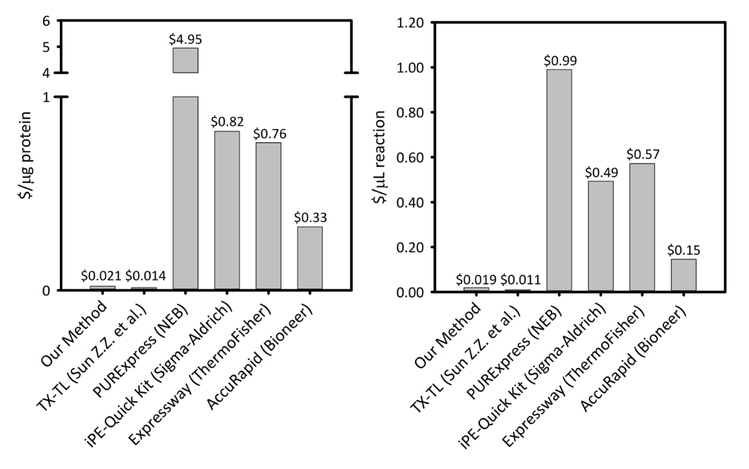
Supplemental Figure 1: Cost per microgram of protein produced and per microliter of reaction across six cell-free protein synthesis platforms. Our platform is compared to five different cell-free protein synthesis kits/platforms with varying productivity and pricing. Our sonication-based CFPS platform is more cost-effective in both $/µg of protein and $/µL of reaction than most commercial kits and provides the ease of a kit for reaction setup, while remaining cost-comparable to other academic CFPS platforms.
*An excel sheet detailing how the cost calculation for our platform was made is provided.

SDS-PAGE of sfGFP Expression in CFPS
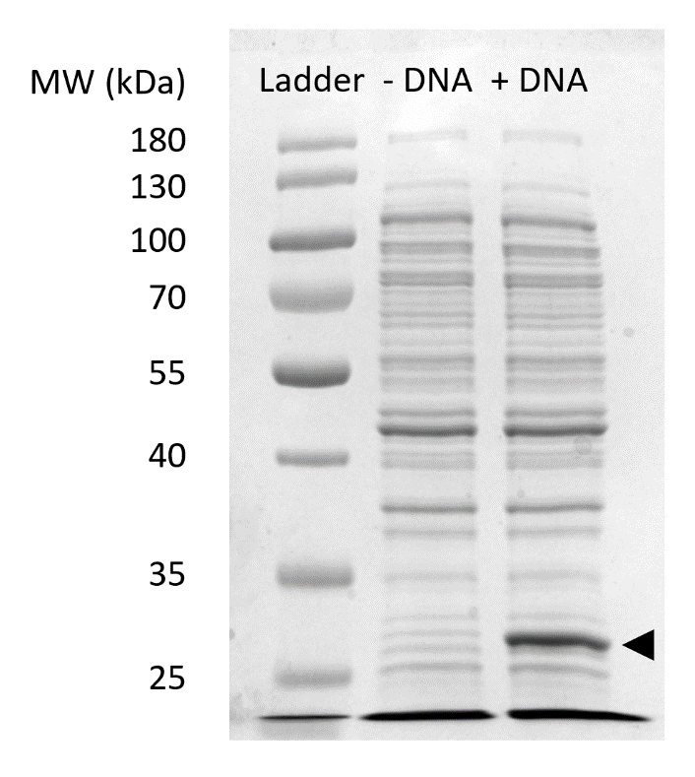
Supplemental Figure 2. SDS-PAGE of sfGFP expression in CFPS. Cell-free protein synthesis reactions with (+ DNA) and without (- DNA) DNA template for sfGFP were run on a 12% SDS-PAGE gel to demonstrate the expression of sfGFP observed at 27 kDa (black arrow). Traditional SDS-PAGE techniques were used. Each sample loaded onto the gel included 18 µg of total protein based on Bradford assay quantification of total protein in the cell extract. Based on fluorescence intensity measurements and our standard curve, we estimate that the “+ DNA” lane contains 0.42 µg of sfGFP. In order to obtain these samples, CFPS reactions were run at a 15 µL scale in 1.5 mL microfuge tubes producing volumetric yields consistent with Figure 3C. Ladder represents the PageRuler Prestained Protein Ladder (Thermo Scientific).

Methods for Preparation of an sfGFP Standard Curve
To prepare a standard curve for quantification of sfGFP, a single colony of BL21* pJL1-sfGFP was inoculated into 5 mL of LB with kanamycin in a round bottom test tube and grown overnight at 37 °C and 250 rpm. After 15-18 h, this culture was centrifuged at 10,000 x g for 5 min in a 15 mL falcon tube, with the appropriate balance. The supernatant was discarded, and the pellet was flash frozen in liquid nitrogen and stored at –80 °C. Strep-tag purification was then carried out as follows using a strep-tag affinity purification column. The pellet was retrieved from the –80 °C and 500 µL of wash buffer was added to the falcon tube. The mixture was placed on ice for 20-30 minutes to thaw. The pellet was completely resuspended through gentle vortexing, with resting periods on ice, to minimize bubble formation. The resuspended mixture was transferred to a 1.5 mL microfuge tube and sonicated for 10 s on, 10 s off, until the total J delivered was ~200 J. The sample was centrifuged at 10,000 x g for 5 min, and the supernatant was collected and saved in a separate 1.5 mL microfuge tube. Next, the column was prepared by allowing the storage buffer to drip through and equilibrating the column with 2 column volumes of wash buffer (400 µL). 500 µL of supernatant was then applied to the column, and the flow through was collected. The column was washed with 5 column volumes of wash buffer (1000 µL). Elution was performed by adding 7 separate 0.5 column volumes of elution buffer (100 µL each), and collecting the elution in 7 separate 1.5 mL microfuge tubes. Lastly, the column was washed with 3 column volumes of 10 mM NaOH (600 µL) followed by 10 column volumes of wash buffer (2000 µL). The column was then capped and wash buffer was added for storage at 4 °C. SDS-PAGE was performed on all collected samples to determine purity, and those samples with high yields of pure sfGFP were combined. The combined stock was then used to create dilutions in HEPES buffer (0.05 M, pH 7.0), and the absorbance at 280 nm was obtained to determine the concentration of the stock sfGFP solution, given that the extinction coefficient for strep tagged sfGFP is 24410 M⁻¹ cm⁻¹. Serial dilutions of the stock sfGFP were prepared, ranging from 0 to 1500 µg/mL of protein. Each dilution was then quantified via a multi well plate fluorometer as follows: 48 µl 0.05 M HEPES, pH 7.0 buffer and 2 µL of the respective sfGFP dilution were added to each well of a flat bottom 96-well half area black plate and each dilution was quantified in triplicate. Excitation and emission wavelengths for sfGFP fluorescence quantification were 485 nm and 510 nm, respectively. A standard curve was created from the collected data in order to convert from fluorescence readings to concentration of sfGFP in µg/mL.

Standard curve for sfGFP on Cytation 5
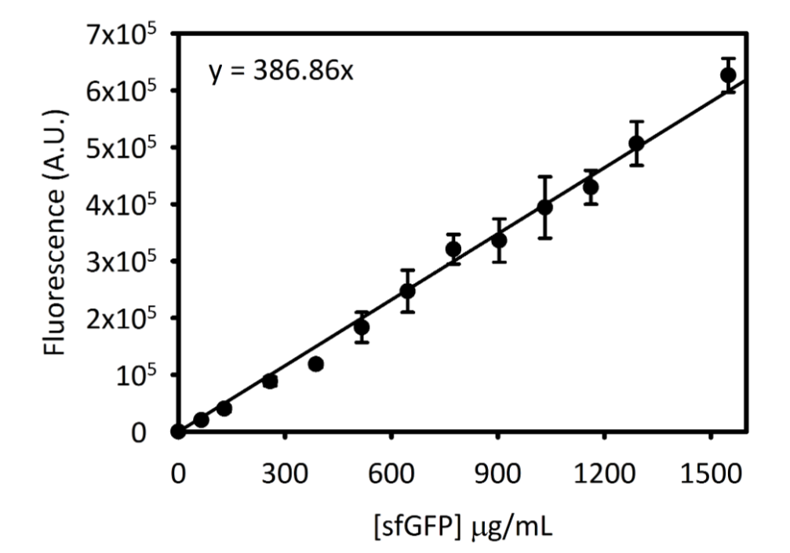
Supplemental Figure 2. Standard curve for sfGFP on Cytation 5. This curve was determined using the methods outlined above. All data collected for this manuscript was converted from endpoint fluorescence readings to [sfGFP] in µg/mL using this standard curve.

Methods for T7 RNAP Preparation
T7 RNA Polymerase was purified by affinity tag chromatography as previously described.⁵¹

Reagent Preparation Instructions
- Tris(OAc): Prepare by weighing out 6.057 g Tris Base and bringing volume up to 50 mL. pH with Glacial Acetic Acid to pH 8.2. Store at room temperature.
- Mg(OAc)₂: Prepare by weighing out 15.01 g Mg(OAc)₂ and bringing final volume to 50 mL using nanopure water. Store at room temperature.
- K(OAc): Prepare by weighing out 29.442 g K(OAc) and bringing final volume to 50 mL using nanopure water. Store at room temperature.
- DTT: Prepare by weighing out 1.54 g of DTT and bringing final volume to 10 mL using nanopure water. Aliquot 1 mL of solution into each 1.5 mL microfuge tube and store at –80 °C.
- S30 components: Prepare by adding 1 mL Tris(OAc), 1 mL Mg(OAc)₂, 1 mL K(OAc), and 0.200 mL DTT and bringing volume to 100 mL using nanopure water. Do not add DTT until day of use and store at 4 °C.
- 2x YTP Media: Prepare by weighing out 5 g NaCl, 16 g Tryptone, 10 g Yeast Extract, 7 g Potassium Phosphate Dibasic, and 3 g Potassium Phosphate Monobasic and bringing volume to 375 mL using nanopure water. Adjust pH to 7.20 using 5 M KOH. Dilute solution to a final volume of 750 mL. Autoclave in 2.5 L baffled flask at liquid 30 setting. Store at 37 °C until use.
- D-Glucose Solution: Prepare by weighing out 18 g D-Glucose and bringing volume to 250 mL using nanopure water. Autoclave solution in a glass bottle at liquid 30 setting. Store at 37 °C until use. Combine with 2x YTP media prior to inoculation of 2x YTPG media with overnight BL21*DE3 culture.
- IPTG: Prepare by weighing out 2.38 g IPTG and bringing final volume to 10 mL using nanopure water. Aliquot 1 mL of solution into each 1.5 mL microfuge tube and store at –80 °C.
For the following stocks, we recommend keeping log sheets for each batch. Over time, this will help identify batch-to-batch variation in reaction performance.
- NAD: Prepare by weighing out 0.050 g NAD and bringing final volume to 0.750 mL using molecular grade water. Store at –80 °C
- PEP: Prepare by weighing out 0.206 g PEP and bringing volume to 0.500 mL using molecular grade water. pH solution to 7.0 by adding 10 M KOH. Bring final volume to 1 mL using molecular grade water. Store at –80 °C.
- CoA: Prepare by weighing out 0.010 g CoA and bringing final volume to 0.260 mL using molecular grade water. Store at –80 °C.
- Putrescine: Prepare by weighing out 0.011 g Putrescine and bringing final volume to 0.500 mL using molecular grade water. Store at –80 °C.
- Spermidine: Prepare by weighing out 0.018 g Spermidine and bringing final volume to 0.500 mL molecular grade water. Store at –80 °C.
- HEPES: Prepare by weighing out 2.38 g HEPES and bringing volume to 5 mL using molecular grade water. pH solution to 7.5 by adding 10 M KOH. Bring final volume to 10 mL using molecular grade water. Store at –80 °C.
- Folinic Acid: Prepare by weighing out 0.015g folinic acid and bringing final volume to 1.5 mL using molecular grade water. Store at –80 °C.
- tRNA: Prepare by weighing out 0.050g tRNA and bringing final volume to 1 mL using molecular grade water. Store at –80 °C.
- 15X MasterMix: Prepare by combining 180 µL ATP, 127.5 µL GTP, 127.5 µL CTP, 127.5 µL UTP (NTPs were purchased at a stock concentration of 100 mM), 47.22 µL folinic acid, and 51.18 µL tRNA. Store at –80 °C.
- 15X Salt Solution: Prepare by weighing out 0.290 g of Magnesium Glutamate, 0.120 g of Ammonium Glutamate, and 1.98 g of Potassium Glutamate and bringing final volume to 5 mL using molecular grade water. Store at –80 °C.
- Oxalic Acid: Prepare by weighing out 0.92 g and bringing final volume to 5 mL using molecular grade water. Store at –80 °C.
- 20 Amino Acids: Prepare by weighing out 0.234 g L-Valine, 0.408 g L-Tryptophan, 0.330 g L-Phenylalanine, 0.262 g L-Isoleucine, 0.262 g L-Leucine, 0.242 g L-Cysteine, 0.298 g L-Methionine, 0.178 g L-Alanine, 0.348 g L-Arginine, 0.264 g L-Asparagine, 0.266 g L-Aspartic Acid, 0.406 g L-Glutamic Acid Potassium Salt Monohydrate, 0.150 g Glycine, 0.292 g L-Glutamine, 0.308 g L-Histidine, 0.365 g L-Lysine, 0.230 g L-Proline, 0.210 g L-Serine, 0.238 g L-Threonine, 0.362 g L-Tyrosine and adding molecular grade water to a final volume to 40 mL. Shake for 15 min in 37 °C incubator. pH of solution should be ~6.7. Store at –80 °C.

Solution A and B Recipes
Solutions A and B are generated upon mixing the aforementioned stock solutions as described below:
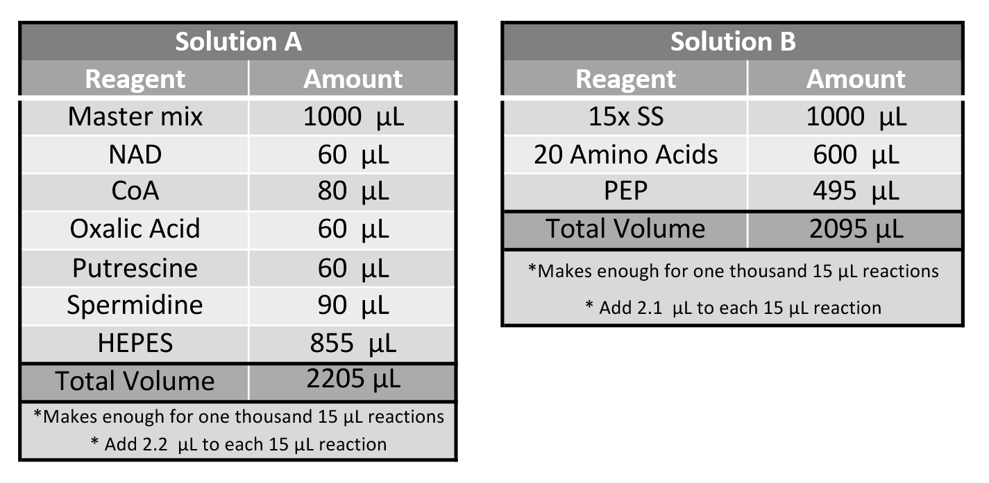
The final CFPS reaction will contain the following concentrations of each reagent: Solution A (1.2 mM ATP, 0.850 mM GTP, 0.850 mM UTP, 0.850 mM CTP, 31.50 µg/mL Folinic Acid, 170.60 µg/mL tRNA, 0.40 mM Nicotinamide Adenine Dinucleotide (NAD), 0.27 mM Coenzyme A (CoA), 4.00 mM Oxalic Acid, 1.00mM Putrescine, 1.50 mM Spermidine, and 57.33 mM HEPES buffer), 2.20 µL Solution B (10 mM Mg(Glu)₂, 10 mM NH₄(Glu), 130 mM K(Glu), 2 mM each of the 20 amino acids, and 0.03 M Phosphoenolpyruvate (PEP)).

CFPS Reaction Setup Guide (excel sheet provided)
