Reviewer 1

The authors present a preparation of gold nanoparticles with a mixed ligand shell of a hydrophobic and hydrophilic ligand at a carefully selected ratio intended to give stability under biological conditions and to also be useful for delivering drugs to cell membranes. This is an important topic of broad utility. A good detailed synthesis of the 11-mercaptoundecane sulfonic acid ligand is provided in addition to synthesis and modification procedure for the nanoparticles. It seems enough information is provided for others to try the procedure.

Please provide more references or a little bit more discussion on how the iodine etching method for determining the ligand ratio works and how reliable it is. Why does it say a ratio of 66:34 is desired but on line 90 a 50:50 ratio is mentioned? Please run spell check, for example on line 113 we have 'undec-10-enefulfonate'.

We thank Reviewer 1 for the comments. A more detailed discussion about iodine etching is added to the discussion part of the paper. Line 449 - 455.

The ratios of nanoparticles were corrected. Line 100.

Spell check was run on the manuscript.

Reviewer 2

Guven et al. demonstrated a protocol to synthesize of amphiphilic gold nanoparticles by using MUS and OT as ligand shell. Then the prepared nanoparticles are characterized by NMR, TGA, TEM, UV-Vis techniques to identify the ligand ratios of MIS and OT. As authors mentioned, the use of MUS ligand with low inorganic salt content is a key point to prepare the reproducibility of the gold nanoparticles. Thus, the protocol of the synthesis of MUS ligand with low content of inorganic salt is the major part in this manuscript. The reproducibility, high salt and pH tests for the prepared AuNPs are
lacked in the manuscript. Overall, this manuscript provided a reasonable procedure of
the synthesis of MUS and eventually can be published after major corrections.

Could the provided protocol (MUS/OT as ligand shell and NaBH4 as reducing agent) be also used for the preparation of amphiphilic silver nanoparticles?

How about using 11-Mercaptoundecanoic acid to replace 11-mercapto-1-undcanesulfonate? It can reduce the synthesized procedure of 11-mercapto-1-undcanesulfonate.

Figure 5 is missed in the manuscript. According to manuscript, the diameter of the prepared AuNPs are about 2-3 nm. As we known, the smaller size of AuNPs, the less stability of long-term storage. How about the stability of the prepared AuNPs? Is it possible to prepare larger size of AuNPs (~13-15 nm)? How to do it?

We thank Reviewer 2 for the comments. The reproducibility of the nanoparticle synthesis protocol was provided in the Figure 8. 3 different batches of MUS:OT 2:1 nanoparticles were synthesized and resulted in nanoparticles with an average of 12% OT on the surface. The reaction is supposed to be performed under the conditions specified avoiding changes in salt and pH, this is implicitly discussed when we say that the starting materials (MUS) should be free of extra salt.

1-Silver nanoparticles were synthesized following the same protocol. Particles with a core diameter of 2.8 ± 1.3 nm were obtained using this synthesis. The ¹H-NMR characterization revealed the amount of OT on the surface was 20%, slightly higher than equivalent gold nanoparticles. However, contrary to the gold nanoparticles, silver nanoparticles were less water soluble. All the characterization results are depicted in Figure 1.
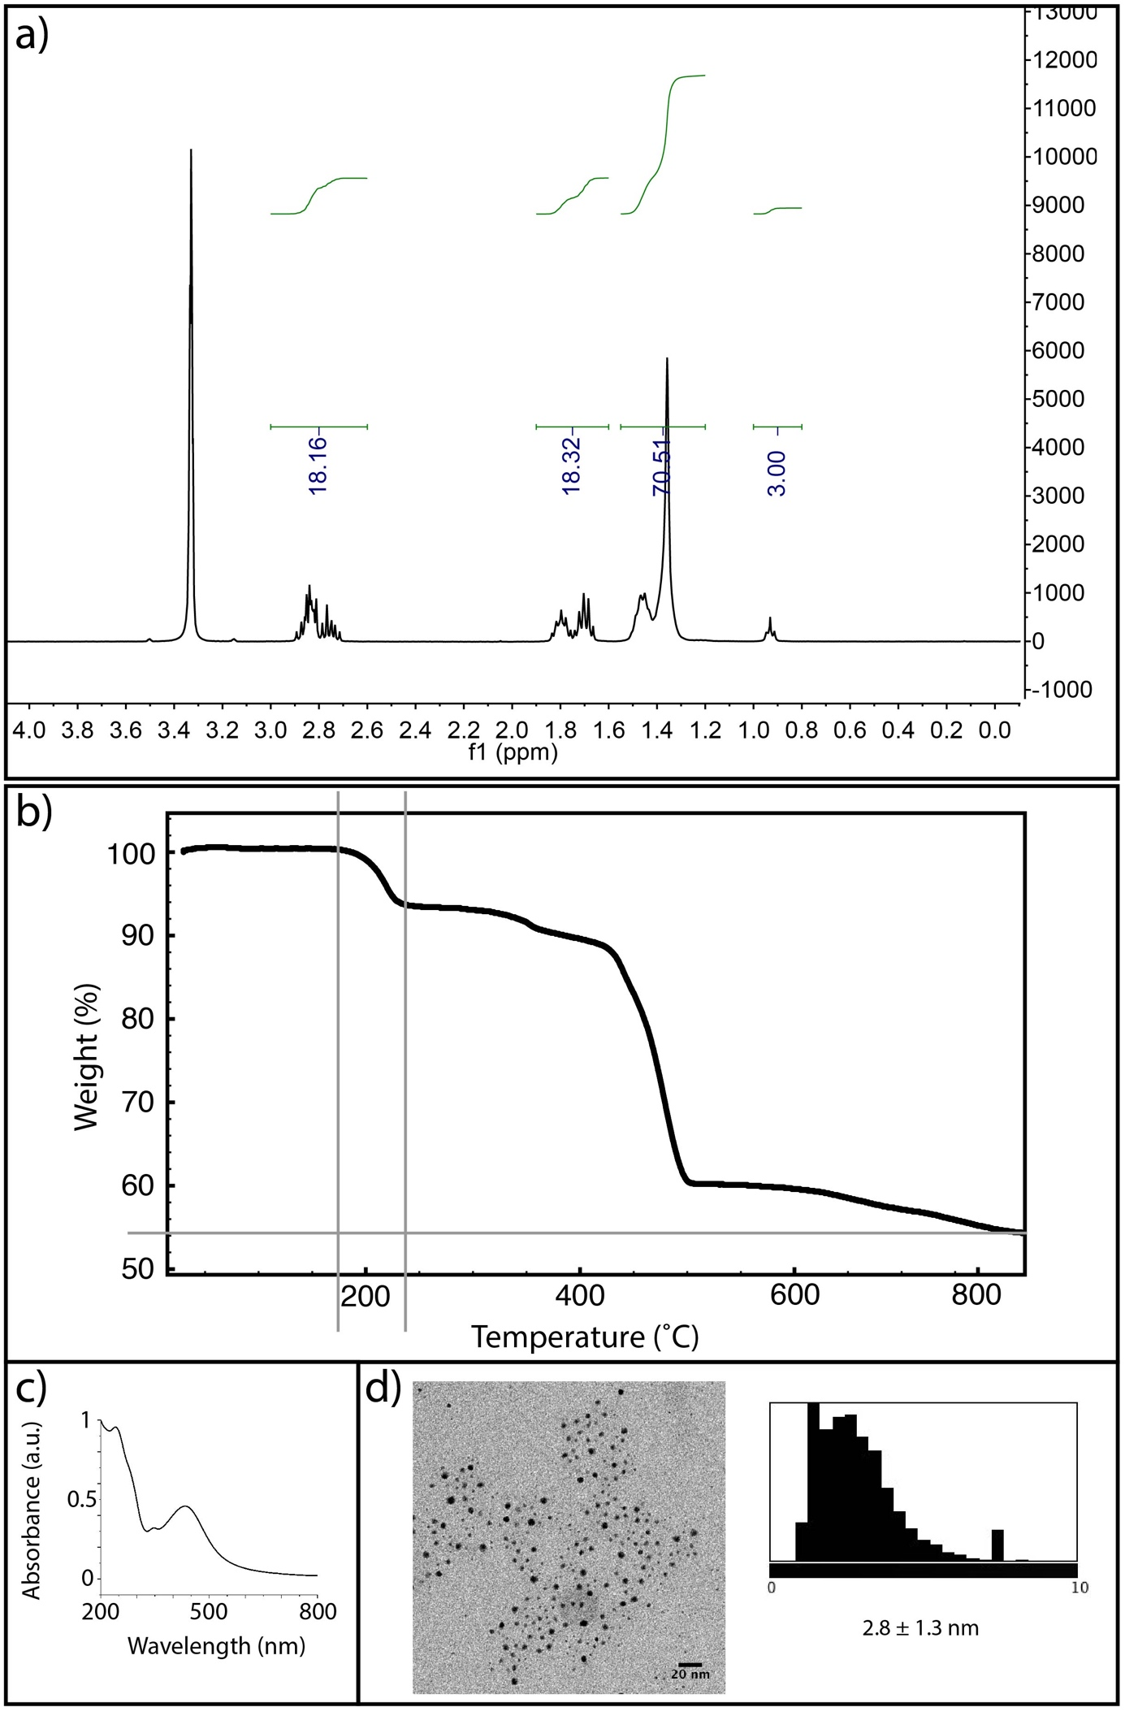

2- To produce amphiphilic nanoparticles phosphonic acid (11-mercaptophosphonic acid, MUP) terminated ligands were used instead of MUS. The synthesis resulted in 3.13 ± 1.4 nm core size with 7% OT on the surface (calculated using ¹H-NMR of the etched particles). TGA and calculations revealed 5 ligands per nm², similar to 2:1 MUS:OT nanoparticles. However, the solubility of MUP:OT, amphiphilic nanoparticles in physiological buffers is drastically lower than that of MUS:OT nanoparticles. MUP:OT nanoparticles dissolve in basic solutions, as well as water-ethanol mixtures. Therefore, in our experience amphiphilic nanoparticles having sulfonated ligands on the surface are more colloidally robust in physiological buffers compared to other amphiphilic nanoparticles tested. All the characterization results are depicted in Figure 2.

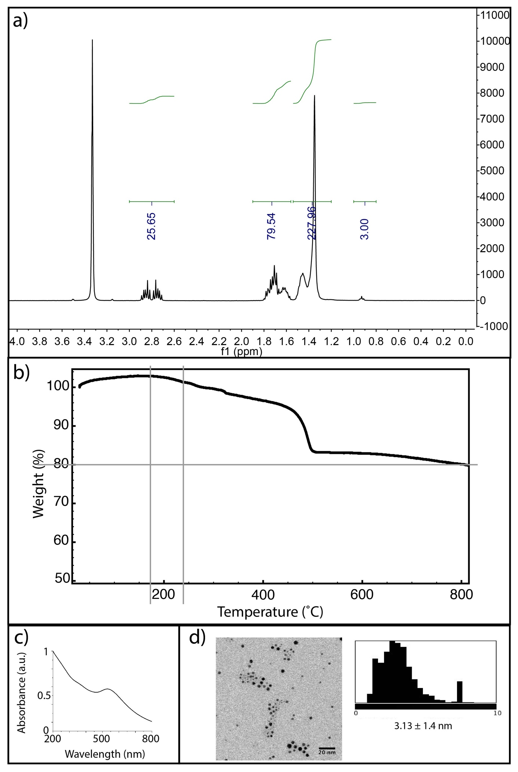
3- Figure 5 is added. The stability of the prepared AuNP is extremely high. No distinct degradation of MUS:OT gold nanoparticles could be seen after 1 year. This synthesis method does not result in nanoparticles larger than the dimensions reported in this protocol.

The chemical names were corrected and a spellcheck was ran throughout the manuscript.

Reviewer 3

The manuscript "Synthesis and Characterization of Amphiphilic Gold Nanoparticles therapy by Guvenet al., underwent review and work was found scientifically sound and well structured. The discussion of the manuscript is also very well written.
This work is dedicated to the one-phase chemical reduction followed by thorough purification to generate these nanoparticles. This approach seems promising. However, the submitted manuscript provokes some questions and comments (see below).
1 The level of English is not good especially in introduction.
2 Generally in abstract references should be avoided.
3 Line 44 what is the meaning of this sentence "in water 9combined with"
4 Line 71, remove 9 from start of next sentence "9 Moreover, these"
5 The author does not refer the current published articles dedicated to the synthesis of traditional methods. Please incorporate these references in revised manuscript,
a Mirza, A.Z., Shamshad, H. Fabrication and characterization of doxorubicin functionalized PSS coated gold nanorod. Arabian Journal of Chemistry (2014), http://dx.doi.org/10.1016/j.arabjc.2014.08.009.
c Eugenia Li Ling Yeo, Joshua U-Jin Cheah, Bing Yi Lim, Patricia Soo Ping Thong, Khee Chee Soo, and James Chen Yong Kah, Protein Corona around Gold Nanorods as a Drug Carrier for Multimodal Cancer Therapy, ACS Biomater. Sci. Eng., 2017, 3 (6), pp 1039-1050.
b Mirza, A.Z., A novel drug delivery system of gold nanorods with doxorubicin and study of drug release by single molecule spectroscopy, Journal of Drug Targeting, Volume 23, Issue 1, 2015, Pages 52-58.
6 Author should mention name of chemical with abbreviation then use abbreviation throughout the manuscript for example "11-mercaptoundecane sulfonic acid (MUS)".
7 Line 166 something missing after chemical name "1.3. 11-mercapto-1-undecanesulfonate (MUS):"?
8 Why author mention protocol in numbering not in paragraph?.
9 ml and μl should be mL and μL throughout the manuscript.
10 There is missing of Figure 5. Size distribution of nanoparticles in manuscript. Please provide image of TEM.
This paper should be accepted after major revision.

- We have improved the level of the technical English employed throughout the text.
- References in the abstract were removed.
- It was a misspelling and it was corrected. Line 79
- Misspelling was corrected.
- The references were added. Lines 66 and 67.
- Abbreviations were mentioned once and used throughout the manuscript.
- There was not missing part on the sentence. ’11-mercaptoundecane-1-undecanesulfonate (MUS)’in line 215 represents the headline of the 3rd and final step of overall MUS ligand synthesis.
- The format of the JOVE paper requests the protocol with numbering.
- The units were corrected throughout the manuscript.
- Figure 5 is provided.

