
Chia-Lin Hsu Ph.D.
National Yang-Ming University, School of Life Sciences
Institute of Microbiology and Immunology
155, Sec.2, Li-Nong Street, Taipei 112, Taiwan
Tel: 886-2-2826-7113/Fax: 886-2-2821-2880 chialin.hsu@ym.edu.tw

Editorial Team
JoVE
September 4th, 2018

Dear Scientific Editors,

Thank you for the opportunity to revise our manuscript. The constructive advice of the editor and reviewers have substantially improved our paper. Based on the suggestions, we added in two additional sessions to describe sample collection on flow cytometer and data analysis, and carefully reviewed the manuscript for any typos or errors. Attached is our detailed response to their comments. Please note that all changes in the manuscript have been highlighted in yellow color. We believe that we have addressed all of the comments and that our manuscript has been significantly strengthened by these modifications.

We appreciate your time and look forward to your response.

Sincerely,



Responses to the editors:
Thank you for your thorough review of our manuscript. Each comment or concern has been carefully revised and responded. Changes are highlighted in the revised manuscript.
1. Please take this opportunity to thoroughly proofread the manuscript to ensure that there are no spelling or grammar issues.
We are grateful for this opportunity to proofread the manuscript and have corrected spelling or grammar issues.

2. Please spell out each abbreviation the first time it is used.
Each abbreviation has been spelled out on the first time of usage:
line 80: immunofluorescent (IF),
line 139: fetal bovine serum (FBS)
line 144: ammonium-chloride potassium (ACK) lysing buffer,
line 135: room temperature (RT),
line 195: fluorescence minus one (FMO),
line 201: propidium iodide (PI),
line 214: forward scatter (FSC), side scatter (SSC),
line 278: double negative (DN), double positive (DP), single positive (SP),
line 315: lysosomal-associated membrane protein 1 (LAMP-1).

3. JoVE policy states that the video narrative is objective and not biased towards a particular product featured in the video. The goal of this policy is to focus on the science rather than to present a technique as an advertisement for a specific item. To this end, we ask that you please reduce the number of instances of "MitoTracker” /”LysoTracker" within your text. The term may be introduced but please use it infrequently and when directly relevant. Otherwise, please refer to the term using generic language.
We appreciate this reminder and have replaced most of the terms with “Lysosome/ mitochondria-specific dyes” or “organelle-specific probes” and significantly reduced the number of using “MitoTracker/LysoTracker" in the paragraphs.

4. Please move the ethics statement before your numbered protocol steps, indicating that the protocol follows the animal care guidelines of your institution.
The ethics statement has been moved to line 115, in front of the beginning of protocol.
5. Please revise the Protocol steps so that individual steps contain only 2-3 actions per step and a maximum of 4 sentences per step. Use sub-steps as necessary.
We have revised the protocol steps accordingly.
6. Please specify all surgical instruments used in each step.
We have added the specifications of surgical instruments in each step and materials.
7. 2.2: What happens after centrifugation, discard the supernatant?
To clarify the step, we have revised the sentence to “Wash the cells with 1 mL FACS buffer and centrifuge (300 x g, for 5 min at 4 °C) and discard the supernatant.”
8. 3.2: Please describe how to analyze the samples on a flow cytometer.
We added additional section 4 “Sample collection on flow cytometry” and section 5 “Data Analysis” in the revised manuscript.

9. Please include single-line spaces between all paragraphs, headings, steps, etc.
Single-line spaces are inserted between all paragraphs, headings, and steps.

10. Figures 2 and 3: Please line up the left and right panels better.
Figure 2 and 3 have been revised to have better presentation.

11. Table 1: Please change “μl” to “μL”, and include a space between all numbers and their units (i.e., 100 μL, 0.1 μM, 0.1 μg, 25 ng, etc.).
All units used in the manuscript has been carefully examined and corrected to µL with a space between numbers and their units.
12. References: Please do not abbreviate journal titles.
We have examined all the references and updated the style not to abbreviate journal titles.

Response to Reviewers' comments:
Reviewer #1:
Major Concerns:
The manuscript is well written with a clear description of the necessity of this protocol. However the expectative indicated in the summary and abstract are not fulfilled in the protocol. The authors introduced the analysis of rare cells or the possibility to quantify mitophagy but none of these challenges were take into consideration in the methodology or in the representative results. Without this, current protocol reduced enthusiasm for the manuscript. Here, the list of the issues:

1-The protocol could not be used to combine both mitochondrial and lysosomal staining. First, because they use the same fluorochrome, the green one, and secondly time of incubation for the mitotracker probe is half of the time that is required for the lysotracker probe. In the introduction it is well mentioned the interesting process of mitophagy. So how can be distinguished or computed those cells with defective or damaged mitochondria content? Current protocol makes impossible its application to measure mitochondrial autophagy for instance.

We thank Reviewer 1’s for the comments and would like to clarify that we did not and do not recommend to combine mitochondrial and lysosomal staining in the same sample. We will revise the wording in our manuscript to avoid this misunderstanding. Secondly, the proposed protocol here does not intend and cannot be used to distinguish normal to damaged mitochondria. It is simply a method to quantify cellular mitochondrial contents. Further biochemical analyses are required to study mitophagy process or identify damaged mitochondria, but these go beyond the scope of the current protocol.

2- The authors mention that this protocol is useful for mitochondria/lysosome quantification in rare cells. However, they use tissues where lymphocytes are the most abundant cells. How accurate is their protocol in non-lymphoid tissues where lymphocytes are less abundant? What is the minimum number of target cells required to obtain a significant ΔMFI for both mitotracker and lysotracker?

In this manuscript we used lymphoid tissues as an example to show that one can quantify mitochondrial/lysosomal contents in different cell populations of interest. We showed that this method could successfully quantify mitochondrial/lysosomal contents in immune cell sub-populations such as the rare double-negative 1 (0.75% of all cells in the thymus) or the abundant double-positive thymocytes (85%). One can definitely apply this method in non-lymphoid tissues (eg. tumor or tissue biopsy). In principle, as long as the cell population of interest has distinct surface marker expression and is at least 1,000 in number, one should be able to perform the analysis with confidence (line 232-233).

3- How repetitive and significant are the data? How ΔMFI varies between staining? When comparing surface staining between figure 2A and 3A for DN3 populations a noticeable difference is observed that affects the MFI.
We have optimized our protocol so that the results are with good consistency. We showed only representative results in the figures for simplification, but we do have at least 5 technical repeats for each experiment as shown here.
It is not surprising to find MFI differences between Fig. 2A (mitochondrial staining) and 3A (lysosomal staining) since different dyes were applied.

4- Mitochondria are very dynamic organelles that suffer processes such as fusion or fission. It is not clear in the protocol whether authors are measuring the amount of mitochondria as a mass or as a number. Visualization of mitochondrial content by IF or by imaging flow cytometry and comparing it with multicolor flow cytometry will render data more useful.

The protocol provides a method to measure the amount of mitochondria, not number. To quantify the absolute number of mitochondria, one needs to apply methods such as measuring citrate synthase, cardiolipin content, or mitochondrial DNA copy. The MitoTracker signals detected by flow cytometry and the mitochondria contents by microscopy do have a strong correlation as shown in Buck et al., Cell 2016.

Minor Concerns:
5- How the metabolism of T cell is affected by euthanizing mice with CO₂ for 5-7 minutes?

It is unclear if euthanizing mice with CO₂ affects the T cell metabolism nor not. Nevertheless, it is a well-recognized IACUC protocol for humane euthanasia and is applied for the majority of the studies using mouse models, including T cell metabolism studies.

6- The protocol should also include the time lasting from sacrifice to analysis since when performing experiments with several mice this would be a critical step.

The whole procedure takes ~2 hour from tissue harvest to analysis and we added this information to the text (line 367-368). We have not performed detailed analysis to compare the effects of sample preparation time on the readout. It is critical to acquire the samples on the flow cytometer as soon as the staining is completed (noted in protocol step 3.4). Nevertheless, we do recommend to streamline the experiment with sufficient support if large number of mice are involved.

7- Fc receptors are blocked by using 2.4G2 hybridoma instead of purified IgG. Should be hybridoma titrated and used according to its titration?

Yes, the hybridoma supernatant should be titrated before application. We have added this to the text (line 185). We performed the titration and tested its effectiveness by CD16/32 surface staining after 2.4G2 supernatant incubation. The results are shown below. However, the details of how antibody titration are done goes beyond the scope of the current manuscript.

8- Controls for compensation. In the protocol, single staining for spillover assessments is indicated after mitotracker/lysotracker staining. Single staining must be performed for all dyes, including mitotracker and lysotracker as well as for all the cell surface fluorochrome-conjugated antibodies.

All the experiments performed were with proper compensation setups. We included this information in the revised manuscript as suggested (line 192-196).

9- In Figure 1, a relevant number of cells are discarded because they are not considered as single cells. When working with a cell lineage, FSC-A vs FSC-H linearity could be considered as a parameter for doblet exclusion. But what happens when working with homogenate tissues where many type of cells with different size (FSC parameter) are present? Can you consider only one type of FSC-A vs FSC-H linearity?

The FSC-A vs. FSC-H gating is not assuming a single linearity; it is used to determine the accuracy of the electric pulse. The principle is explained below:
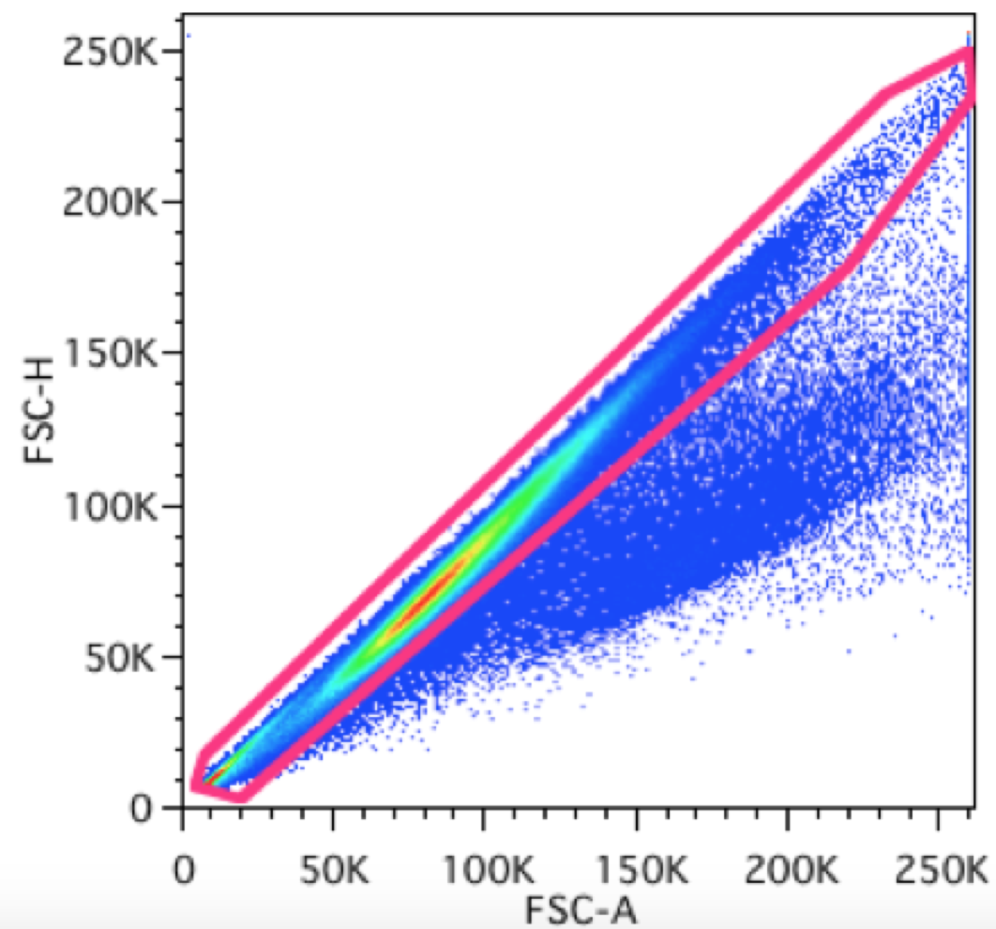
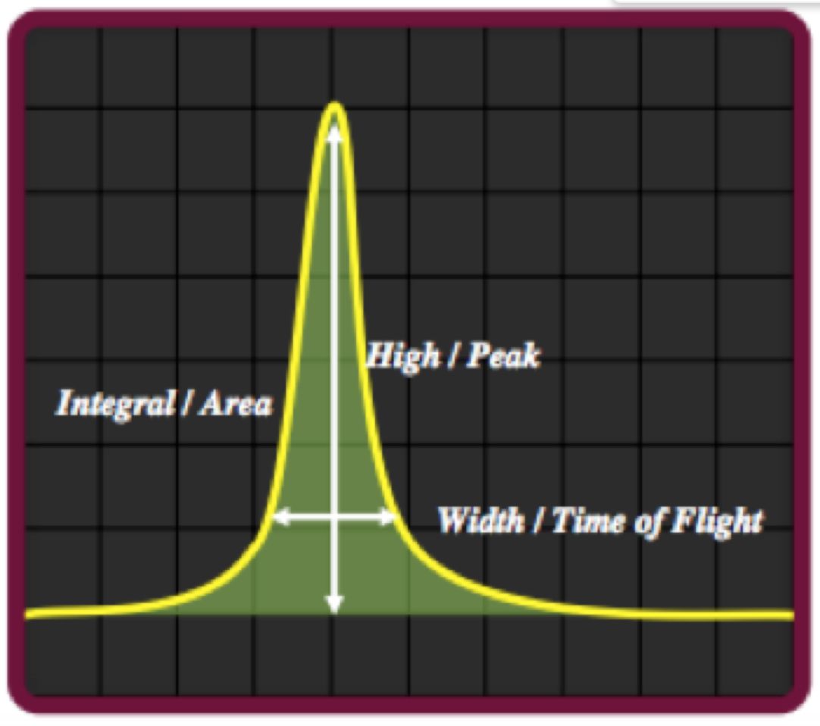
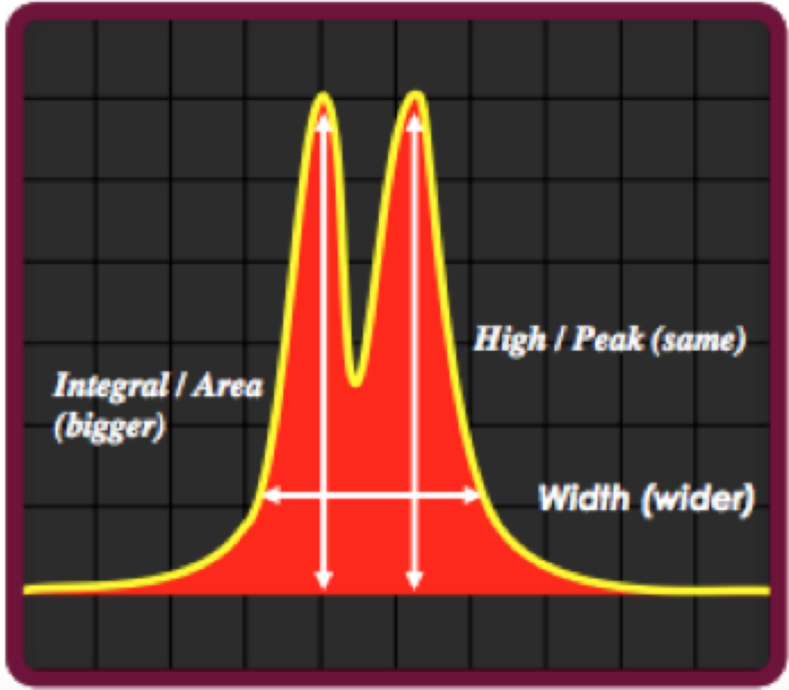
Since the flow cytometer analyses the sample at single cell basis, one can create a gate that eliminates cells that show an increase in pulse area without an increase in pulse height.

10- It is well explained the rationale for CD62L vs CD44 staining to distinguish naïve, memory and effector T cells. What about the rationale for CD44 vs CD25?

The usage of CD44 (Pgp-1) and CD25 (IL-2R) to distinguish different stages of CD4-CD8- (double-negative or DN) T cells is a well-validated system (Godfrey et al., J.Immunol, 1993). The earliest stages of T cell development, when the cells do not express the co-receptors CD4 and CD8, can be classified on the basis of CD44 and CD25 expression. The earliest progenitors are CD44+ CD25- (DN1), then they start expressing CD25 and become CD44+CD25+ (DN2) cells. After that the cells down-regulate CD44 and become CD44-CD25+ (DN3) cells and, finally, they down-regulate CD25 as well to become CD44-CD25- (DN4) cells that are on the way of expressing CD4 and CD8 and become double-positive (DP) cells. We added this information to the text (lines 276-286).

11- The assertion that "naïve T cells have the lowest mitochondria mass" (pag 6 line 165) is not accurate, because when compared with memory and effector T cells these two later show less mitochondria content.

In this sentence, we were referring to thymocyte populations. We re-phrased it, so that it is clear that the mitochondrial mass of naïve T cells is lower than that of thymocyte populations (lines 298-301).

12- In Figure 3. How specific and significant is the staining for lysotracker? Did the authors perform a statistical test to conclude differences in the staining? Some of these probes induce shift in the background fluorescent that have not to be taken as a positive staining.

LysoTracker has been considered and tested as a specific marker for lysosomes (Chen et al., Sci Rep 2015). For each experiment, we do have at least 3 technical repeats to ensure the validity of results. It is also noteworthy that we presented our results as ΔMFI = mean fluorescence intensity (LysoTracker) - mean fluorescence intensity (surface marker only), therefore we are confident that the shifts in the staining as low but positive signals. But, perhaps, the best argument for the validity of the staining is that cells with the highest LysoTracker staining are the ones known to have large lysosomal compartments (effector and memory CD8⁺ T cells).

13- About the lysosomal content in memory and effector CD8 T cells, did the authors perform intracellular staining for other lysosomal markers to corroborate their conclusions on lysotracker staining?

We did not perform such comparisons, since LysoTracker is only applicable to intact cells and cannot be combined with intracellular staining. However, Shen et al., J Leu Biol, 2006 also detected increase of lysosomal content in memory and effector CD8 T cells using different assays, further corroborates our findings with LysoTracker.

14- The list of dyes in table 1 does not mention the lysotracker.

We have included this information in the table.

15- In the materials list, flow cytometer is a BD LSRfortessa instead of BD LSRfortrees.

We have corrected this typo.

Reviewer #2:
Minor Concerns:
I would like to suggest careful editing of the text to the authors because I found some typos. It might be helpful if the authors can provide the method to optimize concentration of MitoTracker and LysoTracker, although this is not mandatory.

We appreciate the reviewer’s comment and have carefully edited the text. Below we showed the example of LysoTracker titration results:
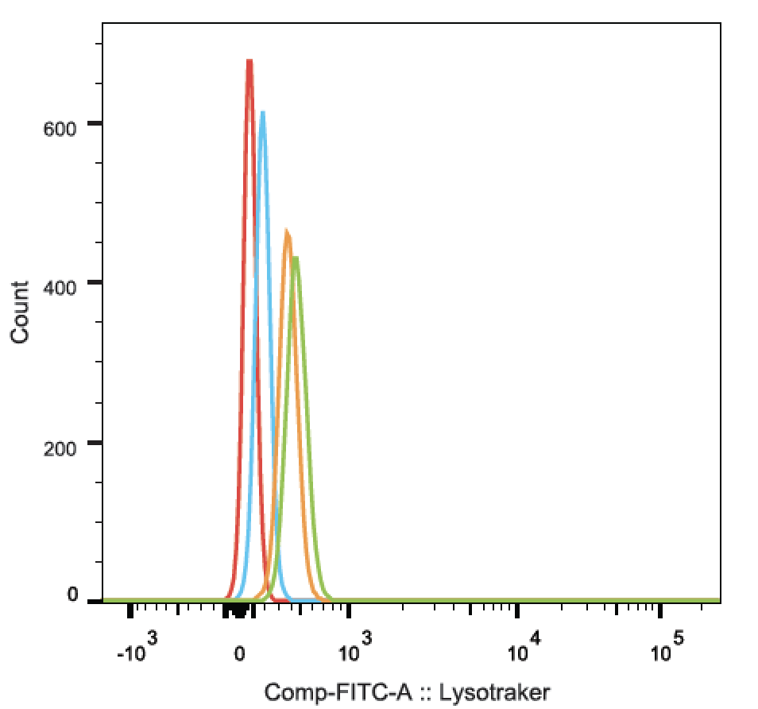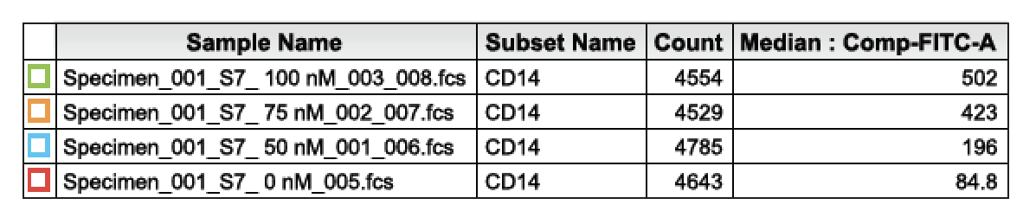
We performed the LysoTracker titration using human monocytes (CD14⁺). It is recommended to choose a cell population that is known to have good expression of staining target (eg. Lysosomes). 100nM was chosen based on two factors: 1) good separation between negative to positive staining; 2) good cell viability. We reflected this in the text (line 170-175).

Reviewer #3:
Minor Concerns:
1. There are several typos that require to be corrected. Line 78 "uncertainly" changes to "uncertainty", Line 79 "immune-blot" changes to "immunoblot" and Line 217 "It's" changes to "It is".

We thank the reviewer’s reminder and have corrected these typos.

2. Since LysoTracker and MitoTracker dyes are two key reagents used in this manuscript. It is suggested that the authors need to write a paragraph to introduce how these two dyes are working.

We agree that this information should be included in the manuscript and have added it (line 97-100).

3. In Protocol, the authors may need to explain why MitoTracker or LysoTracker staining should be performed before surface marker staining. What will happen if surface marker staining is performed first?

The MitoTracker or LysoTracker staining was performed first because the optimal staining condition for these organelle-specific dyes is incubation at 37˚C. If the surface staining is performed first and then cells are incubated at 37˚C, the surface marker staining can be significantly reduced because of antibody capping and endocytosis of antibody-bound surface markers. We have added text to indicate this (line 159-161).

4. In Line 108, the authors described the location of spleen (on the left side…). However, It is unclear the position of the spleen is from ventral view or dorsal view. It is suggested that the authors need to specify.

We have edited this description and clarified the position of the spleen (line 126-131).

