 |  | Professor Yuri L. Lyubchenko  Office (402) 559-1971  Lab (402) 559-1973  FAX (402) 559-9543  Email: ylyubchenko@unmc.edu
Nebraska’s Health Science Center |  | College of Pharmacy  Department of Pharmaceutical Sciences
October 13, 2018

Vineeta Bajaj, Ph.D.
Review Editor
JoVE

Dear Dr. Vineeta Bajaj

I am submitting this cover letter for the additional revised version of our original submission:
Probing the Structure and Dynamics of Nucleosomes Using AFM Imaging
By Micah P Stumme-Diers, Zhiqiang Sun, and Yuri L. Lyubchenko

In this revision we addressed all the concerns. Please let me know if additional changes are still needed.

Sincerely,

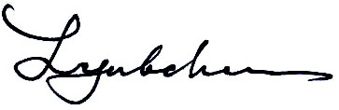
Yuri Lyubchenko, Ph.D., D.Sc.
Professor, Department of Pharmaceutical Sciences
E-mail – ylyubchenko@unmc.edu
Phone - 402-559-1971
fax - 402-559-9543

