State-Trait Anxiety Inventory (STAI)

Read each statement and then circle the appropriate answer to the right of the statement to indicate how you feel now, at the present time. There are no right or wrong answers. Give the answer which seems to describe how you feel at this moment.

1. I feel calm  Not at all Somewhat Moderately so Very much so | 11. I feel self-confident  Not at all Somewhat Moderately so Very much so
2. I feel secure  Not at all Somewhat Moderately so Very much so | 12. I feel nervous  Not at all Somewhat Moderately so Very much so
3. I am tense  Not at all Somewhat Moderately so Very much so | 13. I am jittery  Not at all Somewhat Moderately so Very much so
4. I feel strained  Not at all Somewhat Moderately so Very much so | 14. I feel indecisive  Not at all Somewhat Moderately so Very much so
5. I feel at ease  Not at all Somewhat Moderately so Very much so | 15. I am relaxed  Not at all Somewhat Moderately so Very much so
6. I feel upset  Not at all Somewhat Moderately so Very much so | 16. I feel content  Not at all Somewhat Moderately so Very much so
7. I am presently worrying over misfortunes  Not at all Somewhat Moderately so Very much so | 17. I am worried  Not at all Somewhat Moderately so Very much so
8. I feel satisfied  Not at all Somewhat Moderately so Very much so | 18. I feel confused  Not at all Somewhat Moderately so Very much so
9. I feel frightened  Not at all Somewhat Moderately so Very much so | 19. I feel steady  Not at all Somewhat Moderately so Very much so
10. I feel comfortable  Not at all Somewhat Moderately so Very much so | 20. I feel pleasant  Not at all Somewhat Moderately so Very much so

Self-Assessment Manikin (SAM)

Please circle the figurine that best represents your emotional state (negative or positive) at the present time, at this moment.
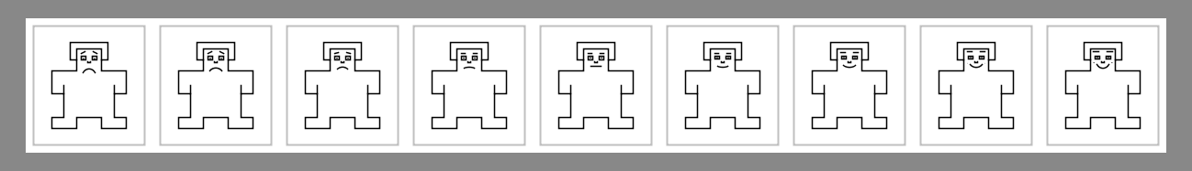
Please circle the figurine that best represents your emotional tension at the present time, at this moment
(low emotional tension = small figurine ; strong emotional tension = big figurine)
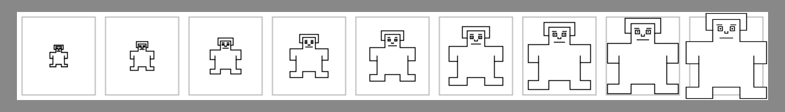
Please circle the figurine that best represents the control of your feelings at the present time, at this moment
(you have no control = small figurine ; you have total control = big figurine)

