Explicit copyright permission

Editor. Comment #12.
Please obtain explicit copyright permission to reuse any figures from a previous publication. Explicit permission can be expressed in the form of a letter from the editor or a link to the editorial policy that allows re-prints. Please upload this information as a .doc or .docx file to your Editorial Manager account. The Figure must be cited appropriately in the Figure Legend, i.e. “This figure has been modified from [citation].”

PLoS ONE permission

-----Message d'origine-----
De : noreply@salesforce.com <noreply@salesforce.com> De la part de Julie Coleman
Envoyé : vendredi 21 septembre 2018 16:35
À : olivier.vors@univ-amu.fr
Objet : explicit copyright permission

Dear Mr. Vors,
Thank you for your message. PLOS ONE publishes all of the content in the articles under an open access license called "CC-BY." This license allows you to download, reuse, reprint, modify, distribute, and/or copy articles or images in PLOS journals, so long as the original creators are credited (e.g., including the article's citation and/or the image credit). Additional permissions are not required. You can read about our open access license here: http://journals.plos.org/plosone/s/licenses-and-copyright
There are many ways to access our content, including HTML, XML, and PDF versions of each article. Higher resolution versions of figures can be downloaded directly from the article.
Thank you for your interest in PLOS ONE and for your continued support of the Open Access model. Please do not hesitate to be in touch with any additional questions.
Kind regards,
Julie Coleman
Staff EO
PLoS ONE
Case Number: 05964510

PSYCHONEUROENDOCRINOLOGY permission

Dear Dr Vors,,
This can be obtained by following the Copyright link on Science Direct:
https://www.sciencedirect.com/science/article/pii/S0306453010002088
Yours sincerely, Rose-Marie Bluthé

*****************************************
Rose-Marie Bluthé, PhD
Editorial Assistant for Robert Dantzer, DVM, PhD
FRANCE
E-mail : rosemarie.bluthe31@orange.fr;
psychoneuroendo@gmail.com
******************************************
PSYCHONEUROENDOCRINOLOGY
https://www.evise.com
2017 PNEC impact factor = 4.731
5-Year 2017 Impact Factor: 5.522
CiteScore : 4.86
48th Annual Conference of ISPNE – Irvine (CA), United States.
6th – 8th September, 2018
"Diversity, Health, and Resilience: Taking Science Beyond Discoveries"
Please go to : http://www.ispne.net for more information
***************************************************

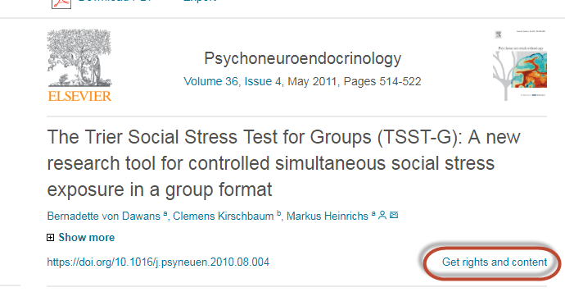

Hope I helps!
Best wishes,
Agnieszka

