Submission ID #:
Editor Name:
Videographer name:
Film Date:
Authors and Affiliations:
Faddi G. Saleh Velez^{1,2}, Camila B. Pinto^{1,3}, Emma S. Bailin⁴, Marionna Münger¹, Andrew Ellison⁵, Beatriz T. Costa¹, David Crandell⁶, Nadia Bolognini^{7,8}, Lotfi B. Merabet⁴, Felipe Fregni¹

¹Laboratory of Neuromodulation & Center for Clinical Research Learning, Department of Physical Medicine and Rehabilitation, Harvard Medical School, Spaulding Rehabilitation Hospital, Boston, MA, USA.
²University of Chicago Medical Center, Department of Neurology, University of Chicago, Chicago, IL, USA.
³Department of Neuroscience and Behavior, Psychology Institute, University of Sao Paulo, Sao Paulo, Brazil.
⁴The Laboratory for Visual Neuroplasticity, Department of Ophthalmology, Massachusetts Eye and Ear Infirmary, Harvard Medical School, Boston, USA
⁵Center for Biomedical Imaging, Department of Anatomy and Neurobiology, Boston University School of Medicine, Boston, USA
⁶Spaulding Rehabilitation Hospital, Harvard Medical School, Boston, MA, United States
⁷Department of Psychology & Milan Center for Neuroscience, University of Milano-Bicocca, Milano, Italy
⁸Neuropsychological Laboratory, IRCCS Istituto Auxologico Italiano, Milano, Italy

Corresponding author:
Felipe Fregni, MD, PhD
Laboratory of Neuromodulation, Spaulding Rehabilitation Hospital, 125 Nashua Street #727, Boston, MA, USA 02114
Email: fregni.felipe@mgh.harvard.edu
Phone: 617–573-2195

Title: Real Time Video Projection in an MRI for the Characterization of the Neural Correlates Associated with Mirror Therapy treatment for Phantom Limb Pain

Authors, please fill out the brief questionnaire below.

A. Will you require assistance with video microscopy, such as filming a complex dissection or microinjection technique (Y/N, please specify steps by number. Also, please list make and model of your microscope)? ____N______
B. Does your protocol include detailed, step-by-step, descriptions of software usage (Y/N, please specify steps by number)? ______N___
C. Which steps of your protocol will viewers benefit most from having filmed? Please list 4-6 steps_step: 3.2., step: 4.2., step: 4.9. and step: 5.3. _____
D. What is the single most difficult aspect of this procedure? Positioning the mirror inside the scanner as to allow the patient to observe the reflection adequately.

1. Introduction (Schematic Overview and Interview)

A. Schematic Overview (read by voice talent at JoVE):
Authors, please select from “Procedural Narrative” or “Conceptual Narrative” and complete the statements below. Please do not add additional steps. Then, attach your finished graphic overview. See accompanying instructions for details and examples.

Procedural Narrative:

The overall goal of this procedure is to more accurately characterize the neural correlates of mirror therapy in phantom limb pain patients, that is PLP patients. (Intro).

This is accomplished by the following steps. Step one: ensure that the participant does not have any known contraindications to MRI scanning and provide a prerecorded audio to make sure that they are able to understand and follow the instructions provided during the scanning procedure. (P1).

Step two: position the patient as comfortably as possible in the scanner bed where he or she should be lying supine with a single piece MRI compatible horizontal mirror between his or her legs. This mirror should be supported by triangular stand to avoid contact with any part of the patient's body. (P2).

Step three: place a MRI compatible digital camera on an adjustable tripod stands near the patient's intact leg to provide real-time video transmission. (P3).

Step four, the final step: Begin with an anatomical MRI and adjust the machine settings to each patient and then while the functional MRI scan is being performed play the recordings to the patient instructing him or her to complete the specific behavioral tasks. (P4).

Ultimately the mirror attached to the MRI coil will allow patients to watch the mirrored leg movements in real time without moving their heads. (P5).

Paste a copy of your graphic overview here. The original file should be adobe illustrator (preferred) or powerpoint (see instructions) and should be uploaded through your online submission on the JoVE website.
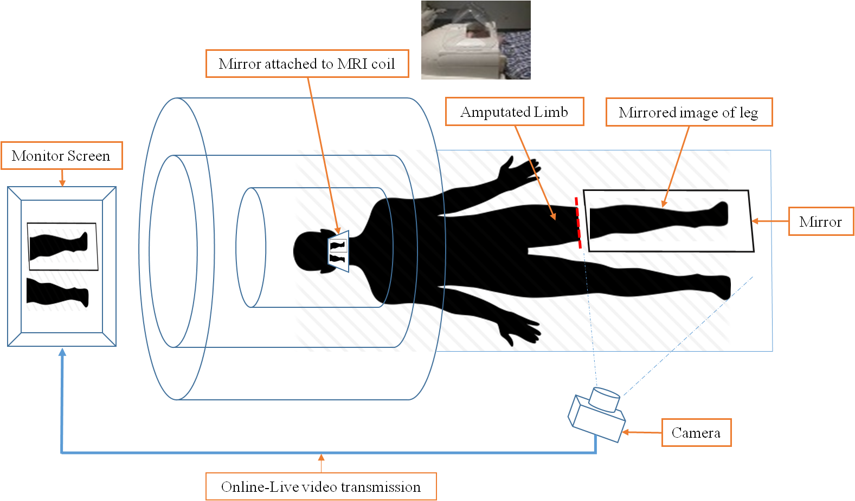

B. Interview: (Said by you on camera. Don’t forget to smile!)

Authors: Below are statements we would like you to complete that are complementary to the information contained within the schematic overview. Only one statement should be chosen and completed per author who will be on camera demonstrating the protocol. In addition to choosing and filling out the appropriate statement, please enter the name of the individual who will say each line. **If individuals will be doing the demonstrations but not speaking in the introduction, please use statement 1.8 to introduce these demonstrators (ex PI introducing students).

Protocol (read by voice talent at JoVE):

Authors: In order to ensure that your protocol can be filmed in a single day, the protocol text must be limited to 30 steps – each step being defined as 3 lines of 12 pt text in our formatting style below. This amounts to 3 pages of protocol text. The scope of the scripted protocol text should include only those aspects of the procedure that require visualization in order to be well understood.

- Materials (film the materials)

For this protocol you will need the following items: an MRI scanner, two MRI compatible mirrors; a large one placed between the patient's legs as well as a small one to place on the head coil. Additionally, you will need sandbags, an MRI compatible digital camera, a tripod for the camera, a computer controlled system and a monitor to place in the back of the scanner bore.

- Subject placement

  - Before proceeding to the MRI it is critical to make sure the patient has no known contraindications to MRI scanning for example metal implants, aneurysm clips or severe claustrophobia.
Initially you will explain to the patients exactly what they should expect during the experimental procedure. The patients will then listen to a recording with instructions to follow during the scan.

  - Patients may first practice during a mock scan to become familiar with the task as well as the scanner environment. The mock scanner is similar in every way to the real MRI scanner but without the active magnet.

  - Before entering the scanner room patients must remove their prostheses as well as any metal objects they might be wearing on their heads or bodies for example watches or jewellry. The MRI technician will make sure that patients have no metal that might put them at risk.

  - All patients are transported to the scanner room using a MRI safe wheelchair to avoid falling out.

  - After that the patient's will transfer themselves to the MRI scanner bed.

  - After the patient is lying comfortably in the supine matter on the scanner bed a single piece MRI compatible horizontal mirror is placed between his or her legs and adjustable arm is then positioned to point the camera at the mirrored leg.

    - FIGURE 2

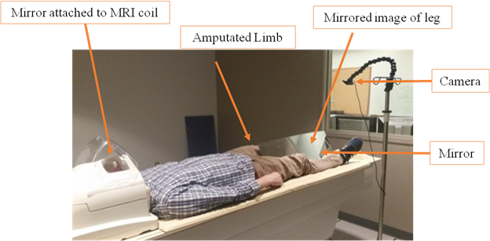

  - The large mirror is positioned between the legs at an angle about 45° depending on patients height and amputation level. The goal is to cover the stump to make it invisible to the videocamera. Sandbags are used to keep the mirror at the correct angle.

  - A smaller mirror is positioned on the head coil angled at 45° at eye level. This mirror allows the patient to visualize the mirrored leg image directly without moving their head while lying completely inside the scanner bore.

  - A MRI compatible digital camera is mounted on a tripod stand near the intact leg. This camera will transmit real-time video images of the mirrored leg movements to a computer control system that then projects the video to a monitor near the patient's head, so she or he can view the mirrored leg movement.

- Preparing the experiment

  - The patient will undergo a four-minute anatomical scan first followed by four runs of functional acquisitions while he or she performs the tasks. Each run lasts six minutes.

  - During the scans the patient wears sound isolating MRI compliant headphones which emit a series of auditory cues instructing the patient to perform the given behavioral task. The following commands are used 1) leg, 2) mirror and 3) rest. Additionally the investigator says start and end at the beginning and end of the experimental run.

  - The patient has already been instructed on hearing the word “leg” to follow the tapping sound presented in the audio with the eyes closed he or she will tap the foot at a rate of one tap for two seconds for a total of 10 taps in 20 Seconds.

  - On hearing the second command mirror the patient has to continue tapping his foot at the same rate this time while looking at the display showing the mirrored image of the two legs. Again this would be at a rate of 10 taps in 20 Seconds.

  - On hearing the third command rest patient should stop moving his or her foot and lying motionless with both eyes closed.

    - FIGURE 3
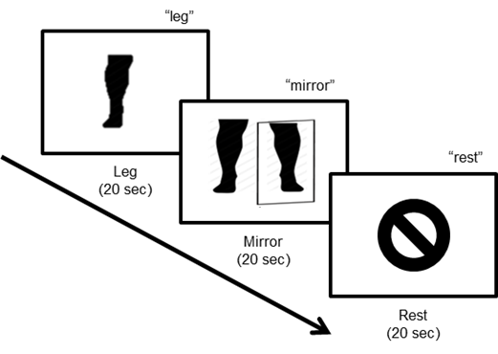

- Scanning and Data collection

  - Data is collected in a single session for each patient and the entire scanning procedure last approximately 30 minutes.

  - The investigators take notes of any unwanted movements. Between the runs they can ask the patients to keep the right pace and do the correct movements.

  - After the procedure is finalized the data is transferred to an encrypted flash drive and stored in secure location in the facility.

- Analysis

  - A longitudinal analysis design is used comparing baseline and posttreatment data. The FSL software package and processing stream will be applied.

  - Volumes with motion above 0.9 mm in any direction are identified with FSLs motion outlier detection processing stream and mathematically scrubbed from the final analysis. If more than 25% of the volumes are designated for removal the whole acquisition is excluded from the total data set.

  - A region of interest - ROI - analysis is used. The primary ROI is defined structurally using FreeSurfer’s Desikan Atlas of the primary sensory motor cortex and refined with the subject specific functional activation during the leg versus rest condition at the baseline scan.

  - This ROI is then reflected on the homologous area of the other hemisphere. This is the ipsilateral primary sensorimotor representation of the intact lower limb. The secondary ROI is the entire – bilateral- occipital visual cortex as defined by the anatomical Desikan atlas.

- Representative tDCS Results.

  - Patient reported that the experience immersive and the video images is lifelike. Therefore this real-time video projection process can generate sensations associated with conventional mirror therapy.

  - We expect that the leg condition that is the foot tapping task will lead to robust activation of the sensorimotor cortex representing the intact leg compared to the rest condition. However we also expect to see a less pronounced activation of the sensorimotor leg area representing the amputated leg.

    - Figure 4 A

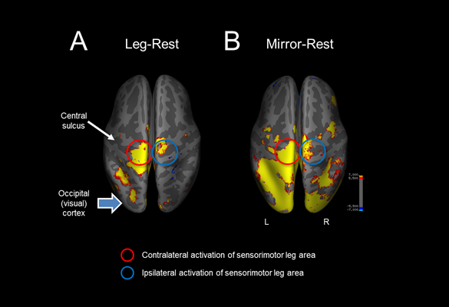

  - The mirror condition also shows robust contralateral as well as some ipsilateral activation of the cortical leg sensorimotor area compared to the rest condition. Additionally, robust cortical activation is seen posteriorly in the visual cortical areas associated with viewing the mirrored leg.

  - The activation patterns described represent the baseline condition; that is prior to beginning therapy. These initial responses serve to define regions of interest - ROIs - and allow for comparison after the therapeutic protocol is completed in each individual.

INSTRUCTIONS FOR AUTHORS:
Please ensure that the representative results narration is appropriate and correctly describes your images, movies, or figures. Our editors have ensured that the results are written in our format.

We consider this section a critical aspect of the video, because here is where you provide validation for your experiments. For example, if this is a cell culture preparation, this section is where the video will show your cells at various time points following culturing. If this is an imaging prep, then this part is where you will show examples of your imaging experiments.

Please limit the extent of narration to no more than 2-3 lines of text per image or movie file being described. Figures with multiple panels submitted with the original protocol should be broken up so that each panel is a separate image. Like the schematic, each image or movie file supplied in the results should be referenced by annotation in parenthesis, however for the results, the specific filename should be given in parenthesis.

Below is an example of results text:

EXAMPLE REPRESENTATIVE RESULTS

5. Evaluation of Morpholino Injection and Knockdown
5.1 Representative results of both morpholino injection and mRNA injection are shown here. The
uninjected control at 48 hours post fertilization looks normal, as expected
-LAB MEDIA: 0123_PIname_Figure1.tif (Replace 0123 with your jove video #)

5.2 However, embryos injected with the morpholino heg_e3i3_egfr1, which knocks down Heg isoforms
containing the first of two EGF-like repeats, exhibit brain edema.
-LAB MEDIA: 0123_PIname_Figure2.tif

5.3 Injection of heart of glass mRNA also produced an obvious phenotype. At 24 hours post fertilization,
the heads of the uninjected controls look normal
-LAB MEDIA: 0123_PIname_Figure3.tif

5.4 Conversely, some of the embryos injected with the mRNA exhibit cyclopia
-LAB MEDIA: 0123_PIname_Figure4.jpg

Please visit the following URL to see an example of how the results will look when complete:
http://www.jove.com/index/Details.stp?ID=1597

- Conclusion (said by authors on camera)

Authors: Below are statements we would like you to complete that summarize and conclude the video. Only one statement should be chosen and completed per author who will be on camera demonstrating the protocol. In addition to choosing and filling out the appropriate statement, please enter the name of the individual who will say each line.

  - Camila Pinto: After watching this video, you should have an adequate and sufficient understanding of the necessary steps required to set up all the equipment to perform mirror therapy inside an MRI scanner.

  - Faddi Saleh: This protocol describes a novel, feasible procedure that allows investigators to more accurately characterize the neural correlates associated with mirror therapy in individuals with Phantom Limb Pain.

  - Camila Pinto: We could answer additional questions regarding brain organization after a limb amputation following the steps of this protocol using other neurophysiological measurements or imaging techniques.

  - Lotfi Merabeth: A challenge associated with this approach is the risk of generating excessive head motion artifacts, given that the leg must be moving repletely inside the scanner. Excessive head motion may compromise image data quality. In this regard, it is important to plan ahead and implement a variety of strategies to mitigate this possibility. These include training the participant in a mock scanner to carry out the task without excessively moving their head, making sure that the head is secure yet comfortably restrained and implementing motion detection and correction strategies during the acquisition and data analysis phase respectively.

  - Felipe Fregni: Given the method to implementing the experimental setup is relatively simple, this approach may allow the evaluation of the mirror therapy effects not only in limb amputees, but also in other conditions, such as stroke or spinal cord injury where mirror therapy is already commonly used in clinical practice.

Provided Media

Authors, Please list all images, movie files, or 3-D rendered animations that can be included in the video per editor’s request. The step in the script/video where these images will be inserted should be specified. For example:

6.2 – 0123_PIname_Figure1.tif - dual color imaging of tumor angiogenesis at 40X
6.2 – 0123_PIname_Figure2.tif - dual color imaging of tumor angiogenesis at 100X

Formats: For static images we prefer .tiff files at dimensions of at least 720X480 pixels and 300 dpi. The higher resolution, the better. Likewise any exported movie files should have at minimum these dimensions and be rendered to .mov, .mp4, or .avi files.

Insert your media file names here.

General Preparation

It’s critical for a smooth and organized shoot that all reagents are accounted for, in advance.

Any overnight or long incubation steps should be recognized and specimens/samples be prepared in advance so that prior steps can be recorded and shooting can continue with pre-prepared specimens/samples.

All tubes/flasks should be pre-labeled neatly before we arrive.

Ex. Luciferase assay done in 96 well plates should be labeled with negative/positive control wells and experimental samples are labeled accordingly.

