Dr Anne Roumier
Institut du Fer à Moulin
17 rue du Fer à Moulin
75005 Paris, France
+ 33 1 45 87 61 24
+33 6 15 10 33 98
Anne.roumier@inserm.fr

Dear editors,

It’s my pleasure to resubmit to JoVE the revision of our manuscript entitled “2-photon imaging of microglial processes attraction toward ATP or serotonin in acute brain slices of young and adult mice”, by F. Etienne et al.
To address the comments of the editors and reviewers, which were very constructive and relevant, we made numerous revisions and thanks to that, we think that the manuscript is now much more precise and provides more useful indications for readers interested in doing live imaging on microglia. Notably, we added a figure (7B) and discussed more deeply our protocol in comparison with others, highlighting its strengths and limitations, and providing suggestions for improvements or application to other biological questions.
We therefore hope that our revised manuscript will fulfill the criteria of JoVE editorial board for acceptance and look forward recording the video.
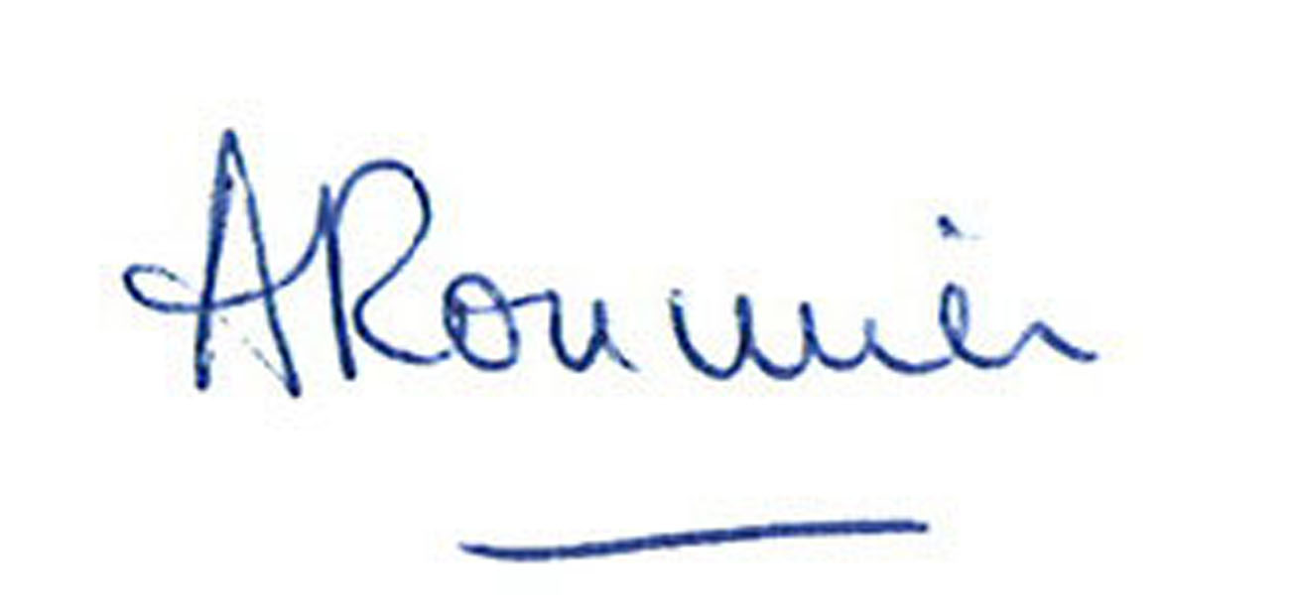
Sincerely,

Dr Anne Roumier

