Supplemental Information:
Flash NanoPrecipitation for the Encapsulation of Hydrophobic and Hydrophilic Compounds in Polymeric Nanoparticles

Section 1: Drawings and files for FNP mixers
A CIJ mixer can be produced from polyacetal thermoplastic according to the details provided in Han et al. ¹⁵ Required parts are enumerated in the materials list for this manuscript. The μMIVM can be fabricated as described by Markwalter & Prud’homme.²² The CAD files for the CIJ and μMIVM mixers are available as supplemental files with this article. Engineering drawings for the MIVM are below (Figure S1-S4) for ease of reference. The authors can provide drawings for a two-part MIVM rather than the three-part option included here. This design may be more straight-forward to design.
CIJ validation before use
Validation of proper machining is crucial for consistent performance. First, check chamber inlet alignment with a 26S gauge needle, which should pass without strong resistance or bending across the mixing chamber and into the second bore. Inspect the mixing chamber and inlets for burrs from machining. Carefully work to remove these with the drill bit or a fine scalpel. Residual burrs or threads of polymer can interfere with jet alignment and lead to inconsistent results in replicates. A stereoscopic microscope is useful in this inspection. Assemble plugs onto mixer sides and Luer adapters onto the two inlets. Assemble the outlet tubing fitting such that no tubing extends past the fitting and into the mixing chamber itself. Note: One source of high polydispersity is tubing that has been pushed up into the mixing chamber.
MIVM validation before use
New MIVMs should be prepared by first polishing the face of the mixing disk with a 15μm silicon carbide paper. If produced from all stainless steel parts, we suggest electropolishing of the faces. Proper alignment of the top disk and the mixing geometry is best confirmed using a fine syringe and a dye solution in the following manner. Assemble the two disks together. Transfer a small amount of the dye solution to the tip of the needle. Pass the needle through each inlet hole in the top disk to leave a light colored mark on the mixing geometry where the stream is aligned. Then disassemble the disks and check to ensure that each mark falls in the corresponding channel.
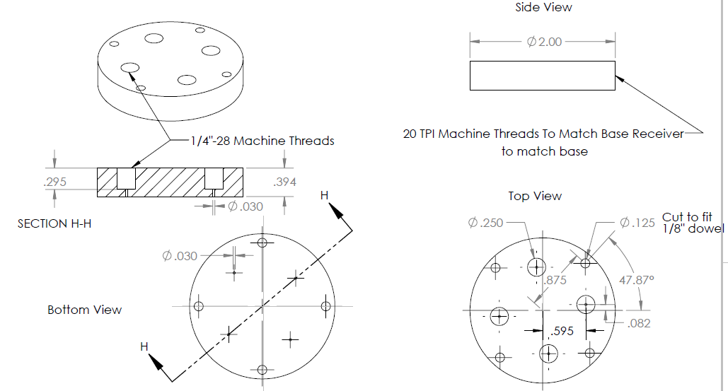
Figure S1: Engineering drawing for the top disk of the μMIVM mixer, with the dowels not included for clarity (see Figure 2). The mixer is not functional without the dowels because they ensure alignment of the inlets with the mixer channels. The outer edge of the disk is threaded to fit the base receiver. Dimensions in inches.
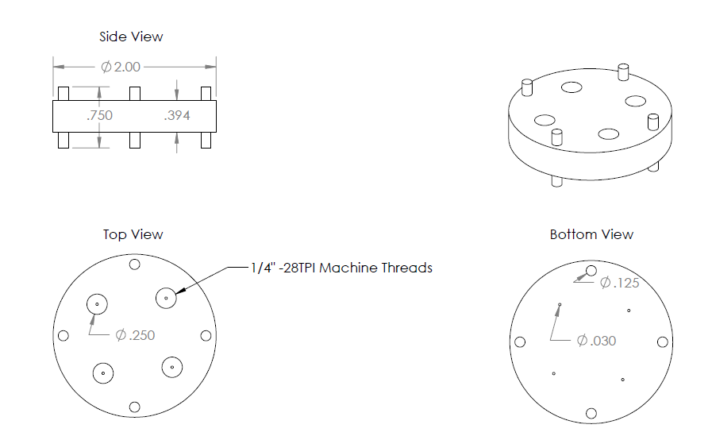
Figure S2: Engineering drawing for the top disk of the μMIVM mixer, with the dowels included. Dimensions in inches.
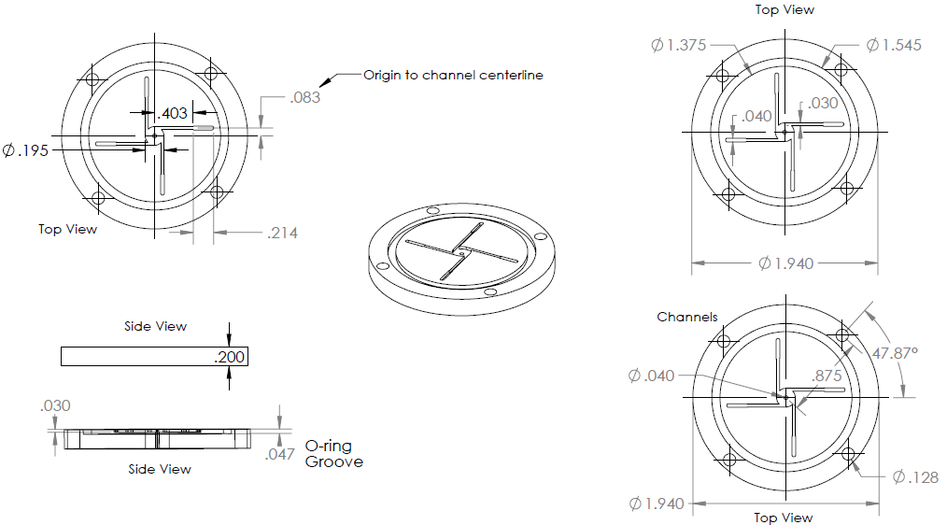
Figure S3: Engineering drawing for the center disk of the μMIVM mixer showing the mixing geometry. Dimensions in inches.
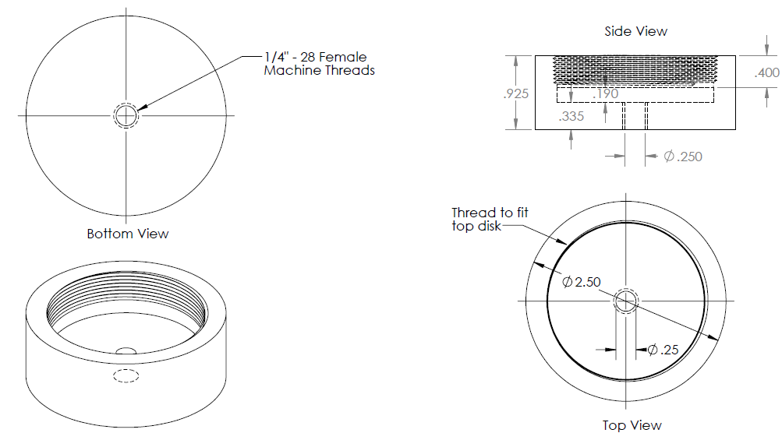
Figure S4: Engineering drawing for the base receiver of the μMIVM mixer. The inner edge is threaded to fit the top disk. Dimensions in inches.

Section 2: Analysis of particle concentration by thermogravimetric analysis (TGA)
Thermogravimetric analysis may be employed to measure residual solids after solvent evaporation from the pan. This is a useful technique for the accurate determination of nanoparticle concentration (yield) after FNP as long as the solvent composition is composed of all volatile components. The presence of salts or buffer components will complicate the analysis. Figure S5 illustrates a typical TGA cycle for a nanoparticle solution. Particle concentration, C, is determined on a mass percent basis according to the formula:

$$C=\frac{N-T}{M-T}*100$$
where N is the residual nanoparticle solids after solvent evaporation, determined from the average TGA mass in the region 115 – 130 °C; T is the pan tare, determined from the average mass measured from 550-600 °C; and M is the initial sample mass in the pan.
Figure S5: Model TGA data generated from a nanoparticle solution in THF/Water. The initial steep drop is water evaporation (TGA held at 110 °C) from an initial mass of 94.18 mg. The plateau from 100 to 350 °C represents the nanoparticle mass. Further heating results in removal of organic solids to afford an in situ tare of the pan and any non-volatile inorganics. (inset) The full TGA profile showing solvent evaporation.
Sample loss during filtration can be determined when TGA is conducted on the sample before and after the operation. We have found that minimal sample loss occurs when filtering relatively monodisperse PEG-coated particles produced by FNP, as long as the filter pore size is larger than the DLS size distribution. See Table S1 for representative results for a 140 nm nanoparticle with a poly(styrene) core and a PS-b-PEG corona with two different PVDF filter pore sizes. The loss value for each filter type is relative to the initial value. Figure S6 demonstrates the minimal size distribution change upon filtration.
Table S1: Result of TGA analysis for filtered nanoparticle solutions
 | Monodisperse sample |  | Aggregated sample
Initial Value | 0.428 wt% |  | 0.225 wt%
0.45μm Filter | 0.423 wt% | 1.2% loss | 0.186 wt% | 17.3% loss
0.22 μm Filter | 0.406 wt% | 5.3% loss | NT

Sample aggregation can occur in the FNP step or in later processing steps. Since DLS analysis results are dominated by light scattering from larger sub-populations, minor aggregation can strongly impact apparent sample quality. To address this, filtration can often be employed with minimal losses. Table S1 presents the results for a PEG-stabilized ecumicin nanoparticle that had aggregated after lyophilization (“aggregated sample”). It was treated with a 0.45μm filter and characterized by DLS and TGA. Losses were 17.3% and the polydispersity by DLS was reduced from 0.66 to 0.18. Figure S7 illustrates the changes in the DLS analysis that result from removal of this minor aggregate population.
Figure S6: DLS analysis before and after filtration of a monodisperse nanoparticle solution. Initial sample (solid gray line); after 0.45μm filter (dashed light gray line); after 0.22μm filter (dotted black line). These operations are associated with minimal sample loss by TGA (Table S1).
Figure S7: Correlation function from the DLS analysis of a PEG-stabilized ecumicin nanoparticle solution before (dashed line) and after (solid line) filtration showing the recovery of a low polydispersity sample. (inset) DLS size distribution of the ecumicin nanoparticle solution before (dashed line) and after (solid line) filtration. The peaks that appear prior to filtration were generated from the correlation function but were a poor fit of the data.

