Princeton University

Robert K. Prud’homme
Director Engineering
Biology Program

Chemical and Biological Engineering
A 301 Engineering Quadrangle
Princeton NJ 08544
Telephone: 609-258-4577
E-mail: prudhomm@princeton.edu

6 July 2018
Nandita Singh
Senior Science Editor
We are submitting this manuscript, entitled “Flash NanoPrecipitation for the Encapsulation of Hydrophobic and Hydrophilic Compounds in Polymeric Nanoparticles,” to the Journal of Visualized Experiments in response to your initial invitation from 2017 (Manuscript JoVE56575). We have prepared a manuscript presenting the Flash NanoPrecipitation method as applied to the encapsulation of both hydrophobic and hydrophilic compounds. The work in our lab has expanded the slate of compounds that can be encapsulated by this method significantly in the last few years. Additionally, we have described the use of two mixing geometries: a confined impinging jet mixer and a multi-inlet vortex mixer.
We seek to enable the use of this technology widely. To this end, we are including CAD drawings of the mixers to allow other research groups to fabricate their own mixers. The visualized format of JoVE is ideal for the widespread dissemination of the best practices we have developed in our lab. Thank you for your consideration.
The authors have contributed in the following specific manners: C. Markwalter was the primary author of the text, prepared the figures, and generated the data not otherwise attributed below. R. Pagels assisted in editing, figure design, and generated the data in Figure 4. B. Wilson and K. Ristroph generated data for the protocols described in the supplemental information for TGA analysis of concentration and assisted in editing. R. Prud’homme is the principal investigator for this work.
We recommend the following reviewers who would be well suited to review this work:
Aleksandr Kabanov | U. North Carolina | kabanov@email.unc.edu
Tatiana Bronich | U. Nebraska Medical Center | tbronich@unmc.edu
Chris Macosko | Emeritus, U. Minnesota | macosko@umn.edu
John Torkelson | Northwestern | j-torkelson@northwestern.edu
Saad Kahn | North Carolina State University | khan@ncsu.edu
Evan Scott | Northwestern | evan.scott@northwestern.edu

Yours truly,
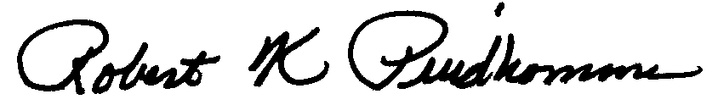
Robert K. Prud’homme
Professor

