 | Cleveland Clinic  Lerner Research Institute | Paul D. Marasco, Ph.D.  Associate Staff …

Dear Dr. Myers:

We thank you for the invitation to submit our work to the Journal of Visualized Experiments. Please find attached a manuscript for consideration of publication titled A Methodology to Characterize the Sense of Agency over the Actions of Neural-Machine-Interface Operated Prostheses.

The attached manuscript describes a methodology to explicitly and implicitly characterize the formation of agency during the operation of prostheses controlled via neural-machine interfaces. Agency, the experience of authorship of our actions, is fundamental to how we perceive and control our limbs. By striving to incorporate advanced upper-limb prostheses into this same perceptual framework, we can begin to more closely integrate the user and their artificial limb. Our protocol requires participants to control and receive feedback from a virtual prosthetic hand using their pre-existing NMI systems. A virtual grasping task is performed and two separate measures of agency are employed: established psychophysical questionnaires (to capture the explicit sense of agency) and a time interval estimate task to capture the implicit sense of agency (intentional binding). The results of this protocol may help us understand how to provide prosthetic users with an intrinsic sense of control over their device, and may serve as a platform for assessment and tuning of a device to ultimately improve prosthetic control.

We thank you for your consideration and look forward to working with you to communicate our work to the wider research community.

Yours sincerely,

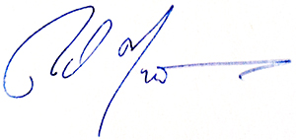

Paul D. Marasco, Ph.D.

