

Date: Aug13, 2018

To
Science Editor,
Journal of Visualized Experiments
1 Alewife Center, Suite 200,
Cambridge, MA 02140

Subject: Revised manuscript # JoVE58690_R1

Dear Dr. Ronald Myers,

I would like to submit revision to our manuscript to JoVE. We have addressed all editorial comments. Please find an updated manuscript file, figures and table-1.

Sincerely,
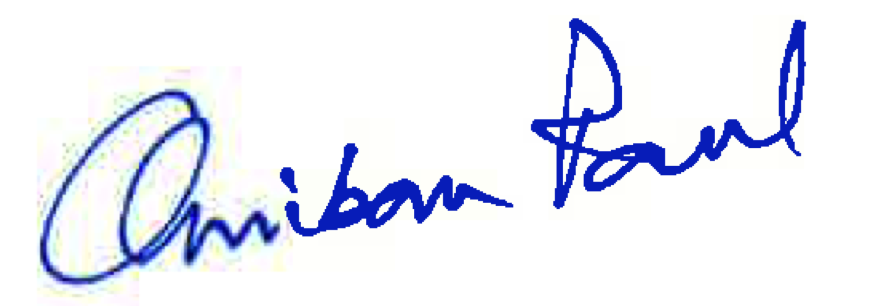
Anirban Paul.
Senior Research Associate,
Cold Spring Harbor Laboratory,
NY 11724.

Editorial comments:

Changes to be made by the Author(s) regarding the manuscript:
1. Please take this opportunity to thoroughly proofread the manuscript to ensure that there are no spelling or grammar issues.

2. Figure 1: Please capitalize the first word in a title/phrase (i.e., Fresh brain, Vibratome sectioning, Coronal brain slice, Data analysis, etc.
Done

3. Figures 1-3: Please remove commercial language (Illumina, Ampure-XP, SPIRI).
Done

4. Figure 4: Please capitalize only the first word in the title of x-axis.
Done

5. Table 1: Please change Table 3 to Table of Materials. Please use subscripts in chemical formulae to indicate the number of atoms, e.g., NaH2PO4, NaHCO3, etc. Please use SI abbreviations for all units: L, mL, µL, h, min, s, etc. Please include a space between all numerical values and their corresponding units: 15 mL, 37 °C, 60 s; etc.
Done

