You are being carbon copied ("cc:'d") on an e-mail "To" "R Dr. Vizcardo" raul.vizcardosakoda@nih.gov
CC: rafiqul.islam@nih.gov, takuya.maeda@nih.gov, naritaka.tamaoki@nih.gov, marta.bosch-marce@nih.gov, meghan.good@nih.gov, li.jia2@nih.gov, nicholas.klemen@yale.edu, mk396p@nih.gov, restifon@nih.gov
Dear Dr. Vizcardo,
Your manuscript, JoVE58672 3D Thymic Culture System: A Method for the Generation of Tumor Antigen-Specific iPSC-Derived Thymic Emigrants, has been editorially and peer reviewed, and the following comments need to be addressed. Note that editorial comments address both requirements for video production and formatting of the article for publication. Please track the changes within the manuscript to identify all of the edits.
Please note that the manuscript has been modified to include line numbers and minor formatting changes. The updated manuscript is attached and please use this updated version for future revisions.
After revising and uploading your submission, please also upload a separate rebuttal document that addresses each of the editorial and peer review comments individually. Please submit each figure as a vector image file to ensure high resolution throughout production: (.svg, .eps, .ai). If submitting as a .tif or .psd, please ensure that the image is 1920 pixels x 1080 pixels or 300 dpi.
Your revision is due by Aug 03, 2018.
To submit a revision, go to the JoVE submission site and log in as an author. You will find your submission under the heading "Submission Needing Revision".
Best,
Peer Review,
Peer Review
JoVE
617.674.1888
Follow us: Facebook | Twitter | LinkedIn
About JoVE
____________________________________
Editorial comments:
Changes to be made by the Author(s) regarding the manuscript:
1. Please take this opportunity to thoroughly proofread the manuscript to ensure that there are no spelling or grammar issues. The JoVE editor will not copy-edit your manuscript and any errors in the submitted revision may be present in the published version.
Done
2. Please upload each Figure individually to your Editorial Manager account as a .png, .tiff, .svg, .eps, .psd, or .ai file.
Done
3. Figure 2: Please explain the bottom two panels in the figure legend.
Done
4. Figure 4 lines 294: Should be upper right, not lower right.
Done
5. Please revise the title to be more concise.
Done
6. Please provide an email address for each author.
Email addresses for all of the authors have been included.
7. Please rephrase the Long Abstract to more clearly state the goal of the protocol.
The abstract was rephrased.
8. JoVE cannot publish manuscripts containing commercial language. This includes trademark symbols (™), registered symbols (®), and company names before an instrument or reagent. Please remove all commercial language from your manuscript and use generic terms instead. All commercial products should be sufficiently referenced in the Table of Materials and Reagents. For example: GemCell, Invitrogen, Gibco, R&D Systems, Sigma Aldrich, Whatman, Dumont, etc.
We removed all commercial language.
9. Please place the ethics statement before your numbered protocol steps, indicating that the protocol follows the animal care guidelines of your institution.
Done
10. Please revise the protocol text to avoid the use of any personal pronouns (e.g., "we", "you", "our" etc.).
We fixed any personal pronouns in the protocol.
11. Please revise the protocol (lines 94-101, lines 116-117, lines 124-125, 3.1.1, 3.1.2, 4.14-4.16, etc.) to contain only action items that direct the reader to do something (e.g., “Do this,” “Ensure that,” etc.). The actions should be described in the imperative tense in complete sentences wherever possible. Avoid usage of phrases such as “could be,” “should be,” and “would be” throughout the Protocol. Any text that cannot be written in the imperative tense may be added as a “Note.” Please include all safety procedures and use of hoods, etc. Please move the discussion about the protocol to the Discussion.
Done.
12. Please add more details to your protocol steps. There should be enough detail in each step to supplement the actions seen in the video so that viewers can easily replicate the protocol. Please ensure you answer the “how” question, i.e., how is the step performed? Alternatively, add references to published material specifying how to perform the protocol action.
13. Line 94: Please specify culture conditions.
Corrected.
14. 1.1.6: What is the diameter of the petri-dish?
Corrected.
15. 2.3.1: What volume of PBS is used to wash?
Corrected.
16. 5.7: Please describe how this is done. How irradiation is set up? What is the distance between splenocytes and the irradiation source?
Since the technical specifications of laboratory radiators can vary widely, we preferred to mention only the total amount of irradiation exposure to the mice.
17. 6.1: What is used to count?
It was counted using a Neubauer hemocytometer and Trypan Blue. It is now specified in the text.
18. Please include single-line spaces between all paragraphs, headings, steps, etc.
Done.
19. After you have made all the recommended changes to your protocol (listed above), please highlight 2.75 pages or less of the Protocol (including headings and spacing) that identifies the essential steps of the protocol for the video, i.e., the steps that should be visualized to tell the most cohesive story of the Protocol.
Highlighted.
20. Please highlight complete sentences (not parts of sentences). Please ensure that the highlighted part of the step includes at least one action that is written in imperative tense. Please do not highlight any steps describing anesthetization and euthanasia.
Done.
21. Please include all relevant details that are required to perform the step in the highlighting. For example: If step 2.5 is highlighted for filming and the details of how to perform the step are given in steps 2.5.1 and 2.5.2, then the sub-steps where the details are provided must be highlighted.
Done.
22. Please include at least one paragraph of text to explain the Representative Results in the context of the technique you have described, e.g., how do these results show the technique, suggestions about how to analyze the outcome, etc. The paragraph text should refer to all of the figures. However for figures showing the experimental set-up, please reference them in the Protocol. Data from both successful and sub-optimal experiments can be included.
The updated manuscript now includes a results section.
23. As we are a methods journal, please revise the Discussion to explicitly cover the following in detail in 3-6 paragraphs with citations:
a) Critical steps within the protocol
b) Any modifications and troubleshooting of the technique
c) Any limitations of the technique
d) The significance with respect to existing methods
e) Any future applications of the technique
The updated manuscript covers all the mentioned topics.
24. References: Please do not abbreviate journal titles.
Done.
25. Table of Equipment and Materials: Please provide lot numbers and RRIDs of antibodies, if available.
Done.
Reviewers' comments:
Reviewer #1:
Minor Concerns:
This is a useful protocol description that provides welcome detail to the3D culture system the authors described in a Cell Reports article published a few months ago. I have some minor concerns that could be addressed:
1. in line 134, is the IL-7 at 5ng/mL also? Please clarify.

Yes, cells were cultured with 5ng/mL FLT3L and 5 ng/mL IL-7 from Day 10. This has been corrected in the text.
2. In line 160, is this d0 or d1 of the 16 day developmental period? Please clarify.

Given that mice pairing will not occur until the room is dark, Day 1 pregnancy stage is counted as e0.5. Therefore, fetal thymic lobes harvested on Day16 are e15.5 mice embryos. These lobes were depleted of endogenous thymocytes by deoxy-guanosine treatment for an additional 7 days.

3. in lines 169-170, please expand on the intracellular cytokine staining protocol. When are the cells stains relative to their last stimulation with antigen? Is golgi-stop or golgi-plug used to amplify staining? How are the positive versus negative markers set? How were the samples in Figure 4 pre-gated? The legend to Figure 4 mentions "quadrants", but histograms are shown.

Thank you for the advice. iTE that exit the fetal thymic lobes are collected daily, therefore they are not pre-stimulated. iTE were stained 72 hrs after first stimulation. BD GolgiStop was used and incubated for 6 hrs to enhance the staining. Cells were gated on congenically marked, Live/Dead excluded CD3+CD8+ T cells. Bulk cells without antibody staining were used for negative controls (not shown). We added these changes to the main text.
4. Please show or mention the numbers of cells collected at each stage. It is crucial for the reader to understand just how many cells it is possible to generate with this system. This is an important point to discern just how useful this technique is likely to be.
Thymic lobes co-cultured with 2x10^3 bulk iPSC-derived T cell lineage for 6 days generated an average of 0.77±0.27x10^3 iTE overnight. These data are now presented as a distribution plot of 12 independent experiments (Figure 3B). As detailed in our recent Cell Reports published article, the 3D thymic culture system produced a daily halo of iTE from days 6-12. After day 12, T cell production varies from lobe to lobe, with some lobes still producing iTE at day 21 (See Panel A).

Panel A for editorial use only: We have observed iTE produced in the third week. To assess production of CD3⁺ cells, we have attached a confocal image of 3D thymic cultures that we photographed 22 days after seeding with Pmel-iPSC.

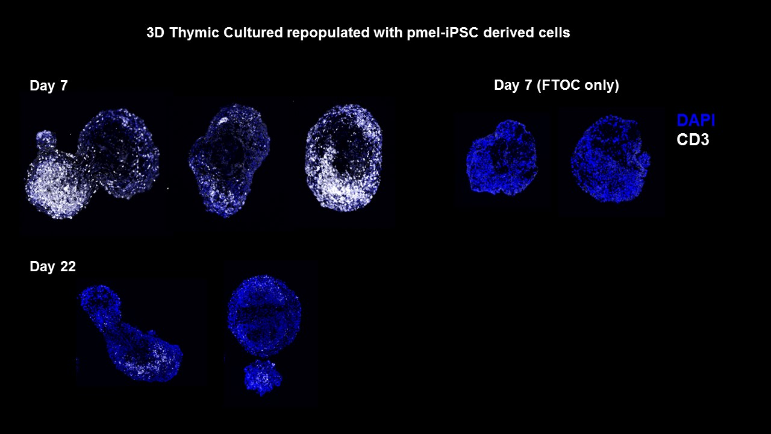

Reviewer #2:
Manuscript Summary:
The JoVe manuscript by Vizcardo et al describes a readapted system using a multistep culture to obtain naïve T cells from iPS cells. The system as described involves a short term culture on OP9 delta like 1 without lymphoid cytokines, followed by a culture with lymphoid cytokines where T lineage cells are obtained and finally a organ culture in thymic lobes. This appears to be the crucial step of the method and it would just be useful to get more information on this phase of the methodology
Major Concerns:It would be useful to know for how long are these lobes efficient in generating naïve T cells, in other words, a time course and how many T cells are in general generated. Is the number of cells variable in different cultures. How reliable is the method? If the T cells coming out of several independent lobes are analyzed how much do they vary?
All these informations are also important to evaluate how much can this procedure be applied to different experimental situations
In general, differentiation experiments using induced pluripotent stem cells are characterized by inherent variability in yield and heterogeneity of their cell products. Our protocol was optimized to reduce the variability of the output in several steps. We included a more detailed description of the cell yield in Reviewer #1’s comment number 4. Briefly, we generate up to 1x10^6 cells of T cell lineage from 1x10^6 starting iPSC. A single addition of 2x10^3 immature T cells into a single fetal thymic lobe produces a daily yield of 0.5-1x10^3 iTE between days 6-12. After day 12, we observe individual lobe variability in cell production, with some lobes still producing a low number of immature T cells even at Day 21 (See Panel A above).

Reviewer #3:
Manuscript Summary:
This manuscript represents a method to develop iPSC-derived T cells that are potentially useful to study anti-tumor immunity or other means to for adoptive T cell therapy to modify immune responses. Overall the method is well described. The included data support the feasibility of the approach
Major Concerns: None
Minor Concerns:
It would be useful for some discussion concerning the cells yields one might expect.
Thank you for your constructive comment. Please see our response to Reviewers #1 and #2 regarding this comment.

Reviewer #4:
Manuscript Summary:
The authors of this paper describe a new method to generate pluripotent stem cell (iPSC) derived T cells, using a 3D thymic organ culture system.
Successful reprograming of iPSC cells into antigen specific T cells in-vitro holds huge therapeutic potential to drive successful adoptive T cell therapy against advanced cancers. The classically used in-vitro OP9/DLL1 culture system, however, it is severely limited in its ability to successfully support T cell development, due to its inability to provide essential signals needed to drive differentiation of T cells past the DP stage in development. The authors, therefore, recreate the thymic environment, using a novel 3D thymic organ culture system, providing the necessary signals to support successful T cell development from iPSC, and thus generating a CD8 T cell repertoire that is more successful after adoptive transfer.
Authors describe an interesting, novel method, which could have wide applications to understanding T cells development and improve adoptive T cell transfers, by enhancing in-vitro, antigen specific T cell generation. Overall the work is executed to a high standard and the method is detailed and easy to follow. No results provided support the claims that iTE generated in this culture system can proliferate, form memory populations and have anti-tumor properties, however this is referenced in the authors recent Cell Reports paper.
Minor Concerns:
Overall the protocol is very descriptive and easy to follow. General comments:
1. Section 3 'Mouse fetal organ isolation' has already been published on Jove; Jenkinson, W., Jenkinson, E., Anderson, G. Preparation of 2-dGuo-Treated Thymus Organ Cultures. J. Vis. Exp. (2008). This section, therefore, should be referenced, and may not be need.

We agree with this comment and have revised our manuscript.
2. Section 5 and 6 'preparation and pulsing of APC' is confusing. How are the authors ensuring a pure population of APC, and an accurate count of APC, on a total irradiated spleen sample that is not enriched or cell sorted. Clarification of why and how this is achieved is needed in this section. If this APC population is not pure, could it be affecting the results shown in figure 4?

As the reviewer highlights, the population of APC is not pure. We used whole irradiated live splenocytes depleted of red blood cells by ACK lysis. The APC origin can be excluded in the FACS because we are using a congenic marker. Moreover, since only the group co-cultured with hgp-100 peptide has a considerable increment of cells expressing TNFa, IL-2 and IFNg, we can conclude that iTE are antigen specific.
3. Overall more description is need for the results. No results section is provided, and figure legends have very little information. For example, what is Pmel-iTE? How was the RNA seq performed, on what populations?
We have included a Results section in the updated manuscript.
4. In the discussion authors refer to the system as long-term culture. Authors, therefore, should clarify how long these cultures systems can be kept in-vitro producing iTE.

The 3D thymic culture is able to generate a constant output of iTE between 6-12 days. After this, lobe-to-lobe production starts to become variable and the overall cell output decreases gradually. Some lobes are able to continue producing iTE even 21 days after co-culture.

5. Introduction needs more references. Long paragraphs with very few references.

Thank you for the advice.
6. This method is performed only with mouse material, so this could be included in the title.
We agree and have updated the title. Thank you for all the constructive comments.

