
INGMAR RIEDEL-KRUSE, Ph.D.
Assistant Professor of Bioengineering

June 12th, 2018

RE: Article submission Jin & Riedel-Kruse “Optically patterning biofilms using pDawn-Ag43”

Dear Editor,

We are pleased to submit our manuscript, “Optically patterning biofilms using pDawn-Ag43” for consideration for publication in Journal of Visual Experiments. All authors have approved this manuscript.

This manuscript is closely related to and intended to accompany our earlier publication, “Biofilm Lithography enables high-resolution cell patterning via optogenetic adhesin expression” published in PNAS in March 2018, where we described a new and flexible method for depositing bacteria onto surfaces with high spatial resolution by using light to optogenetically drive the expression of adhesins. This manuscript documents in greater detail the established protocol for patterning bacterial biofilms, discussing the nuances involved in the technique, critical steps, alternatives and modifications of the protocol, its advantages and disadvantages, as well as offering tips and tricks regarding troubleshooting.

This manuscript will be of interest to the interdisciplinary audience of Journal of Visual Experiments, as it provides a detailed insight into our biofilm patterning technique, for readers interested repeating and extending on our published results, and in using it to investigate structure of natural biofilm colonization, bacterial community growth, and microbial ecology, as well as applications such as metabolic engineering and patterning/functionalization of biomaterials. Moreover, we hope this protocol may be of interest to a wider community of bio-artists and biology educators, given its convenience and reasonable material requirements.

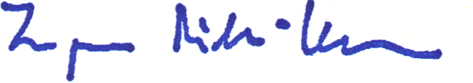
Sincerely,
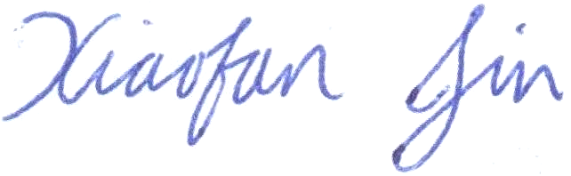

Xiaofan Jin Ingmar Riedel-Kruse

