Alisha DSouza, Ph.D.
Senior Review Editor
JoVE

RE: JoVE58624
Title: Construction of multilayered stem cell sheet with a 3D dynamic culture system
Revised Title: Construction of multilayered mesenchymal stem cell sheet with a 3D dynamic culture system

Dear Alisha DSouza,

We appreciate you and your reviewers for the prompt and favorable review of our paper entitled “Construction of multilayered stem cell sheet with a 3D dynamic culture system” The comments give us an opportunity to further improve the quality of our manuscript. Accordingly, we have made significant revisions to our manuscript, and our responses to the comments are attached below.

We hope that this revised version is now acceptable for publication in JoVE.

Sincerely,

Zheng Wu, Ph.D.

Responses to editorial and production comments
Revision of the manuscript：
Comment 1
Please take this opportunity to thoroughly proofread the manuscript to ensure that there are no spelling or grammar issues. The JoVE editor will not copy-edit your manuscript and any errors in the submitted revision may be present in the published version.
Author answer:
We appreciate your prompt reviews and valuable suggestions, and we had proofread the manuscript according to your comments and suggestions. We have revised several English grammar/word errors by using the red text in the revised manuscript.

Comment 2
Please provide an email address for each author.
Author answer:
Thank you for your suggestion. We have provided an email address for each author on the title page.

Revisions:
AUTHORS& AFFILIATIONS:
Corresponding Author:
Zheng Wu
wuzheng@jnu.edu.cn
Tel: (8620)-85222711

Jianhua Zhang
zhangjh@jnu.edu.cn
Tel: (8620)-38688961

Email Addresses of Co-Author:
Yingwei Wang (vinmi_wong@126.com)
Cheng Lu (lc471015366@126.com)
Chengzhi He (1732513111@qq.com)
Baoxin Chen (baoxin_chen@126.com)
Youling Zheng (youling_z@126.com)
Junming Zheng (646880087@qq.com)

Comment 3
Please use SI abbreviations for all units: L, mL, µL, h, min, s, etc.
Author answer:
Thank you for your suggestion. We have proofread the manuscript, and make sure use SI abbreviations for all units.

Comment 4
Please use centrifugal force (x g) for centrifuge speeds.
Author answer:
Thank you for your suggestion. We have proofread the manuscript, and make sure use centrifugal force (x g) for centrifuge speeds.

Revisions:
Protocol:
- Preparing cells for cell sheet construction. (Figure 1B)
  - Centrifugate the cells at 225 x g for 5 min.

  - Centrifugate the cells at 225 x g for 5 min.

3.17 Centrifugate the cells at 260 x g for 5 min.

Comment 5
Please include a space between all numbers and their corresponding units: 15 mL, 37 °C, 60 s; etc.
Author answer:
Thank you for your suggestion. We have proofread the manuscript, and make sure include a space between all numbers and their corresponding units.

Comment 6
Please adjust the numbering of the Protocol to follow the JoVE Instructions for Authors. For example, 1 should be followed by 1.1 and then 1.1.1 and 1.1.2 if necessary. Please refrain from using bullets, dashes, or indentations.
Author answer:
Thank you for your suggestion. We have proofread the manuscript according to the JoVE Instructions for Authors, and adjusted the numbering of the Protocol.

Comment 7
Please add more details to your protocol steps. There should be enough detail in each step to supplement the actions seen in the video so that viewers can easily replicate the protocol. Please ensure you answer the “how” question, i.e., how is the step performed? Alternatively, add references to published material specifying how to perform the protocol action.
Author answer:
Thank you for your careful review, and this is very important to improve our protocol. We have added more details to the protocol steps according the following suggestions. All revised text was highlighted in yellow color in the revised manuscript.

Revisions:
Protocol:
- Preparations before cell sheet construction
  - Reagents and materials preparation. Autoclave the instruments and tissue carrier components (MINUSHEET 1300 Regensburg) at 121 °C for 30 min, including 1.5 mL centrifugal tubes, forceps, toothed forceps, scissors, black bases (tissue carrier component), and white tension rings (tissue carrier component).
  - Prepare 20 mL germ-free 10% sucrose solution. Weight 2 g sucrose and resolve the sucrose in 18 mL ultrapure water. Autoclave the 10% sucrose solution at 121 °C for 30 min or filter the solution with a 0.22 µm filter.
  - Autoclave the dynamic perfusion system (MINUSHEET, Regensburg) devices at 121 °C for 30 min, including a gas exchange equipment (MINUSHEET 0006), a 500 mL glass bottle (MINUSHEET 0002), a perfusion culture container (MINUSHEET 1301), and the connective tubes.
  - Take out the autoclave instruments and tissue carrier components.
  - Put the black base part of the tissue carrier in a culture dish.
  - Pick up a dried DPP scaffold and put it in the center of the black base.
  - Put a white tension ring on the DPP scaffold and fix it in the tissue carrier.
NOTE: Ensure the scaffold is totally fixed in the tissue carrier and no gap between the black base and the white tension ring. If not, separate the tissue carrier and fix the scaffold again.
  - Add 100 µL culture medium on the DPP scaffold for rehydration.
NOTE: If the scaffold is not well fixed in the tissue carrier, the culture medium would infiltrate to the culture dish.
  - Put the scaffold into the 37 °C incubator and allow it to soak for 15 min.

- Preparing cells for cell sheet construction (Figure 1B).
  - BMSCs isolation¹³.
NOTE: This method is designed for constructing multilayered MSC cell sheet. Rat BMSCs are used in this protocol. The BMSCs are isolated by using the whole bone marrow adherent method, and the BMSCs are expanded in vitro to obtain enough cell amount.
    - Reagents and materials preparation. Autoclave the instruments at 121 °C for 30 min, including forceps, toothed forceps, and scissors. Prepare 2 mL injection syringe and BMSCs culture medium (Dulbeccos modified Eagles medium (DMEM), 10% fetal bovine serum, 1% glutamine, and 1% penicillin–streptomycin)
    - Sacrifice the three-week-old male Sprague-Dawley (SD) rats by cervical vertebra dislocation. Soaked the animal in 100 mL 75% alcohol solution in a beaker for 5 min.
    - Take the animal out from the beaker and put it face down the operation table.
    - Open the back skin of the animal with a scissor and a forceps. Isolate the skin and muscle tissues to expose the thigh femurs.
    - Isolate the thigh femurs and put it in 30 mL PBS in a 50 mL centrifugal tube. Two thigh femurs put in one tube. Vortex the centrifugal tube to wash the tissue thoroughly. Repeat this step for twice.
    - Cut both ends of the femurs with a scissor and expose the marrow cavity.
    - Aspirate 2 mL BMSCs culture medium with an injection syringe. Insert the needle in the marrow cavity and flush out the bone marrow with culture medium. Every two thigh femurs inject into one 100 mm culture dish.
    - For each 100 mm culture dish, add 2 mL culture medium in the culture dish.
    - Put the culture dish into the 37 °C incubator and static culture for 72 h.
    - Take out the culture dish from the incubator. Replace the supernatant with 6 mL fresh culture medium.
    - Observe primary BMSCs in a microscope. Following this, the BMSCs were passaged every 5–7 days.
    - Take the cells out of the incubator. Observe the cells in a microscope and choose suitable cells for cell sheet construction.
NOTE: When the BMSCs reach 80-90%, the cells could be chosen as seeded cells.

- Obtain the multilayered MSC cell sheet.
  - Materials preparation. Autoclave the instruments and tissue carrier components at 121 °C for 30 min, including 1.5 mL centrifugal tubes, forceps, and toothed forceps.
  - Pull out the input duct from the glass bottle to stop the supply of culture medium to the container.
NOTE: Stop the peristaltic pump when the culture container is basically empty.
  - Take out the cell sheet from the culture container and put it in a culture dish.
  - Use one forceps to immobilize the tissue carrier and use another toothed forceps to separate the white tension ring from the black base. Finally obtain the multilayered BMSCs cell sheet.
  - For short preservation, each cell sheet could be transfer to a 1.5 mL centrifugal tube with the forceps. The DPP scaffold should be attached to the inner wall of the centrifugal tube, and the cell sheet should spread out in the centrifugal tube as much as possible.
  - Gently add 1 mL culture medium in the centrifugal tube to immerse the cell sheet.
  - Close the cap of the centrifugal tube and stored the cell sheet in 4 °C.
NOTE: The cell sheet should be transplanted or analyzed as soon as possible. The cell sheet is recommended to be used within 4 h.

Comment 8
Line 84: What container is used? What volume of PBS is used to wash? Please specify throughout.
Author answer:
Thank you for your suggestion. We have added corresponding parameter in the corresponding parts. Corresponding revisions are shown below:

Revisions:
Protocol:
- Preparation of DPP scaffold with PLA2 decellularized method
  - Wash the FPP with 200 mL PBS contained 1% penicillin-streptomycin thoroughly in 500 mL beaker at 10°C for 10 min. Repeat this step for twice.

Comment 9
Line 88: What is used to shape the FPP into pieces?
Author answer:
Thank you for your suggestion. We have added corresponding details in the corresponding parts as follows:

Revisions:
Protocol:
- Preparation of DPP scaffold with PLA2 decellularized method
  - Shape the FPP into 10×10 cm² pieces with scissor.

Comment 10
Line 89: What container is used? What volume of CBS is used to wash? Please specify throughout.
Author answer:
Thank you for your suggestion. We have added corresponding parameter in the corresponding parts as follows:

Revisions:
Protocol:
- Preparation of DPP scaffold with PLA₂ decellularized method¹⁴ (Figure 1A).
  - Wash the FPP with 200 mL carbonate buffer solution (CBS) contained 1% penicillin-streptomycin in 500 mL beaker at 10 °C for 10 min. Repeat this step for twice.

Comment 11
Line 92: What volume of sample is used?
Author answer:
Thank you for your suggestion. We have added corresponding parameter in the corresponding parts as follows:

Revisions:
Protocol:
- Preparation of DPP scaffold with PLA₂ decellularized method¹⁴ (Figure 1A).
  - Soak 10×10 cm² sample in 50 mL CBS contained 200 U/mL PLA₂ and 0.5% (w/v) sodium deoxycholate solution at 37 °C for 6 h.

Comment 12
Line 123: Please describe how this is actually done.
Author answer:
Thank you for your suggestion. We have added corresponding parameter in the corresponding parts as follows:

Revisions:
Protocol:
3.Preparing cells for cell sheet construction (Figure 1B).
3.1. BMSCs isolation¹³.
NOTE: This method is designed for constructing multilayered MSC cell sheet. Rat BMSCs are used in this protocol. The BMSCs are isolated by using the whole bone marrow adherent method, and the BMSCs are expanded in vitro to obtain enough cell amount.
3.1.1. Sacrifice the three-week-old male Sprague-Dawley (SD) rats by cervical vertebra dislocation. Soaked the animal in 100 mL 75% alcohol solution in a beaker for 5 min.
3.1.2. Take the animal out from the beaker and put it face down the operation table.
3.1.3. Open the back skin of the animal with a scissor and a forcep. Isolate the skin and muscle tissues to expose the thigh femurs.
3.1.4. Isolate the thigh femurs and put it in 30 mL PBS in a 50 mL centrifugal tube. Two thigh femurs put in one tube. Vortex the centrifugal tube to wash the tissue thoroughly. Repeat this step for twice.
3.1.5. Cut both ends of the femurs with a scissor and expose the marrow cavity.
3.1.6. Aspirate 2 mL BMSCs culture medium with an injection syringe. Insert the needle in the marrow cavity and flush out the bone marrow with culture medium. Every two thigh femurs inject into one 100 mm culture dish.
3.1.7. For each 100 mm culture dish, add 2 mL culture medium in the culture dish.
3.1.8. Put the culture dish into the 37 °C incubator and static culture for 72 h.
3.1.9. Take out the culture dish from the incubator. Replace the supernatant with 6 mL fresh culture medium.
3.1.10. Observe primary BMSCs in a microscope. Following this, the BMSCs were passaged every 5–7 days.

Reference:
13 Wang, Y. et al. Preparation of high bioactivity multilayered bone-marrow mesenchymal stem cell sheets for myocardial infarction using a 3D-dynamic system. Acta Biomaterialia. 72 182-195, doi:https://doi.org/10.1016/j.actbio.2018.03.052, (2018).

Comment 13
Line 131: Please specify the incubation temperature.
Author answer:
Thank you for your suggestion. We have added corresponding parameter in the corresponding parts as follows:

Revisions:
Protocol:
3.Preparing cells for cell sheet construction. (Figure 1B)
3.5. Remove all PBS from the culture dish and make sure no liquid remains. Add 2 mL 0.25% trypsin (or other dissociating solution) to the dish and incubate at 37 °C for 3 min.

Comment 14
Line 176: What is the flow rate? More details are needed here in order to replicate the step.
Author answer:
Thank you for your suggestion. We have added corresponding details in the corresponding parts as follows:

Revisions:
Protocol:
5. In vitro culture of 3D multilayered cell sheet using a dynamic culture system.
  - Put the dynamic perfusion system in the incubator and start the pump. Set the flow rate of the peristaltic pump as 8 mL/min. Culture the cell sheet in the dynamic perfusion system for 48 h.

Comment 15
Please reference Figure 1 in the Protocol section.
Author answer:
Thank you for your suggestion. We have added a reference to Figure 1 in the corresponding place in the manuscript.

Revisions:
Protocol
1 Preparation of DPP scaffold with PLA₂ decellularized method¹⁴ (Figure 1A).
3 Preparing cells for cell sheet construction (Figure 1B).
4 Preparing BMSCs and RAD16-I peptide hydrogel mixture (Figure 1B).
5 In vitro culture of 3D multilayered cell sheet using a dynamic culture system (Figure 1C).

Comment 16
Please include single-line spaces between all paragraphs, headings, steps, etc.
Author answer:
Thank you for your suggestion. We have added single-line spaces in the corresponding parts.

Comment 17
Discussion: Please also discuss any limitations of the technique.
Author answer:
Thank you for your comment. We have added corresponding parameter in the corresponding parts as follows:

Discussion:
In addition, the weak mechanical connection between the DPP scaffold and the multilayered cell structure remains the limitation of the present construction method, which may cause the division of the multilayered cell layers and the scaffold. Therefore, further studies are required to enhance the mechanical biocompatibility of the 3D hydrogel scaffold and the DPP scaffold.

Comment 18
References: Please do not abbreviate journal titles.
Author answer:
Thank you for your suggestion. We have proofread the References, and make sure all the journal titles are use full name.

Revisions:
References:
10 Godier-Furnemont, A. F. et al. Composite scaffold provides a cell delivery platform for cardiovascular repair. Proceedings of the National Academy of Sciences of the united states of america. 108 (19), 7974-7979, doi:10.1073/pnas.1104619108, (2011).

Revision of the video
Comment 1
Please increase the homogeneity between the written protocol and the narration in the video. It would be best if the narration is a word for word from the written protocol text.
Author answer:
Thank you for your suggestion. We have modified the content of the manuscripts and narration to increase the homogeneity of them.

Comment 2
01:30-01:37: This step presented in the video is not stated in the written manuscript.
Author answer:
Thank you for your suggestion. We have added the corresponding content in the manuscript as follows:

Protocol:
- Preparations before cell sheet construction¹⁴ (Figure 1A).
  - Put the scaffold into the 37 °C incubator and allow it to soak for 15 min.

Comment 3
02:41-03:15: The section card indicates that we are at step 4 (Preparing BMSCs and RAD16-I peptide hydrogel mixture). But what presented in the video is shown in step 3 of the written manuscript. Steps here are generally hard to follow with the steps in the written manuscript.
Author answer:
Thank you for your suggestion. We have adapted the video content to the content of the manuscript so that the video content follows the steps in the manuscript.

Comment 4
03:35-04:05: Similarly, the section card indicates that we are at step 5 (In vitro culture of 3D multilayered cell sheet using a dynamic culture system). But what presented in the video is shown in step 4 of the written manuscript. Steps here are generally hard to follow with the steps in the written manuscript. In addition, some details do not match. The written manuscript (lines 163-164) states that “put the cell sheet at 37 ℃ incubator for 5 min”, which is not shown in the video.
Author answer:
Thank you for your suggestion. We have adapted the video content to the content of the manuscript so that the video content follows the steps in the manuscript. And we have added the corresponding clips to the video according to the steps in the manuscript to improve the continuity of the video.

Comment 5
04:17: The video says 200 mL while the written manuscript indicates 100 mL.
Author answer:
Thank you for your suggestion. We have added the corresponding content in the manuscript as follows:

Protocol:
5. In vitro culture of 3D multilayered cell sheet using a dynamic culture system. (Figure 1C)
5.2. Add 200 mL culture medium in the sterile glass bottle.

Comment 6
5:38 - A numbered chapter title card reading, "Conclusion" should be added here.
Author answer:
Thank you for your suggestion. We have added a numbered chapter title card in the corresponding position.

Comment 7
Please upload a revised high-resolution video here: http://www.jove.com/files_upload.php?src=17880368
Author answer:
Thank you for your suggestion. We have uploaded a high-definition version of the video as requested.

Comment 8
The audio quality of the voiceover narration does not meet our standards. There is a noticeable background hum, and the recording quality is low. This audio would need to be rerecorded under better conditions.
Author answer:
Thank you for your suggestion. We have re-recorded the voiceover narration with a better device and denoised the audio file after recording to reduce the background hum.

Comment 9
If the authors view the video on our website, they may notice that there is jagged artifacting on anything moving. This is because the video provided is interlaced. Our web player does not support interlacing. Future submissions should be provided at a progressive frame rate. When exporting, if there is a field where options for "Field Rendering" can be selected, "None" should be selected.
Author answer:
Thank you for your suggestion. We only uploaded a low-quality version of the video when we first uploaded the file. Now we have exported the video file and uploaded the high quality version as required.

Response to reviewer 1
Major concerns
Comment 1
The title "Construction of multilayered stem cell sheet with a 3D dynamic culture system" is too broad. Though it is possible that this method can be applied for other stem cell types like epithelial stem cell or neural stem cell, no such evidence was provided in the manuscript. Additionally, it is not likely that this method fits for some stem cell types, like hematopoietic stem cell. Thus, it is suggested that the title should specify "mesenchymal stem cell sheet" and the authors can discuss its potential extended applications in the following sections.
Author answer:
Thank you for your comment. This is a good suggestion. You are right about that using “stem cell” in the title is too broad. Therefore, we have revised the title and specifically point out “mesenchymal stem cell” in the tile, and we also add the discussions of possible applications of this method for other stem cell types.

Revisions:
Title:
Construction of multilayered mesenchymal stem cell sheet with a 3D dynamic culture system

Discussion:
Constructing a stem cell sheet product with high cell load and favorable stem cell property is significant to the tissue regeneration. Using this efficient constructed method, different kinds of multilayered stem cell sheets could be constructed by altering the seeded stem cell types, such as epithelial stem cell sheet, neural stem cell sheet, or cardiac stem cell sheet. Further explorations and alternations of the multilayered stem cell sheet are expected to enlarge the applications for more tissue regeneration.

Comment 2
It is better to add a section to describe the preparation of important solutions, like PLA2 solution. Please list how each solution is stored and how they can be stored. Also, because this protocol is time-sensitive, please add a section to list the equipment / tools that need to be prepared prior to each step.
Author answer:
Thank you for your comment. This is an important question. For better illustration, we have added the preparation and store requirements of important solutions. Also, we summarize the preparation steps in section 2, and the related reagents and materials would be also mentioned in the first part of the section. Corresponding revisions are shown below:

Protocol:
- Preparation of DPP scaffold with PLA₂ decellularized method¹⁴ (Figure 1A).
1.1 Prepare 100 mL 200 U/mL PLA₂ solution. Add 0.5 g sodium deoxycholate and 2 mL PLA₂ in 198 mL carbonate buffer solution. This solution should be used within 24 h after preparation.

2. Preparations before cell sheet construction
2.1 Reagents and materials preparation. Autoclave the instruments and tissue carrier components (MINUSHEET 1300 Regensburg) at 121 °C for 30 min, including 1.5 mL centrifugal tubes, forceps, toothed forceps, scissors, black bases (tissue carrier component), and white tension rings (tissue carrier component).
2.2 Prepare 20 mL germ-free 10% sucrose solution. Weight 2 g sucrose and resolve the sucrose in 18 mL ultrapure water. Autoclave the 10% sucrose solution at 121 °C for 30 min or filter the solution with a 0.22 µm filter.
2.3 Autoclave the dynamic perfusion system (MINUSHEET, Regensburg) devices at 121 °C for 30 min, including a gas exchange equipment (MINUSHEET 0006), a 500 mL glass bottle (MINUSHEET 0002), a perfusion culture container (MINUSHEET 1301), and the connective tubes.
2.4 Take out the autoclave instruments and tissue carrier components.

5. In vitro culture of 3D multilayered cell sheet using a dynamic culture system.
5.1 Take out the dynamic perfusion system (Minucells, Regensburg), including a peristaltic pump (IPC-N Ismatec, Glattbruch-Zurich), a gas exchange equipment (MINUSHEET 0006), a 500 mL glass bottle (MINUSHEET 0002), a perfusion culture container (MINUSHEET 1301), and the connective tubes. Assembly the dynamic perfusion system as Figure 2 shown.

6. Obtain the multilayered MSC cell sheet.
6.1 Materials preparation. Autoclave the instruments and tissue carrier components at 121 °C for 30 min, including 1.5 mL centrifugal tubes, forceps, and toothed forceps.

Comment 3
Line 105 says "Stored the DPP samples at 4 ℃ before use.". Please specify how long the DPP scaffolds can be stored and if there are other storage options.
Author answer:
Thank you for your comment. This is a very important question. We have added more details about storing DPP samples in the corresponding parts as follows:

Protocol：
- Preparation of DPP scaffold with PLA₂ decellularized method¹⁴ (Figure 1A).
NOTE: All samples can be stored for up to 6 months at 4 °C.

Comment 4
Section 1.3. Line 86 states "Split the FPP in to two layers". Can both layers be used as scaffolds?
Author answer:
Thank you for your comment. This is an important question. The two-layer structure of the pericardium is the Visceral layer and the parietal layer, which are soft films composed of a large number of dense collagen fibers. In the preparation of DPP, as long as the pericardium is still intact after the tearing is ensured, the two films which are torn apart can be used as a material for preparing DPP.

Comment 5
Please provide more information about the tissue carrier used in protocol section 2, include company & catalog # for purchasing. If possible, please take a picture of a tissue carrier and label each part on the picture.
Author answer:
Thank you for your comment. This is important for the protocol replication. The present study uses a MINUSHEET perfusion system from the Regensburg company, and the tissue carrier is a kit of the whole system and used for cell culture. The information of the tissue carrier and the perfusion system have been added in the material table. Thank you for your valuable advice, and now we have replenished the company and catalog of the equipment, and we also added a picture of the entire pump system in the protocol. Corresponding revisions are shown below:

2. Preparations before cell sheet construction
2.1 Reagents and materials preparation. Autoclave the instruments and tissue carrier components (MINUSHEET 1300 Regensburg), at 121 °C for 30 min, including 1.5 mL centrifugal tubes, forceps, toothed forceps, scissors, black bases (tissue carrier component), and white tension rings (tissue carrier component).
2.3 Autoclave the dynamic perfusion system devices (MINUSHEET, Regensburg) at 121 °C for 30 min, including a gas exchange module (MINUSHEET 0006), a 500 mL glass bottle (MINUSHEET 0002), a perfusion culture container (MINUSHEET 1301), and the connective tubes.

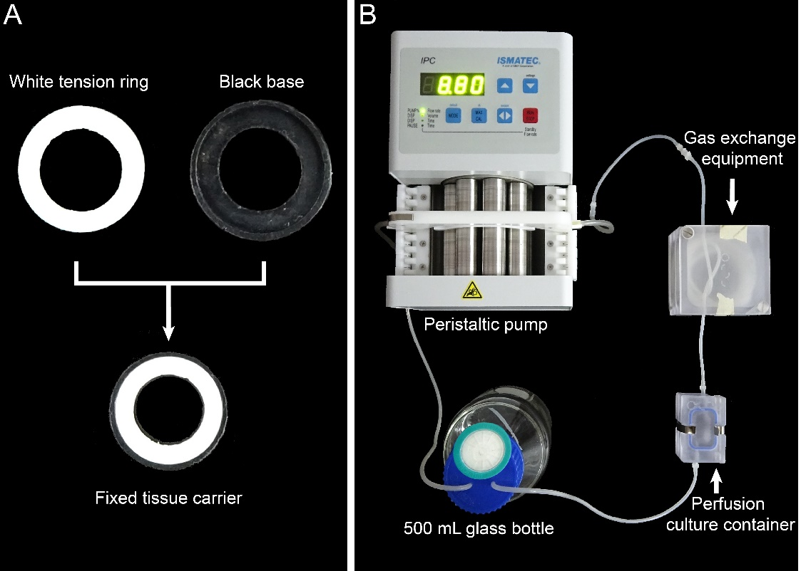
Figure 2. The tissue carrier and the dynamic perfusion system. (A) The 13 mm diameter tissue carrier. (B) The assembly of dynamic perfusion system.

Comment 6
Please provide a reference for the isolation / culture of BMSC.
Author answer:
Thank you for your comment. This is a good suggestion. The isolation and characterization of the BMSCs have been previously reported by our colleagues, and we have now replenished the detailed steps of BMSC isolation and culture as below and the corresponding reference. The revisions are shown below:

3.1 BMSCs isolation¹³.
NOTE: This method is designed for constructing multilayered MSC cell sheet. Rat BMSCs are used in this protocol. The BMSCs are isolated by using the whole bone marrow adherent method, and the BMSCs are expanded in vitro to obtain enough cell amount.
3.1.1 Reagents and materials preparation. Autoclave the instruments at 121 °C for 30 min, including forceps, toothed forceps, and scissors. Prepare 2 mL injection syringe and BMSCs culture medium (Dulbeccos modified Eagles medium (DMEM), 10% fetal bovine serum, 1% glutamine, and 1% penicillin–streptomycin)
3.1.2 Sacrifice the three-week-old male Sprague-Dawley (SD) rats by cervical vertebra dislocation. Soaked the animal in 100 mL 75% alcohol solution in a beaker for 5 min.
3.1.3 Take the animal out from the beaker and put it face down the operation table.
3.1.4 Open the back skin of the animal with a scissor and a forceps. Isolate the skin and muscle tissues to expose the thigh femurs.
3.1.5 Isolate the thigh femurs and put it in 30 mL PBS in a 50 mL centrifugal tube. Two thigh femurs put in one tube. Vortex the centrifugal tube to wash the tissue thoroughly. Repeat this step for twice.
3.1.6 Cut both ends of the femurs with a scissor and expose the marrow cavity.
3.1.7 Aspirate 2 mL BMSCs culture medium with an injection syringe. Insert the needle in the marrow cavity and flush out the bone marrow with culture medium. Every two thigh femurs inject into one 100 mm culture dish.
3.1.8 For each 100 mm culture dish, add 2 mL culture medium in the culture dish.
3.1.9 Put the culture dish into the 37 °C incubator and static culture for 72 h.
3.1.10 Take out the culture dish from the incubator. Replace the supernatant with 6 mL fresh culture medium.
3.1.11 Observe primary BMSCs in a microscope. Following this, the BMSCs were passaged every 5–7 days.
3.2 Take the cells out of the incubator. Observe the cells in a microscope and choose suitable cells for cell sheet construction.
NOTE: When the BMSCs reach 80-90%, the cells could be chosen as seeded cells.

Reference:
13 Wang, Y. et al. Preparation of high bioactivity multilayered bone-marrow mesenchymal stem cell sheets for myocardial infarction using a 3D-dynamic system. Acta Biomaterialia. 72 182-195, doi:https://doi.org/10.1016/j.actbio.2018.03.052, (2018).

Comment 7
Please provide more specific information about the peptide gel, like its mechanic properties, working temperature and what need to be aware of while handing the gel. If possible, please add some discussion about how it is more superior than other forms of matrix.
Author answer:
Thank you for your comment. This is a good question. The RAD16-I is a commercial hydrogel peptide (Puramatrix, BD, Erembodegem, Belgium), and it consist of 1% amino acid and 99% water. And several studies reported that this hydrogel could mimick the natural fiber structure and support cell growth in vitro. In the present protocol, 3 million MSC suspension (in 20 μl 10% sucrose solution) was mixed with 20 μl RAD16-I peptide hydrogel. The volume ratio of the cell suspension and the peptide hydrogel is 1:1. Because the peptide molecules are sensitive to the environment pH value. When the pH value change from acid to neutral, the peptide molecules would automatically assembly as nanofiber structure and form 3D network structure. Therefore, after the cells mix with peptide hydrogel, the cell mixture will change from liquid to hydrogel in a short time. This phenomenon would make it hard to evenly add the cell mixture on the scaffold and cause abundant cell loss. Therefore, a favorable cell-hydrogel should be an even mixture of the cell suspension and the peptide hydrogel, and the cell mixture could be evenly added on the scaffold. Thank you again for your valuable suggestion, now we have revised the corresponding discussion as below.

Revisions:
Discussion：
Constructing the temporary multilayered cell structure is the critical step of the protocol. The RAD16-I is a commercial hydrogel peptide, and it consists of 1% amino acid and 99% water. Several studies reported this peptide hydrogel could mimic the natural ECM environment and is beneficial for stem cell proliferating and surviving¹⁵⁻¹⁷. In the present protocol, 3 million MSC suspension (in 20 μL 10% sucrose solution) was mixed with 20 μL RAD16-I peptide hydrogel. The volume ratio of the cell suspension and the peptide hydrogel is 1:1. This peptide hydrogel is sensitive to the environment pH value, and the peptide molecules would automatically form the 3D network when the pH value changes from acid to neutral. Because the cell surface contains charged particles, so the cell mixture will change from liquid to hydrogel in a short time, which would have great influence on evenly mixing the cells. Therefore, a favorable cell-hydrogel should be an even mixture of the cell suspension and the peptide hydrogel, and the cell mixture could be evenly added on the scaffold. The researchers could optimize the mixture condition by altering the seeded cell number, sucrose solution volume, and the peptide hydrogel volume according to their actual need. It is worthwhile to notice that washing the cells with 10% sucrose solution and evenly mixing the cell-hydrogel mixture are the critical steps of the protocol, and the uneven mixture could cause great cell loss and unstable temporary multilayered structure.

Comment 8
How to measure stem cell bioactivity of the cells embedded in the construct? Please provide some reference to show the benefits of the model on stem cell activity.
Author answer:
Thank you for your comment. This is an important question. The present protocol has been reported to construct a MSC cell sheet for myocardial infarction therapy in our previous study. We focused on the influence of nutrition supply on the stem cell bioactivity. Following the construction of multilayered cell sheet, the cell sheets were either cultured in the dynamic perfusion system (dynamic culture cell sheet, DCcs) or traditional static culture dish (static culture cell sheet, SCcs). After 48 h culture in vitro, the cells within the cell sheet were digested into single cells, and the cell numbers, cell apoptosis, cell proliferation ability, and stem cell markers expression levels were analyzed. The results showed the DCcs exhibited lower cell apoptosis, better cell proliferation ability, and higher levels of MSC stem cell markers expression. Also, the cells within DCcs exhibited normal ultrastructure in the TEM analysis. These results supported that using the present construction method could efficiently acquire a multilayered MSC cell sheet with favorable stem cell property. For your convenience, corresponding results are shown below.

Related previous results
Reference:
13 Wang, Y. et al. Preparation of high bioactivity multilayered bone-marrow mesenchymal stem cell sheets for myocardial infarction using a 3D-dynamic system. Acta Biomaterialia. 72 182-195, doi:https://doi.org/10.1016/j.actbio.2018.03.052, (2018).

3.3. Structure and stem cell characteristics of DCcs

3.4. BMSC bioactivities and ultrastructure within multilayered cell sheet in vitro
The effect of culture system on cell apoptosis was evaluated by the TUNEL assay, more apoptosis positive staining could beobserved in the SCcs compared to DCcs (Fig. 4A). The apoptosis rate quantified by Annexin/PI flow cytometry assay, and BMSC within DCcs (6.3 ± 1.0%) showed significantly lower apoptosis rate compared to SCcs (70.6 ± 4.0%) (Fig. 4B). The survived BMSC from DCcs exhibited significantly greater proliferation ability than the cells from SCcs (Fig. 4C). Furthermore, the BMSC from DCcs and SCcs demonstrated different ultrastructures: in the DCcs group, the BMSC showed regular rough endoplasmic reticulum, normal mitochondria, and rich microvillus. However, in the SCcs cells, endoplasmic reticulum dilatation and degranulation were obviously observed. Normal mitochondria structures were scarcely found in the SCcs group, and medullary corpuscles were identified in the lysosome, representing the ridding of damaged mitochondria. Few microvilli could be seen around the SCcs cells (Fig. 4D). In addition, the levels of HGF, bFGF, IGF-1, and VEGF from the DCcs culture medium were significantly higher than those of SCcs (Fig. 4E).
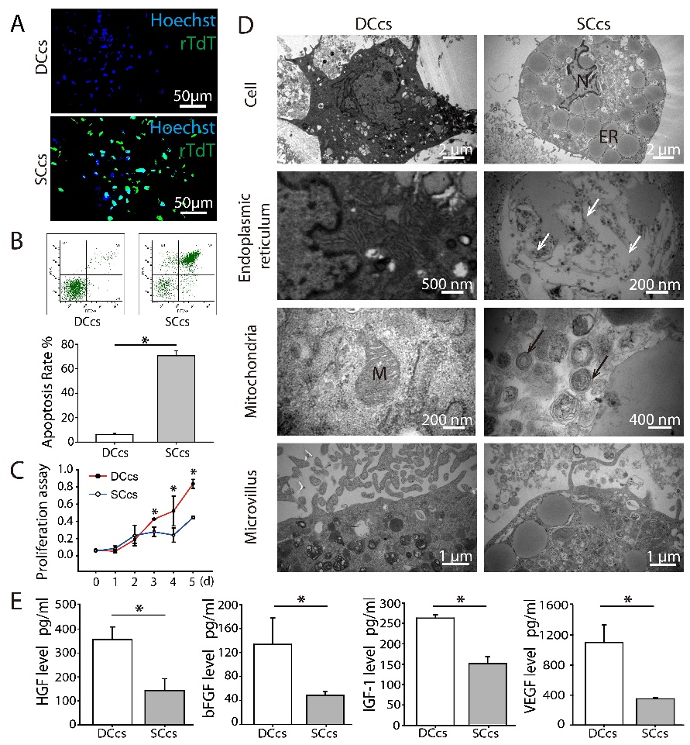
Fig. 4. Bioactivities and ultrastructures of BMSC within DCcs and SCcs. (A) TUNEL cell apoptosis results of DCcs and SCcs. (B) Annexin/PI flow cytometry analysis results of the cell apoptosis rate. (C) Proliferation ability assay of BMSC from DCcs and SCcs. (D) Ultrastructure of BMSC within DCcs and SCcs, where the representative images show the structures of the nuclei (N), endoplasmic reticulum (ER), mitochondria (M) and microvillus. The white arrow indicates the endoplasmic reticulum degradation, while the black arrow indicates that the damaged mitochondria were cleared by lysosome. (E) The levels of HGF, bFGF, IGF-1, and VEGF in DCcs and SCcs. *p < 0.05.

Comment 9
Please provide some evidence, or reference, showing that the stem cells are proliferating in the scaffolds. 3 million cell on a 10.5mm sheet seems like a high cell density to start with.
Author answer:
Thank you for your comment. This is a good question. So far, the insufficient nutrition supply within the multilayered cell sheet structure remains a major influence on preserving the stem cell bioactivity. The present protocol aims to provide a possible solution for constructing a multilayered stem cell sheet as well as preserving the stem cell viability. You are right about that seeding 3 million cells in a 10.5 mm diameter sheet is a high cell density. In order to maintain the stem cell bioactivity, we developed the present multilayered cell sheet construction method. The RAD16-I peptide hydrogel was used to shorten the construction period of multilayered cell structure, and a dynamic perfusion system was used to improve the nutrition supply within the multilayered structure. In our previous study, the cell sheet structure (density), cell numbers, cell apoptosis, and cell proliferation ability were analyzed, and corresponding results are shown below for your convenience. Also, we will keep on optimizing the construction parameters to further improve the cell sheet properties.

Related previous results
Reference:
13 Wang, Y. et al. Preparation of high bioactivity multilayered bone-marrow mesenchymal stem cell sheets for myocardial infarction using a 3D-dynamic system. Acta Biomaterialia. 72 182-195, doi:https://doi.org/10.1016/j.actbio.2018.03.052, (2018).

3.3. Structure and stem cell characteristics of DCcs
The BMSC was positive for CD90 and CD29, and negative for CD45. And the BMSC showed osteogenic and adipogenic abilities in the differentiation assay (Supplementary Fig. S1). P3–P5 BMSC was used for cell sheet construction, and once the multilayered BMSC cell sheet was cultured in either the 3D-dynamic system or traditional static conditions for 48 h, DCcs and SCcs were acquired. The DCcs cell number was counted as 3.4 ± 0.3×10⁶, while that of SCcs was counted as 2.0 ± 0.4×10⁶. The appearances and structural characteristics are illustrated in Fig. 3. The thickness of DCcs (749 ± 48 μm) and SCcs (801 ± 52 μm) showed no significant differences. More uniform cell organization of DCcs was noted in the SEM images, compared to the irregular cell distribution observed in SCcs. Furthermore, the cell-to-cell distance in DCcs (21 ± 5 μm) is significantly smaller than that of SCcs (24 ± 8 μm) (Fig. 3A and B). In order to observe the differentiation condition of DCcs and SCcs, the expression of BMSC surface markers CD90 and CD29 were determined by means of immunofluorescence staining and flow cytometry (Fig. 3C and D). The expression of the stem cell marker decreased in DCcs and SCcs after 48 h of culture in vitro, but significantly higher CD90 and CD29 expression levels were maintained in DCcs than SCcs.
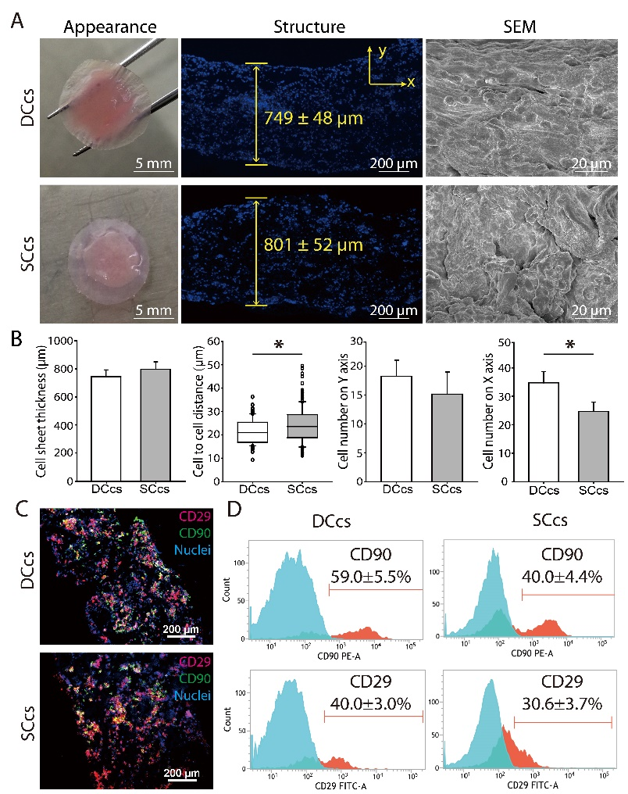
Fig. 3. Structure and stem cell characteristics of multilayered cell sheet. (A) Appearance, structure, and SEM results of DCcs and SCcs. (B) Measurement and analysis of cell sheet structure. Cell sheet thickness (n = 10), cell-to-cell distance (n > 100), cell number on Y-axis (n = 10) and X-axis (n = 10). (C) Immunofluorescence staining results of CD90 (green) and CD29 (red) in DCcs and SCcs. (D) Following 48 h culture in vitro, cells within DCcs and SCcs were digested and the expressions of CD90 and CD29 were determined by flow cytometry. *p < 0.05.

3.4. BMSC bioactivities and ultrastructure within multilayered cell sheet in vitro
The effect of culture system on cell apoptosis was evaluated by the TUNEL assay, more apoptosis positive staining could beobserved in the SCcs compared to DCcs (Fig. 4A). The apoptosis rate quantified by Annexin/PI flow cytometry assay, and BMSC within DCcs (6.3 ± 1.0%) showed significantly lower apoptosis rate compared to SCcs (70.6 ± 4.0%) (Fig. 4B). The survived BMSC from DCcs exhibited significantly greater proliferation ability than the cells from SCcs (Fig. 4C).
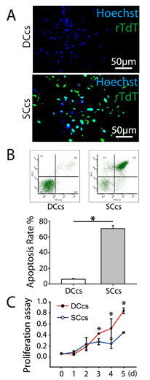
Fig. 4. Bioactivities and ultrastructures of BMSC within DCcs and SCcs. (A) TUNEL cell apoptosis results of DCcs and SCcs. (B) Annexin/PI flow cytometry analysis results of the cell apoptosis rate. (C) Proliferation ability assay of BMSC from DCcs and SCcs.

Comment 10
For the perfusion culture system, please give a picture of the pump system, or a picture of cellurized DPP in the pump system, or draw a diagram to show how the system is connected.
Author answer:
Thank you for your comment. This is a good suggestion for improving the quality of the article. and we have added a figure to show the elements and the connection of the pump system. Corresponding revisions are shown below.
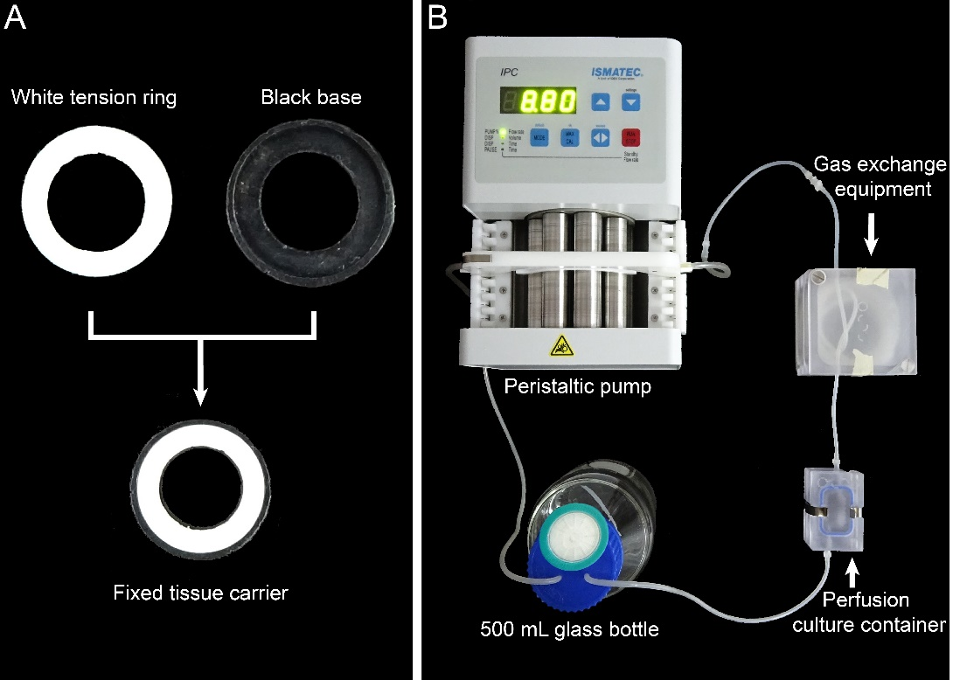
Figure 2. The tissue carrier and the dynamic perfusion system. (A) The 13 mm diameter tissue carrier. (B) The assembly of dynamic perfusion system.

Comment 11
Please show some pictures to compare the seeded cells before and after the perfusion culture step. Please explain more about how it helps the cells to be stabilized in the construct.
Author answer:
Thank you for your comment. (1) This is an important question. The aim of the present construction method was to preserve the stem cell property of the seeded cells, so it is important to compare the cell properties before and after the perfusion culture step. We have characterized the MSC before cell sheet construction, and corresponding results have been reported in our previous study (Shown below). Thank you again for your valuable advice, we have now added the MSC CD90 and CD29 immunofluorescence staining results before cell sheet construction as the control group.

Related previous results
Reference:
13 Wang, Y. et al. Preparation of high bioactivity multilayered bone-marrow mesenchymal stem cell sheets for myocardial infarction using a 3D-dynamic system. Acta Biomaterialia. 72 182-195, doi:https://doi.org/10.1016/j.actbio.2018.03.052, (2018).

3.3. Structure and stem cell characteristics of DCcs
The BMSC was positive for CD90 and CD29, and negative for CD45. And the BMSC showed osteogenic and adipogenic abilities in the differentiation assay (Supplementary Fig. S1).
Supplementary Figure S1: Characterization of the bone-marrow mesenchymal stem cells (BMSCs). (A) Cell morphology of Passage 3 rat BMSCs. (B) Alizarin red staining result of the BMSC underwent 14 days of osteogenic induction. (C) Oil Red O staining result of the BMSC underwent 21 days of adipogenic induction. (D) Flow cytometry analysis results of BMSCs stem cell surface markers.

Revisions:
As the immunofluorescence staining result shows, the BMSCs is highly positive for the stem cell markers CD90 and CD29. After the cell sheet construction, the BMSCs within the multilayered cell sheet remained high levels of CD29 and CD90(Figure 5).

Figure 5. Immunofluorescence staining results of BMSC stem cell markers expression. (A) Immunofluorescence staining results of BMSC before cell sheet construction. (B) Immunofluorescence staining results of the multilayered BMSCs cell sheet section. CD90 (green) and CD29 (red) were positively expressed in the BMSCs and the cell sheet.

(2) Based on the DPP scaffold, we used RAD16-I peptide hydrogel as a temporary 3D scaffold to quickly construct a multilayered cell sheet. However, the mechanical strength of the hydrogel was not strong enough to maintain the multilayered cell sheet structure, and stable cell connections and ECM secretions are needed to enhance the stability of the cell sheet. Additionally, the nutrition supply is closely related to the cell survival within the cell sheet. Previous result showed that the using dynamic perfusion system could decrease the cell apoptosis within the cell sheet, and more cells could be preserved in the multilayered cell sheet structure. Also, the remaining cell number within the dynamic perfusion cell sheet (DCcs) was significantly higher than the static control group. In order to better clarify the relationship between the perfusion culture and the cell sheet structure stability, the discussion has been revised as below:

Related previous results
3.3. Structure and stem cell characteristics of DCcs
The BMSC was positive for CD90 and CD29, and negative for CD45. And the BMSC showed osteogenic and adipogenic abilities in the differentiation assay (Supplementary Fig. S1). P3–P5 BMSC was used for cell sheet construction, and once the multilayered BMSC cell sheet was cultured in either the 3D-dynamic system or traditional static conditions for 48 h, DCcs and SCcs were acquired. The DCcs cell number was counted as 3.4 ± 0.3×10⁶, while that of SCcs was counted as 2.0 ± 0.4×10⁶. The appearances and structural characteristics are illustrated in Fig. 3. The thickness of DCcs (749 ± 48 μm) and SCcs (801 ± 52 μm) showed no significant differences. More uniform cell organization of DCcs was noted in the SEM images, compared to the irregular cell distribution observed in SCcs. Furthermore, the cell-to-cell distance in DCcs (21 ± 5 μm) is significantly smaller than that of SCcs (24 ± 8 μm) (Fig. 3A and B). In order to observe the differentiation condition of DCcs and SCcs, the expression of BMSC surface markers CD90 and CD29 were determined by means of immunofluorescence staining and flow cytometry (Fig. 3C and D). The expression of the stem cell marker decreased in DCcs and SCcs after 48 h of culture in vitro, but significantly higher CD90 and CD29 expression levels were maintained in DCcs than SCcs.
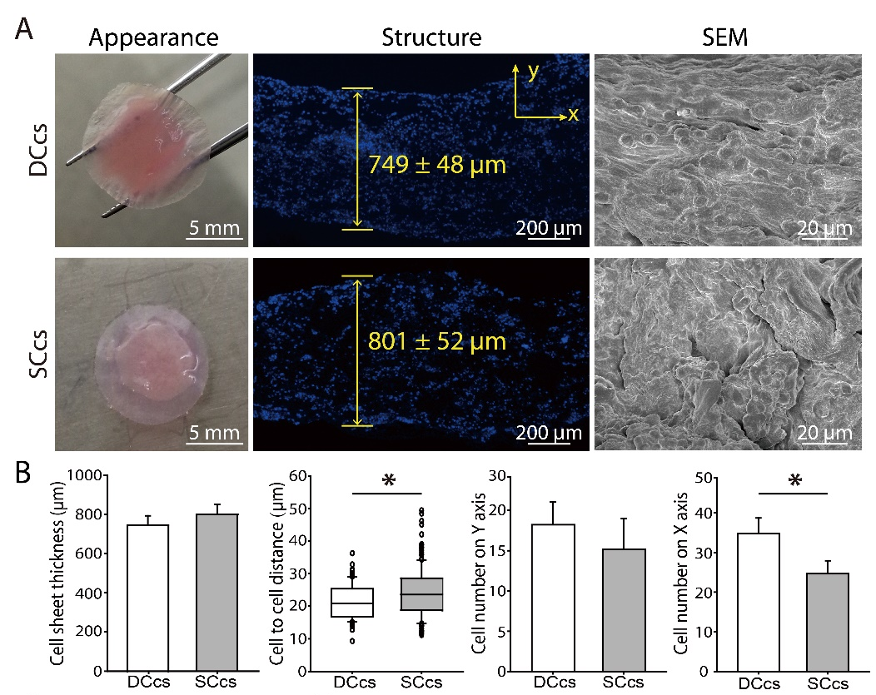
Fig. 3. Structure and stem cell characteristics of multilayered cell sheet. (A) Appearance, structure, and SEM results of DCcs and SCcs. (B) Measurement and analysis of cell sheet structure. Cell sheet thickness (n = 10), cell-to-cell distance (n > 100), cell number on Y-axis (n = 10) and X-axis (n = 10).

Revisions:
Discussion:
Following adding the cell-hydrogel mixture on the DPP scaffold, the mechanical strength of the multilayered cell sheet structure is weak. Because the peptide hydrogel network was not strong enough to maintain the long-term multilayered cell structure, and cell connections and ECM secretions are needed to enhance the stability of the cell sheet. Moreover, the dynamic infiltration of the culture medium could facilitate the stem cells to proliferate and establish cell contacts within the multilayered cell structure, while insufficient nutrition supply would cause cell apoptosis and reduce the cell density of the cell sheet¹³. Therefore, the dynamic perfusion system is important for stabilizing the multilayered cell sheet structure. In addition, the appropriate flow rate of the culture medium should be adjusted according to the specific stem cell type and cell seeding density.

Comment 12
Line 211: "it could be temporarily preserved in the 1.5 ml tube before examination": in what buffer? For how long? Temperature?
Author answer:
Thank you for your comment. We have added more details about storing the cell sheet in the corresponding parts as follows:

Revisions:
- Obtain the multilayered MSC cell sheet.
  - For short preservation, each cell sheet could be transfer to a 1.5 mL centrifugal tube with the forceps. The DPP scaffold should be attached to the inner wall of the centrifugal tube, and the cell sheet should spread out in the centrifugal tube as much as possible.
  - Gently add 1 mL culture medium in the centrifugal tube to immerse the cell sheet.
  - Close the cap of the centrifugal tube and stored the cell sheet in 4 °C.
NOTE: The cell sheet should be transplanted or analyzed as soon as possible. The cell sheet is recommended to be used within 4 h.

Representative results:
When the stem cells reached 80~90% confluency, the cells are isolated from the culture dish and washed with 10% sucrose solution. After centrifugation, the cells are mixed with the RAD16-I peptide hydrogel and added on the rehydrated DPP scaffold. Temporary multilayered structure is formed following a 2 h static culture. Finally, the multilayered BMSC cell sheet product (Figure 4) is acquired following a 48 h culture in the dynamic perfusion system. With the support of DPP scaffold, the cell sheet could be easily manipulating with the forceps, and it could be temporarily preserved in culture medium in the 1.5 mL tube at 4 °C for 4 h before examination or transplantation (Figure 4). As the immunofluorescence staining result shows, the BMSCs within the multilayered cell sheet are highly positive expression for stem cell markers CD29 and CD90(Figure 5).

Minor concerns
Comment 1
Protocol 1.3. Line 87: please specify "keep in wet". Constantly add PBS on top while dissecting or dissect within PBS?
Author answer:
Thank you for your comment. We have added more details about storing the cell sheet in the corresponding parts as follows:

Protocol:
- Preparation of DPP scaffold with PLA₂ decellularized method¹⁴. (Figure 1A)
NOTE: Keep the FPP in wet by adding 50 mL PBS every 20 min during the removal of adipose tissue.

Comment 2
1. 11. Line 100: how often to weigh the samples to know they had reached a "constant weight"?
Author answer:
Thank you for your comment. The purpose of this step is to ensure that the sample is completely dried and free of moisture. Multiple weighing methods can be used to determine that the sample has been dried. We have added more details about weighing the samples in the corresponding parts as follows:

Protocol:
- Preparation of DPP scaffold with PLA₂ decellularized method¹⁴ (Figure 1A).
NOTE: The sample needs to be completely dried. Weigh the DPP sample every 10 minutes and repeat more than 3 times until the weight is no longer changed.

Comment 3
Line 70: "multilayered BMSCs cell sheet was successfully prepared and an exhibited optimal therapeutic effect on the rat myocardial infarction model". Please provide references.
Author answer:
Thank you for your comment. We are sorry for the carelessness. The MSC cell sheets have been developed, also, the multilayered BMSCs cell sheet described in the present protocol has been previously reported as a cardiac cell sheet, and transplanting the cell sheet in a rat myocardial infarction model exhibited favorable outcome after 4 months. Thank you for your kind reminder, and the corresponding references have now been added.

Revision:
Introduction:
Using this system, a multilayered BMSCs cell sheet was successfully prepared and exhibited optimal therapeutic effect on the rat myocardial infarction model¹³.

Reference:
13 Wang, Y. et al. Preparation of high bioactivity multilayered bone-marrow mesenchymal stem cell sheets for myocardial infarction using a 3D-dynamic system. Acta Biomaterialia. 72 182-195, doi:https://doi.org/10.1016/j.actbio.2018.03.052, (2018).

Comment 4
Section 4.5. Line 158: please specify how to remove medium from the scaffolds. Use vacuum with glass pipette or more gentle means?
Author answer:
Thank you for your comment. The culture medium on the scaffold was aspirated with a tip. A more careful operation description has been rewritten as below:

Revision:
4. Preparing BMSCs and RAD16-I peptide hydrogel mixture (Figure 1B).
4.5 Take out the DPP scaffold within the tissue carrier and gently aspirate the culture medium with a tip.

Comment 5
Line 49: please give references about cell sheet applications
Author answer:
Thank you for your comment. The cell sheet techniques have been used in many tissue/organs regeneration areas, including myocardial regeneration, teeth regeneration, and cartilage regeneration. Thank you for your kind reminder, and the corresponding references have now been added.

Revisions:
Introduction：
So far, certain types of cell sheet were constructed and studied in the treatment of myocardial infarction⁵, cartilage injury⁶, and skin wound⁷.

Reference:
5 Alshammary, S. et al. Impact of cardiac stem cell sheet transplantation on myocardial infarction. Surgery Today. 43 (9), 970-976, doi:10.1007/s00595-013-0528-2, (2013).
6 Chen, G. P. et al. The use of a novel PLGA fiber/collagen composite web as a scaffold for engineering of articular cartilage tissue with adjustable thickness. Journal of Biomedical Materials Research Part A. 67a (4), 1170-1180, doi:10.1002/jbm.a.10164, (2003).
7 Cerqueira, M. T. et al. Human Adipose Stem Cells Cell Sheet Constructs Impact Epidermal Morphogenesis in Full-Thickness Excisional Wounds. Biomacromolecules. 14 (11), 3997-4008, doi:10.1021/bm4011062, (2013).

Comment 6
Line 202: "Additionally, the scaffolds could be modified as a growth factor control release system to support stem cell growth and improve the in vivo regeneration." Please specify how this can be achieved or give references.
Author answer:
Thank you for your comment. This is a good question. In our previous study, we prepared a DPP scaffold by using the PLA₂ decellularized method. Also, we used the aspartic acid as the spacer arm to crosslink the VEGF on the DPP scaffold, corresponding results are shown below for your convenience, and the reference has been added in the protocol.

Related previous results
13 Wang, Y. et al. Preparation of high bioactivity multilayered bone-marrow mesenchymal stem cell sheets for myocardial infarction using a 3D-dynamic system. Acta Biomaterialia. 72 182-195, doi:https://doi.org/10.1016/j.actbio.2018.03.052, (2018).

3.2. Established VEGF controlled release system for DPP by crosslinking Asp
After crosslinking Asp on DPP, the FTIR spectroscopy results showed stronger bands at 3315, 1745, and 1180 cm⁻¹ in DPP-Asp compared to DPP. The characteristic band of the carbonyl group(-C=O) of the amido bond at 1637 cm⁻¹ was strengthened in DPP-Asp-VEGF compared to DPP-Asp, while the stretching vibration band of the carbonyl group (-C=O) of carboxy (–COOH) at 1745 cm⁻¹ decreased (Fig. 2A). These changes indicated that VEGF successfully crosslinked on the DPP scaffold by bonding the carboxyl from Asp. Moreover, the XRD results indicate that the collagen fiber arrangement order was enhanced in DPP-Asp compared to DPP (Fig. 2B). The surface hydrophilicity of the scaffolds was examined by contact angle assay, and significant differences were observed among DPP, DPP-Asp and DPP-Asp-VEGF (Fig. 2C). The controlled release effect of DPP-Asp-VEGF was examined by ELISA. In the DPP-VEGF group, VEGF exhibited a burst release of 53 ± 8% by the first day, while the release rate of VEGF in the DPP-Asp-VEGF group was 19 ± 2%. The results indicate that VEGF was successfully crosslinked and achieve stable release within seven days on DPP-Asp-VEGF (Fig. 2D and E).

Fig. 2. Using Asp as a spacer arm improved VEGF crosslinking on DPP. (A) FTIR results of DPP, DPP-Asp, and DPP-Asp-VEGF. The black arrow indicates the change bands between different groups: 3315 cm⁻¹ indicates the stretching vibration band of the hydroxyl group (–OH) and amine (–NH); 1745 cm⁻¹ indicates the stretching vibration band of the carbonyl group (–C=O) in carboxyl (–COOH); 1637 cm⁻¹ indicates the carbonyl group (–C=O) in the amido bond; and 1180 cm⁻¹ indicates the carbon-nitrogen bond from the primary amine bond of Asp. (B) XRD measurement results of DPP, DPP-Asp, and DPP-Asp-VEGF. (C) Contact angle assay of DPP, DPP-Asp, and DPP-Asp-VEGF. (D) Cumulative release rate of VEGF with time. (E) Release rate of VEGF with time, *P＜0.05.

Revisions:
Additionally, the scaffolds could be modified as a growth factor control release system to support stem cell growth and improve the in vivo regeneration¹³.

Reference:
13 Wang, Y. et al. Preparation of high bioactivity multilayered bone-marrow mesenchymal stem cell sheets for myocardial infarction using a 3D-dynamic system. Acta Biomaterialia. 72 182-195, doi:https://doi.org/10.1016/j.actbio.2018.03.052, (2018).

Comment 7
Line 211: "it could be temporarily preserved in the 1.5 ml tube before examination": in what buffer? For how long? Temperature?
Author answer:
Thank you for your comment. We have added more details about storing the cell sheet in the corresponding parts as follows:

Representative results：
When the stem cells reached 80~90% confluency, the cells are isolated from the culture dish and washed with 10% sucrose solution. After centrifugation, the cells are mixed with the RAD16-I peptide hydrogel and added on the rehydrated DPP scaffold. Temporary multilayered structure is formed following a 2 h static culture. Finally, the multilayered BMSC cell sheet product (Figure 4) is acquired following a 48 h culture in the dynamic perfusion system. With the support of DPP scaffold, the cell sheet could be easily manipulating with the forceps, and it could be temporarily preserved in culture medium in the 1.5 mL tube at 4 °C for 6 h before examination or transplantation (Figure 4). As the immunofluorescence staining result shows, the BMSCs within the multilayered cell sheet are highly positive expression for stem cell markers CD29 and CD90(Figure 5).

Response to reviewer 2
Major Concerns
while the manuscript reads well and the method is generally well described, it needs to be revised by a native english speaker for style. Some detail is needed, such as the production of PLA2 scaffolds.
Author answer:
We appreciate your prompt reviews and valuable suggestions, and we had revised the manuscript according to your comments and suggestions. We have checked the spellings and grammars in the article and revised the wrong expressions.

Revisions:
- Preparation of DPP scaffold with PLA₂ decellularized method¹⁴ (Figure 1A).
  - Prepare 100 mL 200 U/mL PLA₂ solution. Add 0.5 g sodium deoxycholate and 2 mL PLA₂ in 198 mL carbonate buffer solution. This solution should be used within 24 h after preparation.
  - Obtain the fresh porcine pericardium (FPP) from the slaughterhouse and return to the laboratory within 1 h.
NOTE: The FPP should be stored at 4 °C during the transportation.
NOTE: Step 2 to step 10 should be conducted with continuous shaking in a thermo stat controlled water bath.
  - Wash the FPP with 200 mL PBS contained 1% penicillin-streptomycin thoroughly in 500 mL beaker at 10 °C for 10 min. Repeat this step for twice.
  - Split the FPP in to two layers and remove the adipose tissue with forceps and scissors.
NOTE: Keep the FPP in wet by adding 50 mL PBS every 20 min during the removal of adipose tissue.
  - Shape the FPP into 10×10 cm² pieces with a scissor.
  - Wash the FPP with 200 mL carbonate buffer solution (CBS) contained 1% penicillin-streptomycin in 500 mL beaker at 10 °C for 10 min. Repeat this step for twice.
  - Transfer the FPP into pure water and soaked at 10 °C for 12 h.
  - Soak 10×10 cm² sample in 50 mL CBS contained 200 U/mL PLA₂ and 0.5% (w/v) sodium deoxycholate solution at 37 °C for 6 h.
  - Wash the samples with CBS contained 1% penicillin-streptomycin at 10 °C for 10 min. Repeat this step for twice.
  - Soak each sample in 50 mL CBS contained 200 U/mL PLA₂ and 0.5% (w/v) sodium deoxycholate solution at 37 °C for 2 h.
  - Wash the samples with CBS contained 1% penicillin-streptomycin at 10 °C for 2 h. Repeat this step for 10 times at least.
  - Place the samples in flat plates and dry the samples to a constant weight in a constant temperature oven at 55 °C.
NOTE: The sample needs to be completely dried. Weigh the DPP sample every 10 minutes and repeat more than 3 times until the weight is no longer changed.
  - Shape the DPP samples into 10.5 mm diameter circle with a trephine. Pack each DPP with sterile sealed bag.
  - Sterilize the DPP samples by g-irradiation (25 kGy).
  - Stored the DPP samples at 4 °C before use.
NOTE: All samples can be stored for up to 6 months at 4 °C.

Response to reviewer 3
Major concerns
Comment 1
Title contains "multilayered 3D structure", but there was no data or text describing multilayered structure. It was not clear what type of multilayered structure they were referring to. Please clarify the terminology.
Author answer:
Thank you for your comment. This is an important question. The definition of the cell sheet was first brought up by Y. Miyahara and his colleague. By using the thermo-responsive culture dish, a confluent monolayered MSC cell sheet was constructed. And then they construct a multilayered cell sheet by staking the 3 layers monolayered cell sheet to increase the cell sheet thickness and cell survival rate within the infarcted area. After that, many scientists developed different methods to construct multilayered cell sheet (more than 3 layers), such as using magnetic nanoparticles, porous scaffolds. The present study introduces the DPP was used as a scaffold, and the seeded cells were mixed with the nano peptide hydrogel to construct the multilayered cell sheet. The multilayered cell structure was shown in the previous study, and 15 to 20 cell layers were counted within the cell sheet. Thank you again for your valuable comment, we have now made revision to article for better clarification:

Revisions:
Introduction:
To solve this problem, tissue engineering scientists developed the cell sheet technique. A monolayered cell sheet with intact extracellular matrix was firstly prepared by using the temperature-response culture dish1, and its follow-up studies reported the significant improvements of stem cell retention and survival within the infarcted area^{2,3}. Among, constructing the multilayered cell sheet have been reported as an effective strategy for improving the cell survival and the cell sheet therapeutic effect^{3,4}. Since then, scientists worked on developing different cell sheet construction methods in order to increase the cell amount, stem cell property, and mechanical property of the cell sheets. So far, certain types of cell sheet were constructed and studied in the treatment of myocardial infarction⁵, cartilage injury⁶, and skin wound⁷.

References：
3 Narita, T. et al. The Use of Scaffold-free Cell Sheet Technique to Refine Mesenchymal Stromal Cell-based Therapy for Heart Failure. Molecular Therapy. 21 (4), 860-867, doi:10.1038/mt.2013.9, (2013).
4 Matsuo, T. et al. Efficiently Piled-Up Cardiac Tissue-Like Sheets With Pluripotent Stem Cell-Derived Cells Robustly Promotes Cell Engraftment and Ameliorates Cardiac Dysfunction After Myocardial Infarction. Circulation. 128 (22), (2013).

Comment 2
To show retention of the cells on the sheet, comparison of a tissue size or cell density between starting and ending product should be included. But there was no information showing initial cell seeding density and remaining cell density after 48 hours of dynamic culture. It is likely that cells would bind on matrix at some extent but to showing high binding and retention will be very beneficial for stem cell delivery.
Author answer:
Thank you for your comment. This is an important question. The present protocol introduces a fast construction method of the multilayered cell sheet, and a dynamic perfusion system is used to maintain the nutrition supply within the multilayered structure. Measuring the cell seeding density is of great importance. In the previous related study, we aimed to construct the multilayered cell sheet and developed a 3D dynamic system to ensure the nutrition supply of the stem cells, and the cell density and stem cell property within the cell sheets were measured. The results showed that a higher cell density was observed in the dynamic perfusion group (DCcs) compared to the static culture group (SCcs), and higher levels of stem cell surface markers were observed in the dynamic perfusion group. These results indicate using the dynamic perfusion system could preserve high cell density, multilayered structure, and stem cell property of the cell sheet. It is also a good advice to compare the initial cell seeding density and the remaining cell seeding density after 48 h culture. Thank you again for your valuable advice, we will consider your suggestion in the following studies. And corresponding reference and revision are shown as follows:

Related previous results
13 Wang, Y. et al. Preparation of high bioactivity multilayered bone-marrow mesenchymal stem cell sheets for myocardial infarction using a 3D-dynamic system. Acta Biomaterialia. 72 182-195, doi:https://doi.org/10.1016/j.actbio.2018.03.052, (2018).

3.3. Structure and stem cell characteristics of DCcs
The BMSC was positive for CD90 and CD29, and negative for CD45. And the BMSC showed osteogenic and adipogenic abilities in the differentiation assay (Supplementary Fig. S1). P3–P5 BMSC was used for cell sheet construction, and once the multilayered BMSC cell sheet was cultured in either the 3D-dynamic system or traditional static conditions for 48 h, DCcs and SCcs were acquired. The DCcs cell number was counted as 3.4 ± 0.3×10⁶, while that of SCcs was counted as 2.0 ± 0.4×10⁶. The appearances and structural characteristics are illustrated in Fig. 3. The thickness of DCcs (749 ± 48 μm) and SCcs (801 ± 52 μm) showed no significant differences. More uniform cell organization of DCcs was noted in the SEM images, compared to the irregular cell distribution observed in SCcs. Furthermore, the cell-to-cell distance in DCcs (21 ± 5 μm) is significantly smaller than that of SCcs (24 ± 8 μm) (Fig. 3A and B). In order to observe the differentiation condition of DCcs and SCcs, the expression of BMSC surface markers CD90 and CD29 were determined by means of immunofluorescence staining and flow cytometry (Fig. 3C and D). The expression of the stem cell marker decreased in DCcs and SCcs after 48 h of culture in vitro, but significantly higher CD90 and CD29 expression levels were maintained in DCcs than SCcs.
Fig. 3. Structure and stem cell characteristics of multilayered cell sheet. (A) Appearance, structure, and SEM results of DCcs and SCcs. (B) Measurement and analysis of cell sheet structure. Cell sheet thickness (n = 10), cell-to-cell distance (n > 100), cell number on Y-axis (n = 10) and X-axis (n = 10).

Comment 3
The authors mentioned dynamic perfusion system but there was no description about their flow rate and how they optimized this dynamic condition.
Author answer:
Thank you for your comment. This is an important question. The dynamic culture parameters have great impacts on the cell sheet structure and the cell metabolism. If the flow rate is high, big fluid shearing force may destroy the structure of the cell sheet. If the flow rate is low, the stem cells within the cell sheet may differentiate or apoptotic owing to the low nutrition and metabolism exchange efficiency. As different cell types would form different cell connections and exhibit different characteristics, such as the MSC and the epithelial stem cells, researchers should analyze the seeded cell biological characteristics within the cell sheets, to find the ideal dynamic perfusion flow rate (or fluid shearing force), including cell density, cell apoptosis, and stem cell differentiation. Furthermore, these analyses were helpful in understanding the therapeutic effects of cell sheet in vivo. Thank you again for your valuable advice, and corresponding reference and revision are shown as follows:

Revision:
Protocol
5. In vitro culture of 3D multilayered cell sheet using a dynamic culture system.
5.5 Put the dynamic perfusion system in the incubator and start the pump. Set the flow rate of the peristaltic pump as 8 mL/min. Culture the cell sheet in the dynamic perfusion system for 48 h.

Comment 4
What was the concentration of RAD16-1 for mixture composition? What was their criteria for optimized mixture condition?
Author answer:
Thank you for your comment. This is an important question. The RAD16-I is a commercial hydrogel peptide (Puramatrix, BD, Erembodegem, Belgium), and it consist of 1% amino acid and 99% water. In the present protocol, 3 million MSC suspension (in 20 μL 10% sucrose solution) was mixed with 20 μL RAD16-I peptide hydrogel. The volume ratio of the cell suspension and the peptide hydrogel is 1:1. Because the peptide molecules are sensitive to the environment pH value. When the pH value change from acid to neutral, the peptide molecules would automatically assembly as nanofiber structure and form 3D network structure. Therefore, after the cells mix with peptide hydrogel, the cell mixture will change from liquid to hydrogel in a short time. This phenomenon would make it hard to evenly add the cell mixture on the scaffold and cause abundant cell loss. Therefore, a favorable cell-hydrogel should be an even mixture of the cell suspension and the peptide hydrogel, and the cell mixture could be evenly added on the scaffold. The researches could achieve this goal by altering the seeded cell number, sucrose solution volume, and the peptide hydrogel volume according to their actual need. Thank you again for your valuable suggestion, now we have revised the corresponding discussion as below:

Revisions:
Discussion:
Constructing the temporary multilayered cell structure is the critical step of the protocol. The RAD16-I is a commercial hydrogel peptide, and it consists of 1% amino acid and 99% water. Several studies reported this peptide hydrogel could mimic the natural ECM environment and is beneficial for stem cell proliferating and surviving¹⁵⁻¹⁷. In the present protocol, 3 million MSC suspension (in 20 μL 10% sucrose solution) was mixed with 20 μL RAD16-I peptide hydrogel. The volume ratio of the cell suspension and the peptide hydrogel is 1:1. This peptide hydrogel is sensitive to the environment pH value, and the peptide molecules would automatically form the 3D network when the pH value changes from acid to neutral. Because the cell surface contains charged particles, so the cell mixture will change from liquid to hydrogel in a short time, which would have great influence on evenly mixing the cells. Therefore, a favorable cell-hydrogel should be an even mixture of the cell suspension and the peptide hydrogel, and the cell mixture could be evenly added on the scaffold. The researchers could optimize the mixture condition by altering the seeded cell number, sucrose solution volume, and the peptide hydrogel volume according to their actual need. It is worthwhile to notice that washing the cells with 10% sucrose solution and evenly mixing the cell-hydrogel mixture are the critical steps of the protocol, and the uneven mixture could cause great cell loss and unstable temporary multilayered structure.

Minor concerns
There were several spelling errors throughout the text. Please review the manuscript carefully..
Author answer:
Thank you for your comment. This is an important question. We have checked the spellings and grammars in the article and revised the wrong expressions.

