The Editors
JOVE

October 24th, 2018

Dear Editors.

Thank you for your letter dated July 31st, 2018 about your decision on our article, 58613_R0_062518 “Optogenetic manipulation of neural circuits during monitoring sleep/wakefulness states in mice”. We found the reviewers’ comments to be constructive and helpful to improve our manuscript.

I am pleased to resubmit our revised manuscript, which, we believe, is totally improved over the previous version. We have addressed all of reviewers’ concerns.

We attach a point-by-point response to the reviewers' specific concerns, and our changes to the previously submitted version of the text are mentioned. Thank you for your consideration of our revised manuscript and patience for revision process. We hope that our revised version of manuscript could be suitable for publication in JOVE.

Sincerely yours,

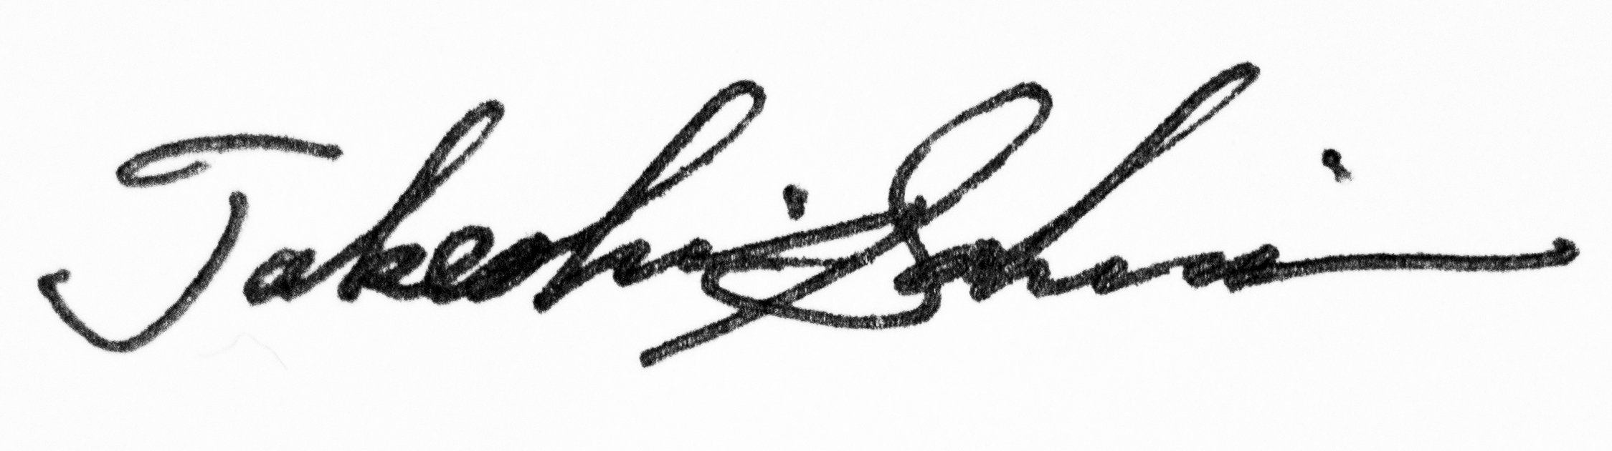

Takeshi Sakurai, MD, PhD

