
Lerner Research Institute
Jianjun Zhao, M.D; Ph.D.
Assistant Staff
Department of Cancer Biology
Lerner Research Institute
Cleveland Clinic

Ronald Myers, PhD.
Science Editor
JoVE
1 Alewife Center, Suite 200, Cambridge, MA 02140

Dear Dr. Myers,
Thank you for your review our manuscript and give us the opportunity to resubmit our manuscript for your consideration. This resubmission to the JoVE Journal has been revised based on reviewer comments. I am particularly grateful for the critiques and suggestions from the reviewer on the experiments to improve our manuscript. Below, I outline the changes made in the text of our resubmitted version and an underline indicates new or revised text.

Reviewer #1:
Manuscript Summary:
This is an interesting paper, which I think will be highly qualified for JoVE. The author for the first time to conjugate LNA Gapmer antisense oligonucleotides targeting MALAT1 and apply the newly formed ASO in mice treated with tumor cells to investigate the therapeutic function of ASO anti-MALAT1. The results in this paper showed that the conjugated ASO had high efficiency and low toxicity, and could significantly extended the lifespan of tumor cell treated mice.
Major Concerns:
1. Have the author tested that how long does the conjugated oligo could stay in mouse body? Please interpret this point.

There are multiple literatures shown that the ASO conjugated on SWCNT will be released from SWCNT in 2 hours under the action of enzyme in cell lysosomes such as lysosomal thiol reductase (Biomaterials, 34(4):1213-1222). We did not check the retention time of SWCNT-anti-MALAT1 in mice in our study.
2. Concerning the treatment of tumor cells, have the authors tried pretreat the mice with the conjugated ASO anti-MALAT1, which will function as a protection to the mice? Please interpret this point.

We started to treat the mice in our dissemination mouse model on the day 7 after tumor cell injection, when the tumor cells could be detected by IVIS system. We didn’t pretreat the mice with the conjugated ASO anti-MALAT1 because we think it didn’t mimic the clinical situation.
3. Is there any comparison between injection of the LNA Gapmer ASO anti-MALAT1 and the conjugated ASO in mice? What is the difference of the amount and efficiency in mice? Please interpret this point.

Since there are studies have demonstrated that, SWCNT conjugated ASO inhibited target gene (mTERT) more intensively than ASO only in vitro and in vivo (Clinical Cancer Research.12(16):4933-9). We did not compare the treatment efficiency between MALAT1 and SWCNT-anti-MALAT1 directly.
Minor Concerns:
N/A

Reviewer #2:

Manuscript Summary:
The manuscript presents a method for non-viral delivery of antisense oligo targeting the MALAT1 RNA. The study starts with in vitro experiments and then the efficiency of the delivery system is confirmed by in vivo animal studies. The methods are explained step-by-step. The results are discussed properly. The manuscript would help the readers to design similar delivery systems.
Major Concerns:
There are no major concerns.
Minor Concerns:
There are some minor issues that can be explained more. It would be more helpful for the readers, if the following issues were clarified.
1. Line 76: The conversion of absorbance to the concentration could be explained briefly.

The molecular weight of SWCNT is about 170 kDa; the molar extinction coefficient ε is about 7.9 × 10⁶ M^{–1}·cm^{–1} (Proc Natl Acad Sci U S A. 102(33):11600-5). Thus the weight extinction coefficient is about 21.52 mg·L^{–1}·cm^{–1}. We measured the absorption at 808 nm wavelength with liquid diameter of 0.5 cm, and the values we got from the UV-visible spectroscopy was about 4.7, thus the final concentration was calculated as 4.7 × 21.52 mg·L^{–1}·cm^{–1} × 0.5 cm, which was about 50 mg/L.
2. Do the authors check the conjugation efficiency of antisense oligo? Do they verify the conjugation?

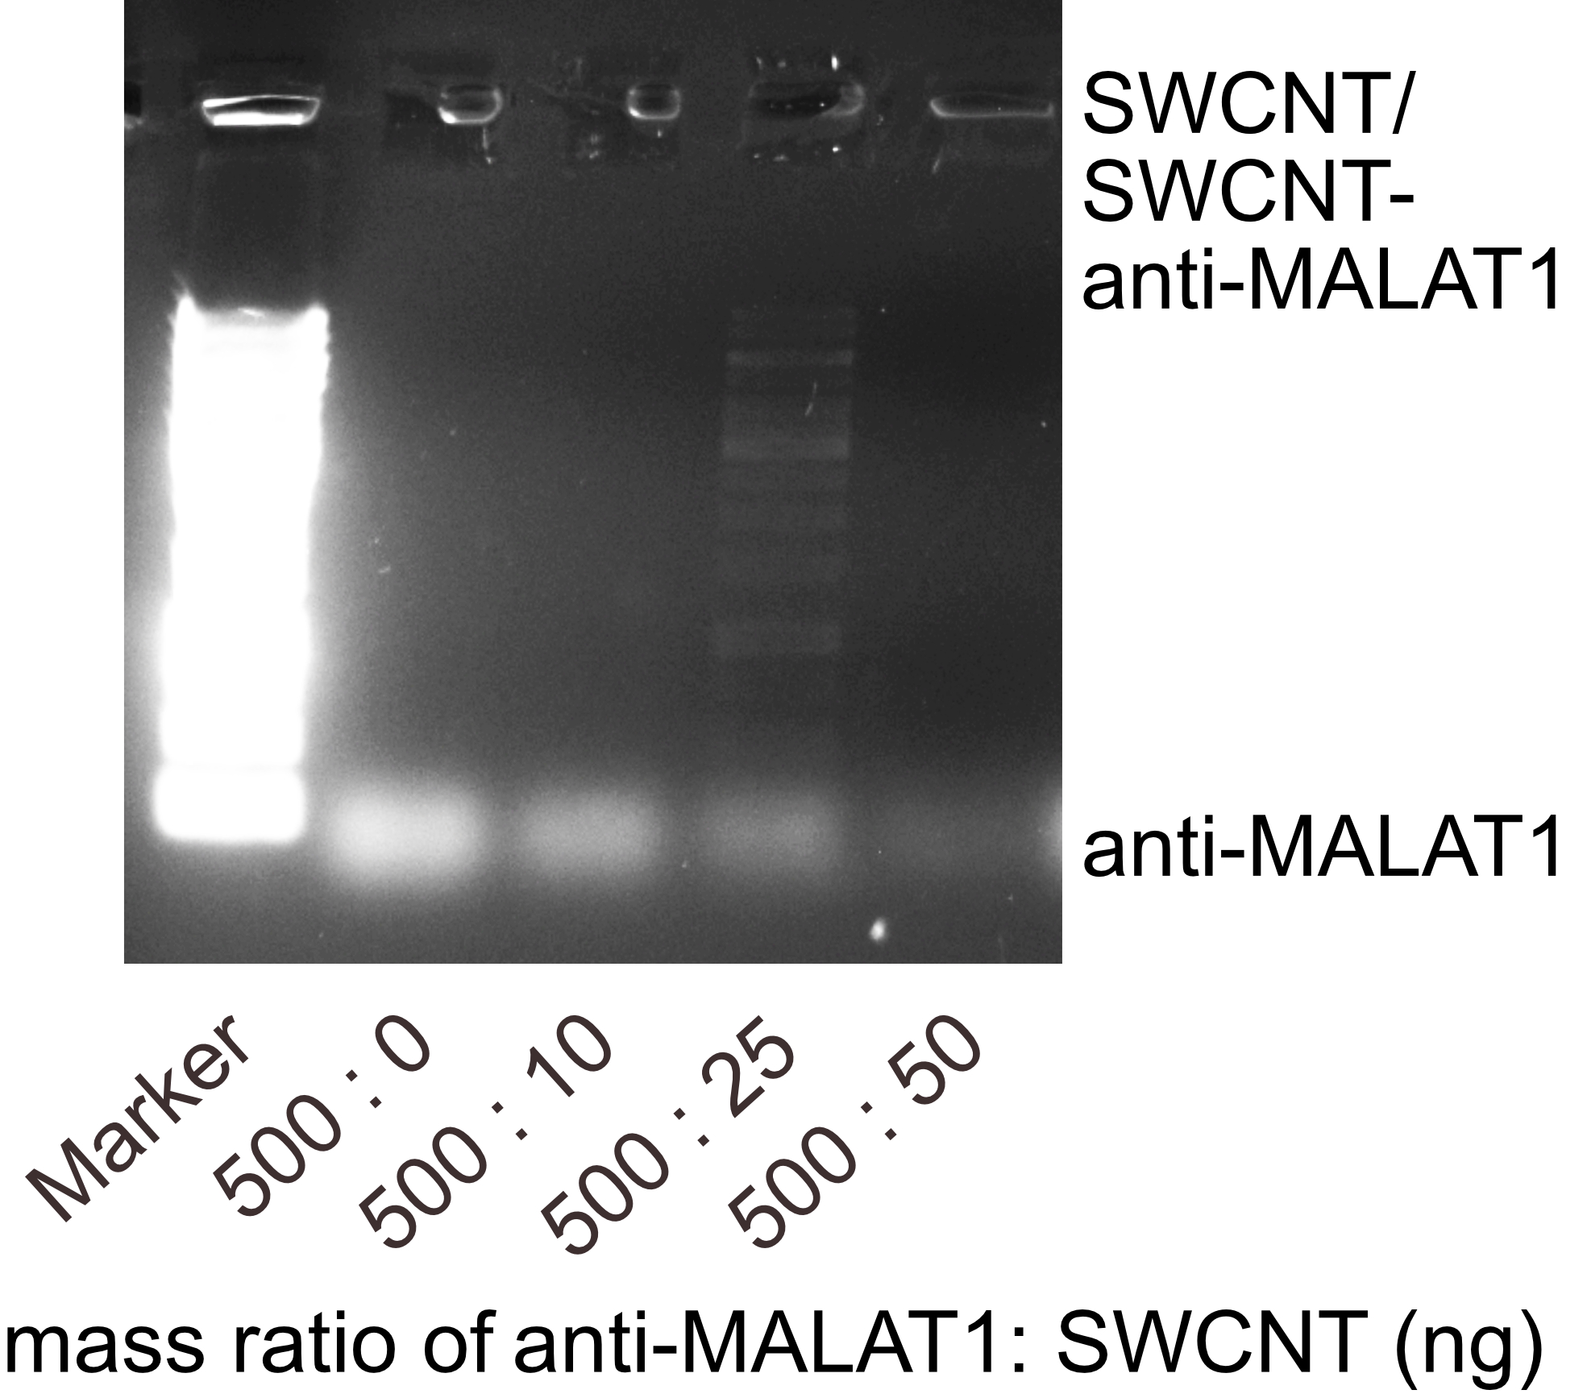
We checked the optimized mass ratio between anti-MALAT1 and SWCNT conjugation using DNA agarose gel electrophoresis. We found the unconjugated free anti-MALAT1 (lower band) gradually reduced and there is clearly conjugated SWCNT-anti-MALAT1 stay in the gel well (upper band) in 10:1, which is the ratio we used in the experiment. The consumption ratio of NAP-5 column was 40-60 %. The molecular weights of anti-MALAT1 and SWCNT are about 6.5 kDa and 170 kDa and the molar ratio between anti-MALAT1 and SWCNT is about 300:1. Thus, 1 SWCNT molecule binds with 200-400 anti-MALAT1 oligos. This number may be variable because the length and diameter of each SWCNT may be different.

3. Regarding Figüre 1, the cleavable property of the linker could be emphasized in the figüre or in the text. Once inside the cell, the status of the SWCNT conjugate could be simply schematized. For instance, how is the antisense oligo released from the conjugate?

We have added this part in the new figure 1.

Thank you for your consideration!
Sincerely,

Jianjun Zhao, M.D; Ph.D.

