Dr Bing Wu
Review Editor
JoVE
08/08/2018
Dear Dr Wu,
Resubmission in response to further editorial comments.

We have completed all requested further changes, as listed below:
1. Generic steps cannot be filmed. All compounds have to be specified for all steps. Please specify compound X and reference compound ref in step 1.1. Please also specify the amount of the compounds.
Answer: this is done (cf steps 1.1, 3.1, and 4.2)
2. Step 4.1.3, 4.1.4: For steps that are done using software, a step-wise description of software usage must be included in the step. Please mention what button is clicked on in the software, or which menu items need to be selected to perform the step.
Answer: this has been done
3. Please sign the new Author License Agreement, which is attached to this email. Please upload the full agreement to your Editorial Manager account when you submit your revision.
Answer: this has been done.

We hope that the draft is now satisfactory.
Yours sincerely,
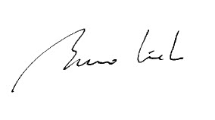
Bruno Linclau

