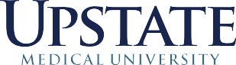
Department of Ophthalmology
Audrey M. Bernstein, PhD
Associate Professor
Department of Ophthalmology
Phone: 315-464-7739
Fax: 315-464-5243

08/1618
Dear JOVE,
Please accept our revision of the manuscript entitled: “Ex vivo corneal organ culture model for wound healing studies”. We have extensive experience in ocular studies including the use of human and animal corneas for wound healing studies. Here we describe a useful organ culture assay for discovering novel agents that promote regenerative healing or testing the potentially toxic effects of agents. Use of this multi-cellular 3D model is a tremendous cost savings over animal studies and can be used to select the best targets and reagents prior to embarking on in vivo studies. Since ocular human tissue is readily available, this assay can be performed with donated human tissue making it translatable to human disease.

Sincerely,

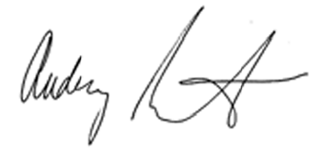

Audrey Bernstein, PhD
Associate Professor
Center for Vision Research
Department of Ophthalmology
SUNY Upstate Medical University
Syracuse, New York 13210
315-464-7739
bernstea@upstate.edu

