July 31, 2018
To the editor,

Thank you for your consideration of our paper (JoVE58547). Attached, please find our revised manuscript. We have made several formatting and wording changes requested by the JoVE editorial staff. Notably, we have highlighted the steps we believe are most useful to include in the video. We have highlighted steps within the protein purification section of the protocol and the enzyme activity assay section. If time permits, both would be useful, but we believe that the enzyme activity assay is the most important section of the paper. If necessary, the protein purification section could be excluded from the video, if this allows more thorough coverage within a reasonable video length of the enzyme activity assay. As none of the authors have direct experience with filming a protocol video, we would like to defer to the Journal’s expertise re: inclusion of the protein purification section.
As requested, we have removed all direct references to commercial products from the protocol and added more detail to the Table of Materials. We have added more detail to the data analysis section detailing the specific commands used to quantitate signal within Regions of Interest (section C, part 4).
We thank the editorial staff for their detailed reading of the manuscript.

Sincerely,
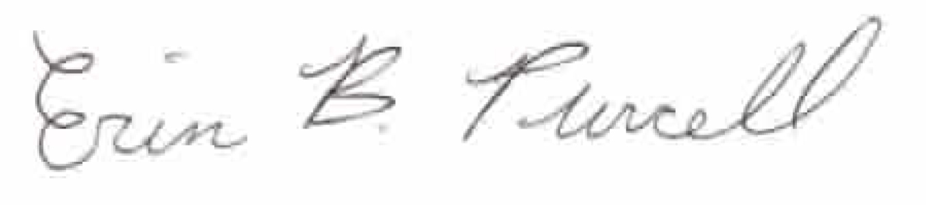
Erin B. Purcell, Ph.D.
Assistant Professor of Chemistry and Biochemistry
Old Dominion University
epurcell@odu.edu
(757) 683-4240

