Submission ID #: 58527

Scriptwriter Name: Anthony Iannazzi

Project Page Link: https://www.jove.com/account/file-uploader?src=17850783

Title: Methionine Functionalized Biocompatible Block Copolymers for Targeted Plasmid DNA Delivery

Authors and Affiliations:

Yang Wu*¹, Wei Zhang*², Jian Zhang², Zhi-Xiang Mao³, Li Ding², Hao Li³, Rong Ma¹, Jin-Hai Tang²

¹Research Center of Clinical Oncology, Jiangsu Cancer Hospital & Jiangsu Institute of Cancer Research & Nanjing Medical University Affiliated Cancer Hospital, Nanjing, P.R. China

²Department of General Surgery, the First Affiliated Hospital with Nanjing Medical University, Nanjing, China

³School of Clinical Medicine, Xuzhou Medical University, Xuzhou, P.R. China

* These authors contributed equally.

Corresponding Authors:

Rong Ma ailuo06@126.com

Jin-Hai Tang jhtang@njmu.edu.cn

Email Addresses for Co-authors:

yangwu@njmu.edu.cn

weizhang@njmu.edu.cn

zhangjian9198@jsph.org.cn

301600212352@stu.xzhmu.edu.cn

liding9287@njmu.edu.cn

301600211113@stu.xzhmu.edu.cn

Author Questionnaire:
1. Microscopy: Does your protocol involve video microscopy, such as filming a complex dissection or microinjection technique? N
2. Does your protocol include software usage? Y
If yes, we will need you to record using screen recording software to capture the steps. If you use a Mac, QuickTime X also has the ability to record the steps.
3. Which steps from the protocol section below are the most important for viewers to see? Please list 4-6 individual steps using the step numbers listed in this document. This information is important to prepare your Videographer for your shoot.
Sections 2.3, 2.4, 2.5, 4.2 and 4.3 are the most important in this manuscript.
4. What is the single most difficult aspect of this procedure and what do you do to ensure success? Please list 1-2 individual steps using the step numbers listed in this document.
In section 2.3, nitrogen protection step is critical. We use a conduit tripped with a needle to vacuum the flask and inject nitrogen into the flask.
5. Will the filming need to take place in multiple locations? Y
If yes, how far apart are the locations? The distance between the two labs is about 5 kilometers.

Section - Introduction
Videographer: Interviewee Headshots are required. Take a headshot for each interviewee.

- REQUIRED Interview Statements: (Said by you on camera) - All interview statements may be edited for length and clarity.

  - Rong Ma: Cationic polymer drug carriers have the advantages of good stability, low immunogenicity, and facile preparation and modification. Here we offer a rapid and simple method for its synthesis [1].

    - INTERVIEW: Named author says the statement above in an interview-style shot while looking slightly off-camera.

  - Rong Ma: Reversible addition-fragmentation chain transfer polymerization method is a method applicable to yield block polymers with controlled molecular weight and structure and carrying functional groups [1].

    - INTERVIEW: Named author says the statement above in an interview-style shot while looking slightly off-camera.

OPTIONAL Interview Statements: (Said by you on camera) - All interview statements may be edited for length and clarity.

  - Yang Wu : These drug carriers can simultaneously carry different drugs to achieve the collaborative treatment of cancer, inflammation and other diseases [1].

    - INTERVIEW: Named author says the statement above in an interview-style shot while looking slightly off-camera.

  - Li Ding : RAFT polymerization is a classic method and this protocol gives an example of its application in gene therapy [1].

    - INTERVIEW: Named author says the statement above in an interview-style shot while looking slightly off-camera.

  - Wei Zhang: The key to the successful synthesis of this polymer is to precisely control the reaction temperature. It is more advisable to use an oil bath than a water bath [1].

    - INTERVIEW: Named author says the statement above in an interview-style shot while looking slightly off-camera.

Section - Protocol
- Synthesis of BNHEMA Polymer (PBNHEMA)
  - To begin this procedure, obtain a round-bottom flask with a rubber stopper and a magnetic stirrer to be used as the polymerization bottle [1]. Dissolve 1.87 grams of BIS-HYDROXY HEMA in 1 milliliter of distilled water in the polymerization bottle [2-TXT].
    - MED: Establishing shot of the talent approaching the work area with a round-bottom flask (equipped with a rubber stopper and a magnetic stirrer) in hand.
    - MED: Talent adds water and BNHEMA to the flask. TEXT: BNHEMA: N, N-bis(2-hydroxyethyl)methacrylamide.
  - In a 5 milliliter beaker, dissolve 0.03 grams of CTP and 0.02 grams of ACVA in 0.5 milliliters of 1,4-dioxane [1-TXT]. Add this mixture to the polymerization bottle [2].
    - MED: Talent adds CTP, ACVA, and 1,4-dioxane to a beaker. TEXT: CTP: 4-cyanopentanoic acid dithiobenzoate; ACVA: 4,4’-azobis(4-cyanovalericacid).
    - MED: Talent adds the mixture from the beaker to the flask.
  - Then, use a condensate trap to freeze the solution in the polymerization bottle [1]. Fix the bottle to the iron support [2] and use a conduit tripped with a needle to vacuumize and inject nitrogen into the reaction mixture [3-TXT].

Videographer: The author has noted that this step is one of the most important for the viewers to see, and one of the most difficult in the procedure.
    - MED: Talent uses a condensate trap to freeze the solution in the flask.
    - MED: Talent fixes the flask to the iron support.
    - MED: Talent uses the conduit (tipped with a needle) to vacuumize and inject nitrogen into the reaction mixture. TEXT: #9 needle; Inner diameter: 0.65 mm; Outer diameter: 0.9 mm.
  - Then, seal the polymerization bottle [1] and thaw the solution at room temperature for 30 minutes [2]. Repeat this freeze-pump-thaw cycle three times [3].

Videographer: The author has noted that this step is one of the most important for the viewers to see.
    - CU: Talent seals the flask.
    - MED: Talent sets the flask aside on the lab bench to thaw at room temperature.
    - MED: Talent freezes the flask again. Alternatively, any action in this process can be filmed for this shot as long as it communicates that the process is being repeated.
  - After this, place the bottle into a oil-bath at 70 degrees Celsius and let the solution react for 24 hours under the nitrogen atmosphere [1]. The next day, chill the polymerization bottle at zero degrees Celsius [2] and open the rubber stopper to terminate the polymerization reaction [3].

Videographer: The author has noted that this step is one of the most important for the viewers to see.
    - MED: Talent places the flask into an oil bath.
    - MED: Talent places the bottle into a freezer or onto ice to chill it.
    - CU: Talent opens the rubber stopper.
  - Next, precool acetone in a refrigerator at -20 degrees Celsius for 2 hours [1] and mix it with the reaction solution in the polymerization bottle at a ratio of 50-to-1 [2]. Centrifuge this mixture at 8,200 x g for 10 minutes to remove the acetone and collect the precipitate [3].
    - MED: Talent places acetone in a refrigerator.
    - MED: Talent transfers 1 mL reaction solution to a centrifuge tube, then adds 49 mL acetone to the flask.
    - MED: Talent centrifuges the mixture.
  - To purify the synthesized POLY BIS-HYDROXY HEMA, dissolve the collected precipitate in 2 milliliters of pure water [1]. Then, mix it with 100 milliliters of precooled acetone at a ratio of 1-to-50 [2]. Centrifuge the solution at 8,200 x g for 10 minutes to collect the precipitate [3]. Repeat this purification process of dissolving, mixing, and centrifuging the precipitate three times [4].
    - MED: Talent dissolves the precipitate in water.
    - MED: Talent adds acetone to the precipitate/water mixture.
    - MED: Talent centrifuges the mixture. (Author Comment: same as 2.6.3) (Editor: I’m not sure if this is to let us know that the action is the same, or if they want us to use 2.6.3 here. If no 2.7.3 was provided, reuse 2.6.3 here)
    - MED: Talent dissolves the precipitate in water again. Alternatively, any action in this purification process can be filmed for this shot as long as it communicates that the process is being repeated.

- Synthesis of BNHEMA-b-APMA polymer (BA)
  - First, dissolve 0.96 grams of APMA and 0.93 grams of the purified POLY BIS-HYDROXY HEMA in 5 milliliters of distilled water in a 10 milliliter beaker [1]. Dissolve 0.01 grams of ACVA in 0.5 milliliters of 1,4-dioxane [2], and add this to the APMA and POLY BIS-HYDROXY HEMA solution [3].
    - MED: Talent dissolves APMA and the purified PBNHEMA in a beaker containing water. TEXT: APMA: N-(3-aminopropyl)methacrylamide hydrochloride.
    - MED: Talent dissolves ACVA in 1,4-dioxane. TEXT: ACVA: 4,4’-azobis (4-cyanovaleric acid).
    - MED: Talent adds the ACVA solution to the APMA/PBNHEMA solution.
  - Transfer this mixture to a polymerization bottle [1], and ventilate with dry nitrogen for 1 hour [2]. Then, put the polymerization bottle into an oil-bath at 70 degrees Celsius and let it react for 24 hours under the nitrogen atmosphere [3].
    - MED: Talent transfers this mixture to the round-bottom flask.
    - CU: Talent ventilates the mixture with dry nitrogen. Any action in this process can be filmed for this shot.
    - MED: Talent places the flask into an oil-bath.
  - The next day, chill the polymerization bottle at zero degrees Celsius and open the rubber stopper to terminate the polymerization process solution [1].
    - MED: Talent places the flask into a refrigerator or onto ice to chill, and then opens the rubber stopper.

- Transfection Efficiency of mBG/ GFP-pDNA Polyplexes
  - To begin, seed MCF-7 cells into the wells of a 6-well plate at a density of 20,000 cells per well [1]. Culture the cells in a humidified incubator at 37 degrees Celsius with 5 percent carbon dioxide for 12 hours [2].
    - MED: Talent seeds cells into the wells of a 6-well plate.
    - MED: Talent places the 6-well plate into an incubator.
  - After this, replace the culture medium with the fresh culture medium containing Cationic polymer and pDNA polyplex polyplexes of different ratio of nitrogen to phosphorus ratios [1]. Culture the cells for 6 hours [2], and then replace the medium with 2 milliliters of fresh RPMI 1640 medium [3].

Videographer: The author has noted that this step is one of the most important for the viewers to see.
    - MED: Talent replaces the culture medium in each well of the 6-well plate with the mentioned fresh culture medium.
    - MED: Talent places the 6-well plate into an incubator.
    - MED: Talent replaces the culture medium in each well of the 6-well plate with RPMI 1640 medium.
  - Continue culturing for 48 hours [1]. Then, collect the cells and use a flow cytometer to detect the green fluorescence [2].

Videographer: The author has noted that this step is one of the most important for the viewers to see.
    - MED: Talent places the 6-well plate into an incubator.
    - MED: Talent, at a flow cytometer, detects the green fluorescence.

Section – Results
- Results: Analysis of the Targeted Plasmid DNA Delivery

(Editor: The authors added updated copies of their figures below. I’m not sure why they did, except perhaps to make sure we used the right version of each figure. I’ve left them included below, and have also uploaded all of the updated figures)
  - In this study, methionine functionalized biocompatible block copolymers are prepared via the reversible addition-fragmentation chain transfer method, and the plasmid DNA complexing ability of the obtained mBG and their transfection efficiency is investigated [1].
    - LAB MEDIA: Figure 3

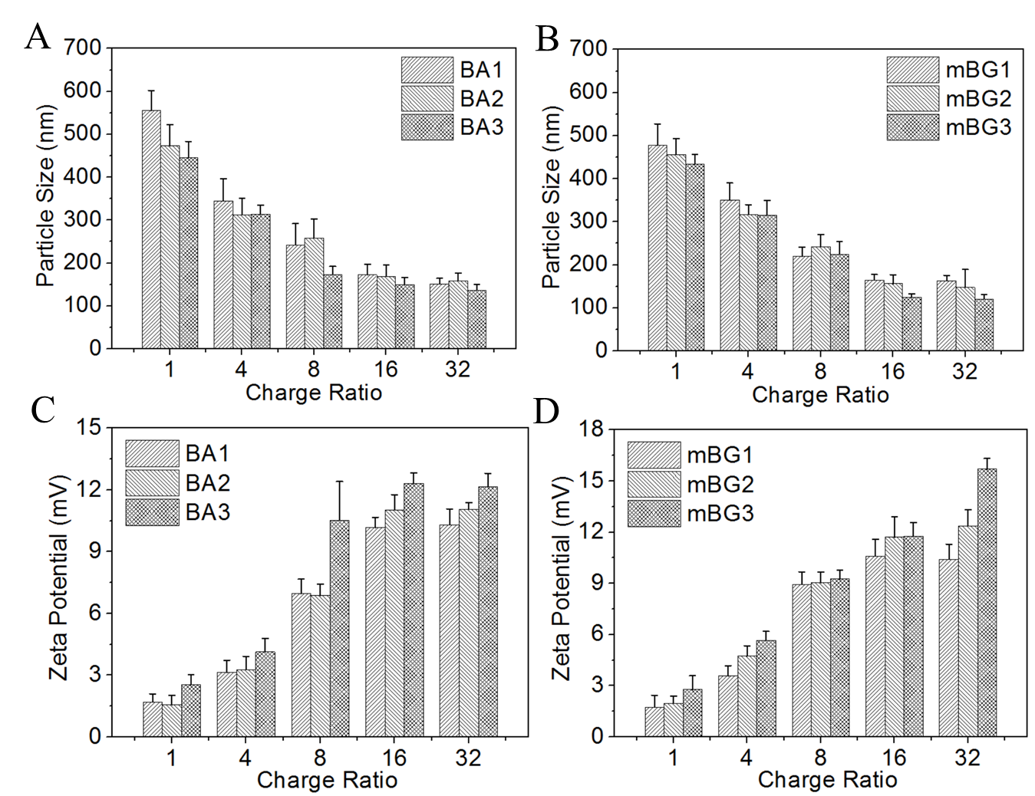
  - The average particle size and Zeta potential of mBG/pDNA polyplexes are 124 nanometers and +15.7 milliVolts, respectively, at an N/P ratio of 16 [1].
    - LAB MEDIA: Figure 3.
  - Electrophoretic retardation reveals that pDNA, with an N/P ratio of zero, can move without restraint in the agarose gel [1], and is observed as a stripe in the gel imager [2].
    - LAB MEDIA: Figure 4.
    - LAB MEDIA: Figure 4. Video Editor: Emphasize lane 0 through the entire figure.

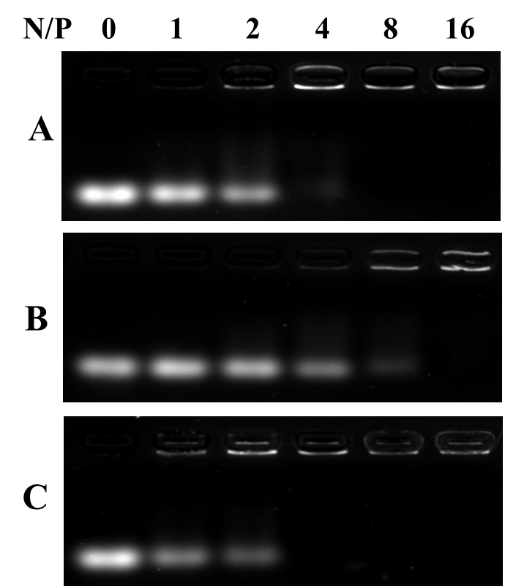
  - When pDNA is complexed with mBG, the movement of pDNA is retarded and subsequently, the brightness of the band is reduced [1]. This shows that mBG can completely complex the pDNA when N/P is higher than 4 [2].
    - LAB MEDIA: Figure 4.
    - LAB MEDIA: Figure 4. Video Editor: Emphasize lane 4 through the entire figure.
  - The cytotoxicity of the mBG/pDNA polyplexes is then measured using the standard MTT assay [1]. These results show that mBG/pDNA polyplexes have cytotoxicity than PEI/pDNA polyplexes at the N/P ratios of 4, 8, 16, and 32 [2].
    - LAB MEDIA: Figure 5.
    - LAB MEDIA: Figure 5. Video Editor: Emphasize the gray data columns (for mBG1, mBG2, and mBG3) in all four groups.

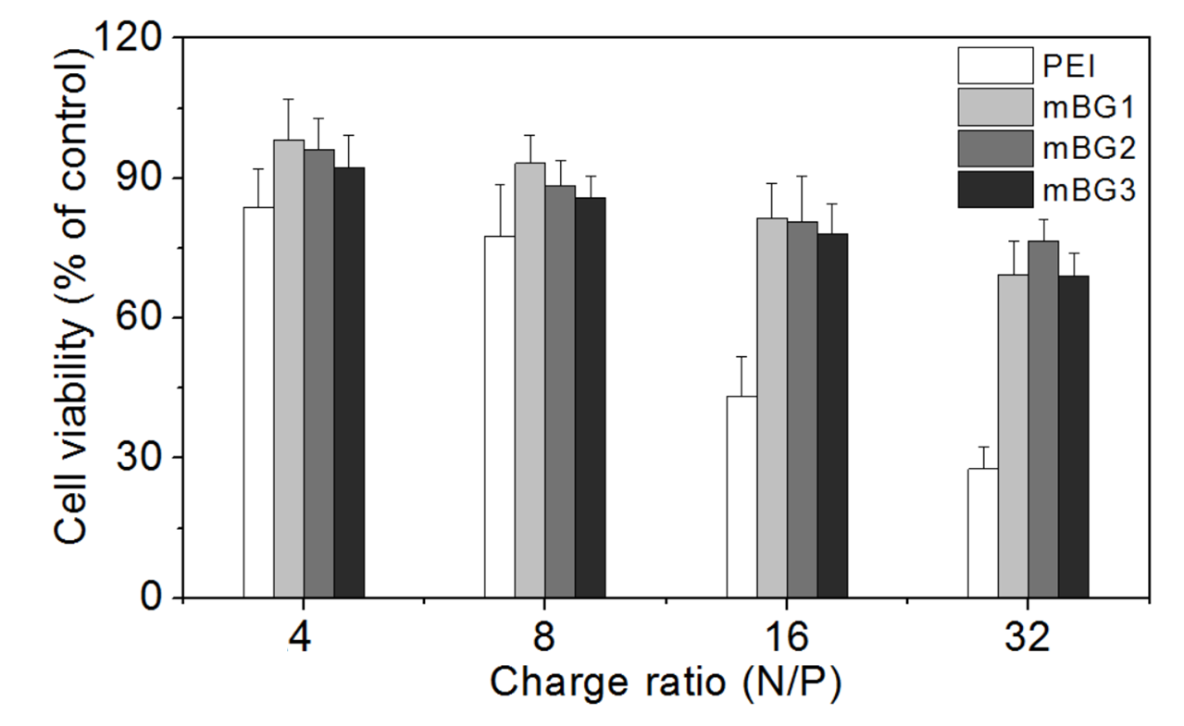
  - As can also be seen, the cytotoxicity of the mBG/pDNA polyplexes increases with increased N/P ratio. This increased cytotoxicity is a result of the positively charged GPMA component [1].
    - LAB MEDIA: Figure 5. Video Editor: Hold the emphasis from 5.5.2.
  - The N/P ratio used in the pDNA transfection experiment is selected according to the cytotoxicity results [1]. The transfection abilities of mBG1, mBG2, and mBG3 are compared by measuring the GFP fluorescence intensity and the results showed that mBG3 is the optimal gene carrier [2].
    - LAB MEDIA: Figure 6.
    - LAB MEDIA: Figure 6.

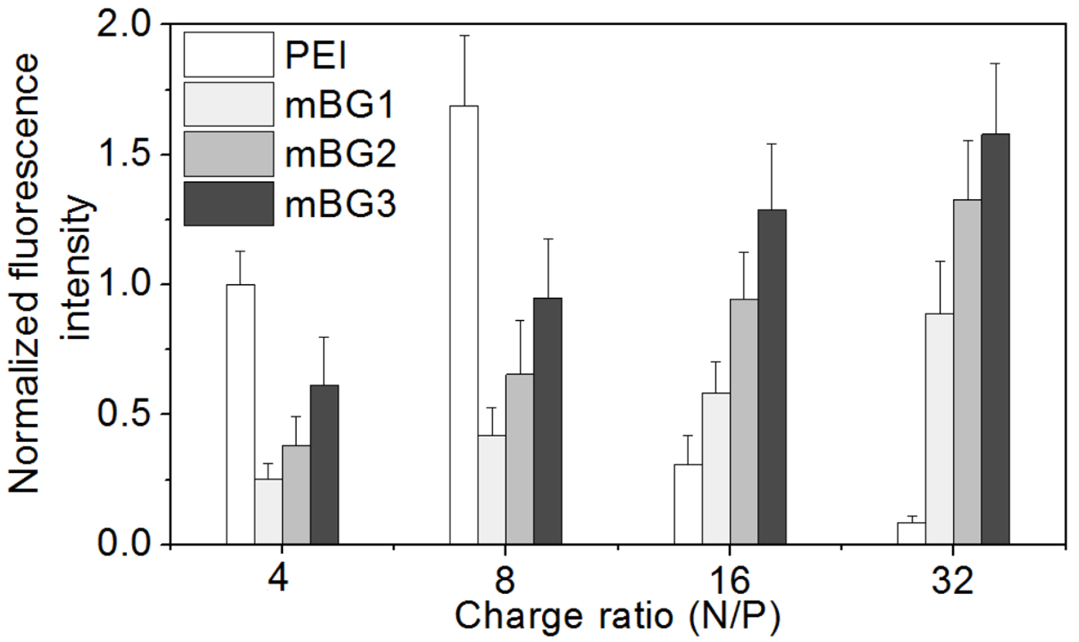

Section - Conclusion
- Conclusion Interview Statements: (Said by you on camera) - All interview statements may be edited for length and clarity.
  - Yang Wu: It is important to exhaust air form the sealed round-bottom flask and maintain the reaction temperature [1].
    - INTERVIEW: Named author says the statement above in an interview-style shot while looking slightly off-camera.
  - Yang Wu Wei Zhang: The obtained polymer drug carriers can be applied to the co-delivery of chemotherapy drugs and gene drugs to synergistically treat drug resistant cancer [1].
    - INTERVIEW: Named author says the statement above in an interview-style shot while looking slightly off-camera.
  - Li Ding: The molecular mechanism of combination of gene drugs and chemotherapeutic drugs can be further explored for the treatment of drug-resistant tumors [1].
    - INTERVIEW: Named author says the statement above in an interview-style shot while looking slightly off-camera.
  - Li Ding: Acetone is rated as low toxic for its acute toxicity, hence inhalation or contact with eyes or skin should be avoided. Avoid the risk of scalding during the heating procedure [1].
    - INTERVIEW: Named author says the statement above in an interview-style shot while looking slightly off-camera.

