Dear Author(s),
This document is divided into a number of sections in which you can add your comments to the video, voiceover, and online text/PDF. Please be aware that our policy is to do a single complimentary revision, so it is critical that all participants in this project offer their comments collectively. In addition, please make sure that your comments are easily interpreted and transparent.
Have fun!
Protocol Name: 58524 Combining Histochemical Staining and Image Analysis to Quantify Starch in the Ovary Primordia of Sweet Cherry During Winter Dormancy
Date: 28-02-2019

Authors and Affiliations
Please fill in any missing author information not included in the video.
Order | Author | Affiliation | Email

Video Comments
Please fill in any comments you wish to make using the table below using the example as a guide. If you need more space to write, please do so below the table. DO NOT ADD CORRECTIONS TO THE NARRATION HERE. PLEASE DO THIS IN THE AUDIO COMMENTS SECTION.
 | Time code | Comment | Requested Change
1. | 3:07 | Images shows the “filter holder” while the audio (4.1) indicates “the brightness control”. | Change the image that showed “the filter holder” (3:07) for the image of the adjustment of the brightness control. This was filmed just after the aperture diaphragm (picture below). (The red arrow shows the brightness control)  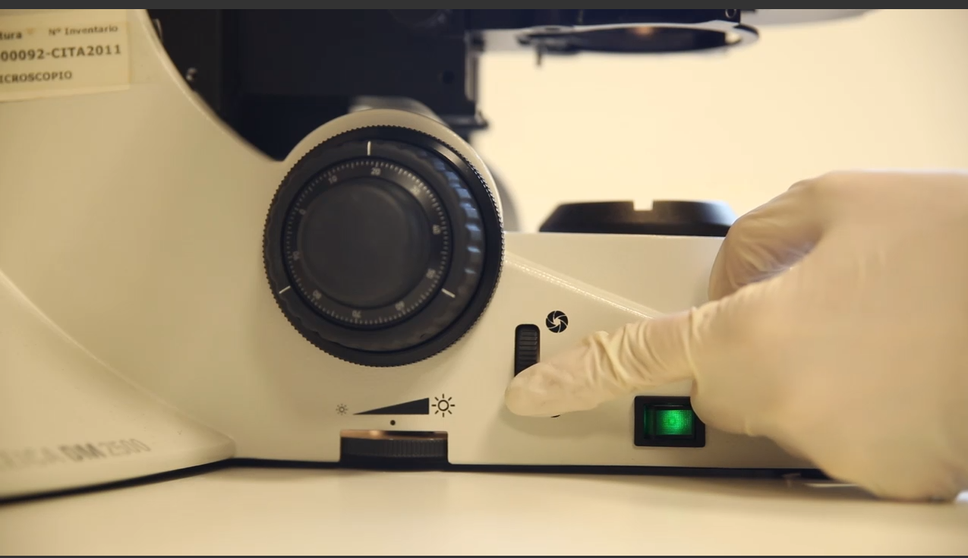
2. | 3:13 | Audio said “(4.1) Then, make sure there are no filters in the filter holder …” and this was not show. | This comment corresponded to the image showed at 3:07. (picture below)  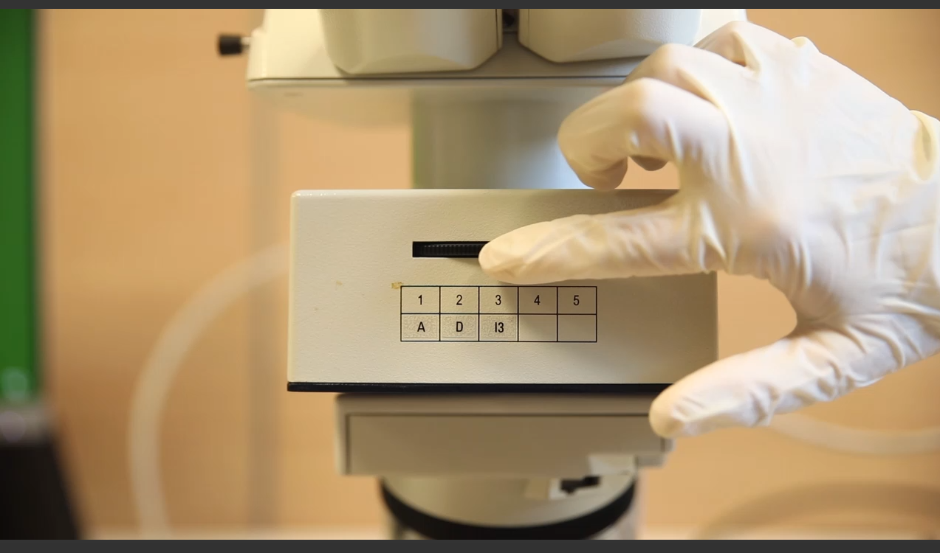
3. | 4:24 | The images do not correspond to the audio (4.7) | Remove the part of the square adjustment  And incorporate the images that show the setting of the three color thresholds (image below).  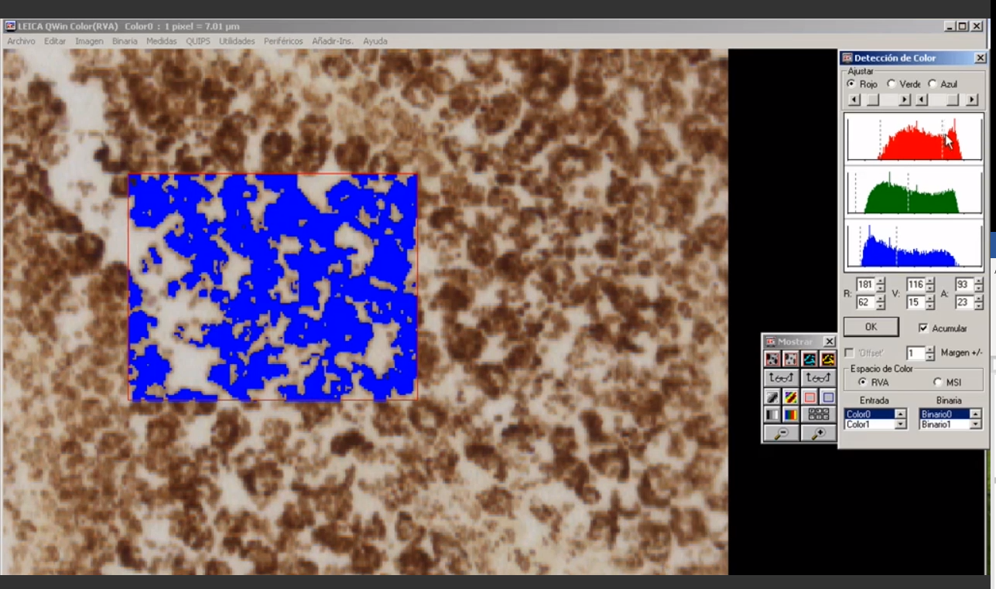

Audio Comments
This section is used to specify the changes that need to be made to the narration. Please follow the example below as a guide to list your changes. If there is a pronunciation change, please provide a phonetic pronunciation key.

 | Time code | Comment | Step(s) in Shotlist | Rewritten Text or Corrected Pronunciation (highlight in bold)
1. | 4:45 | Using the image analysis system, convert the original color image to a black and white image. Then, superimpose the binary image over the color image. Finally, measure the sum of the optical density of every pixel under the mask to quantify the starch content in the field | 4.8 | Using the image analysis system, measure the sum of the optical density of every pixel under the mask to quantify the starch content in the field.

Online Text/PDF Protocol
Please use this table to address changes that need to be made to the online text/PDF document. Both the online text and PDF are generated from the HTML template of your article. Since the PDF is generated from the HTML by our conversion software, it may contain formatting errors. For major structural changes or more than 10 spelling or grammatical mistakes, we will require re-upload of the entire document.

 | Protocol Step | Comment | Requested Change (highlight in bold)
Example | 1.1 | Step says “Centrifuge lysate at 2,000 x g.” | Please correct to “Centrifuge lysate at 4,000 x g.”
1.
2.
3.
4.
5.
6.
7.
8.
9.
10.
11.
12.

