Please add the following photo to either the beginning or the end of the video. Feel free to crop/adjust the photo.

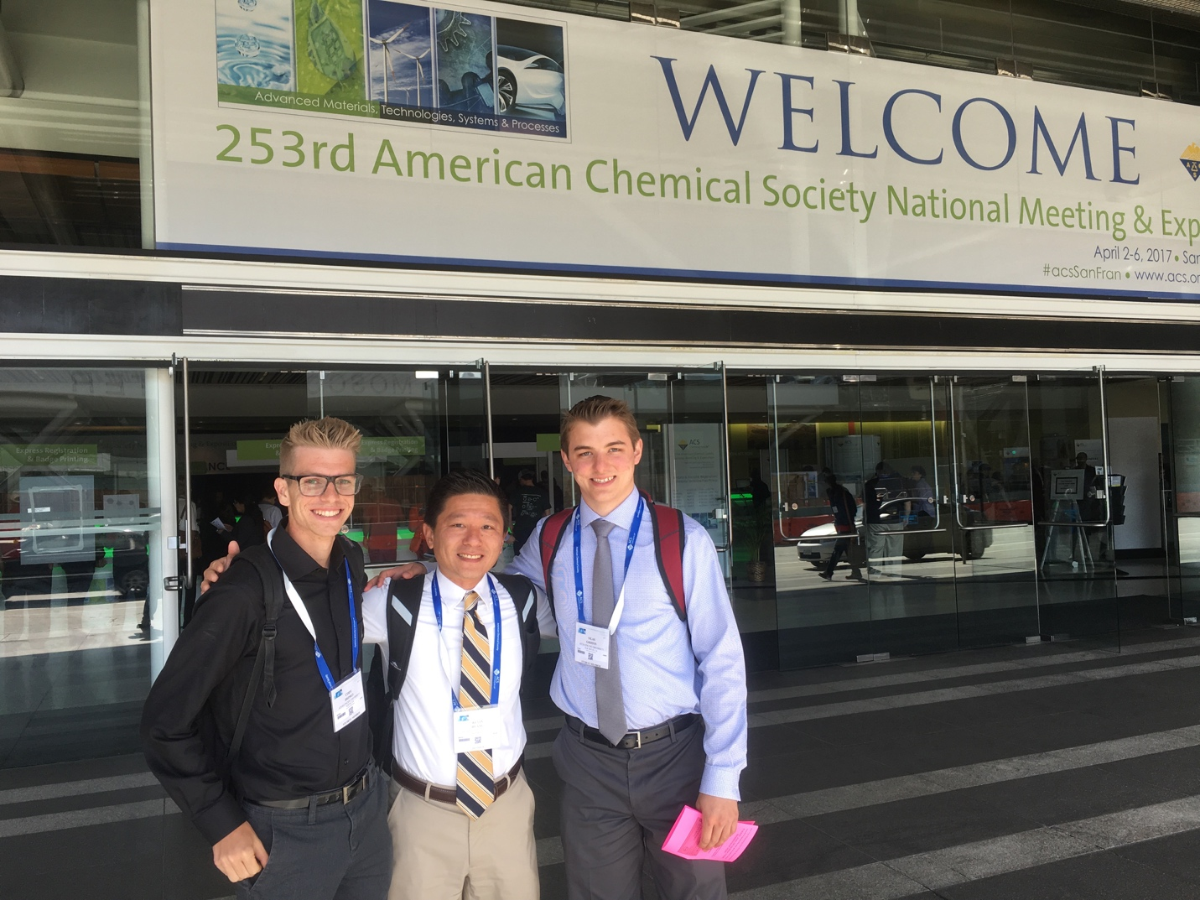
Narration: Authors (left to right) Cody Drisko, Dr. Kevin Huang and Silas Griffin conducted the experiments and prepared the manuscript. Cody Drisko is a John Stauffer Fellow and a recipient of the Gencarela Research Grant. Silas is a S2S Azusa Pacific University Research Fellow. Dr. Kevin Huang provided the research mentoring and is a recipient of the Azusa Pacific University Faculty Research Council Grant.

