Responses to Reviewer Comments
We appreciate the insightful suggestions from the reviewers. In the following, we provide detailed responses to every comment. The manuscript was revised accordingly, and the changes were tracked to facilitate review.

Reviewer #1
Manuscript Summary: The authors have written an interesting manuscript. They describe a novel method of assess chondrocyte viability in a native mouse knee. The model described has a detailed protocol to ensure readers could duplicate the dissection required for the model.
We thank the reviewer for these compliments.
The model appears to have restriction toward younger mice, and this may be a limitation. The authors provide only one method of assessing chondrocyte viability without other technique to confirm the observed data. Finally, the authors choose to load the posterior femoral condyles without a clear explanation why this anatomic location has been chosen.

Major Concerns
1) The authors provide no other means of assessing chondrocyte viability other than Live / Dead staining and confocal microscopy assessment. Why not use other methods of assess viability to validate the model? Why should the reader accept this limited validation of the model?
We thank the reviewer for this important comment and apologize for not addressing this issue in the original manuscript. In fact, we considered several different alternatives to live/dead staining to assess cell viability and validate our model. However, we determined that none of these methods is able to capture the key outcome parameter of interest in our testing platform: the spatial extent of in situ cell injury/death on the surface of articular cartilage due to mechanical loading.
For example, in one class of alternative cell viability assessment techniques, histological evaluation of in situ chondrocytes is required. With some of these methods, the total number of nuclei (as assessed through analysis of H&E- or DAPI-stained sections) are counted as a surrogate measure of cell loss. However, while this approach is useful for quantifying long-term cell loss in the context of tissue degeneration, it cannot differentiate between viable and non-viable cells in the immediate aftermath of an injury (before the nuclei are cleared from the tissue). Another histological cell viability assessment technique – the TUNEL assay – is not appropriate for validation of our methodology, as it is only able to identify cells that die through apoptosis (whereas we anticipate that necrosis dominates immediate mechanically induced cell death). Finally, it is important to note that even if a suitable histological cell viability assessment technique were identified, capturing the spatial extent of cell injury on the articular surface (the key outcome parameter of interest in our testing platform) would require time-consuming serial sectioning of paraffin-embedded specimens¹.
In another class of alternative cell viability assessment techniques, cell suspensions are required²⁻⁵. However, since murine articular cartilage is very small in size (e.g., articular surface width on femoral condyle < 1.5 mm, thickness < 50 μm), isolating cells from this tissue – especially in a specific region of interest (i.e., surrounding the site of injury) – is highly challenging. Moreover, isolating chondrocytes requires shaving cartilage from a joint, and the act of shaving itself could lead to additional cell injury/death that could confound results. Finally, most cell suspension-based methods (except those that work through the same principle as propidium iodide, one of the stains used in our study) only detect live cells, and thus require comparison to a control group for quantification of cell death. However, since these techniques generally have large coefficients of variation (e.g., 9.72% for the MTT assay⁶, corresponding to approximately 1000 cells for a suspension of 10,000 cells), they cannot detect the small numbers of injured/dead cells induced by some loading regimens that can be easily quantified by live/dead staining. For instance, according to our findings, statically applied loading magnitudes of 0.1 N, 0.5 N and 1 N induce injury/death of just 3, 107 and 197 articular chondrocytes, respectively.
To avoid the limitations of cell suspensions, we did attempt to perform an alternative viability assay designed for cell suspensions but applied to the cartilage-on-bone explants used in our testing platform. In particular, we attempted to develop a tissue-based Alamar Blue assay. Alamar Blue is a resazurin reduction assay in which enzymatic activity of a cell is measured as a proxy for viable cells. In particular, viable cells reduce non-fluorescent resazurin to fluorescent resorufin. We followed a staining protocol used for the assessment of isolated mammalian cell cytotoxicity⁷. Briefly, after application of injurious loading, the dissected specimens were incubated in 10% of Alamar Blue at 37 ºC for 4 h and 17 h later followed by 2 h wash in HBSS (pH 7.4, 303 mOsm). The specimens were imaged under fluorescent illumination at 560 nm excitation and 590 nm emission wavelengths. We hoped to observe bright fluorescence in viable cells, since metabolically active cells increase fluorescence by reduction of resazurin to resorufin. Unfortunately, since resorufin is membrane permeable and can escape to the extracellular matrix, it was nearly impossible to distinguish metabolically active cells from the surrounding ECM and surrounding non-viable cells. In other words, the entire specimen exhibited strong fluorescence, inhibiting our ability to detect live cells.
Although we were unable to provide an alternative validation for our live/dead staining-based quantification of cell injury/death, we have performed additional experiments to more rigorously investigate and quantify the limitations of live/dead staining. Presumably, the primary weakness of permeability stains like PI and calcein AM lies in the potential detection of false PI-positive and false calcein-negative cells due to their mechanism of action. For example, consider calcein AM, a molecule that is membrane permeant and non-fluorescent until it is cleaved by intracellular esterases and becomes membrane impermeant and fluorescent. The fluorescent form of this molecule (calcein) remains within the cell while the membrane is intact; hence, calcein-positive cells are considered to be viable. However, if the membrane is only temporarily permeabilized (i.e., damaged prior to repair/resealing), a viable cell could appear calcein-negative. Similarly, consider PI is a membrane-impermeant molecule that is only able to diffuse into the cell and bind DNA if the membrane is not intact. A PI-positive cell is considered to have a ruptured membrane and be dead. However, if the membrane is only temporarily permeabilized (i.e., damaged prior to repair/resealing), a viable cell could appear PI-positive.
To investigate whether these limitations could be affecting our findings, we have conducted a pilot study (n=5) in which we longitudinally analyzed injury of in situ chondrocytes on femoral condyles immediately and 3 h after mechanical tests (0.5 N statically applied over 5 min) with calcein AM re-staining applied 2.5 h after the injury. The time scale of membrane repair is approximately 5 min⁸; thus, we presume that 2.5-3 h provides sufficient time to quantify the number of false PI-positive and false calcein-negative cells (i.e., the number of cells whose membrane was permeabilized only temporarily prior to repair/resealing). We found that the area of injured cells recovered by only 5.25% (approximately 22 cells per specimen) over the course of 180 min following the mechanical trauma (Figure R1). It is worth noting that cells in which the plasma membrane appeared to be repaired became both PI and calcein positive, a finding that is consistent with the mechanism of action of both permeability dyes.
Despite the absence of an alternative validation of our live/dead staining-based quantification of cell injury/death, these additional experiments (which are now described in the Supplementary Material section of the manuscript) suggest that in our system, live/dead staining (i.e., the use of permeability dyes) provides a reasonably accurate indication of cell viability, overestimating true viability by just 5%. Nevertheless, we have decided to alter the title and text to reflect that live/dead staining is a direct measure of membrane integrity that is not always indicative of cell viability. In particular, we define PI-positive and calcein-negative cells as “injured”, where injury (and not necessarily cell death) is defined as a (potentially temporary) loss of plasma membrane integrity due to mechanical trauma.
The title now reads as “Real-time Visualization and Analysis of Chondrocyte Injury Due to Mechanical Loading in Fully Intact Murine Cartilage Explants”.
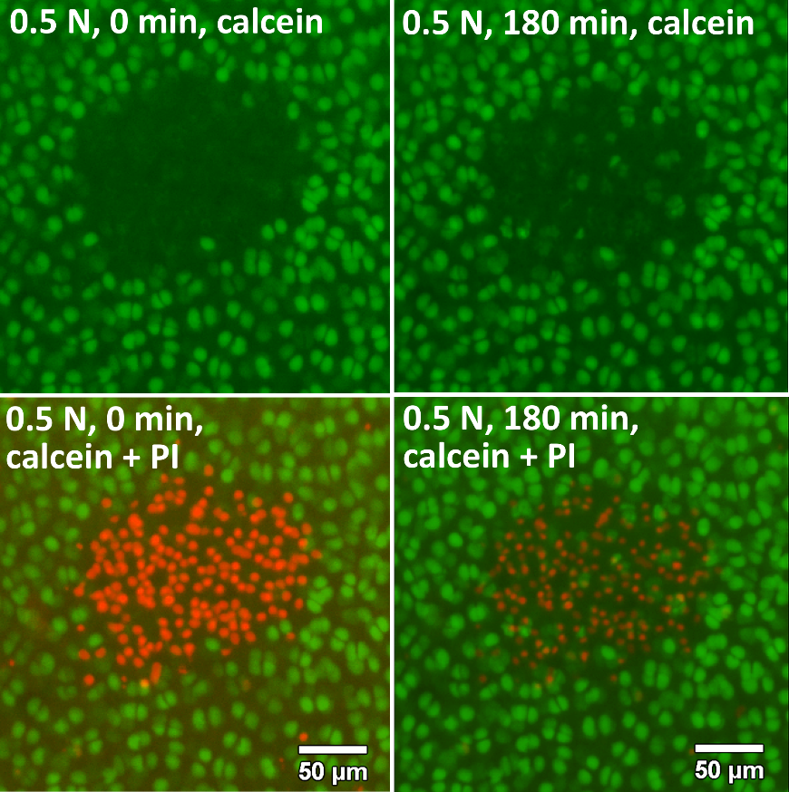
Figure R1 (Figure S2 in Supplemental Materials) (a) Representative micrographs of in situ articular chondrocytes on a medial femoral condyle obtained at 0 min (left) and at 180 min (right) after the application of mechanical loading (0.5 N static loading for 5 min). Green calcein fluorescence and the absence of red fluorescence indicate articular chondrocytes with intact plasma membranes; red PI fluorescence and the absence of green fluorescence indicate cells with compromised cell membrane integrity. The area/number of cells that gain calcein fluorescence within the 180 min time interval following mechanical trauma indicates the area/number of cells that exhibited membrane repair. Note that overall PI intensity has decreased over the 180 min time period, presumably due to photobleaching. (b) Area of injured cells (n=5) measured immediately (blue circles) and 180 min (green squares) after mechanical loading. Although the reduction in area of injured cells was significant, only approximately 5.25% of cells exhibited membrane repair. * denotes significance at α=0.05.

2) The authors describe a design of the impactor and confocal microscopy stage, but how they work together is unclear. The baseplate where loading occurs is a glass slide for microscopy - does the glass ever break with physiologically relevant loads?

We apologize for omitting these important details in our description of the mechanical testing platform. The impactor stage is built onto the stage plate of an inverted microscope (which may be either a standard epifluorescence microscope or a confocal laser scanning microscope). The glass slide (where the specimen is placed) sits on top of a stainless-steel plate screwed into the bottom of the base of the device. The center of the plate has a small pinhole (positioned below the location on the glass where specimen is placed) that serves as a viewing window for the inverted epifluorescence microscope. The pinhole/viewing window is sufficiently small that the glass resists bending and does not break under the loading conditions applied in this study (for both physiological and supraphysiological loading conditions).

We have added a paragraph describing these details to the supplementary material.

Minor Concerns:
3) The loads chosen - the authors report applied impact loads. Have the authors calculated the likely articular loads that occur with the model. Again, are these physiologically relevant?
We apologize for not clarifying the physiological relevance of the loads chosen for this study. For our studies using cartilage-on-femur explants, the load distribution on the medial and lateral condyles was measured previously⁹. In this study, we found that both the medial and lateral femoral condyles experience approximately 40% of the total applied load (with the contact point between the glass and femoral diaphysis taking up the remainder of the load). To our knowledge, the physiological loads on the cartilage of each compartment of the mouse knee have not been rigorously assessed. It has been shown that an axial load of approximated 9 N applied to the mouse tibia leads to bone strains similar to those induced during locomotion¹⁰. However, the axial load on the tibia is not equivalent to the load experienced by knee articular cartilage in vivo due to the complex geometry of the knee and the possible contributions of active muscles and passive surrounding tissues (e.g., the menisci). Nevertheless, we can determine the physiological relevance of each loading condition in our study by considering the strains induced in the tissue using our platform and comparing with physiological strains in the human knee reported in the literature (assuming physiological strains in articular cartilage are roughly conserved across species). For total applied loads of 0.1 N, we have previously measured peak compressive strains of 20.7% and 34% on the medial and lateral femoral condyles (data not shown). These strains are comparable to the reported strains of 39% observed in articular cartilage on the tibial plateau in human subjects after 30 min of standing¹¹. Similarly, in unpublished studies, we have found that for a total applied load of 0.1 N on the murine humeral head, the peak strain is 31.6% (data not shown). Previous studies have reported peak strains of 22% 9 min after push-up exercises¹². During this waiting and imaging time (9 min), cartilage may have recovered its thickness, potentially resulting in an underestimate of peak strain during or immediately after exercise. Taken together, these finding suggest that the strains induced by 0.1N loading in our study lie within the upper limit of physiologically relevant strains. We consider higher magnitudes of static loading (0.5N and 1N) to be supraphysiological, since the peak strains surpass physiological levels and induce significant cell injury.
Unfortunately, confocal microscopy is not fast enough to capture tissue strains during impact experiments. However, we have performed additional studies to determine peak forces during these tests. Using a custom strain gauge apparatus, the peak impact forces were found to be higher than the statically applied forces. For example, a 1 mJ impact intensity induced a peak load of 8.3 N (data not shown). It is difficult to assess whether these forces lie within physiological limits in the absence of rigorous analyses of mouse joint mechanics during ambulation. We speculate that the impact-induced forces in this study are supraphysiological, given that substantial cell injury is induced in all experimental groups. However, it is important to note that impacts across a wide range of intensities (e.g., low intensity impact during ambulation and high intensity impacts during vehicle accidents) are clinically relevant.
The physiological relevance of the chosen loading conditions is now discussed in the Supplementary Material.

4) The authors discuss a limitation of the model is that mice used are very young. Older mice have "limited viability" with the harvest techniques. Why not load the joint axially or flip specimen 180 degrees to load anteriorly? Either of these techniques might be considered more realistic for day to day loading of a mouse knee. Will this solve this age problem? Many reports now suggest older joint behave very differently than young joints. This issue may be a limit in using the model more broadly.
We thank the reviewer for this useful feedback and helpful suggestion. It would be interesting to load the specimens from different angles; furthermore, doing so is feasible with our testing platform. This is now noted in the manuscript. However, in our representative data set, we decided to focus on a single location (the posterior femur) of high physiological relevance. Unlike the human, the mouse, as a quadruped, rarely stands on its hind limbs (such that its joint is loaded axially). During weight bearing, the mouse knee is usually flexed, resulting in contact between the tibia and posterior femur (Figure R2).

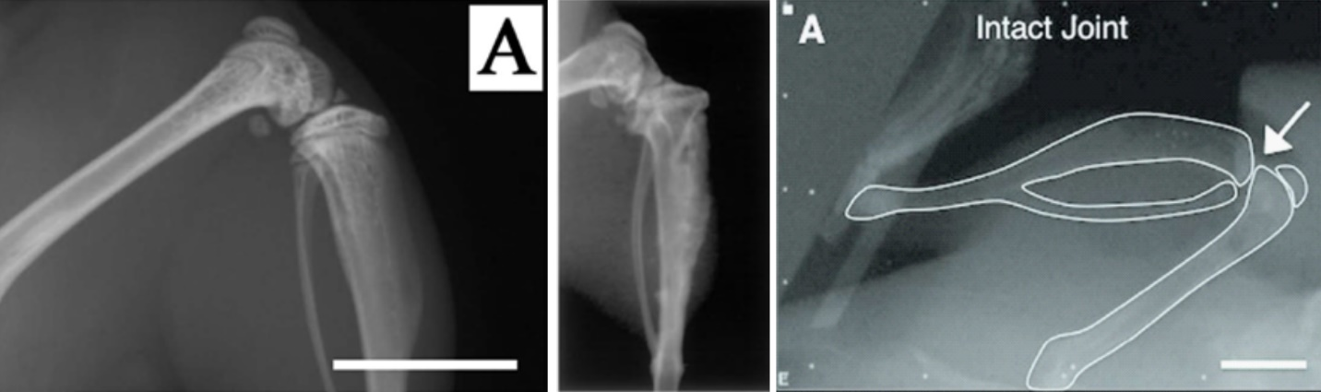
Figure R2 X-ray images of a murine knee joint adopted from (a) Yamawaki et al.¹³, (b) McGary et al.¹⁴, and (c) Adebayo et al.¹⁰. While x-ray images in (a) and (b) were taken to assess efficacy of a therapeutic drug, the x-ray image from (c) was used for analyses of knee kinematics recapitulating physiological loading of the tibia. White arrow indicates articular surface. All the images demonstrate that when the mouse knee is flexed, the primary point of contact between the tibia and the femur occurs at the posterior femoral condyles.
a
b
c

Regarding the applicability of our technique to older mice, through more careful dissections, we have recently overcome the limitation of reduced cell viability after dissecting aged mice (81 weeks old C57BL/6 mice). However, due to noticeable alterations in cell density in these mice, it is challenging though feasible (success rate = 40%) to assess load-induced cell injury in older femurs. In contrast, we did not notice alterations in cell density in articular cartilage on the humeral head of aged mice. Thus, we have been able to successfully apply our technique to the cartilage-on-humerus specimens from 81 week old (equivalent to the age of 65 years in a human) mice (Figure R3).

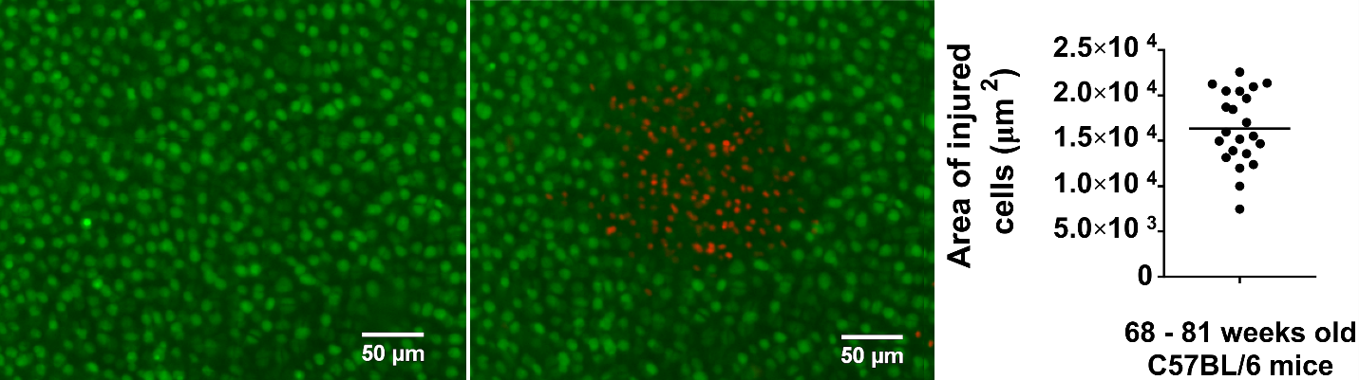
We adjusted the text in the limitation paragraph of the discussion to reflect these new observations and added these data to the Supplementary Material.
a
b
c

Figure R3 (Figure S3 in Supplementary Materials) Representative micrographs of in situ chondrocytes on the humeral head articular surface of an 81 week old male C57BL/6 mouse (a) at baseline and (b) after statically applied mechanical loading of 0.5 N for 5 min. Green calcein fluorescence and the absence of red fluorescence indicate viable articular chondrocytes; red PI fluorescence and the absence of green fluorescence indicate injured/dead cells. (c) Area of injured cells, induced by 0.5 N statically applied for 5 min, quantified for specimens obtained from 68 – 81 weeks old C57BL/6 mice. Each data point represents a test on a different specimen and the mean value is indicated by horizontal bar.

Reviewer #2:
Manuscript Summary: In this manuscript, the authors presented a new method for studying controlled loading-induced cell death of intact murine femoral condyle and head joints. This is a very interesting method. In particular, this method offers a new method for understanding PTOA mechanisms in various genetic mice, and thus, has potentially transformative impact for studying PTOA. This paper is very well written, and detailed method steps are clearly presented. It can be published in the current form.
We thank the reviewer for these compliments.

Major Concerns:
No major concerns.
Minor Concerns:
There are some very minor points that may need clarification:
1) Page 5, line 138: "2.2.11) Remove the menisci…" Why would the menisci be a concern here? Menisci are attached on the tibia bone.
We thank the reviewer for this comment. We have removed this text from the manuscript, which now no longer refers to the meniscus. Instead, we emphasize removal of surrounding soft tissues (i.e., ligaments) from the femur to expose the articular surface.
2) For biological studies, is there any issue with potential contamination from bone marrow during the dissection and calcium imaging?
This is an interesting question. Although it is conceivable that contamination from bone marrow could occur, we have never observed evidence of isolated cells in our fluorescence images of the femoral and humeral articular surfaces. Thus, we do not believe that bone marrow cells have affected our representative findings. Nevertheless, we agree that it would be wise to take extra care to avoid this potential complication. Thus, the script was changed to read “after cutting the bone, wipe away any visible marrow on the outside of the bone to avoid possible contamination from bone marrow cells”.
3) The representative data were obtained on 8-10 week old mice. What is the range of mouse age that this method is applicable to?
We thank the reviewer for this useful comment. As described in our response to Reviewer 1, through more careful dissections, we have recently overcome the limitation of reduced cell viability after dissecting aged mice (81 weeks old C57BL/6 mice). However, due to noticeable alterations in cell density in these mice, it is feasible (though more challenging) to assess load-induced cell injury in older femurs. In contrast, we did not notice alterations in cell density in articular cartilage on the humeral head of aged mice. Thus, we have been able to successfully apply our technique to the cartilage-on-humerus specimens from 81 week old (equivalent to the age of 65 years in a human) mice (Figure R3). Though we have not attempted these studies with mice older than 81 weeks or younger than 8 weeks, it is conceivable that there is an upper (and lower) age limit after which our technique no longer works. Nevertheless, we can safely state that our testing platform is useful for ages between 8 and 81 weeks. These details have been added to the manuscript and to the Supplementary Material (Figure R3).

Reviewer #3:
Manuscript Summary: Overall the manuscript is well written, easy to follow and of interest to others in the field
We thank the reviewer for these compliments.
Minor Concerns:
3.1.3 why centrifuge and vortex. Is vortexing not suffient? explanation here might be useful as it is not clear why this step should be treated in this way - other steps have explanations.
We apologize for not including the explanation of why we suggest both centrifugation and vortexing. When placing 1.25 μL of calcein AM stain into the microfuge tube containing 500 μL of HBSS, the dye may occasionally stick on the walls of the tube. Centrifugation ensures that all of the calcein AM dye mixes with the buffer. After centrifugation, we vortex to ensure proper mixing. The manuscript has been modified to clarify this rationale.
4.3 is there a need to do PI staining at this time to assess integity of tissue before mechanical testing? how do you know that the tissue is not damaged during dissection, or that the animal has some degree of cartilage damage? in the past I have found visibly normal tissue looks different once stained up and under miscroscope.
We thank the reviewer for this useful comment and observation. Our strategy to analyze the initial integrity of the tissue is through calcein AM straining, such that if there is initial damage, areas with obvious “gaps” in calcein-positive cells should be visible. That is, in every specimen, an initial fluorescence micrograph is acquired after calcein AM staining. The reviewer suggests an alternative method of analyzing the integrity of the tissue through PI staining before mechanical testing. To compare this approach to our own, we performed an experiment where a cartilage-on-femur specimen obtained from a 10 week old Balb/c female mouse was stained with both calcein AM and PI prior to mechanical testing (1N applied for 5 min) (Figure R4). At baseline, we observed a uniform distribution (without noticeable gaps) of calcein positive cells on the femoral condyles (Figure R4, left) and negligible numbers of randomly distributed PI-positive cells. In contrast, after mechanical testing, a clear and localized area of cells that lost calcein fluorescence and gained PI fluorescence was observed on both femoral condyles (Figure R4, right). This pilot study suggests that it is not necessary to stain cells with PI before an experiment. However, doing so provides a more rigorous confirmation that dissection-associated damage did not occur, and may be advisable – especially when the researcher is becoming acquainted with the dissection procedure. Hence, we have added PI staining prior to loading as an alternative approach in the protocol.
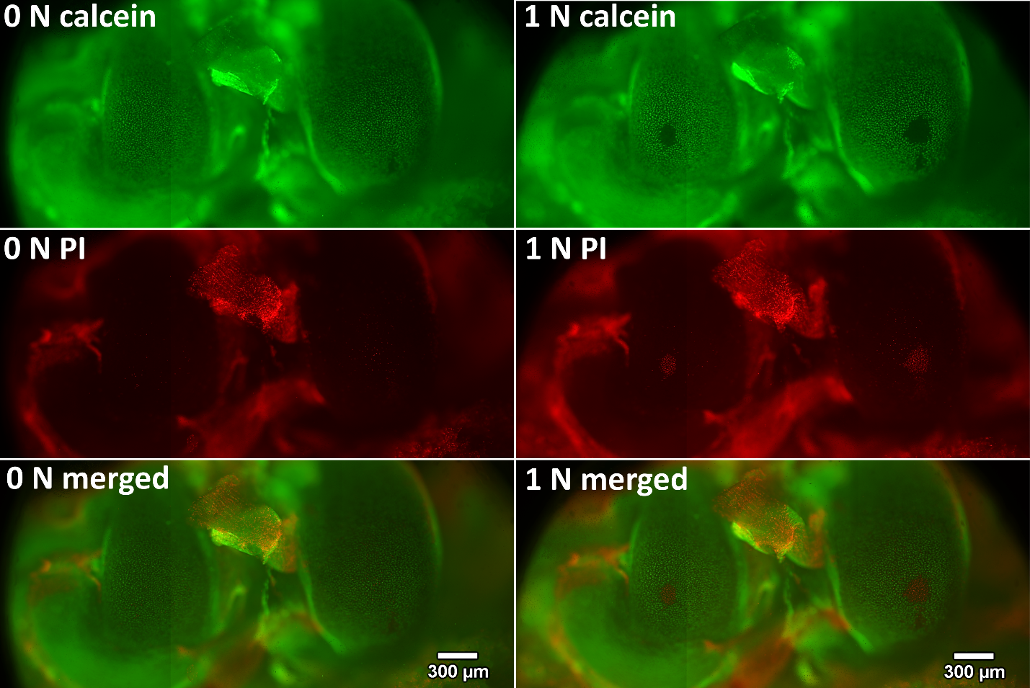
Figure R4 (Figure S1 in Supplementary Materials) Representative micrographs of in situ femoral condyle articular chondrocytes obtained at baseline (left) and after the application of mechanical loading (1 N for 5 min, right). Green calcein fluorescence and the absence of red fluorescence indicate viable articular chondrocytes; red PI fluorescence and absence of green fluorescence indicate injured articular chondrocytes. These figures suggest that cell death patterns indicated by PI and calcein staining are consistent.

Line 299 Is the size of the injured area in comparison to the whole tissues physiologically relevant, or just the fact that the whole issue is the test environment being exposed in small areas to physiological loads - the text does not explictly state this in my opinion, and would benefit from this clarification - I am not sure this is replicating a physiological environment, but is likely to be more relevant than existing protocols.

We thank the reviewer for this useful feedback. As describe in our response to Reviewer 1, we can determine the physiological relevance of each loading condition in our study by considering the strains induced in the tissue using our platform and comparing with physiological strains in the human knee reported in the literature (assuming physiological strains in articular cartilage are roughly conserved across species). For total applied loads of 0.1 N, we have previously measured peak compressive strains of 20.7% and 34% on the medial and lateral femoral condyles (data not shown). These strains are comparable to the reported strains of 39% observed in articular cartilage on the tibial plateau in human subjects after 30 min of standing¹¹. Similarly, in unpublished studies, we have found that for a total applied load of 0.1 N on the murine humeral head, the peak strain is 31.6% (data not shown). Previous studies have reported peak strains of 22% 9 min after push-up exercises¹². During this waiting and imaging time (9 min), cartilage may have recovered its thickness, potentially resulting in an underestimate of peak strain during or immediately after exercise. Taken together, these finding suggest that the strains induced by 0.1N loading in our study lie within the upper limit of physiologically relevant strains. We consider higher magnitudes of static loading (0.5N and 1N) to be supraphysiological, since the peak strains surpass physiological levels and induce significant cell injury.
Unfortunately, confocal microscopy is not fast enough to capture tissue strains during impact experiments. However, we have performed additional studies to determine peak forces during these tests. Using a custom strain gauge apparatus, the peak impact forces were found to be higher than the statically applied forces. For example, a 1 mJ impact intensity induced a peak load of 8.3 N (data not shown). It is difficult to assess whether these forces lie within physiological limits in the absence of rigorous analyses of mouse joint mechanics during ambulation. We speculate that the impact-induced forces in this study are supraphysiological, given that substantial cell injury is induced in all experimental groups. However, it is important to note that impacts across a wide range of intensities (e.g., low intensity impact during ambulation and high intensity impacts during vehicle accidents) are clinically relevant.

References
1 David, M. A. et al. Early, focal changes in cartilage cellularity and structure following surgically induced meniscal destabilization in the mouse. Journal of Orthopaedic Research. 35 (3), 537-547, doi:10.1002/jor.23443, (2017).
2 Prabst, K., Engelhardt, H., Ringgeler, S. & Hubner, H. Basic Colorimetric Proliferation Assays: MTT, WST, and Resazurin. Cell Viability Assays: Methods and Protocols. 1601 1-17, doi:10.1007/978-1-4939-6960-9_1, (2017).
3 Riss, T. L. et al. in Assay Guidance Manual eds G. S. Sittampalam et al.) (2004).
4 Repetto, G., del Peso, A. & Zurita, J. L. Neutral red uptake assay for the estimation of cell viability/cytotoxicity. Nature Protocols. 3 (7), 1125-1131, doi:10.1038/nprot.2008.75, (2008).
5 Smolina, N., Bruton, J., Kostareva, A. & Sejersen, T. Assaying Mitochondrial Respiration as an Indicator of Cellular Metabolism and Fitness. Methods in Molecular Biology. 1601 79-87, doi:10.1007/978-1-4939-6960-9_7, (2017).
6 Petty, R. D., Sutherland, L. A., Hunter, E. M. & Cree, I. A. Comparison of MTT and ATP-based assays for the measurement of viable cell number. Journal of Bioluminescence and Chemiluminescence. 10 (1), 29-34, doi:10.1002/bio.1170100105, (1995).
7 O'Brien, J., Wilson, I., Orton, T. & Pognan, F. Investigation of the Alamar Blue (resazurin) fluorescent dye for the assessment of mammalian cell cytotoxicity. European Journal of Biochemistry. 267 (17), 5421-5426 (2000).
8 McNeil, P. L. & Kirchhausen, T. An emergency response team for membrane repair. Nature Reviews Molecular Cell Biology. 6 (6), 499-505, doi:10.1038/nrm1665, (2005).
9 Kotelsky, A., Woo, C. W., Delgadillo, L. F., Richards, M. S. & Buckley, M. R. An Alternative Method to Characterize the Quasi-Static, Nonlinear Material Properties of Murine Articular Cartilage. Journal of Biomechanical Engineering. 140 (1), doi:10.1115/1.4038147, (2018).
10 Adebayo, O. O. et al. Kinematics of meniscal- and ACL-transected mouse knees during controlled tibial compressive loading captured using roentgen stereophotogrammetry. Journal of Orthopaedic Research. 35 (2), 353-360, doi:10.1002/jor.23285, (2017).
11 Halonen, K. S. et al. Deformation of articular cartilage during static loading of a knee joint--experimental and finite element analysis. Journal of Biomechanics. 47 (10), 2467-2474, doi:10.1016/j.jbiomech.2014.04.013, (2014).
12 Zhang, H. et al. In Vivo Assessment of Exercise-Induced Glenohumeral Cartilage Strain. Orthopaedic Journal of Sports Medicine. 6 (7), 2325967118784518, doi:10.1177/2325967118784518, (2018).
13 Yamawaki, K. et al. The soluble form of BMPRIB is a novel therapeutic candidate for treating bone related disorders. Scientific Reports. 6 18849, doi:10.1038/srep18849, (2016).
14 McGary, E. C. et al. Inhibition of platelet-derived growth factor-mediated proliferation of osteosarcoma cells by the novel tyrosine kinase inhibitor STI571. Clinical Cancer Research. 8 (11), 3584-3591 (2002).

