

July 13, 2018

Bing Wu, Ph.D.
Review Editor
JoVE

Dear Dr. Wu,

This letter accompanies our revised manuscript, “Immunization of Alpacas (Lama pacos) with protein antigens and production of antigen-specific single domain antibodies”. We have addressed all of the editorial points raised, please see specific responses to each point below.
We appreciate the opportunity to submit this revised manuscript, please contact me at any time if there are any questions or concerns.

Sincerely,

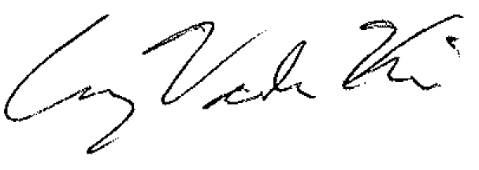
Craig Vander Kooi, Ph.D.
Associate Professor
Department of Cellular and Molecular Biochemistry
University of Kentucky
1-859-323-8418
craig.vanderkooi@uky.edu

1. Please take this opportunity to thoroughly proofread the manuscript to ensure that there are no spelling or grammar issues.

We have proofread the manuscript again.
2. Please adjust the numbering of the Protocol to follow the JoVE Instructions for Authors. For example, 1 should be followed by 1.1 and then 1.1.1 and 1.1.2 if necessary. Please refrain from using bullets or dashes.

We have adjusted the numbering as requested.
3. Please do not highlight notes for filming.

The highlighting was removed.
4. Please revise the text in Protocol to avoid the use of any personal pronouns (e.g., "we", "you", "our" etc.).

We have eliminated all personal pronouns.
5. Line 180-182: Please ensure that all text is written in imperative tense.

Done
6. Line 194: Please write this step in imperative tense.

Done
7. Line 210: Please split this step into two or more steps.

We have split this into two steps, one for the analytical and one for the production bleed.
8. Line 232: Please write this step in imperative tense.

Done
9. Line 338: Please write this step in imperative tense.

Done
10. Line 347: Please write this step in imperative tense.

Done
11. Line 357: Please write this step in imperative tense.

Done
12. Please do not abbreviate journal titles for all references.

Done
13. Please sign the new Author License Agreement, which is attached to this email. Please upload it to your Editorial Manager account when you submit your revision.

Done

