SUPPLEMENTAL MATERIAL

- Evaluation of TMA, TMAO and indoxyl sulfide concentration using liquid chromatography coupled with triple-quadrupole mass spectrometry.

Chemicals
Following chemicals were used: LC-MS grade - acetonitrile, 25% ammonium hydroxide and formic acid, HPLC gradient grade Acetone, trimethylamine N-oxide dihydrate (TMAO), trimethylamine hydrochloride (TMA), indoxyl sulfate potassium salt, trimethylamine-¹³C₃, ¹⁵N hydrochloride (TMA-¹³C₃, ¹⁵N IS for TMA), indoxyl-4,5,6,7-D₄ sulfate potassium salt (IS for indoxyl sulfate). Trimethylamine N-oxide D₉ (TMAO-D₉ IS for TMAO) solution was prepared in methanol and stored at -20º C. Ultra-pure water was obtained from water purification system.

Sample praparation
Sample preparation was performed as follows: 10 μL of sample (plasma, urine, stool extract, calibrators) was transferred into 1.5mL test tube, then 100 μL of acetone containing internal standards was added for protein precipitation and analytes extraction. After the mixture was vortexed and centrifuged. A 10 μL of aliquot was injected into apparatus.

Analyzes
The instrumentation consisted of a Waters Acquity Ultra Performance Liquid Chromatograph coupled with Waters TQ-S triple-quadrupole mass spectrometer. For the instrument control and data acquisition Waters MassLynx software was used. Waters TargetLynx was used to processed data.
Chromatographic separation was performed using a Waters HILIC column (1.7 µm, 2.1 mm x 50 mm) thermostatted at 70 ⁰C. Mobile phase A was Mili-Q water with addition of 1 mL of 25% NH₄OH per 1000 mL of water, and mobile phase B was pure acetonitrile. The flow rate of mobile phase was set at 0.5 mL/min. The gradient scheme is presented in Supplemental Table 1. The total time of separation was 1.7 min. The injection volume was 10 µL. The chromatogram is presented in Supplemental Figure 1.

Supplemental Table 1. LC gradient
Time [min] | Flow [mL/min] | %A | %B
- | 0.5 | 5.0 | 95.0
1.2 | 0.5 | 98.0 | 2.0
1.3 | 0.5 | 5.0 | 95.0

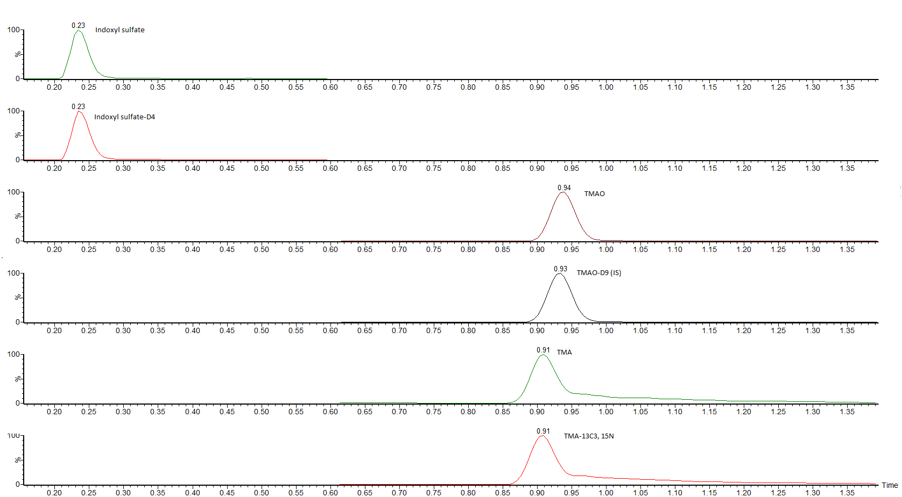
Supplemental Figure 1. Chromatograms of TMA, TMAO, indoxyl sulfate and corresponding internal standards

The mass spectrometer operated in multiple-reaction monitoring (MRM)- negative electrospray ionization (ESI) mode for indoxyl sulfate and in multiple-reaction monitoring (MRM)- positive electrospray ionization (ESI) mode. Mass spectrometer optimized settings are presented in Supplemental Table 2. MRM transitions, cone voltages, collision energies and retention times used in described methods are presented in Supplemental Table 3. The first MRM transition of each compound served as a quantitative transition, the second as a confirmation transition.
The calibration curve ranges were 0.02-20 µg/mL for TMAO, 0.1-120 µg/mL for TMA and 0.1- 50 µg/mL for indoxyl sulfate. Mean R2 coefficients of a calibration curves from 6 calibrators was not lower than 0.99.

Supplemental Table 2. Mass spectrometer parameters
Parameter | ESI (-) | ESI (+)
Capillary voltage [kV] | 1.5 | 2.5
Source temperature [⁰C] | 150 | 150
Desolvation temperature [⁰C] | 380 | 380
Cone gas flow [l/h] | 150 | 150
Desolvation gas flow [l/h] | 300 | 300
Nebuliser gas pressure [Bar] | 7.0 | 7.0

Supplemental Table 3. Monitored transitions, cone voltages, collision energies, retention times of analyzed compounds
Analyte | MRM transition | Cone voltage | Collision energy | Retention  time [min]
TMAO | 76,076>57,97 (*)  76,076>41,95 | 15  15 | 20  20 | 0.94
TMAO- D₉ (IS) | 85,13>68,2 (*)  85,13>66,2 | 20  20 | 10  14 | 0.93
TMA | 60,08>45,05 (*)  05760,08>44,05 | 20  20 | 10  34 | 0.91
TMA- ¹³C₃, ¹⁵N (IS) | 64,09>48,04 (*)  64,09>47,05 | 20  20 | 18  18 | 0.91
Indoxyl sulfate | 212,0>79,96 (*)  212,0>132,04 | 30  30 | 20  20 | 0.23
Indoxyl sulfate – D₄ | 216,11>135,76 (*) | 30 | 20 | 0. 23

- Evaluation of short chain fatty acids (SCFA) concentration using liquid chromatography coupled with triple-quadrupole mass spectrometry.

Chemicals
Short fatty acids standards (acetic acid-AA (C2), propionic acid- PA (C3), butyric acid-BA (C4), isobutyric acid-IBA (C4), valeric acid- VA (C5), isovalareic acid-IVA (C5), 2-methylbutyric acid- 2MBA (C5), caproic acid- CA (C6), 3-methylvaleric acid- 3MVA (C6), 4-methylvaleric acid- 4MVA (C6)), short fatty acids isotope-labeled standards (acetic acid-¹³C₂, propionic acid-D₆, butyric acid-¹³C₂, isobutyric acid-D₇, valeric acid-D₉), pyridine anhydrous, 2-nitrophenylhydrazine (3NPH‧HCl), N-(3-dimethylaminopropyl)-N′-ethylcarbodiimide (EDC‧HCl). All SCFAs stock solutions were prepared in 50% acetonitrile and stored in -20 ºC. LC-MS grade acetonitrile, HPLC grade acetonitrile, HPLC grade methanol, and formic acid. Ultra-pure water was produced by a water purification system.

Sample praparation
Solutions of 400 mM 3NPH and 240 mM EDC-6% pyridine were freshly prepared in 50% aqueous acetonitrile. Derivatization procedure was as follows: 40 µL of plasma, stool extract and calibration samples were mixed with 80 µL methanol (containing internal standards) on 96-well 2 mL sample plate. After, 20 µL of 3NPH solution and and 20 µL of EDC- pyridine solution were added. The mixture was incubated in room temperature for 30 min. Next, solution was diluted to 1 mL with 15% aqueous acetonitrile, centrifuged and aliquot was injected into apparatus.

Analyzes
The instrumentation consisted of a Waters Acquity Ultra Performance Liquid Chromatograph coupled with Waters TQ-S triple-quadrupole mass spectrometer. For the instrument control and data acquisition Waters MassLynx software was used. Waters TargetLynx was used to processed data.
The analytes separation were performed using a Waters BEH C18 column (1.7 µm, 2.1 mm x 50 mm) and Waters BEH C18 guard column (1.7 µm, 2.1 mm x 5 mm). Mobile phase A consisted of 1 mL of formic acid in 1 L of water, and mobile phase B consisted of 1 mL of formic acid in acetonitrile. The flow rate of mobile phase was set at 0.6 mL/min. The column temperature was 60 ⁰C, the autosampler was kept at 5 ⁰C. The gradient scheme is presented in Supplemental Table 4. The injection volume was 10 µL. The chromatogram is presented in Supplemental Figure 2.

Supplemental Table 4. LC gradient
Time [min] | Flow [mL/min] | %A | %B
- | 0.6 | 85.0 | 15.0
2.0 | 0.6 | 80.0 | 20.0
7.0 | 0.6 | 60.0 | 40.0
7.5 | 0.6 | 0.0 | 100.0
8.0 | 0.6 | 0.0 | 100.0
8.5 | 0.6 | 80.0 | 20.0
9.5 | 0.6 | 85.0 | 15.0

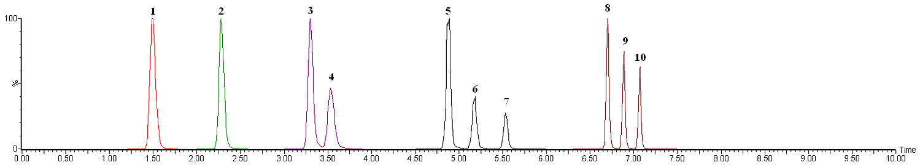
Supplemental Figure 2. Chromatograms of ten SCFAs: 1- AA, 2- PA, 3- IBA, 4- BA, 5- 2MBA, 6- IVA, 7- VA, 8- 3MVA, 9- 4MVA, 10-CA

The mass spectrometer operated in multiple-reaction monitoring (MRM) - negative electrospray ionization (ESI) mode. For all analyzed compounds mass spectrometer optimized settings were as follows: capillary voltage = 2.25 kV, desolvation temperature = 550 °C, desolvation gas flow = 550 L/h, cone gas flow = 150 L/h, nebuliser gas pressure = 7.0 bar, source temperature = 150 °C. MRM transitions, cone voltages, collision energies and retention times used in described methods are presented in Supplemental Table 5. The first MRM transition of each compound served as a quantitative transition, the second as a confirmation transition.

Supplemental Table 5. Monitored transitions for SCFAs derivatives, cone voltages, collision energies, retention times of analyzed compounds
Analyte | MRM transition | Cone voltage | Collision energy | Retention  time [min]
AA | 194.1>137.1 (qt)  194.1>152.1 | 20  20 | 20  20 | 1.49
AA-¹³C₂ (IS for AA) | 196.1>137.1 (qt)  196.1>152.1 | 20  20 | 20  20 | 1.49
PA | 208.1>137.1 (qt)  208.1>165.1 | 20  20 | 15  20 | 2.29
PA- D₆ (IS for PA) | 212.1>137.1 (qt)  212.1>165.1 | 20  20 | 15  20 | 2.26
BA | 222.1>137 (qt)  222.1>152.1 | 20  20 | 20  20 | 3.54
BA-¹³C₂ (IS for BA) | 224.1>137.1 (qt)  224.1>152.1 | 20  20 | 20  20 | 3.53
IBA | 222.1>137 (qt)  222.1>152.1 | 20  20 | 20  20 | 3.31
IBA- D₇ (IS for IBA) | 229.1>137.1 (qt)  229.1>152.1 | 20  20 | 20  20 | 3.24
2MBA  IVA  VA | 236.2>137.1 (qt)  236.2>152.1 | 20  20 | 20  20 | 4.88  5.18  5.54
VA- D₉ (IS for VA, CA, 3MVA and 4MVA) | 244.2>137.1 (qt)  244.2>152.1 | 20  20 | 20  20 | 5.45
IVA-D₉ (IS for IVA and 2 MBA) | 245.2>137.1 (qt)  245.2>152.1 | 20  20 | 20  20 | 5.08
3MVA  4MVA  CA | 252.2>152.1 (qt)  252.2>137 | 20  20 | 20  20 | 6.7  6.89  7.06

The concentration of short fatty acids was calculated using calibration standard mix derived from a series of calibrator samples by spiking standard stock solutions into water. Calibration curves for SCFAs were generated by compared a ratio of the peak area of the analyzed compound to the peak of the internal standard against known analyte concentrations. Stool extract samples and plasma samples were compared with a obtained calibration curve. Mean R2 coefficients of a calibration curves from 6 calibrators was not lower than 0.99. The linear ranges are presented in Supplemental Table 6. The method showed a good intra- and interassay precision below 10%.

Supplemental Table 6. Linearity for stool (S) and plasma (P) samples
Analyte | Linear range [uM]
AA | P: 10-1000  S: 250-5000
PA | P: 1-250  S: 125-4000
BA | P: 1-250  S: 50-4000
IBA | P: 0.1-10  S: 5-1000
2MBA | P: 0.1-50  S: 1-250
IVA | P: 0.1-10  S: 5-500
VA | P: 0.1-50  S: 5-1000
3MVA | P: 0.1-50  S: 0.2-50
4MVA | P: 0.1-50  S: 0.2-1000
CA | P: 0.1-50  S: 0.2-1000

