October 1st, 2018

Dear Dr Philip Steindel:

Thank you for the feedback on our Manuscript (JoVE58443R1, “Construction of a low-cost mobile incubator for field and laboratory use”), and for the opportunity to revise it.
We thank you for the fast and constructive feedback. We have detailed these edits within the point-by-point responses to editor comments, with edits indicated by underlined text. All edits are also visible in “track changes” within the revised manuscript uploaded on your platform.
Please do not hesitate to contact me if you have questions about the files submitted through the online system or require additional information. Thank you in advance for your consideration, and we look forward to hearing from you.
Yours sincerely,
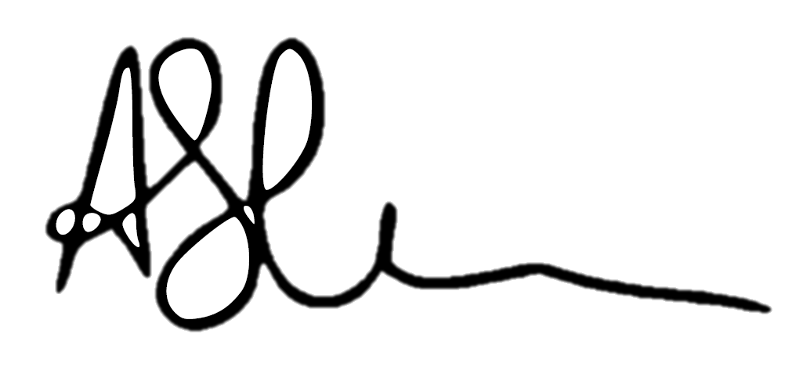

Ariane Schertenleib

