
Simon Wagner
Professor of Translational Haematology
Leicester Cancer Research Centre,
University of Leicester,
University Road, Leicester, LE1 7HB, UK
t: +44 (0)116 252 5584
e: sw227@le.ac.uk
w: www.le.ac.uk

1st July 2018

Dear Editor,
Thank you for your email with its list of editorial revisions.
We have addressed all the points and hope that the manuscript is now acceptable for publication by JoVE.
- Please take this opportunity to thoroughly proofread the manuscript to ensure that there are no spelling or grammar issues.

This has been done

- Please include an ethics statement before the numbered protocol steps, indicating that the protocol follows the guidelines of your institution’s human research ethics committee.

The ethics statement as well as participant information in our study has been moved to the top of the protocol, before the numbered steps.

- Please do not highlight notes for filming.

Highlighting has been removed.

- Please use h, min, s for time units.
This has been done

- Step 1.1: Please write this step in imperative tense. Please split this step into more sub-steps so that each step contains 2-3 actions and is less than 4 lines.

As per point 2, Step 1.1 (in the previous version) included ethics and participant information and has now been placed before the protocol’s numbered steps. As requested the section "Isolation of CD4+ T-cells..." has been rewritten in sections 1.1 to 1.11.
- 5.3-5.9: For steps that are done using software, a step-wise description of software usage must be included in the step. Please mention what button is clicked on in the software, or which menu items need to be selected to perform the step.

For each step, information has been added on the type of plot to set the gate on (i.e. dot or histogram), the axis that should be viewed, the type of gate to use, and how to identify the population in question. In the revised manuscript these steps have become 4.3 to 4.9.

- Table 1: Please remove the last column from the table. Such information should be included in Table of Materials.
This has been done.

- JoVE cannot publish manuscripts containing commercial language. This includes company names of an instrument or reagent. Please remove all commercial language from your manuscript and use generic terms instead. All commercial products should be sufficiently referenced in the Table of Materials and Reagents. Examples of commercial language in your manuscript include BD, etc.

This has been done.

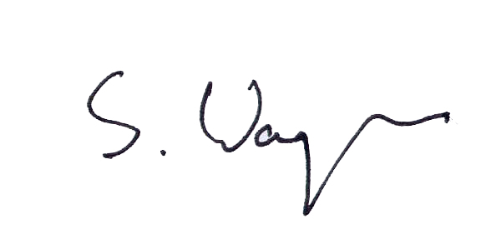
Yours sincerely

Simon Wagner

