SUPPLEMENTARY MATERIAL

Automating a positron-emission tomography (PET) radiotracer synthesis protocol for clinical production

Eric Schopf^{1,†}, Christopher M. Waldmann^{2,3, †}, Jeffrey Collins^{2,4}, Christopher Drake¹, Roger Slavik^{2,3,*}, R. Michael van Dam^{2,4,*}.
¹SOFIE, Culver City, CA, USA; ²Department of Molecular & Medical Pharmacology, David Geffen School of Medicine, University of California Los Angeles (UCLA), Los Angeles, CA, USA; ³Ahmanson Translational Imaging Division, UCLA, Los Angeles, CA, USA; ⁴Crump Institute for Molecular Imaging, UCLA, Los Angeles, CA, USA
†These authors contributed equally to this work.
*Corresponding authors

Contents
1 Manual synthesis of [¹⁸F]CFA 2
2 Details of automated synthesis program 2
3 Setting parameter values for unit operations 4
References 13

Manual synthesis of [¹⁸F]CFA
The manual radiosynthesis of [¹⁸F]CFA was originally described by Shu et al. ²⁵ as a procedure using two reaction vessels, intermediate silica cartridge purification and a final HPLC purification step. In brief, [¹⁸F]fluoride was first separated from [¹⁸O]H₂O by trapping the [¹⁸F]fluoride on a quaternary methylammonium (QMA) cartridge and then eluting with a solution of K₂CO₃ and Kryptofix K_{2.2.2} (K222) into the first reaction vessel. Three steps of azeotropic drying with acetonitrile (MeCN) yielded the anhydrous [¹⁸F]KF/K222 complex. Precursor (6 mg in 0.6 mL MeCN) was added to the vessel and reacted at 110° for 25 min. The mixture was then passed through a silica cartridge and eluted in 4 steps (2 mL each) into the second reaction vessel. After evaporation, 0.5 mL MeCN was added prior to addition of 1M HCl (1 mL). After the deprotection reaction at 100 °C for 5 min, the reaction mixture was diluted and purified on a semi-preparative HPLC system to yield the final product.

Details of automated synthesis program
The programs (unit operations and parameter values for each) for the automated synthesis and formulation of [¹⁸F]CFA are summarized in Tables S1 and S2, respectively. The preparation of reagents for the automated synthesis of [¹⁸F]CFA is summarized in Table 1 of the main paper.

Step | Operation | Source | Destination | Duration(s) | Temp. (°C) | Pressure (psi) | Other Parameters
1 | Trap Isotope | Source vial | Reactor 1 | 120 | -- | 7
2 | Elute Isotope | Reagent 1 | Reactor 1 | 90 | -- | 7
3 | Evaporate | Reactor 1 | -- | 150 | 110 | 10 | - Stirring (210s at 500rpm after 0s delay)  - Cooling: 35C
4 | Elute Isotope | Reagent 2 | Reactor 1 | 60 | -- | 7
5 | Evaporate | Reactor 1 | -- | 150 | 110 | 10 | - Stirring (95s at 500rpm after 0s delay)  - Cooling: 35C
6 | Add Reagent | Reagent 3 | Reactor 1 | 15 | -- | 3 | - Add needle: 1  - No stirring
7 | Evaporate | Reactor 1 | -- | 300 | 110 | 10 | - Stirring (300s at 500rpm after 0s delay)  - Cooling: 40C
8 | Add Reagent | Reagent 4 | Reactor 1 | 15 | -- | 5 | - Add needle: 1  - No stirring
9 | React | Reactor 1 | -- | 600 | 120 | -- | - Seal position: 1  - Stirring (600s at 500rpm after 0s delay)  - Cooling: 35C
10 | Transfer | Reactor 1 | Reactor 2 | 60 | -- | 10 | - Flow path: elute  - Stirring (500rpm at source, 500rpm at destination)
11 | Add Reagent | Reagent 5 | Reactor 1 | 15 | -- | 3 | - Add needle: 2  - No stirring
12 | Transfer | Reactor 1 | Reactor 2 | 60 | -- | 10 | - Flow path: elute  - Stirring (500rpm at source, 500rpm at destination)
13 | Evaporate | Reactor 2 | -- | 120 | 100 | 10 | - Stirring (120s at 500rpm after 0s delay)  - Cooling: 35C
14 | Add Reagent | Reagent 6 | Reactor 1 | 15 | -- | 3 | - Add needle: 2  - Stirring (10s at 500rpm after 15s delay)
15 | Transfer | Reactor 1 | Reactor 2 | 60 | -- | 10 | - Flow path: elute  - Stirring (500rpm at source, 500rpm at destination)
16 | Evaporate | Reactor 2 | -- | 120 | 100 | 10 | - Stirring (120s at 500rpm after 0s delay)  - Cooling: 35C
17 | Add Reagent | Reagent 7 | Reactor 1 | 15 | -- | 3 | - Add needle: 2  - No stirring
18 | Transfer | Reactor 1 | Reactor 2 | 60 | -- | 10 | - Flow path: elute  - Stirring (500rpm at source, 500rpm at destination)
19 | Evaporate | Reactor 2 | -- | 270 | 100 | 10 | - Stirring (270s at 500rpm after 0s delay)  - Cooling: 40C
20 | Add Reagent | Reagent 8 | Reactor 2 | 15 | -- | 5 | - Add needle: 1  - Stirring (25s at 500rpm after 15s delay)
21 | Add Reagent | Reagent 9 | Reactor 2 | 15 | -- | 5 | - Add needle: 1  - No stirring
22 | React | Reactor 2 | -- | 300 | 100 | -- | - Seal position: 2  - Stirring (300s at 500rpm after 0s delay)  - Cooling: 40C
23 | Add Reagent | Reagent 10 | Reactor 2 | 15 | -- | 5 | - Add needle: 1  - No stirring
24 | Transfer | Reactor 2 | HPLC P/F Module: Valve 1 | 0 | -- | 3.5 | - Loop loading mode: manual  - Flow path: PF module  - Stirring (500rpm at source)
25 | Purification | -- | Product collect | -- | -- | -- | - Pump mode: isocratic  - Solvent: 85% A, 15%B  - Flow rate: 5mL/min  - UV detection wavelength: 263 nm

Table S1. Detailed sequence of unit operations to perform the automated synthesis and purification of [¹⁸F]CFA on the ELIXYS FLEX/CHEM radiosynthesizer and PURE/FORM module. The details of each reagent are described in the main text (Figure 4). For the “Purification” unit operation, the ELIXYS PURE/FORM system is equipped with a semi-preparative C-18 column (Gemini, 5 µm, 250 mm x 10 mm, Phenomenex, Torrance, CA, USA), Mobile Phase A is 25 mM ammonium acetate and Mobile Phase B is EtOH.

Step | Operation | Duration(s) | Pressure (psi) | Volume (mL) | Other Parameters
1(a) | Formulation | 0 | 0 | - | Mode: Trap
1(b) | Formulation | -- | -- | -- | Mode: Rinse
1(c) | Formulation | -- | -- | X | Mode: Elute
1(d) | Formulation | -- | -- | Y | Mode: Reconstitute

Table S2. Detailed sequence of unit operations to perform the automated formulation of [¹⁸F]CFA with the ELIXYS PURE/FORM module. In this sequence, the first two sub-operations, Trap and Rinse, are skipped by specifying duration of 0 s and volume of 0 mL, respectively. The Elute and Reconstitute sub-operations must be adjusted to dispense the correct volumes based on the total collected volume of the product after HPLC purification. Volume of HPLC product collected = (5 mL/min) x (1/60) x (Fraction collection duration in s). The Elute operation is configured to dispense a volume of X mL of concentrated sodium chloride (90 mg/mL), where X = (0.096) x (Volume of HPLC product collected). The Reconstitute operation is configured to dispense a volume of Y mL of 0.9% saline solution, where Y = (0.5) x (Volume of HPLC product collected).

Setting parameter values for unit operations
The following figures illustrate the programmable parameters for each type of unit operation.

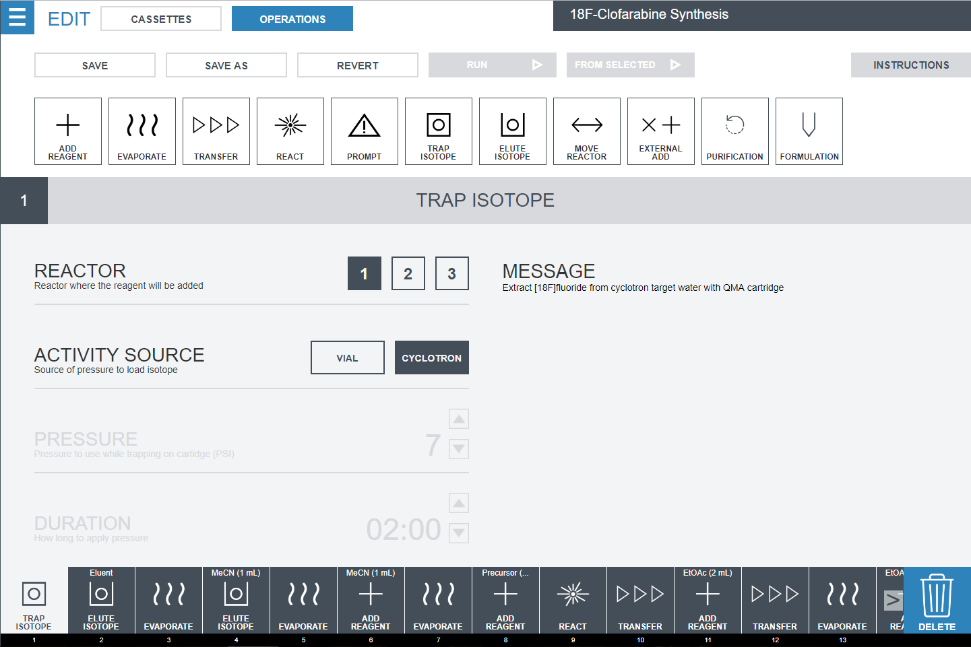
Figure S1. Detail of the Trap Isotope unit operation programming. This unit operation will trap activity, from a source vial or directly from a cyclotron, onto a preconditioned QMA cartridge connected to the cassette and collect the [¹⁸O]H₂O in a sealed container. If the activity is initially in a source vial, the FLEX/CHEM will deliver nitrogen at the programmed pressure for the selected duration, through a special gas delivery line, to push the activity onto the QMA cartridge.

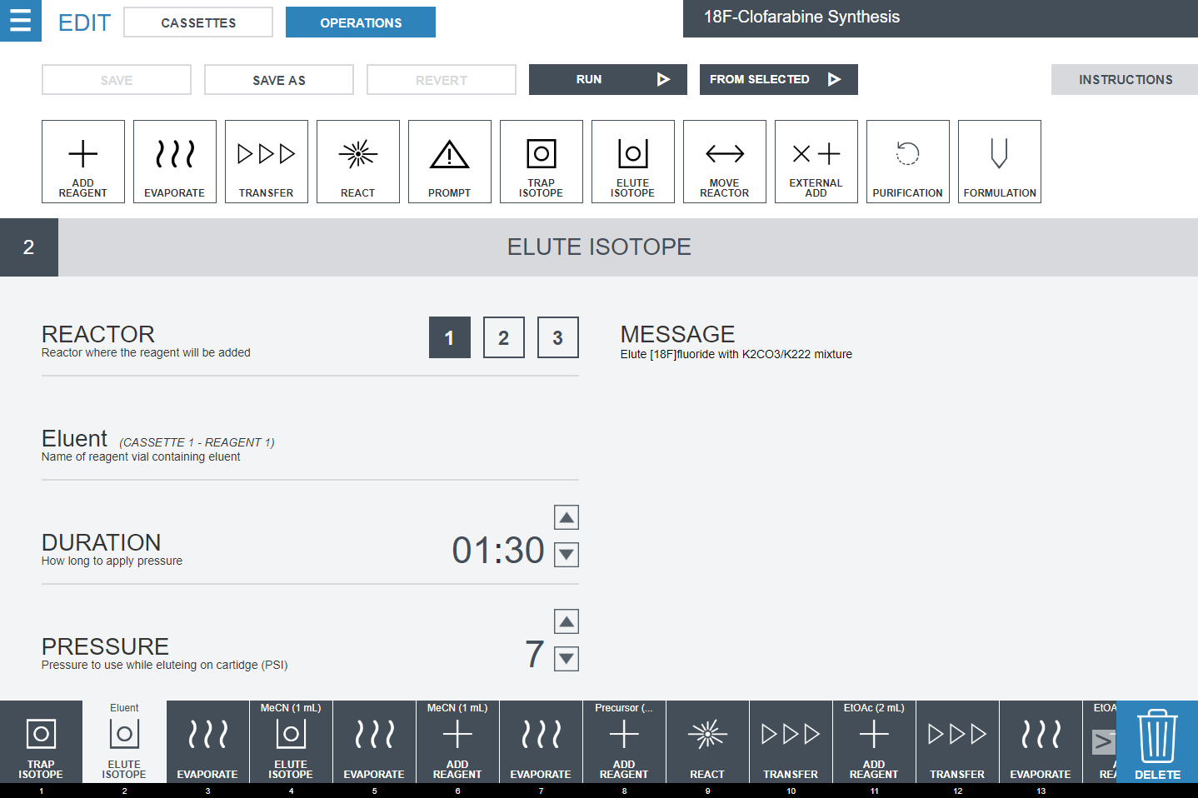
Figure S2. Detail of the Elute Isotope unit operation programming. The operator selects which reagent to use as the eluent solution and specifies the reactor to which the eluate will be directed. The duration and pressure of the operation are programmed as well.

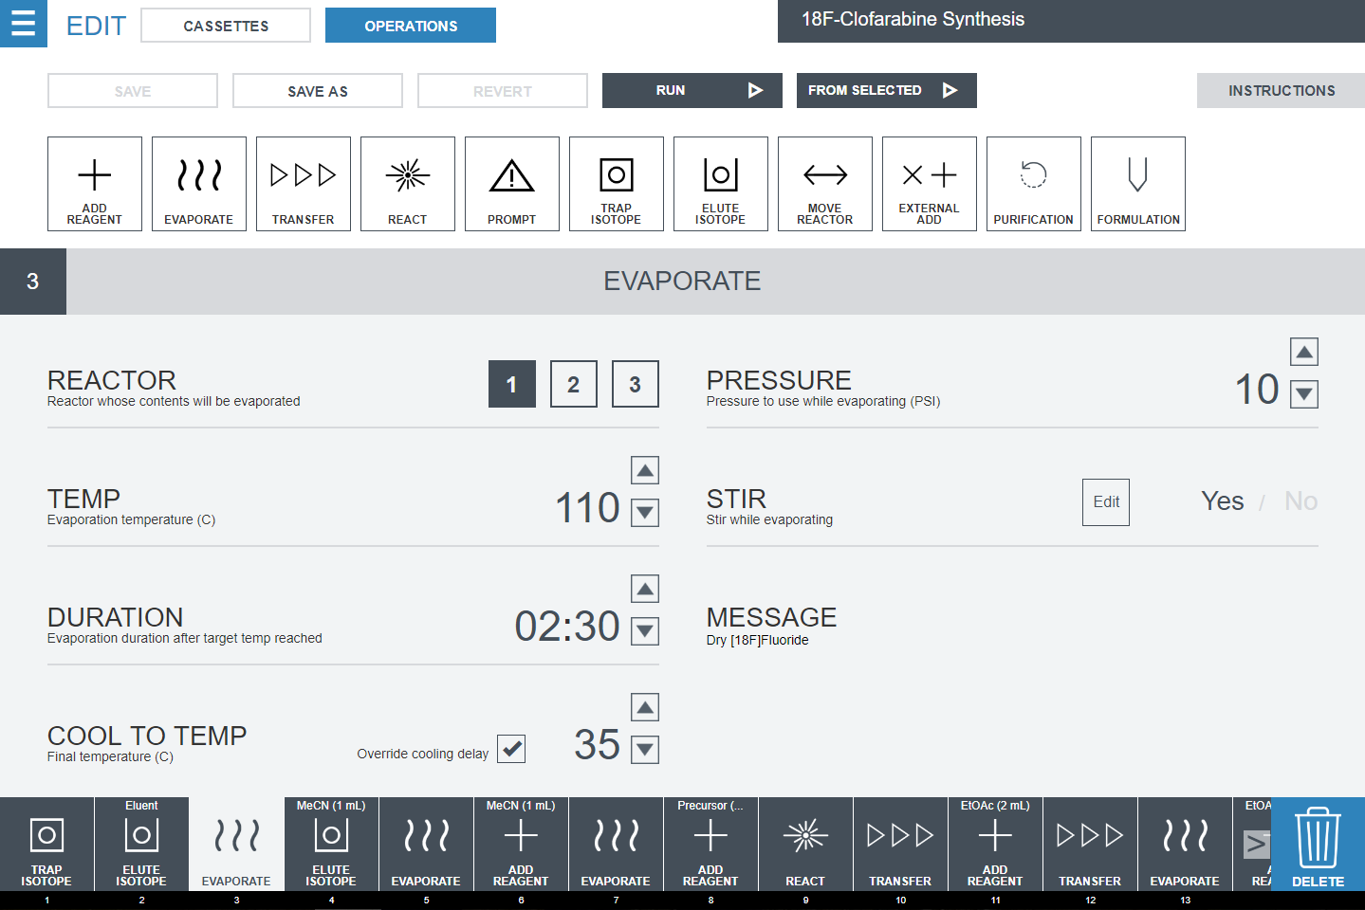
Figure S3. Detail of the Evaporate unit operation programming. The operator selects the desired reactor, evaporation temperature, duration, and pressure of the “sweep gas”. The operator can select to have the reactor stirring during the operation. Finally, when the evaporation is finished, the FLEX/CHEM will cool the reactor to the programmed “Cool to Temp” temperature. By default the cooling is extended if the programmed temperature is greater than 70°C by [0.91*T – 43.6] min, where T is the programmed temperature in °C. This accounts for the delay between cooling of the reactor body (measured by temperature sensor) and liquid in reaction vessel (not measured). If “Override cooling delay” is selected, no additional time will be added.

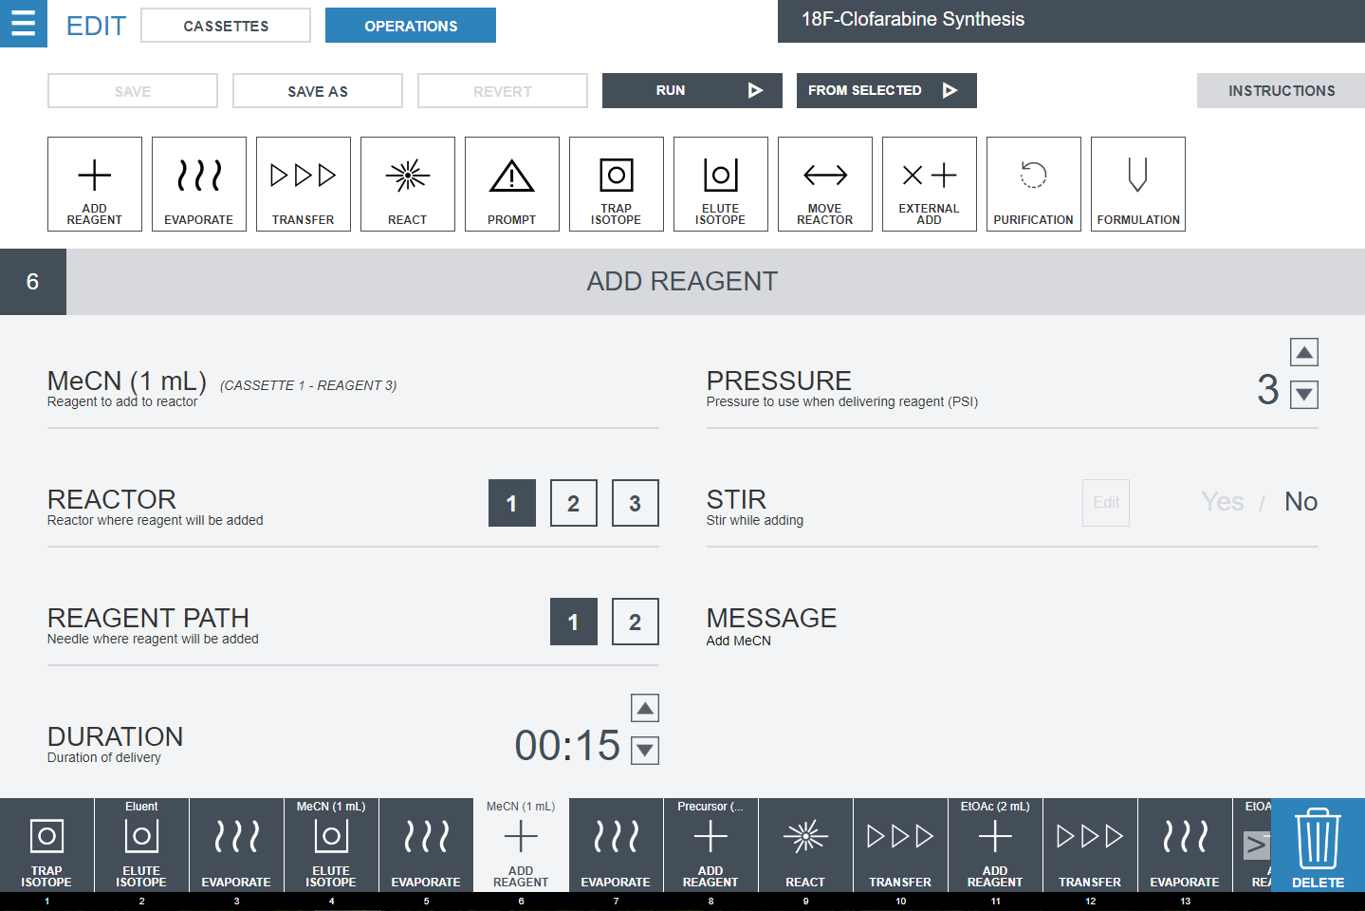
Figure S4. Detail of the Add Reagent unit operation programming. The operator selects which reagent from the “Cassettes” tab (Figure 4 in main text) is added into the chosen reactor via the selected reagent pathway. The duration and pressure are programmed as well. The operator can choose to stir the vial during or after addition, or to skip stirring.

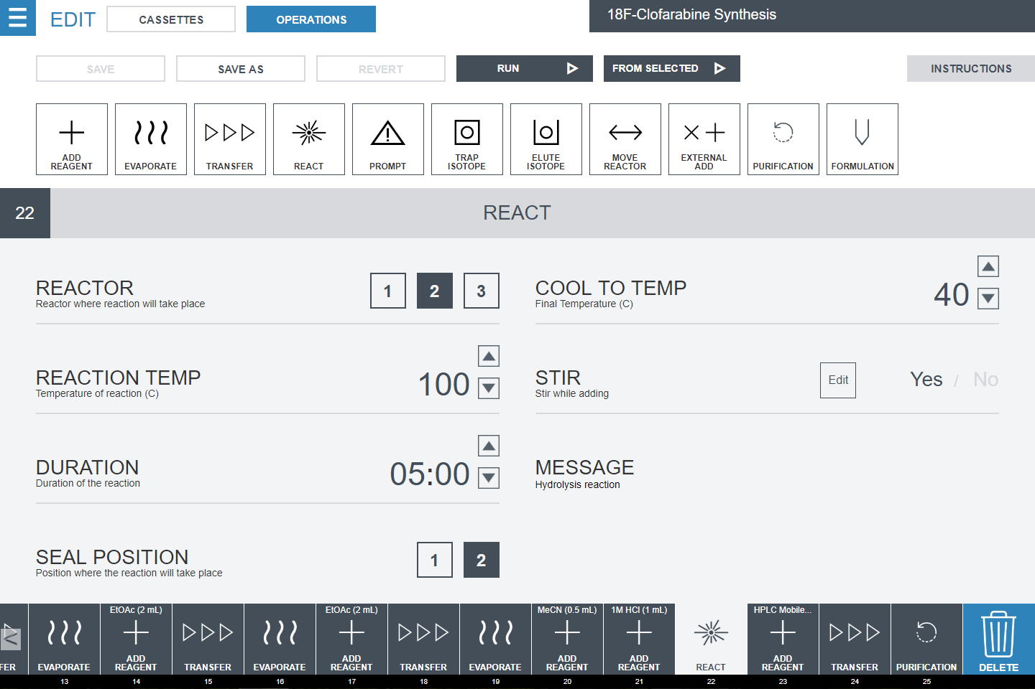
Figure S5. Detail of the React unit operation programming. This unit operation moves the selected reactor to one of two (selectable) seal position on the cassette. The reaction vessel will then be heated to the programmed reaction temperature for the desired duration. The operator programs a desired temperature to which to cool the reactor vial contents after the reaction is complete. A temperature delay will be applied to the cooling time as described for the Evaporate unit operation (Figure S3). Finally, the operator can select whether or not to stir the reactor vial during the operation.

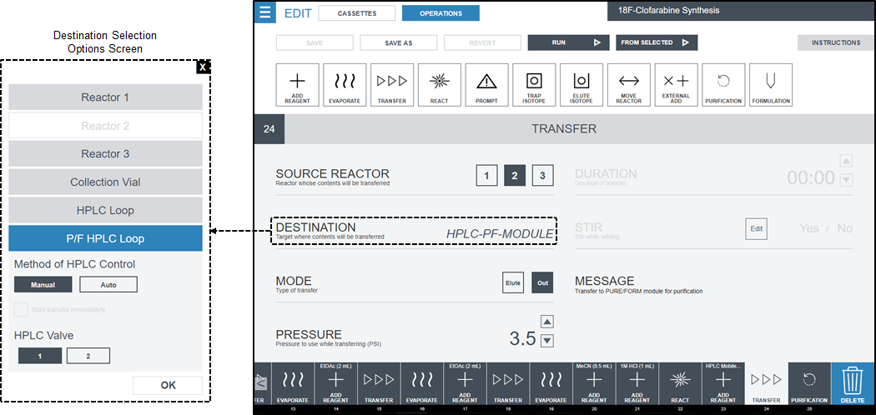
Figure S6. Detail of the Transfer unit operation programming. This unit operation will move the reaction vessel under the dip tube and raise the vial such that the top of the vessel is sealed and the dip tube touches the bottom of the vessel. The contents of the reactor vial will be routed through the cassette fluid pathway chosen to the selected destination, driven by the programmed gas pressure for the programmed duration. In this example, the destination is the purification/formulation module (i.e. injection loop). Because the transfer destination is an HPLC injection loop, the duration is not defined here. Instead, in “Manual” mode, the operator selects when to inject the sample after manually loading the injection loop. “Auto” mode uses the built-in liquid sensors to determine when the entire sample has been loaded into the injection loop and will automatically switch the injection valve to the inject position. If the transfer destination was a reactor, the operator could select the duration and whether or not to stir the reactor vial after the contents have been transferred. In this case, one would also specify whether the transfer is performed in “trap” or “elute” mode (i.e., if the reactor contents are passed through a solid-phase extraction cartridge during the transfer). If no cartridge is used, “elute” would be selected.

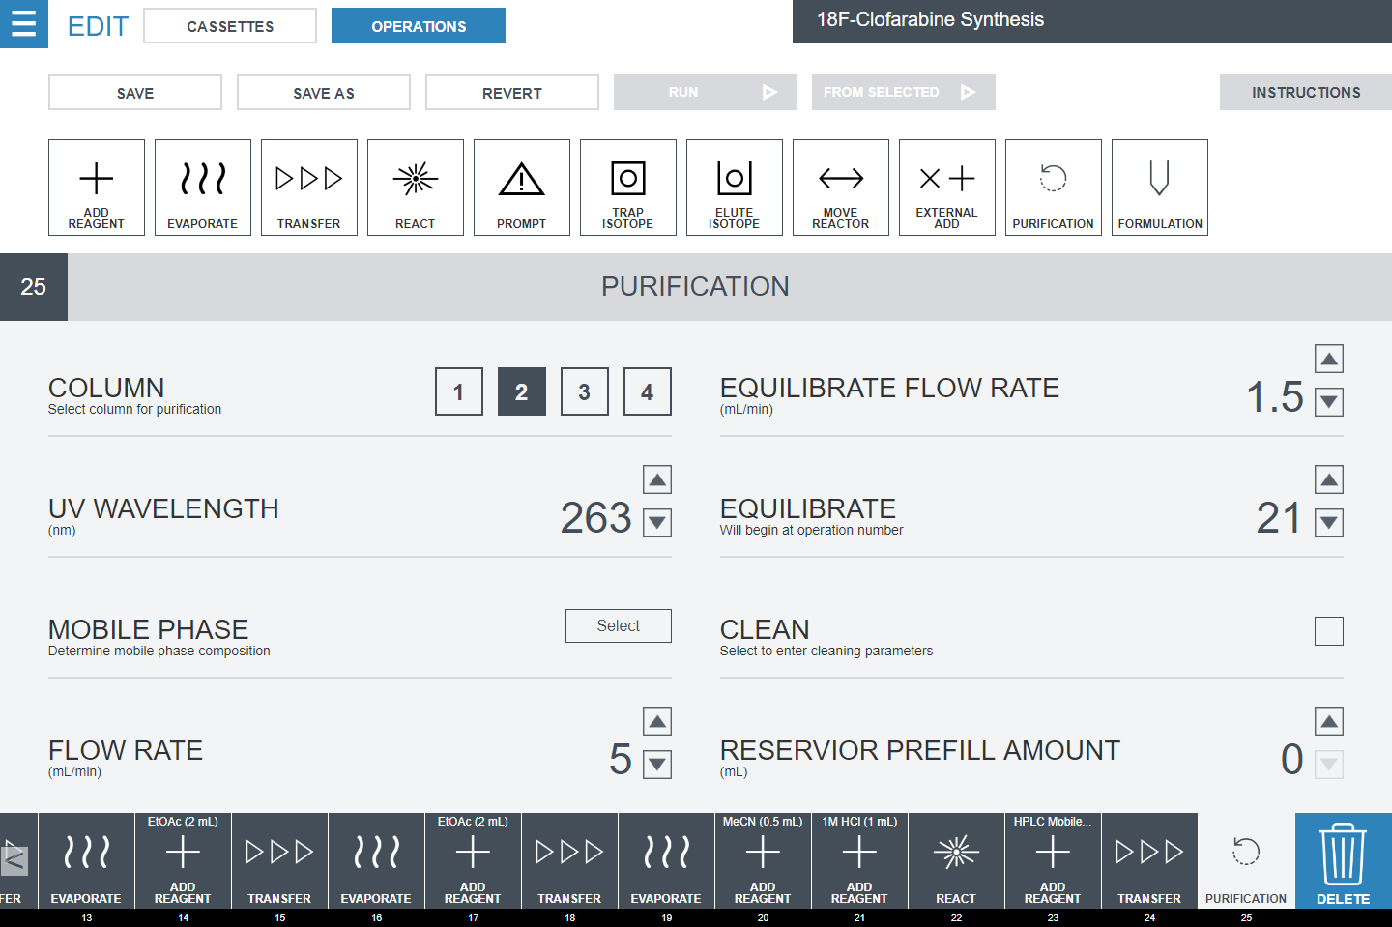
Figure S7. Detail of the Purification unit operation programming. This unit operation controls the HPLC sub-system of the purification/formulation module. First, a column position is selected from the 4 available columns on the column selector valve. The UV detector wavelength is then selected, between 200 and 600 nm. The “Mobile Phase” select button allows the operator to create a solvent program for the quaternary gradient pump to follow; this may be an isocratic or gradient program. The flow rate during the unit operation is then programmed. The module has an equilibration feature where the UV detector lamp will be powered on and the HPLC pump will equilibrate the HPLC sub-system at the desired point in the program. (The flow rate and the unit operation number where the equilibration will begin can be defined.) The “Clean” checkbox will run an automated cleaning of the HPLC sub-system if checked. Finally, the “Reservoir Prefill Amount” allows the operator to specify a volume of diluent that is preloaded in the dilution reservoir to enable calculation of the total volume it contains; this feature is used to alert the operator if the dilution reservoir is at risk of overflowing during the product collection. Since the dilution reservoir and subsequent solid-phase extraction components are not used during the [¹⁸F]CFA synthesis, this value is set to 0.

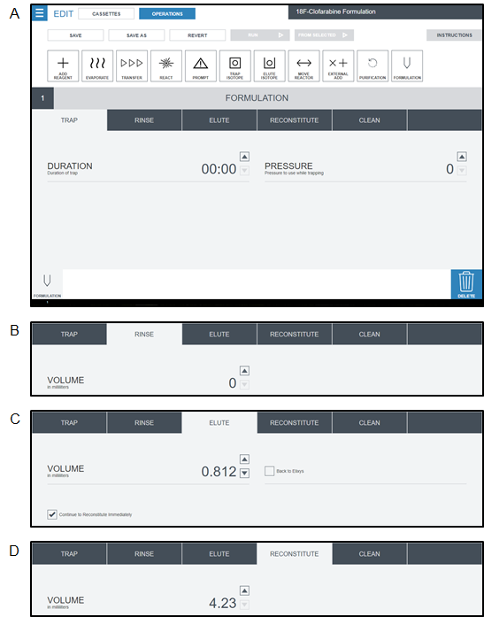
Figure S8. Detail of the Formulation unit operation programming. The Formulation unit operation consists of four sub-operations designed to perform solvent exchange from the HPLC mobile phase to an injectable solution via solid-phase extraction (SPE). (A) The Trap sub-operation pressurizes the dilution reservoir, forcing the diluted product out of the reservoir and through an SPE cartridge where it is trapped; the solvent is routed to waste. (B) The Rinse sub-operation rinses the SPE cartridge containing the trapped product, typically with water, to remove all traces of HPLC mobile phase. (C) The Elute sub-operation is used to elute the trapped product off of the SPE cartridge and into a final product vial. (D) The Reconstitute sub-operation is used to dilute the reformulated product to reduce EtOH content. In the synthesis of [¹⁸F]CFA, formulation can be performed via dilution and no SPE cartridge is needed. The Trap and Rinse sub-operations are thus not used, but the Elute operation is used to supply concentrated NaCl (90 mg/mL) to adjust isotonicity, and the Reconstitute operation is used to supply saline (0.9%) to reduce EtOH content to acceptable levels. In the example shown (validation run #2), the collected product volume of 8.46 mL requires 0.812 mL of concentrated NaCl (90 mg/mL), and 4.23 mL of saline (0.9%). Calculations are performed using the NaCl equivalent method.
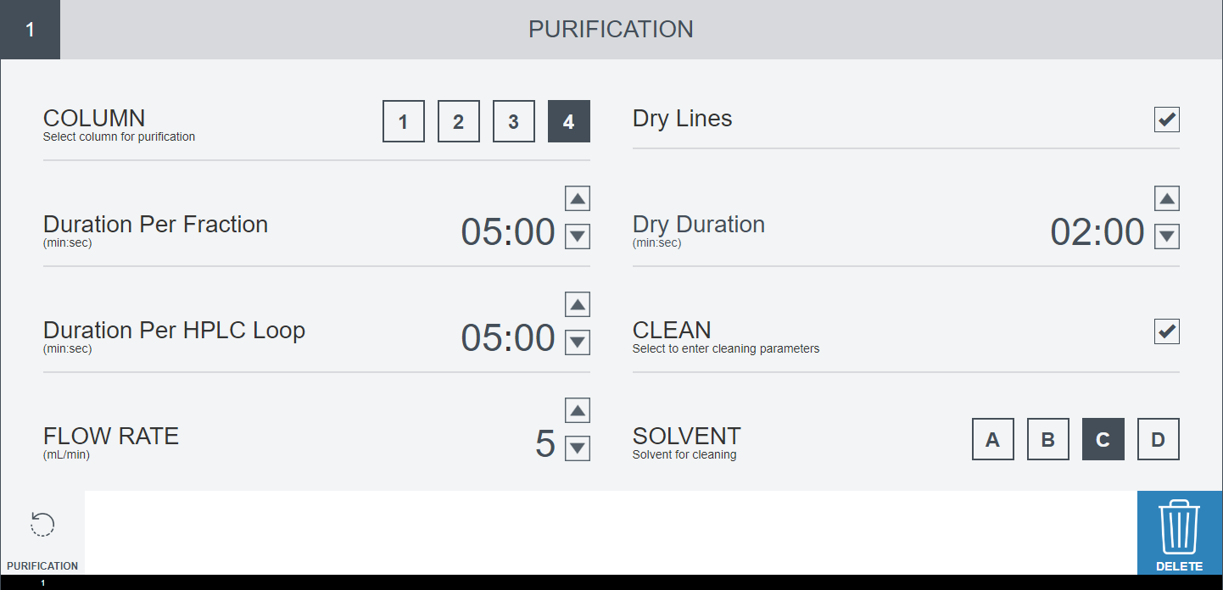
Figure S9. Unit operation configuration of an automated cleaning process for the Purification sub-system (using the Purification unit operation). Mobile phase (input “C” selected here) will be pushed through the system through the selected column (position 4) at the entered flow rate (5 mL/min). The system will switch between the two sample loops after a specified time (5 min). Afterwards, the selection valve will be actuated through each of its outputs, holding for a specified duration at each output (5 min). Finally, if desired (“Dry Lines” checkbox), the system will use nitrogen to dry the output lines from the selection valves, drying each line for a specified duration (2 min).
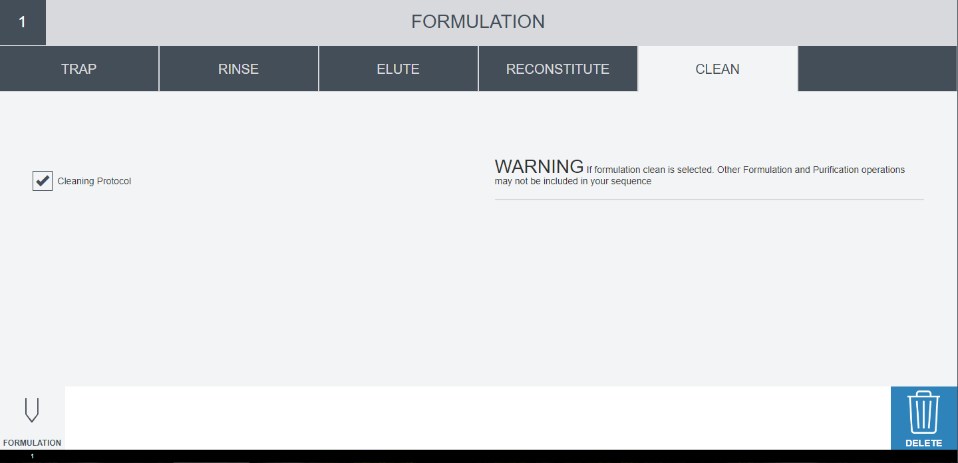
Figure S10. Unit operation configuration of an automated cleaning process for the Formulation sub-system (using the Formulation unit operation). The sub-system cleaning uses pre-set parameters to rinse all input/output lines and fluid paths with ethanol and dry them.

References
1. Shu, C.J. et al. Novel PET probes specific for deoxycytidine kinase. Journal of Nuclear Medicine. 51 (7), 1092–1098, doi: 10.2967/jnumed.109.073361 (2010).

