Dear Dr. DSouza,

On behalf of other co-authors and myself, I would like to thank you for giving us the opportunity to revise our manuscript JoVE58384. Based on the editorial and reviewers' comments, changes have been made and highlighted in the manuscript. For the details of our rebuttal letter, please see them in a separate document.

With kind regards,

Yongmei Sun, Ph.D

Editorial comments:
Changes to be made by the Author(s):
1. Please take this opportunity to thoroughly proofread the manuscript to ensure that there are no spelling or grammar issues. The JoVE editor will not copy-edit your manuscript and any errors in the submitted revision may be present in the published version.
--Thank you for this comment. The manuscript has been thoroughly proofread by a service company. Please see the certificate of this company in the uploaded file.
2. Unfortunately, there are a few sections of the manuscript that show text overlap with previously published work. Though there may be a limited number of ways to describe a technique, please use original language throughout the manuscript. Please see lines: 56-61, 95-106, 163-173, 179-183, 187-188, 197-199, 208-210, 214-216.
-- All of the overlapped sessions have been revised substantially.
3. Please obtain explicit copyright permission to reuse any figures from a previous publication. Explicit permission can be expressed in the form of a letter from the editor or a link to the editorial policy that allows re-prints. Please upload this information as a .doc or .docx file to your Editorial Manager account. The Figure must be cited appropriately in the Figure Legend, i.e. “This figure has been modified from [citation].”
-- We have obtained explicit copyright permission from Elsevier to reuse figure 2 and figure 3. Please see the details of the permission in the uploaded file.
4. Figure 2 legend: Please spell out SEM.
-- We spelled out SEM, which is Standard Error of Mean, in part 5.3 of the revised manuscript.
5. Please shorten the title if possible.
--The title has been changed to A conditioned place preference protocol for measuring incubation of craving in rat.
6. Keywords: Please provide at least 6 keywords or phrases.
-- One more key word, i.e. incubation of craving, was added as suggested.
7. Please expand the Short Abstract to also describe the applications of the protocol.
-- The applications of the protocol was added and highlighted as suggested.
8. Please rephrase the Long Abstract to more clearly state the goal of the protocol.
--The Long Abstract part was re-written to make the goal of the protocol clearer and the future applications of this model.
9. Please revise the Introduction to include all of the following:
a) A clear statement of the overall goal of this method
b) The rationale behind the development and/or use of this technique
c) The advantages over alternative techniques with applicable references to previous studies
d) A description of the context of the technique in the wider body of literature
e) Information to help readers to determine whether the method is appropriate for their application
--- The introduction part has been thoroughly revised and highlighted on pages 1-3.
10. Please include an ethics statement before your numbered protocol steps, indicating that the protocol follows the animal care guidelines of your institution.
--An ethics statement has been added under Protocol on page 3 as suggested.
11. Please revise the protocol text to avoid the use of any personal pronouns (e.g., "we", "you", "our" etc.).
-- The whole protocol section has been revised to avoid the use of personal pronouns.
12. 1.2: This is unclear. What does “handle the animals” mean?
--In order to decrease the stress level of animals during the experiment, experimenters usually " handle the animals" by playing with them or patting them to let them get used to human touch or manipulation later on. For an example, please see the video of one new published JOVE protocol (https://www.jove.com/pdf/55864/) and description part line 169-170 on page 3 of this protocol.
13. 2: Please remove commercial language: Shenyang First Pharmaceutical Factory.
-- The company information has been removed.
14. 3: A schematic of the apparatus and the chamber setup as Figure 1 would greatly aid in the protocol.
-- Although we made the following schematic of the apparatus, we think maybe it is better to show it vividly in the video. Besides, we think it is also very important that other researchers can vary the apparatus according to their research purposes following the rules of apparatus design. Therefore, we think it is better to add it in the video part instead of the manuscript part.
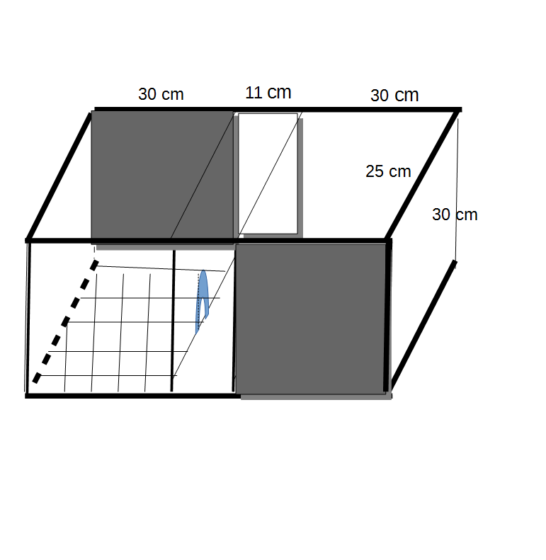

15. 3/4/5: The Protocol should be made up almost entirely of discrete steps without large paragraphs of text between sections. Please revise the protocol to contain only action items that direct the reader to do something. The actions should be described in the imperative tense in complete sentences wherever possible. Avoid usage of phrases such as “could be,” “should be,” and “would be” throughout the Protocol. Any text that cannot be written in the imperative tense may be added as a “Note.”
-- The Protocol has been revised to discrete steps.

16. Please revise to explain the Representative Results in the context of the technique you have described, e.g., how do these results show the technique, suggestions about how to analyze the outcome, etc. The paragraph text should refer to all of the figures. Data from both successful and sub-optimal experiments can be included.
-- One paragraph has been added in the result session to explain the representative results on page 6 (line 277-282).
17. As we are a methods journal, please revise the Discussion to explicitly cover the following in detail in 3-6 paragraphs with citations:
a) Critical steps within the protocol
b) Any modifications and troubleshooting of the technique
c) Any limitations of the technique
d) The significance with respect to existing methods
e) Any future applications of the technique
-- The discussion part has been sufficiently revised based on the editorial and reviewers' comments and highlighted in the manuscript on pages 8-10.
18. References: Please do not abbreviate journal titles.
-- The journal titles are abbreviated referring to the author guidelines and other publications of JOVE (one example is the recent published one https://www.jove.com/pdf/55864/). We are confused by this comment. We appreciate if you could provide us the new version of reference format.
Reviewers' comments:
Reviewer #1:
In this manuscript, Sun and colleagues presented a behavioral procedure on measuring morphine conditioned place preference. In this procedure, they used a biased design and found that CPP to morphine-conditioned chamber peaked 2 days and lasted 18 days after the last conditioning session. In the meanwhile, the entrance to morphine-conditioned side progressively increased after the last conditioning session, which authors stated that this resembles incubation of craving observed with self-administration procedure in rats. Overall, the manuscript is clearly-written and the steps are easy to follow. It will be helpful for others who want to establish this procedure in their own research groups. However, I have a few minor concerns.
-- Thank you for your comments on this manuscript. We have carefully revised the manuscript based on editorial and reviewers' comments and suggestions.
1. Please cite the historical paper Mucha et al., 1982 when introducing CPP procedure.
-- This reference was added in the first paragraph of the introduction on page 1(lines 81-82) as suggested.
2. The Introduction lacks citations for "incubation of craving".
-- References of "incubation of craving" (line 125, line 128) have been added.
3. The Introduction also lacks information on the premises of establishing CPP procedure on morphine, the advantage and differences of current procedure vs previous procedures (such as 2008 JN paper from Lin group). These should also be included in the discussion.
-- The premises of establishing morphine CPP (lines 78-82 on page 1) have been added. And the advantage and differences of different procedures have been discussed in the discussion part (line 424-434, page 9).
4. Here authors used the with-in subject design to study the different time points, which is acceptable. However, when interpreting the entrance data, the with-in subject design may be a confounding factor. During the first test (2 days), while the CPP score was the highest, the rats already went through extinction. During the following tests, rats may enter the chamber more often because of weakened reward memory/extinction learning, instead of increased craving, especially that the animal enhanced the entrance to both the saline and morphine-paired side. Unless the same results are obtained from a between-subject design, I am not convinced that the time-dependent increase of entrance resemble increased craving in these animals.
-- We agree with you that a between subject design makes the conclusion more solid. It is possible that rats entered more often to the side chambers due to weakened reward memory/extinction learning. However, craving/increased craving for the rewarding feeling after repeated testing might also be one of the driving forces for the increased entrances. Although entrances to both side chambers increased, rats entered more frequently to morphine-paired side than saline-paired side at T1 and T2, indicating that rats could clearly distinguish these two side chambers. In our and others' studies, morphine-experienced rats¹, tree shrews^{1,2} and monkeys³ showed increased entries to both side chambers during the morphine-free tests¹. No such increase of entries during abstinence of food was found in tree shrew food CPP paradigm², indicating that it is a drug-specific phenomenon. As the underlying principles of CPP and self-administration paradigms are different: one is classical conditioning, another is operant conditioning. Taken together, we tend to think the increased entrances to both side chambers represent the incubated craving in these three species. We think it is an interesting point for discussion so we add this part in the discussion.
5. Step 4.2.2, Note: Did the rats that had respiratory depression continue their study after they returned to normal behavior? How long did it take? Or they were excluded for the study on that particular day?
-- In our pilot study, one rat with respiratory depression died after putting back to the home cage. Then we learned this way to manage the respiratory depression. According to our experience with 5 depressed rats out 100 morphine experience rats, it took them 15-60 minutes to recover. In this manuscript, 1/21 rat experienced respiratory depression and this rat was excluded for the first morphine conditioning but continued with the rest of experiments.
6. For Figure 1, it would be helpful to show the procedure timeline for saline group, which reminds the readers that there were two groups in this study.
-- The procedure timeline for saline group has been added in Figure 1 as suggested.
7. Analysis of entrances in morphine group: authors used a mixed ANOVA with group (saline-paired and morphine-paired) as the between-subject factor, which is confusing to me. If I understand this correctly, authors analyzed in the morphine rats, the entrances to saline side vs morphine side. If this is the case, isn't the side (saline vs morphine) supposed to be with-in the same subject? The same question also applies to saline control group.
-- For a subject like rat, the two side chambers are different chambers. Therefore, chamber is used as a group factor with two levels. Same with the saline group.
8. As mentioned before, it would be beneficial to the readers if author could briefly discuss different procedures previous literatures used to study morphine CPP. In addition, one important factor for CPP is the dose of morphine, which should be discussed.
-- We have added this part in the discussion as suggested.
Reviewer #2:
Manuscript Summary:
This manuscript had been tried to establish a rat conditioned place preference (CPP) paradigm that mainly employed somatosensory cues. The authors have tried to investigate the neural mechanisms underlying long-term reward memory and incubation of craving in the future studies. However, this manuscript suffers from several major concerns, some of which are commented forthwith.
-- Thank you for your comments on this manuscript. We have carefully revised the manuscript based on editorial and reviewers' comments and suggestions.
Major Concerns:
1. The paper is lack of novelty because this protocol has been previously used in other studies.
-- Although CPP is commonly used, the number of entrances as a parameter is often neglected. Here we showed that number of entries to side chambers is an interesting parameter to reflect the craving of morphine-experienced animals and observed increased entrances to side chambers with this protocol.
We modified several variables of this protocol from previous studies: conditioning time points, length of conditioning period, number of conditioning days, contextual stimuli and testing days. And we found that the reward memory could last at least 18 days.
2. The aim of study is not clear. In the first sentence of abstract, the authors have emphasized on assessing reward induced by somatosensory cortex while it is not main purpose of this study.
-- We have revised the abstract and introduction to clearly express the aim of this protocol.
3. Introduction of this manuscript is short and it is not coherent. It looks like several unrelated paragraphs.
-- Introduction has been revised based on your and other reviewers' comments.
4. What is reason for using dose of Morphine (10 mg/kg)?
-- According to a previous study⁴, 10 mg/kg morphine induced the highest CPP score , which maintained at the same level for at least 14 days.
5. In page 3, the authors of the manuscript mentioned that "around 5% of rats have the respiratory depression after the first injection of morphine (10 mg/kg)." It would be better to test a lower dose like 5 mg/kg to prevent of respiratory depression.
-- Lower doses of morphine (1 mg/kg and 3 mg/kg) could induce morphine CPP but the CPP score increased during the abstinence period using an unbiased design as mentioned above⁴.To exclude the impact of increased CPP score, we used a 10 mg/kg dose. However, we agree with you that it is interesting to check a lower dose, such as 5 mg/kg. We added this point in the discussion part.
6. It would be better to continue the experiment until extinction time (more than 18 days).
-- We agree with this point and add it in the discussion part.
7. The quality of English writing is not good enough, there are several grammatical errors in the manuscript. Therefore, the whole manuscript should be revised and re-written to correct language errors.
-- The whole manuscript has been thoroughly proofread.
Reviewer #3:
Manuscript Summary:
The present study was designed to measure the long-term reward memory and participation of somatosensory cortices in morphine-induced conditioned place preference paradigm. The design protocol was described to study the relapse model in addictive rats. However, few concerns need to be justified so that the efficacy of the protocol can be demonstrated.
-- Thank you for your comments on this manuscript. We have carefully revised the manuscript based on editorial and reviewers' comments and suggestions.
Major Concerns:
1)Section 4.1.3:
Note: Remove rats that enter less than 4 times to either of the side chambers from the
experiment as this correlated 100% with problems in general well-being (e.g., dirty fur and having tumors).
How do the authors claim that the no. of entry correlates 100% with general health such as tumors?
-- We monitored the healthy condition of each animal. The healthy condition of animals can be judged by their fur quality: animals that had dirty fur are unhealthy. We dissected the animals with clean fur but less than 4 times entries and found tumors in their organs. To avoid misunderstanding of 100% correlation, we revised this sentence as " as these rats are likely to have problems in general well-being (e.g., dirty fur and having tumors)" Besides, we added one reference⁵ that used the same exclusion standard.
2) What is the rational of injecting twice a day (morphine and saline) instead of daily injection with alternate morphine and saline?
-- Increasing conditioning trials (twice a day instead of once per day) could enhance CPP learning and memory. In our pilot studies, we tried the protocol with daily injection with alternate morphine and saline, but the CPP memory was weaker and did not last at T2.
3)Section 4.2.2:
To overcome the respiratory depression, the author suggests get the rat out of the chamber, pull its tongue out and put it on a white tissue paper in their home cages.
These do not make sense since the respiratory depression can only be cured by injection of naloxone.
-- Naloxone and nalmefene hydrochloride, are clinically used together with oxygen inhalation to treat respiratory depression caused by morphine. In our pilot study, one rat with respiratory depression died after putting back to its home cage. Then we learned this way to manage the respiratory depressed rats. The purpose of our management is to let rats breathing more oxygen and avoid breathing in small particles. According to our observation and personal communication with Prof. Taco J. De Vries at VU medical center, the respiratory depressed rats can spontaneously recover to normal behavior after 15-60 minutes without any naloxone injections. These difference between rats and human might due to that these two species have different reactions to the side effects of morphine.
4) It is confusing when the CPP score in the saline group was calculated by dividing the spent in the non-preferred chamber by the total time spent in both conditioning chambers.
-- The saline group is the control group. In the morphine group, the morphine paired side is the non-preferred side. For this reason, the CPP score of the saline group was calculated in the same way.

Minor Concerns:
English proofreading is required in this manuscript.
--- The whole manuscript has been thoroughly proofread.
The F values in Morphine group is incorrect.
A mixed ANOVA with group (saline-paired and morphine-paired ) as between-subjects factor and
198 test (T0, T1, T2 and T3) as within-subjects factor revealed that there were no significant
199 differences in the interaction between group and test (F(2.311,92.449)=1.915, p=0.147) and
200 group (F(1,40)=0.898, p=0.349), but significance in test (F(2.311,92.499)=24.243, p<0.001).
-- When performing a mixed ANOVA, the Mauchly's Test was carried out to test the Sphericity of the data. As the data of the number of entrances did not meet the Sphericity assumption, we reported the Greenhouse-Geisser results. For details, please see the table below.
Tests of Within-Subjects Effects
Measure: Entrances
Source |  | Type III Sum of Squares | df | Mean Square | F | Sig. | Partial Eta Squared
test | Sphericity Assumed | 915.548 | 3 | 305.183 | 24.243 | .000 | .377
test | Greenhouse-Geisser | 915.548 | 2.311 | 396.133 | 24.243 | .000 | .377
test | Huynh-Feldt | 915.548 | 2.523 | 362.948 | 24.243 | .000 | .377
test | Lower-bound | 915.548 | 1.000 | 915.548 | 24.243 | .000 | .377
test * group | Sphericity Assumed | 72.310 | 3 | 24.103 | 1.915 | .131 | .046
test * group | Greenhouse-Geisser | 72.310 | 2.311 | 31.286 | 1.915 | .147 | .046
test * group | Huynh-Feldt | 72.310 | 2.523 | 28.665 | 1.915 | .142 | .046
test * group | Lower-bound | 72.310 | 1.000 | 72.310 | 1.915 | .174 | .046
Error(test) | Sphericity Assumed | 1510.643 | 120 | 12.589
Error(test) | Greenhouse-Geisser | 1510.643 | 92.449 | 16.340
Error(test) | Huynh-Feldt | 1510.643 | 100.901 | 14.972
Error(test) | Lower-bound | 1510.643 | 40.000 | 37.766

References:

1 Sun, Y., Pan, Z. & Ma, Y. Increased entrances to side compartments indicate incubation of craving in morphine-induced rat and tree shrew CPP models. Pharmacol Biochem Behav. 159 62-68, doi:10.1016/j.pbb.2017.07.007, (2017).
2 Duan, Y., Shen, F., Gu, T. & Sui, N. Addiction: From Context-Induced Hedonia to Appetite, Based on Transition of Micro-behaviors in Morphine Abstinent Tree Shrews. Front Psychol. 7 816, doi:10.3389/fpsyg.2016.00816, (2016).
3 Wu, X. et al. Morphine-induced conditioned place preference in rhesus monkeys: Resistance to inactivation of insula and extinction. Neurobiol Learn Mem. 131 192-200, doi:10.1016/j.nlm.2016.04.005, (2016).
4 Li, Y. Q. et al. Central amygdala extracellular signal-regulated kinase signaling pathway is critical to incubation of opiate craving. J Neurosci. 28 (49), 13248-13257, doi:28/49/13248 [pii]
10.1523/JNEUROSCI.3027-08.2008, (2008).
5 Meng, Z., Liu, C., Hu, X. & Ma, Y. Somatosensory cortices are required for the acquisition of morphine-induced conditioned place preference. PLoS One. 4 (11), e7742, doi:10.1371/journal.pone.0007742, (2009).

