A practical guide to Merging merge multiple imaging modules into one fluorescence microscope Seongjin Park¹, Jiacheng Zhang², Matthew A. Reyer², Joanna Zareba^{1,3}, Andrew A. Troy⁴, Jingyi Fei^{1,2}

¹Department of Biochemistry and Molecular Biology, ²The Institute for Biophysical Dynamics, The University of Chicago, ³Faculty of Chemistry, Wrocław University of Science and Technology, ⁴Nikon Instruments Inc.
Correspondence to: Jingyi Fei at jingyifei@uchicago.edu

Response to reviewers
Note to the editor: We rewrote most of the sentences in the protocol section, and in the process of editing back and forth between authors, some changes lost track. We added more sentences based on reviews.
Editorial comments:
Changes to be made by the Author(s):
1. Please take this opportunity to thoroughly proofread the manuscript to ensure that there are no spelling or grammar issues. The JoVE editor will not copy-edit your manuscript and any errors in the submitted revision may be present in the published version. → completed.
2. Figure 8: Please provide a scale bar to provide context for the images. → done.
3. Please provide an email address for each author.
Seongjin Park (‘jerpark@uchicago.edu’)
Jiacheng Zhang (‘jczhang@uchicago.edu’)
Matthew A. Reyer(‘reyer@uchicago.edu’)
Joanna Zareba(‘jzareba@uchicago.edu’)
Andrew A. Troy(‘atroy@nikon.net’)
Jingyi Fei(‘jingyifei@uchicago.edu’)
4. Keywords: Please provide at least 6 keywords or phrases. → done.
5. Please rephrase the Short Abstract to clearly describe the protocol and its applications in complete sentences between 10-50 words: “Here, we present a protocol to …” → done.
6. JoVE policy states that the video narrative is objective and not biased towards a particular product featured in the video. The goal of this policy is to focus on the science rather than to present a technique as an advertisement for a specific item. To this end, we ask that you please reduce the number of instances of "Nikon" within your text. The term may be introduced but please use it infrequently and when directly relevant. Otherwise, please refer to the term using generic language. → done.
7. Please remove all commercial language from your manuscript and use generic terms instead. All commercial products should be sufficiently referenced in the Table of Materials and Reagents.
For example: X-Cite, Excelitas, Coherent Obis, Cobolt MLD, National Instruments, etc. → done.
8. Please revise the protocol text to avoid the use of any personal pronouns (e.g., "we", "you", "our" etc.). → done.
9. Please revise the protocol to contain only action items that direct the reader to do something. The actions should be described in the imperative tense in complete sentences wherever possible. Avoid usage of phrases such as “could be,” “should be,” and “would be” throughout the Protocol. Any text that cannot be written in the imperative tense may be added as a “Note.” → done.
10. The Protocol should be made up almost entirely of discrete steps without large paragraphs of text between sections. Please simplify the Protocol so that individual steps contain only 2-3 actions per step and a maximum of 4 sentences per step. → done.
Reviewers' comments:
Reviewer #1:
Manuscript Summary:
This manuscript concisely illustrates how to customize a commercial microscope for multiple, real-world applications in biophysics. It is clear and very well-written. Moreover, it is a much needed addition to the field and will allow non-optics experts to enter the single molecule fluorescence field with confidence.
Major Concerns:
none
Minor Concerns:
Line 51, is it really true that information on molecular interactions "require" angstrom to nanometer resolution? Can't pull-down assays or mass spec also be informative of molecular interactions? →Pull-down assays or mass spec can reveal whether a certain molecule (=A) interacts with another molecule (=B) or not. However molecular interactions between A and B can happen in various conformational dynamics with varying distances between them, and pull-down assay or mass spec cannot provide information of such dynamics. SmFRET can provide such dynamics in real time. But we agree with the reviewer that the original sentence can be misleading, we therefore revised it slightly as follows:
<To gain information on molecular interactions and conformational dynamics in real time, angstrom to nanometer resolution is required. >
line 98, the authors may want to explain why the laser beams should be set at a height of 3"→ It indeed doesn’t have to be exactly at 3’’, but any height not too tall above the optical table. Shorter heights are better for good stability. The text was modified as
<make sure emitted laser beams have the same height, as short as possible to ensure good stability, like 3’’.>
line 109, the authors should explain why the shorter wavelength lasers are closer to the optical fiber coupling. Presumably this is just due to the order in which the laser pass through the dichroics. → Because of the design of dichroics, the order can be either ascending (shorter wavelength closer to the fiber coupling) or descending (longer wavelength closer to the fiber coupling). However, we recommended ascending order, since shorter wavelength lights dissipate more in the air. This effect may be very little due to short distances of optical elements, but for the sensitive nature of single mode optical fiber coupling, we propose that this order would be better for coupling. The text was modified as
< Arrange lasers such that shorter wavelength lasers are closer to the optical fiber coupling (Fig. 1B), since short wavelength lights dissipate more in the air. >
line 211, the authors use some custom JOBS code. is this available somewhere? The authors website or GitHub? → Yes, it is available upon request. We can provide the code as well as details guides of how to run it.
line 253, the authors may want to explain the difference between "fiber coupled" and "air coupled" → the text was modified as
< If the excitation lasers are air coupled (i.e., without optical fiber), >
line 252 and in the parts list, does the 3D lens really have a focal length of 10 meters? Or is this the f/#? → Yes, the 3D lens has 10 m focal length. The optical focal length for astigmatism depends largely on where the lens is placed. From the location where we put, f=10 m lens works very well.
Figure 1, what is the optic in between the two mirrors of the 647nm laser? Is this a laser line filter? Why don't the other lasers require one? → That is a laser clean-up filter. Indeed, we recently added one more laser clean-up filter for the 488 nm laser, so the picture and the diagram are updated. To our experience, some diode lasers tend to be “contaminated” with wavelengths other than the desired wavelength. DPSS lasers tend to be a lot cleaner. However, deciding whether a laser clean-up filter is necessary for a laser is largely dependent on the actual imaging tests. We found noticeable background reduction with the clean-up filter for 647 nm laser. For 488 nm laser, at TIRF mode the laser caused significant interference pattern, mainly caused by internal reflections in Nikon PFS filter cube. However, with the laser clean-up filter, the pattern was removed. On the other hand, we didn’t find a need for clean-up filter for 405 nm diode laser since it didn’t cause any pattern or high background. 561 nm DPSS laser used to have a leaking line to the camera, but it was eliminated by installation of OptoSplit III, so we don’t find a need for a clean-up filter for it either.
Figure 4, what are the dimensions of images in C-F? It may also be useful to report resolution in terms of nanometers per pixel. → scale bars are added.
The authors should check that each of the parts listed in their parts table are still available or provide alternates if no longer in stock. I was unable to find the 3D lens from CVI laser optics by doing a quick internet search. (or if this is a custom part it should be noted). → The cylindrical lens from CVI may not be listed in their website due to low demand. However, CVI may have one, or can manufacture one upon request. In our case, they didn’t have the size we originally wanted (1’’X1’’), so they cut a larger one (2’’X2’’) into half and sold it to us. Similarly, Chroma doesn’t have all their products in their webpage, so one needs to communicate their tech support to find the products. With the parts numbers in the table, that shouldn’t be a problem. A more impending issue is that Nikon is discontinuing their Ti-E body and the exact illumination arm we currently use. However we communicated with Nikon and confirmed that similar or identical modifications can be made in their new products. In the discussion session, we wrote the general guide for different microscope bodies. Especially for the mag lens, we added this line,
< Alternatively, a mount for the field diaphragm slider can be another place, if available. >
Reviewer #2:
The manuscript submitted by Park et al presents the implementation of microscope consisting in an home-made laser module connected to a commercial Nikon TIRF module and microscope and home-made spherical lens before a commercial Andor Optosplit multi-view system connected to an Andor emCCD camera. The whole system is controlled by NIS-Element software provided by Nikon for widefield, STORM/PALM or smFRET applications. If the work is well presented and may constitute an interesting piece of work for JOVE, I found several major weaknesses in this manuscript:
- The title is not adapted. I don't found this prototype as "multiple imaging modules". Every TIRF microscopes with an optosplit and a spherical lens can be considered to perform SMLM and smFRET and eventually wide-field… the work presented here is the implementation of a TIRF microscope for SMLM and smFRET application. →Theoretically that is right, but building the actual instrument that can switch different imaging modes smoothly and reproducibly isn’t trivial. For example, deciding where to put the cylindrical lens of what focal length needs a lot of trials and errors. Also a regular TIRF microscope with lasers only cannot conduct epi-imaging with sufficiently large illumination area, unless with white light source (LED, mercury or other bulbs) and multiple filter cubes. Adding the LED light source as well as multiple filter cubes would cost up to ~$10,000 or more, but building the mag lens costs <$500 and provide very reasonable illumination area. Our approach has economic advantages.
On the other hand, we imagined purchasing a commercial SMLM setup (like Nikon’s N-STORM) and converting it to have epi-fluorescence module as well as smFRET module. It is doable to do so, but due to the long N-STORM module in the emission path,
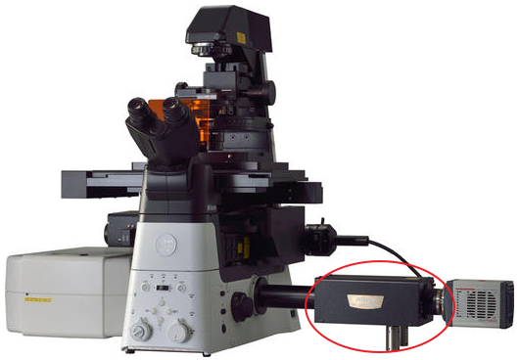
installing OptoSplit III will result in very long emission path. This will require more space for the microscope assembly. After all, this will be a much more expensive solution to what we have already achieved. Overall, our manuscript about providing a practical guide of building such a setup in a reduced cost, so we changed the title to,
< A practical guide to Merging merge multiple imaging modules into one fluorescence microscope>.
- The home-made laser module is a conventional solid laser module with conventional wavelengths. There is no particular tricks for this part. Alternative with commercially available modules such as Omicron, Oxyus and probably others has to be noticed since I'm not sure that the time of implementation, the ease of use, the service and eventually the cost goes for a home-made solution. → The initial cost will be very different. We didn’t check many different products, but
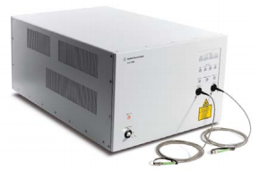such a system (Agilent MCL400B, for N-STORM) costs a lot more ($102,000, if purchased from Nikon.) than all of our lasers and fiber optics components. Our homebuilt laser module is very stable, and needs negligible maintenance, if any. We assume the most challenging part would be the initial fiber coupling alignment. If one was never experienced in fiber coupling, that will require some time to get trained. However, there are plenty of online learning resources, like Youtube. Once trained, then the whole laser module will take less than a weak to build. Then controlling the lasers through TTL and analog outputs are mostly trivial, through National Instruments’ Data Acquisition Card and a program that controls the card (in our case, NIS-Element).
Another issue of a multiline laser box is that their power range may not be optimal for SMLM. For SMLM, the 405 nm laser has to be weak, and its power should be modulated from 0~5mW very precisely. On the other hand, 561 nm or 647 nm lasers need to be much stronger, at least 50 mW or higher (powers denoted after fiber coupling). We found some multiline laser boxes don’t satisfy this power range requirement.
Examples:
https://www.coboltlasers.com/lasers/multi-line-laser/ (mostly 50 mW for all wavelengths)
https://edge.coherent.com/assets/pdf/COHR_OBIS_CellX_DS_0117_3.pdf (50mW is the minimal power for 405 nm laser, and all the other lasers have the same power.)
Direct power modulation of a solid state laser is not very reliable under 10% of its maximum power, so unless a 405 nm laser is weak from the very beginning, modulating it in fine scales requires additional instruments like AOTF, resulting in increased cost as Agilent MCL400B which includes AOTF internally.
- In the excitation part, the authors present the possibility to change from TIRF to wide field using lasers. To have a larger field of view, it necessitates an additional expander. But in fact this part is not so trivial, since there is usually interference fringes on the field and Koller adjustments are not straight forward. What about fringes in your prototype? This has to be discussed. What advantages between the laser and conventional lamp? From my experience, a liquid fiber is sufficient to remove the coherence of the laser and to have really nice wide field illumination (using the conventional Koller port of the microscope. → As far as the design is correct for the mag lens, there isn’t any interference patterns or fringes in our epi-imaging. We asked Nikon to provide necessary dimensions for the illumination arm slot. We built our custom mag lens based on Nikon’s own mag lens. Theirs however can only shrink the laser beam, since it could not be placed in the opposite direction like ours. Our design can either expand or shrink the beam.
We didn’t point out the advantage of laser over conventional lamp in the report. However, in our tests, lasers provide ‘cleaner’ images in general, with noticeably better signal compared to the background. Here is an example.
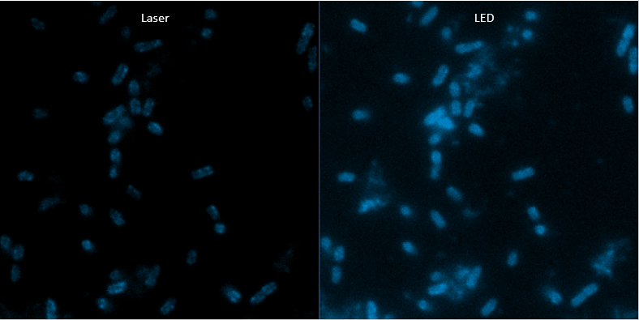
In these two images, the same sample (an inner membrane protein in E.coli cells) area was imaged with exactly same camera condition (100 ms exposure time and maximum gain). The contrast of these images are same so they can be compared side by side. Laser illumination was in Epi mode, with the use of mag lens, to be comparable to LED light.
The laser illumination clearly reveals the membrane localization of this protein. However with LED, the details are more smeared. We attribute this different to the monochromatic nature of laser, so that the emission is in general cleaner, not contaminated by the excitation light of many wavelengths.
Also lasers can provide stronger excitation. In the left image we only used 14% of the laser power, while for LED we used 100%. If a sample isn’t bright enough to be well imaged by LEDs, a laser excitation (with the presence of oxygen scavenger, and just one frame image) can reveal more details.

- For the emission part, only the slide for spherical lens is an addition to other conventional TIRF microscopes. It is not clear for me what makes more… Moreover, the implementation of the multicolor is probably the interesting part since it is not so trivial. What is the difficulties to find the same corresponding pixel? What is the impact for single molecule detection? Is there the same resolution at different wavelength? What about the z resolution at different wavelength? Is the z-focus the same? All these aspects are not controlled and discussed in the result section. → We added the details of multicolor SR imaging in the protocol part (in section 5.7).
< In the case of two-color imaging, always conduct imaging fluorophores with longer excitation wavelengths to shorter wavelengths, since excitation spectrums have longer tails toward shorter wavelengths.
NOTE: Chromatic aberration should be corrected between images with different fluorophores, e.g., Alexa Fluor 647 and Cy3B. Here are the steps.
    - Immobilize multiple 100 nm multichannel beads on the glass coverslip, avoiding forming clusters.
    - Take images of them in different excitation channels.
    - Extract their (X,Y,Z) coordinates by a software (section 5.6).
    - Plot ΔX_{i}=X_{1i}-X_{2i} and ΔY_{i}=Y_{1i}-Y_{2i} (i is for different beads, and 1 and 2 are different color channels) respectively, and fit with proper functions. Save the functions.
NOTE: Linear functions are sufficient for most cases. Once these functions are determined, this kind of measurement doesn’t have to be repeated each time of imaging.
    - In the actual two-color SR imaging of a sample of interest, apply the functions to correct (X,Y) chromatic aberration. For z-directional chromatic aberration, conduct it by obtaining ΔZ=Z₁-Z₂ for multichannel beads or known reference multichannel samples seeded together with the sample of interest.
NOTE: Unlike (X,Y) chromatic aberration, z-directional chromatic aberration is not well reproducible in each experiment, mainly due to incomplete z-directional focus maintenance upon channel shifting. Thus it is recommended to conduct the correction each time. ΔZ=Z₁-Z₂ is mostly independent of (X,Y), so just a few beads or reference samples would be sufficient per each sample area of interest. Plot the finally constructed two-color SR images in Matlab or VMD (Visual Molecular Dynamics) and check ΔZ manually.
>
We didn’t add any more figures, but the procedure was done by firstly obtaining TetraSpeak beads images, 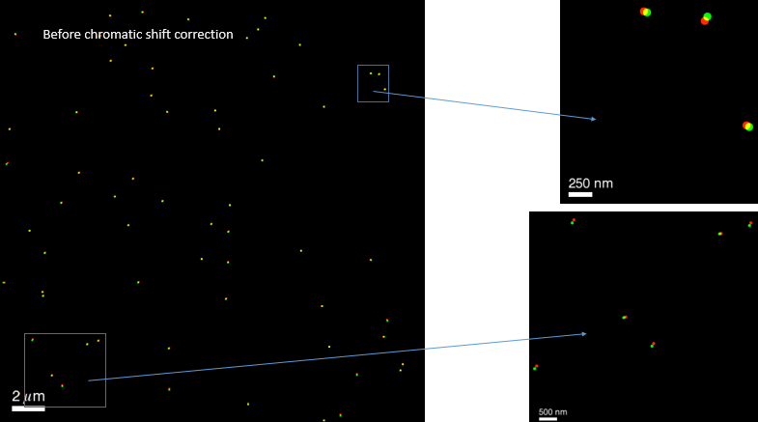
Then plotting ΔX and ΔY in Origin Pro.
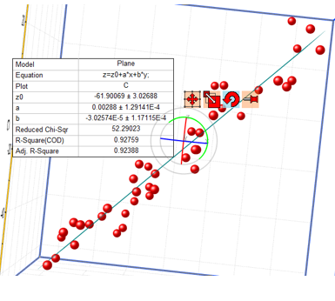 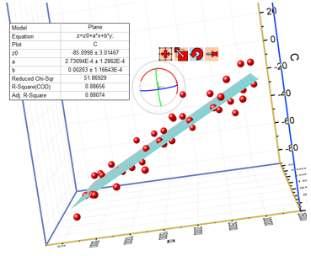 (left one is ΔX, right one is ΔY) The bottom plane of these plots is X-Y plane.
Then applying these functions yield corrected images between two channels.
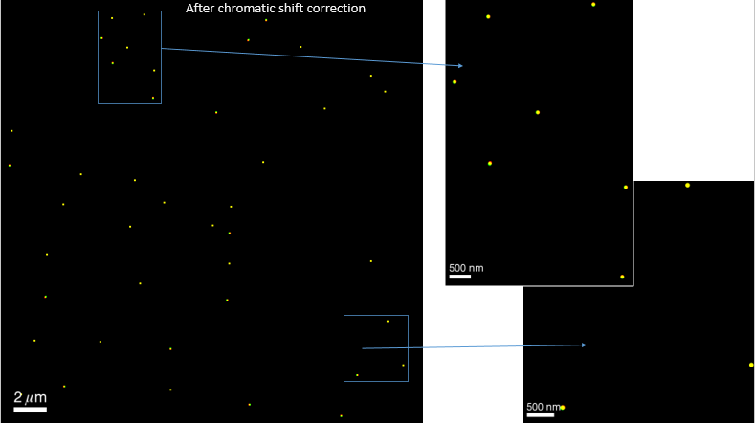

As far as there are these reference samples in the test sample (so immobilize beads to the test sample before imaging), then it is not difficult to align the two channels. Single molecule detection is mostly unaffected, since the beads are not ‘too’ bright to saturate the pixels, even with high laser powers. Also over time they photobleach too (getting dimmer), making them easier to be picked by the analysis software. We assume they have similar XY resolution since the brightness and blinking behavior of Alexa Fluor 647 and Cy3B are comparable. We assume they have very similar Z resolution, since they showed very similar calibration curves (Single molecule PSF width_{x} and width_{y} as the function of z). To prove the points, we labeled the same mRNAs in E.coli cells with different sets of FISH probes (one set with Alexa Fluor 647 and the other with Cy3B or Alexa Fluor 568), and confirmed that the RNA localization distributions are similarly sized between two channels. Z-focuses are not the same. We added this text,
< Unlike (X,Y) chromatic aberration, z-directional chromatic aberration is not well reproducible in each experiment, mainly due to incomplete z-directional focus maintenance upon channel shifting… (skip) Plot the finally constructed two-color SR images in Matlab or VMD (Visual Molecular Dynamics) and check ΔZ manually. >
The correction has to be done for each set of two-color images. We use VMD to plot the final localizations and correct ΔZ.

- The part of software control is not presented in details. Authors choose NIS-element. Is it the only one? There is no details about the laser control? Is it through a DAC card? Which one? Is it possible to drive it with other software? Moreover, there is no details concerning the data analysis which is crucial for SR imaging.What about the module for data analysis (JOBS)? Is it online analysis? What is the algorithm for SML? How to implement it for multicolor? →Details about laser controls through DAC cards are put in the protocol section 1.1.4. PCI-6723 (National Instrument) was used, and is listed in the Materials Table. Of course it is possible to drive all the hardware parts of the microscope by alternative software, like Micro-Manager or Metamorph. However, the feature we wanted the most, the automated modulation of violet laser (explained in 5.4, and the second last paragraph in Discussion, as well as Figure 6 caption) was not readily achievable by Micro-Manager or Metamorph at that time when we built the setup. That’s why we ended up using NIS-Element’s JOBS feature. It is not online analysis. The algorithm of SMLM is based on the original STORM paper and 3D STORM paper, and these are referred multiple times in the text.
Rust, M. J., Bates, M. & Zhuang, X. Sub-diffraction-limit imaging by stochastic optical reconstruction microscopy (STORM). Nature Methods 3 (10), 793–795, doi:10.1038/nmeth929 (2006).
Huang, B., Wang, W., Bates, M. & Zhuang, X. Three-dimensional super-resolution imaging by stochastic optical reconstruction microscopy. Science 319 (5864), 810–813, doi:10.1126/science.1153529 (2008).
Fei, J., Singh, D., et al. RNA biochemistry. Determination of in vivo target search kinetics of regulatory noncoding RNA. Science 347 (6228), 1371–1374, doi:10.1126/science.1258849 (2015).

Prof. Taekjip Ha (JHU) has the copyright of the modified version of the code, so one can ask him for the code.
For multicolor, almost the same automated acquisition code can run, except that the imaging laser is different. (Section 5.7)

- Finally, the authors present "representative results" for widefield, SR image and smFRET. But there is no any details of the different protocols used for it. What about excitation/emission wavelengths? What abourt the preparation of the specimens? If the manuscript is a protocol, then you need to give the protocol for the obtained images… there is no details about SR imaging. Is it storm? Which fluorophore? Which sample preparation? What about the data analysis? And it is the same problem for smFRET. This part should be more detailed. → Our intention of writing this report was providing protocols of building the microscope modules and operation procedures. For the actual sample preparations, we used FISH for labeling, and all the general methods are referred to previous publications. The excitation wavelengths and fluorphores are also specified (In “Representative Results” as well as Figure 5, 7, and 8 captions). For SR imaging, added the text,
< NOTE: This is single-molecule detection based SR microscopy. >
Indicating that this is STORM/PALM type imaging. Fluorophores for STORM imaging was Alexa Fluor 647 for the example, and added in Figure 5 caption. Data analysis is referred to the original STORM paper as well as 3D STORM paper (Rust et al, and Huang et al.) For smFRET, we specified that the measurement was for folded RNA molecules. For all the exemplary samples, we didn’t give further details because they are yet unpublished results.

