

July 12, 2018

Dear JoVE,

We are submitting the second revision of JoVE58297. In the revised manuscript and our rebuttal document, we have addressed all the Editorial comments.

Author contributions: Shino Mitsunaga and Toshi Shioda wrote the original and revised manuscript. Shino Mitsunaga, Keiko Shioda, and Toshi Shioda executed the described experiments and examined accuracy of the protocol. Jacob Hanna, Kurt Isselbacher, and Toshi Shioda confirmed scientific accuracy of the manuscript.

Submission of this manuscript was assisted by Dr. Nandita Singh, Senior Science Editor of JoVE.

Sincerely,

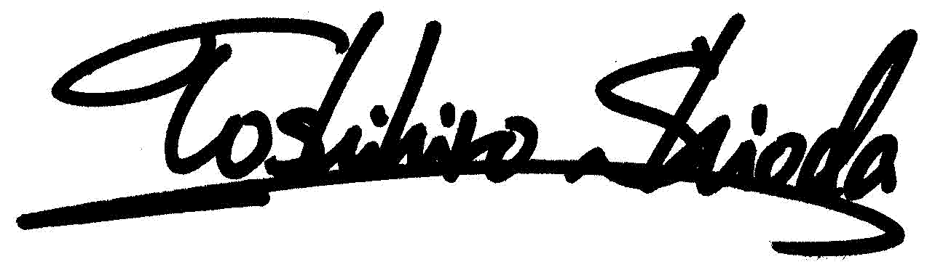
Toshihiro Shioda, MD, PhD

