Submission ID #: 58290

Editor Name: Maja Fiket
Videographer name: Benoît Dietrich

Film Date: August 31. 2018

Link: https://www.jove.com/account/file-uploader?src=17778498

Authors and Affiliations: Camille Forny¹, Romain Sube¹, Eric A. Ertel¹

¹Department of Pharmacology and Preclinical Development, Idorsia Pharmaceuticals Ltd., Allschwil, Switzerland

Title: Contractions of Human-iPSC-derived Cardiomyocyte Syncytia Measured with a Ca-sensitive Fluorescent Dye in Temperature-controlled 384-well Plates

Corresponding Author:

Eric A. Ertel

eric.ertel@idorsia.com

Co-authors:

Camille Forny
camille.forny@idorsia.com

Romain Sube
romain.sube@idorsia.com

Screen Captures for Software Usage

4. Data Acquisition and Analysis

Note: 4.1 and 4.2 must be added before 4.3 (previously 4.1). The following steps will also need some modifications as shown.

4.1. Start the plate reader software and load the pipet tips. [1-SCREEN]

4.1.1. Talent starting the software and loading the pipet tips.
01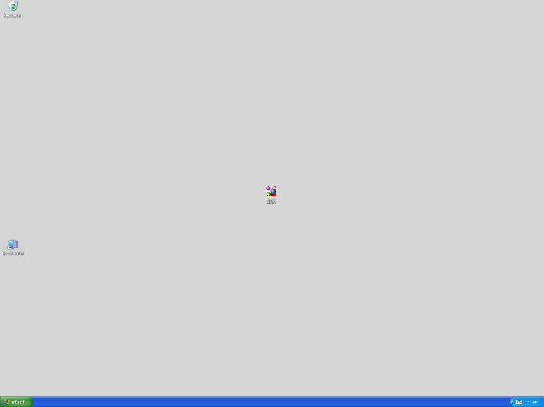 changes to 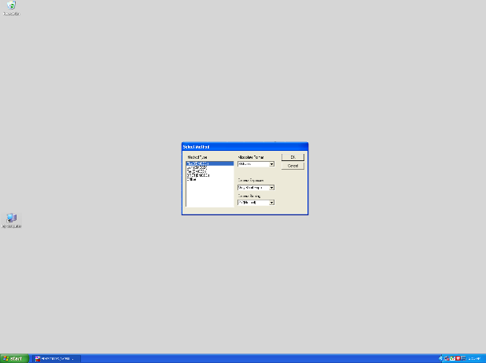02
Mouse on software icon, then double-click
02 changes to 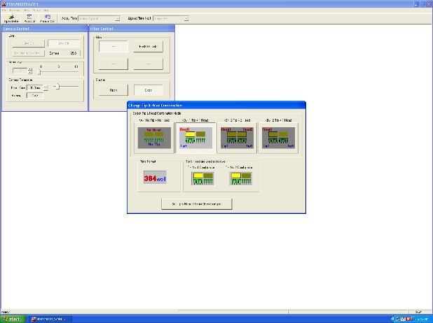03
Select the option shown in "Select Method", then click OK and robot door opens automatically,
then place the pipet tips in the plate reader
(making sure the correct pipeting head is in place)
(is it possible to overlay the following on the rightmost screen capture?
"Robot door opens automatically, place pipet tips in the plate reader,
and make sure the correct pipeting head is in place")
03 changes to 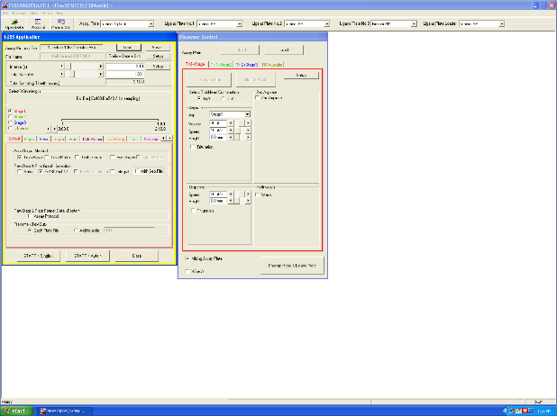04
Select the options shown in "Change Tip & Head Combination", and robot picks up the tips automatically
then click "Set Tip & Head"
(is it possible to overlay the following on the rightmost screen capture?
"Robot door picks up the tips automatically")

4.2. Adjust the software settings to record a 2-minute segment of Calcium waves with an acquisition frequency of at least 10 Hertz to define the baseline beating rate for each well. [1-SCREEN]

4.2.1. Talent adjusting settings to record a 2-min segment of Ca waves with an acquisition frequency of at least 10 Hz.
04 switch tab 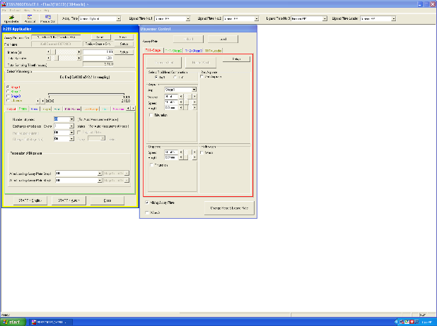05 tab
Select the options shown in "FDSS Application" one tab after another (10 tabs)
06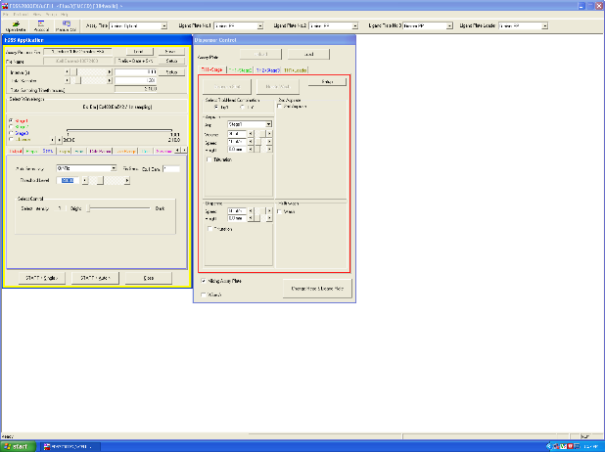 switch tab 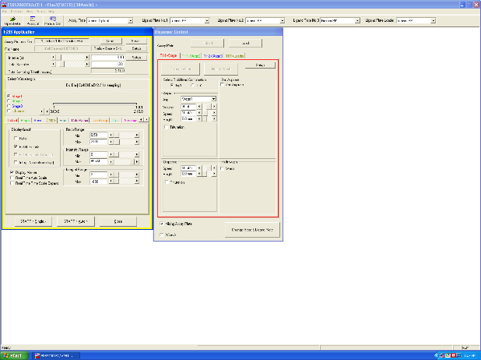07 tab
08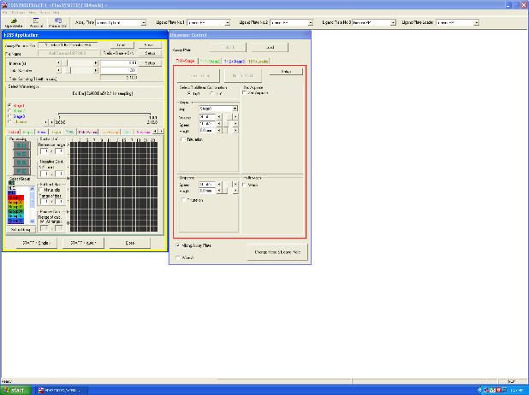 switch tab 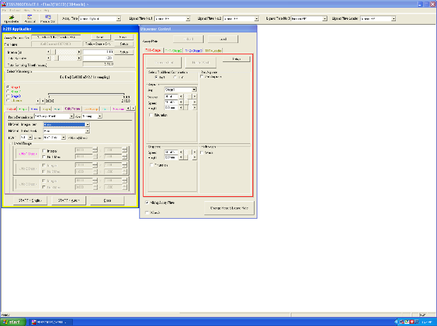09 tab
10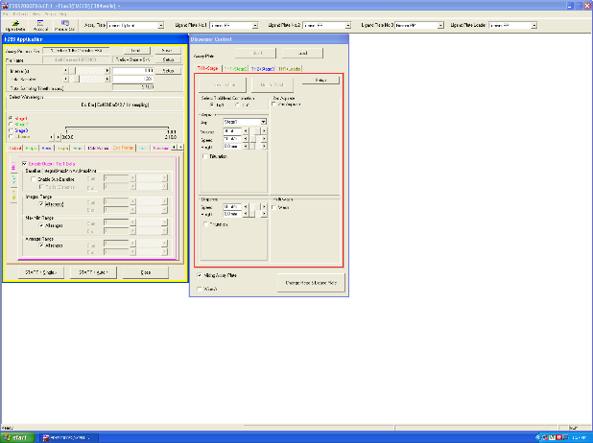 switch tab 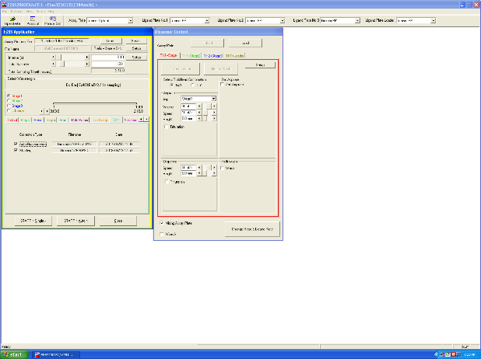11 tab
12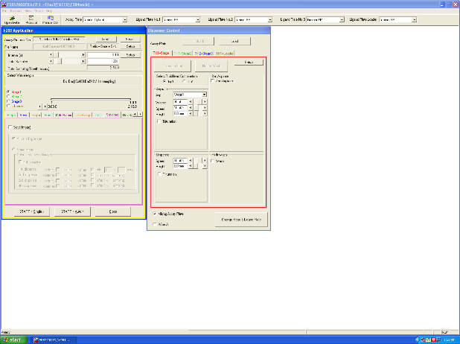 switch tab 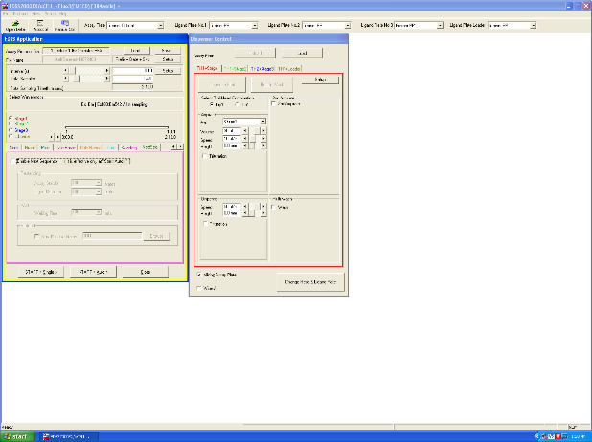13

4.3. To make fluorescence medium for each cell plate dilute 3 mL of stock fluorescence medium with 12 mL of warm maintenance medium with antibiotics. [1-MED] Replace 20 microliters of medium in each well of the cell plate [2-CU] with 30 microliters of fluorescence medium and mix by pipetting up and down once. [3-CU]

4.3.1. Talent diluting the fluorescence medium.

4.3.2. Talent removing 20 μL from a few wells.

4.3.3. Talent adding fluorescence medium to a few wells.

4.4. Immediately after that place the plate into a plate reader in order to let the hiPSC-CMs adjust to the reader temperature for 60 minutes [1-MED] [2-SCREEN] and verify that the Cell Plate is well-positioned for recording [3-SCREEN]. Then start the plate reader software. [2- MED-over the shoulder] Record a 2-minute segment of Calcium waves with an acquisition frequency of at least 10 Hertz to define the baseline beating rate for each well. [3-SCREEN]

4.4.1. Talent placing the plate onto the robot loader.

4.4.2. Talent using the software to move the plate into the reader.
13 changes to 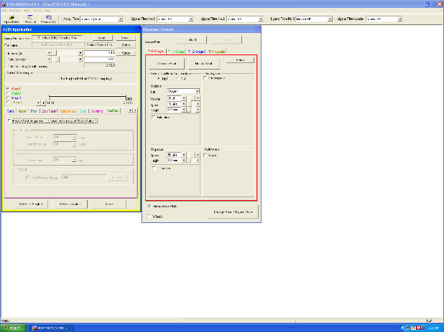14
Move mouse to "Dispenser Control" and Click "Load"
(is it possible to overlay the following on the leftmost screen capture?
"After having placed the Cell Plate onto the robot loader")
and the following on the rightmost screen capture?
"The robot picks up the Cell Plate and moves it inside")

4.4.3. Talent using the software to verify that the Cell Plate is well-positioned.
14 changes to 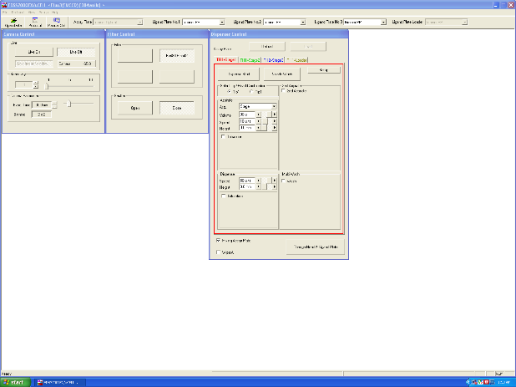15
Mouse Click "Manual Ctrl"
15 changes to 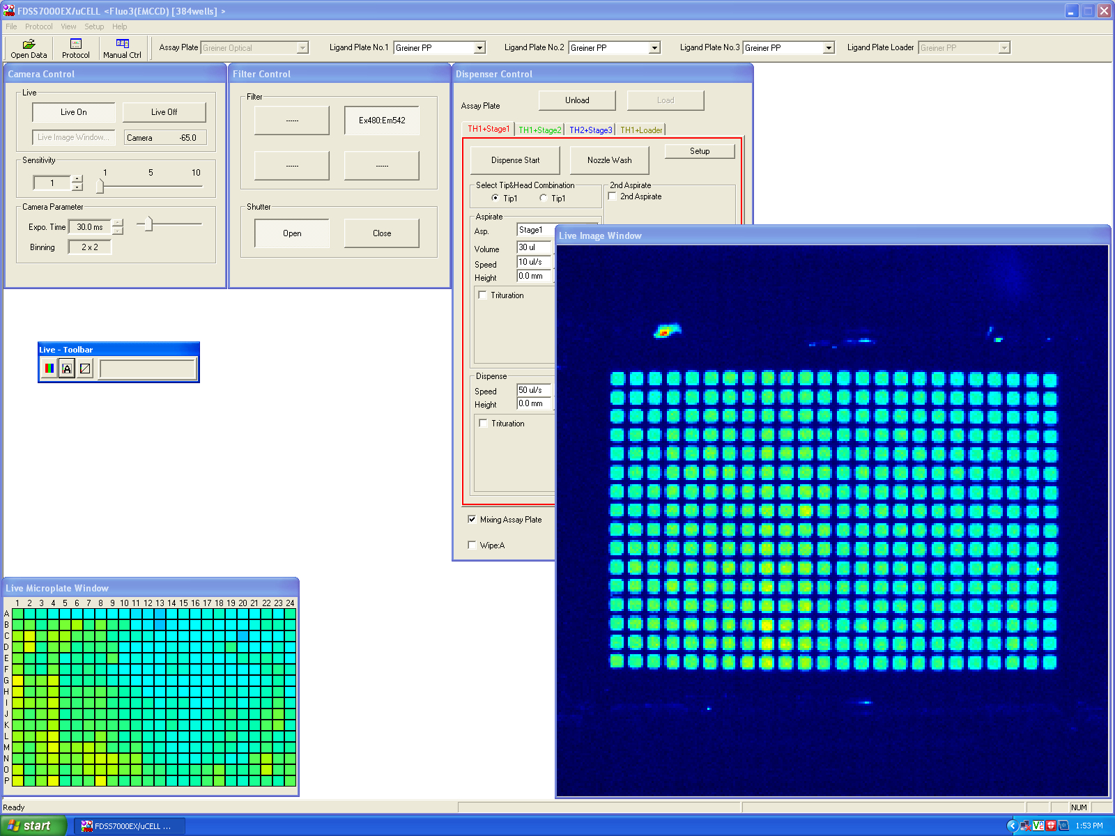16
Mouse Clicks "Live On" and "Shutter Open"
(is it possible to overlay the following on the rightmost screen capture?
"The Cell Plate is well-positioned if the Live Image window shows round homogenous wells")
16 changes to 17
Mouse Clicks "Live Off" and "Shutter Close"
17 changes to 18
Mouse Click "Protocol"

4.5. After waiting 60 minutes, record a 2-minute segment of Calcium waves. [1-SCREEN]

4.5.1. Talent recording a 2-minute segment of Calcium waves.
18 changes to 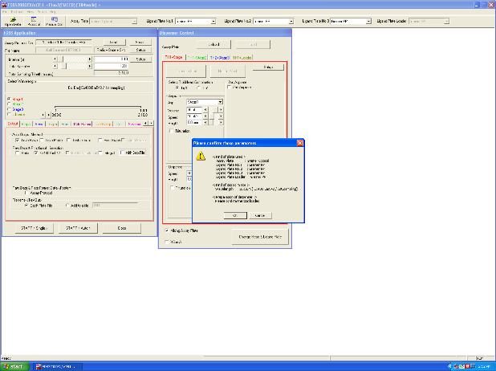19
Mouse Click "Start Single"
19 changes to 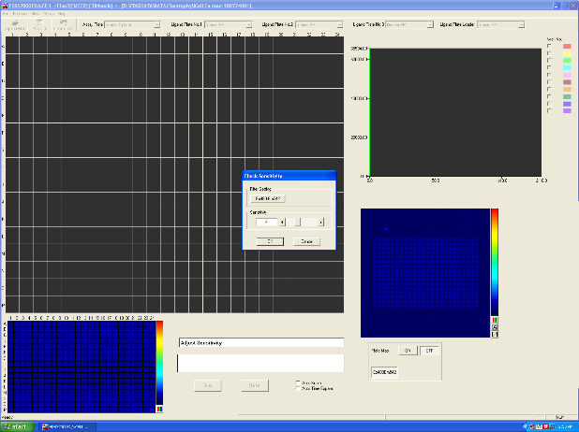20
Mouse Click "OK"
20 changes to 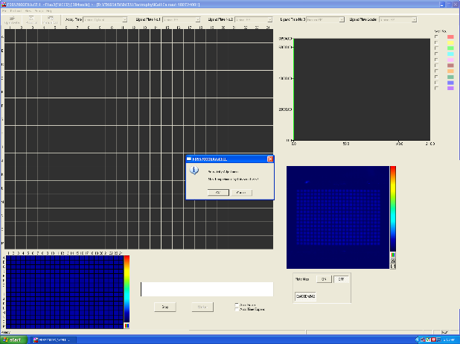21
Mouse Click "OK"
21 changes to 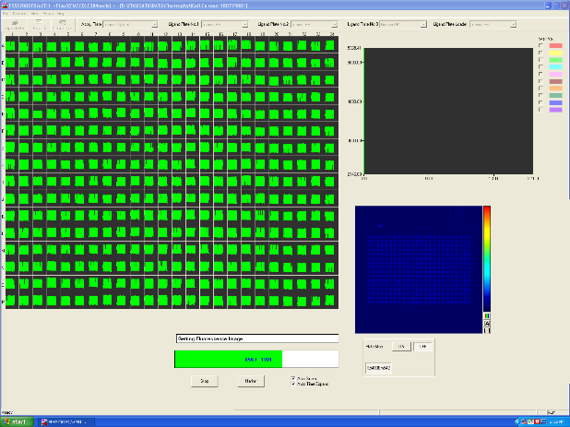22
Mouse Click "OK" with the progress bar advancing
22 changes to 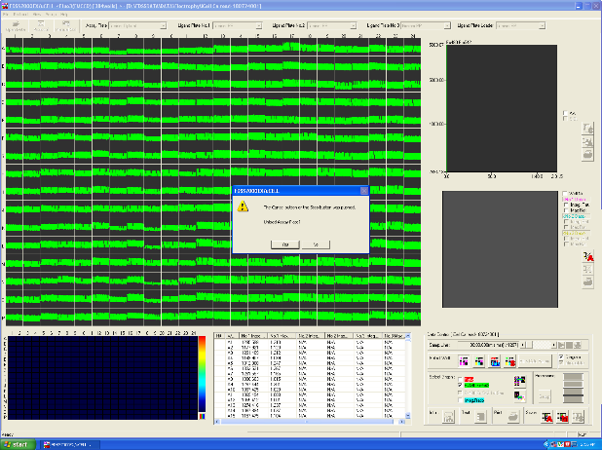23
Mouse Click "Stop"
(is it possible to overlay the following on the leftmost screen capture?
"Once the progress bar has exceeded 1200 frames (2 min)
but before it reaches the end,
Press "Stop" ")
23 changes to 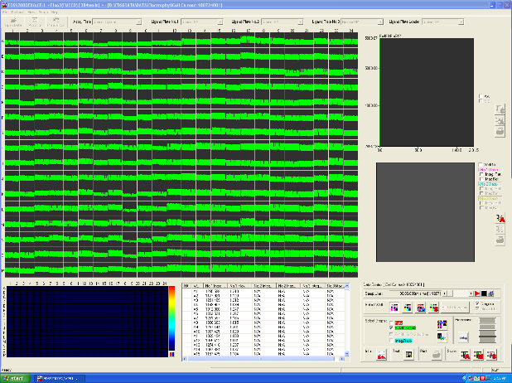24
Mouse Click "No"
(is it possible to overlay the following on the leftmost screen capture?
"It is very important to press "No" ")
24 changes to 25
Mouse Click "Protocol"

4.6. Camille Forny: “It is very important to make sure the Cell Plate is not transferred out of the device after data acquisition. With some software versions, you must stop each recording before it ends completely.”

4.6.1 Camille Forny saying the above, interview style.

4.7. Adjust the plate reader robot to pipette 5 microliters of the test and reference compounds well-to-well from the compound plate into the cell plate [1-MED-TXT] [1-SCREEN]. Then start the compound application [2-SCREEN]

4.7.1. Talent adjusting settings to pipette from the compound plate into the cell plate.
26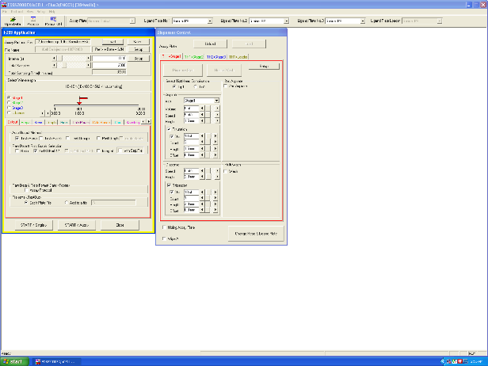
Select the options shown in "FDSS Application" and in "Dispenser Control"

4.7.2. Talent starting the robot. TEXT: DMSO concentration: 0.3% [v/v]
26
Mouse Click "Start Single"
(is it possible to overlay the following on the leftmost screen capture?
"The robot will start recording the Calcium waves and apply the compounds to the cells.
As before, it is important to stop the recording before it ends automatically.
Note that this recording will not be used for the analysis.")

4.8. Re-adjust the plate reader robot to record Ca waves without pipetting from the compound plate into the cell plate [1-MED-TXT] [1-SCREEN]. Then start the data acquisition in the plate reader software to record 2-minute segments of Calcium waves starting at 5, 15, 30, 45, and 60 minutes after the compound addition. [2-SCREEN-TXT]

4.8.1. Talent adjusting settings to stop pipetting from the compound plate into the cell plate.
27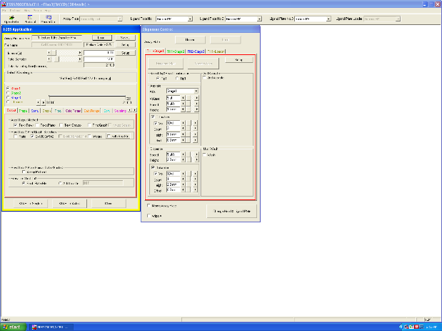
Select the options shown in "FDSS Application"

4.8.2. Talent starting the robot setting the software to record 2-min segments of Ca waves starting at 5, 15, 30, 45, and 60 min. TEXT: Cell plate should stay in the reader
28
Mouse Click "Start Single"
(is it possible to overlay the following on the leftmost screen capture?
"The robot will start recording the Calcium waves.
As before, it is important to stop the recording before it ends automatically.
Note that this is not necessary for the last recording
since the Cell Plate must be off-loaded anyway.")

4.9. To start data analysis, export the raw data for each recording period from the plate reader software as ASCII (pronounce askee) text files, [1-SCREEN] and then import them into data analysis software. [2-SCREEN]

4.9.1. Talent starts exporting the raw data as ASCII text files.
29 changes to 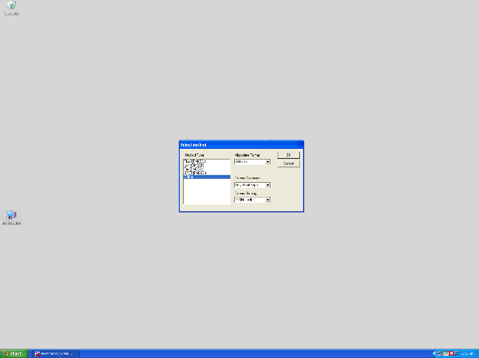30
Mouse on software icon, then double-click
30 changes to 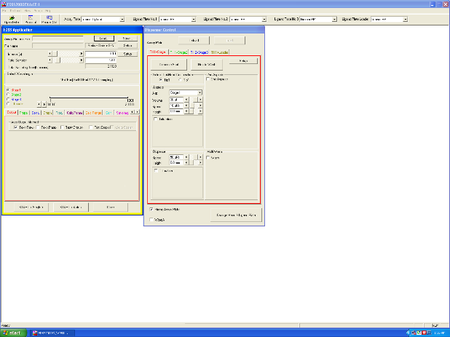31
Select the option shown in "Select Method", then click OK
31 changes to 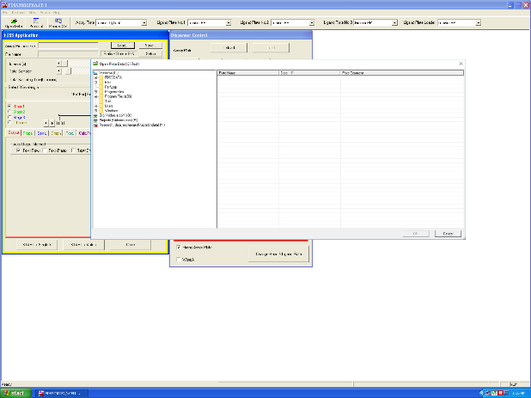32
Mouse Click on "Open Data"
32 changes to 33
Find the 1st file saved during the acquisition and open it
33 changes to 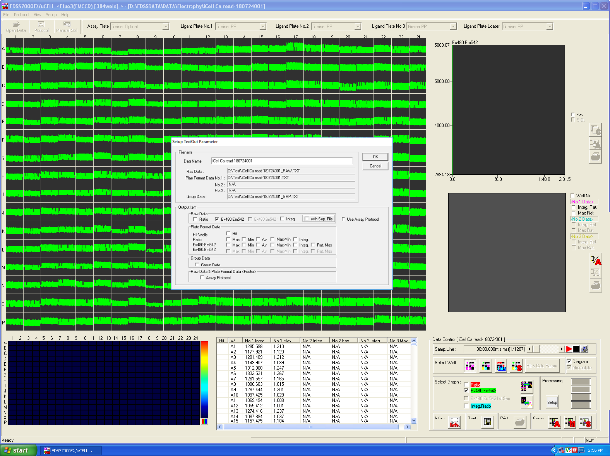34
Mouse Click on "Text" (bottom right)
(is it possible to overlay the following on the leftmost screen capture?
"Verify the filenames and locations for the Export files")
34 changes to 35
Mouse Click on "OK"
(is it possible to overlay the following on the rightmost screen capture?
"Repeat for the 6 acquisition files.")

4.10. Import the raw data into data analysis software [1-SCREEN]. For each recording period, extract the primary beating frequency for each well and export them as clipboard copies [2-SCREEN]. Then, import the primary beating frequency for each well into a spreadsheet software by clipboard pasting [3-SCREEN]. Finally, continue the data analysis as described in the text protocol.

4.9.1. Talent starts importing the raw data into data analysis software.
36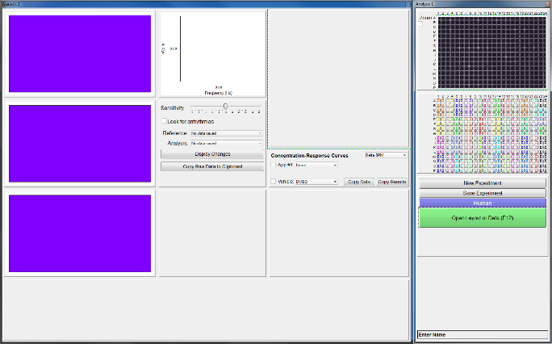 changes to 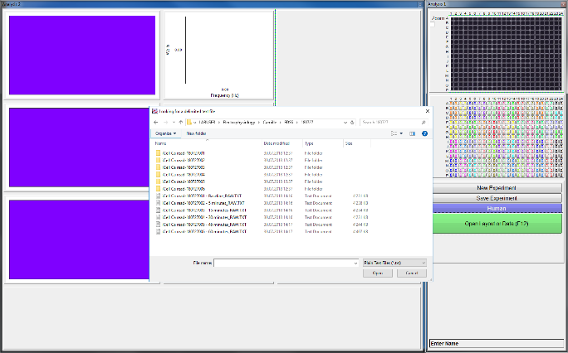37
Once the data analysis software and the spreadsheet software are started,
Mouse Click on "Open Layout or Data"
37 changes to 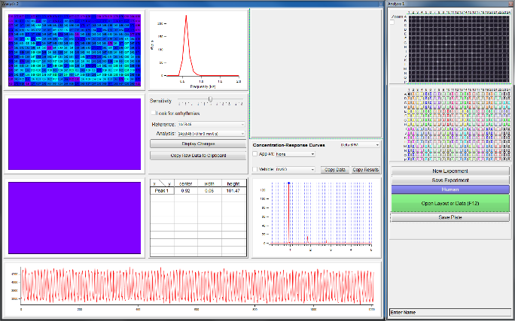38
Select the first exported text file then "Open"

4.9.2. Talent extracts the primary beating frequency for each well and every time point and exports the primary beating frequencies for each recording period. TEXT: Refer to text to calculate beating frequencies.
38 no change 38
Mouse Click on "Copy Raw Data to Clipboard"

4.9.3. Talent imports the primary beating frequencies into a software.
39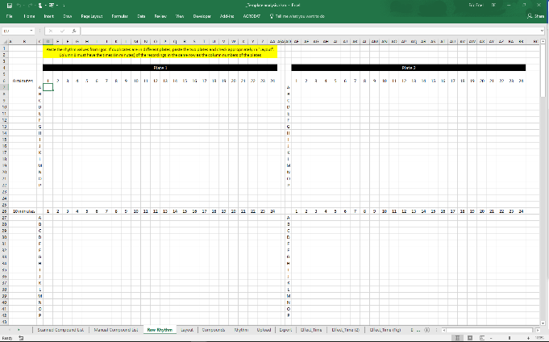 changes to 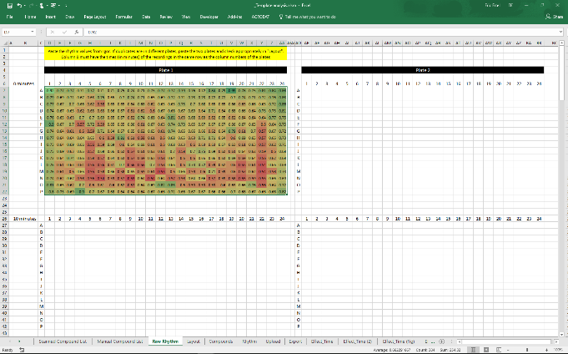40
In the spreadsheet software,
Paste the Clipboard into a new document
(Mouse Click in D7 Paste)
(is it possible to overlay the following on the rightmost screen capture?
"Repeat "Copy Raw Data to Clipboard" and "Paste"
for the 6 raw data files.")

