The following link to the editorial policy gives permission from previous publication (reference 18) to reuse Figure 2A, 3A, 3B, 4A – D in this manuscript. A screen capture of the link is also given below.
https://s100.copyright.com//App/checkLoginCas.jsp?service=https%3A%2F%2Fs100.copyright.com%2FAppDispatchServlet%3Fauthor%3DAnna%2520K.%2520van%2520Koeverden%252C%2520Zheng%2520He%252C%2520Christine%2520T.%2520O.%2520Nguyen%252C%2520Algis%2520J.%2520Vingrys%252C%2520Bang%2520V.%2520Bui%26contentID%3D10.1038%252Fs41598-018-25264-4%26imprint%3DNature%26issueNum%3D1%26oa%3DCC%2520BY%26orderBeanReset%3Dtrue%26publication%3DScientific%2520Reports%26publicationDate%3D2018-05-08%26publisherName%3DSpringerNature%26title%3DSystemic%2520hypertension%2520is%2520not%2520protective%2520against%2520chronic%2520intraocular%2520pressure%2520elevation%2520in%2520a%2520rodent%2520model%26volumeNum%3D8

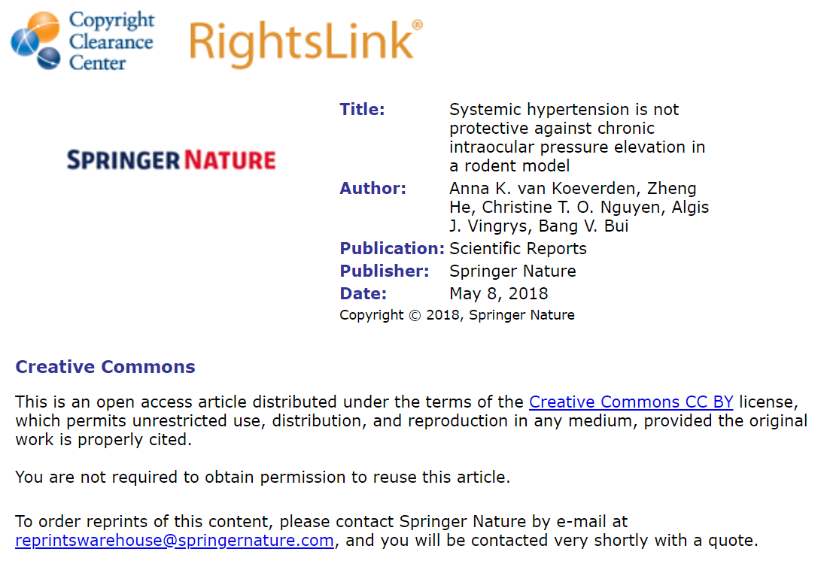

The following link to the editorial policy gives permission from previous publication (reference 16) to reuse Figure 2B, 3C, 3D, 4E – H in this manuscript. A screen capture of the link is also given below.
https://www.frontiersin.org/articles/10.3389/fnins.2017.00041/full

