Dear editor and reviewers,

Thank you very much for reviewing our manuscript. We appreciate the helpful and constructive comments from the editor and the reviewers. We have responded to all comments raised by the editor and the reviewers, and revised the manuscript accordingly. The title of the manuscript has been changed to “Measurement of ion concentration in the unstirred boundary layer with open patch-clamp pipette – implications in control of ion channels by fluid flow” from “Protocols for fluid shear force-regulation of ion channels in patch clamp recordings.” We hope that JOVE will find this revised manuscript acceptable.

Editorial comments:
Changes to be made by the Author(s):
1. Please take this opportunity to thoroughly proofread the manuscript to ensure that there are no spelling or grammar issues. The JoVE editor will not copy-edit your manuscript and any errors in the submitted revision may be present in the published version.
Answer) Thank you for the kind comment. We have proofread the manuscript which was edited by a professional English editor.
2. Please revise lines 92-99 and 192-197 to avoid previously published text.
Answer) Thank you. The lines have been revised.
3. Please obtain explicit copyright permission to reuse any figures from a previous publication. Explicit permission can be expressed in the form of a letter from the editor or a link to the editorial policy that allows re-prints. Please upload this information as a .doc or .docx file to your Editorial Manager account. The Figure must be cited appropriately in the Figure Legend, i.e. “This figure has been modified from [citation].”
Answer) Thank you for the comment. We have uploaded the permission information file.
4. Please upload each Figure individually to your Editorial Manager account as a .png or a .tiff file.
Answer) Thank you. The figures have been uploaded as suggested.
5. Please obtain explicit copyright permission to reuse any figures from a previous publication. Explicit permission can be expressed in the form of a letter from the editor or a link to the editorial policy that allows re-prints. Please upload this information as a .doc or .docx file to your Editorial Manager account. The Figure must be cited appropriately in the Figure Legend, i.e. “This figure has been modified from [citation].”
Answer) Thank you for the suggestion. Your instructions have been followed.
6. Figures: Please line up the panels better. Some panels are off-set in Figure. Please ensure that the panels are of the same dimensions if possible. Please also use consistent font size among panels in the same figure, if possible.
Answer) Thank you for the kind comment. We have edited the figure accordingly.
7. Figure 2: Please change “ml” to “mL” in figure.
Answer) Thank you. This has been corrected.
8. Figure 3: Please change “ml” to “mL”, and “sec” to “s” in figure.
Answer) Thank you. They have been corrected.
9. Please include a space between all numbers and their corresponding units: 1 M, 15 mL, 37 °C, 60 s; etc.
Answer) Thank you. They have been corrected.

10. Please remove all commercial language from your manuscript and use generic terms instead. All commercial products should be sufficiently referenced in the Table of Materials and Reagents.
For example: Warner Instruments, etc.
Answer) Thank you for the suggestion. This has been done.
11. 1.2.3: Please specify the temperature used.
Answer) Thank you for the comment. The temperatures have been specified.
12. 2.5: Please describe how the flow rate is measured.
Answer) Thank you. This has been described.
13. 5: The Protocol should contain only action items that direct the reader to do something. Please move the discussion about analysis of outcome to the Results or Discussion section.
Answer) Thank you. This section has been moved.
14. Please discuss all figures in the Representative Results. However for figures showing the experimental set-up, please reference them in the Protocol.
Answer) Thank you for the suggestion. Your instructions were followed.
15. As we are a methods journal, please revise the Discussion to explicitly cover the following in detail in 3-6 paragraphs with citations:
a) Critical steps within the protocol
b) Any modifications and troubleshooting of the technique
c) Any limitations of the technique
d) The significance with respect to existing methods
e) Any future applications of the technique
Answer) Thank you. We have edited the discussion to cover the items.
16. References: Please do not abbreviate journal titles.
Answer) Thank you. This has been corrected.
Reviewers' comments:
Reviewer #1:
Manuscript Summary:
This manuscript describes a well know method to generate salt-bridges for grounding electrophysiology bath chambers. The authors report flow over the surface of the wire electrode results in an voltage offset. They extend this to suggest such an offset arises due to convective flow. They describe the use of a salt-bridge to remove the effect. The authors describe shear induced ion channel changes as due to an artifact. This artifact is from a calculation(Fig.5) of how convective flows alter the ionic concentrations at the proximity of ion channels. The authors propose that observed shear induced changes in ion channel conductance arise due to this artifact.
Major Concerns:
General Comments:
1.Convective flow effects on cellular boundary layer ionic concentrations are not an experimental artifact. Boundary layers are real phenomena of cellular solutions. If convective flow alters boundary layers, the effect should be more accurately described as a potential mechanism of shear alters ion channel behavior. If this hypothesis is true, then any ion channels subjected to flow and sensitive to ionic conditions would be expected to show responses to flow. However, multiple ion channels, sensitive to ionic concentrations, do not respond to shear stress. Examples of shear stress insensitive ion channels include ROMK (Shi et al., J. Biol. Chem. 291(27)p14012 (2016)); epithelial sodium channel mutations alter the responses to flow (Carattino et. al., J. Biol. Chem. 280 (6) p4393 (2005)); MEC-10 mutations alter shear responses (Shi et.al., J. Biol. Chem. 291(27) p14012 (2016); Kv1.1 (Hoger et.al., Proc. Natl. Acad. Sci. USA. 99(11) p7780 (2002)) and CFTR (Vitzthum et.al., Biochim. Biophy. Acta 1848 p 2942 (2015)). Additional shear stress mechanisms have been reported to include shear induced assembly of Kv1.5 (Boycott et al., Proc. Natl. Acad. Sci. USA. 110(41) E3955 (2013)) and intracellular calcium response of TrpM4 (Son et.al., J. Physiol. 594.11 p2985 (2016)). These examples of channels insensitive to shear are difficult to reconcile the proposed shear response hypothesis of convective flow altered ion layers.
Answer) Thank you for the critical and helpful comment. We understood the concern. In fact, we did not intend to suggest that the boundary layers adjacent to cell membranes are an experimental artifact. Our intention was to suggest that changes of ion concentration in the boundary layer should be considered in interpreting the control of ion current by fluid flow or shear force. However, we feel that the changes in the Cl⁻ concentration in the boundary layer adjacent to the reference electrode are a likely source of experimental errors or artifacts. In order to clarify our contention, we have extensively edited the manuscript, including the title. In regard to the insensitivity of some ion channels to the fluid flow/shear force, a sufficiently fast flow rate through the ion channel pore is required to generate the unstirred flow rate. This point has been discussed in detail in the revised paper as follows:
The unstirred layer effect was originally suggested by Barry and his colleagues¹²⁻¹⁵. Here, we have further provided a way to estimate the real ion concentration in the unstirred layer by measuring changes in junction potential with open patch-clamp pipette. We also suggested that this unstirred boundary layer effect may contribute to fluid flow-induced regulation of ion channel currents and, hence, should be considered while studying fluid flow-mechanosensitivity of ion channels. However, based on this hypothesis, one might ask that if the unstirred boundary layer effect is an electrochemical control, rather than biological, why are some ion channel currents not sensitive to fluid flow-dependent regulation. As briefly addressed above, it is probably because only the ion currents through channels with big enough single-channel conductance and long enough open-time can be facilitated by fluid flow. That is, for the establishment of unstirred layer, in which the ion concentration is different from the average in bulk solution, flux in the membrane phase should be rapid enough compared to that in the aqueous phase¹⁴. We have recently suggested that the current through Kir2.1 channels, whose conductance and open time are high enough, is facilitated by fluid flow via a mechanism of convective restoration of ion concentration in the unstirred boundary layer of cell membrane surface¹¹.
2. Details are described below but modifying solutions with a naked silver chloride electrode will usually result in potential changes. This is not controlled for in the procedures. This could be the source of the voltage offset listed.
Answer) Thank you for the helpful comment. We agree that the changes in ion concentrations, (especially [Cl⁻]) at the junction of the silver chloride electrode will result in the potential changes. As clarified in the revised manuscript, the purpose of the experiment shown in Fig. 3 was to estimate the actual concentrations of [Cl⁻] in the boundary layer. As such, the graph shown in Fig. 3B is a ‘stand curve’ for estimating the real [Cl⁻] in the boundary layer of either reference electrode or cell membrane surface. From the graph in Fig. 3B and data on junction potential changes caused by fluid flow shown in Fig 3A, we may estimate the actual [Cl⁻] in the unstirred boundary layer in the static condition. This concept has been better clarified in the revised manuscript.

Minor Concerns:
1. In Protocol 1, the use of a salt-bridge ground is well established and not a novel technique. Advantages of salt-bridge use are well known for avoiding solution-voltage issues. Changes in solution properties will result in voltage offsets.
Answer) We do agree with this comment. In the revised paper, we have clarified our hypothesis as well as the conclusions.
2. A missing control is a description of controlling chamber fluid depth. If fluid depth is altered by convective flow, then the fluid level on the recording pipette changes. This change can alter the electrical properties of the pipette.
Answer) Thank you for the comment. We did carefully maintain the fluid depth to ~2 mm.
3. The placement of the recording pipette must be down stream of the of the perfusion pipette to minimize turbulent flow over cell surface.
Answer) Thank you. The recording pipette was located downstream of the perfusion pipette. We modified Figure 1A in the revised paper to emphasize this point.
4. Finally, the direct application of flow from a pipette to a cell must have certain parameters met to insure laminar flow (Shi and Carattino, BioProtoc. 7(8) #2224 (2017)). Laminar flow is achieved by keeping the cell within one flow delivery pipette diameter distance from the pipette. The submerged pipe delivers laminar flow only within a short distance of the pipe mouth.
Answer) Thank you for the comment. We do agree that the flow may not be perfectly laminar. We used a commercially available patch-clamp chamber (RC-11 open bath chamber; catalogue # W4 64-0307) from Warner instruments company. Although the chamber may not have supplied ideal laminar flow, we believe that relatively stable laminar flow was applied. To demonstrate the geometry of the patch-clamp chamber more correctly, we have modified Figure 1 in the revised manuscript.
5. Description of flow directed on Ag/AgCl pellet should also describe preparation of pellet by chlorination. Only an adequate chlorinated pellet is a stable electrode.
Answer) Thank you. We agree with the comment. We purchased the Ag/AgCl pellet (catalogue #, EP1) from World Precision Instruments (WPI) company. We have further discussed this issue in the revised manuscript as follows:
In figure 3, we observed that the liquid-metal junction potential between Ag/AgCl reference electrode and bathing fluid was greatly dependent on the condition of the Ag/AgCl electrode. In fact, when the Ag/AgCl electrode was perfect in condition, changes in junction potential due to fluid flow was minimal (data not shown). However, poor chlorination of the Ag/AgCl electrode caused greater shift of the junction potential. Since the Ag/AgCl reference electrode is very susceptible to various external stimuli, such as ultraviolet light and oxidative stress, using an agar or agarose KCl-bridge is always recommended. Although changes in junction potential by fluid flow between bathing fluid and reference electrode is a potential source of experimental error, we could successfully estimate the real ion concentrations in the unstirred boundary layer by measuring the shift of junction potential under various fluid-flow rates (Figure 3A & B).
6. The results in Fig.4 are not an application of the methods described. These second messenger experiments (Fig.4 d) on a different cell line than reported in the literature for Kir2.1. These data are not necessary for communication of this method.
Answer) Yes, we agreed to this comment. Fig. 4d and the related description have been deleted in the revised manuscript.
7. In figure 3b, the experiment changes NaCl concentration. A missing control in these experiments is no correction for liquid-junction potential was described for when a change in NaCl is made. When changing ion concentrations compared to the pipette solution a liquid-junction potential will exist. Normally, these potentials are small. However, when large currents or large ionic solution changes occur (such as described in Fig 3) the potential can be 5-10mV ranges.
Answer) Thank you for the detailed comment. The liquid junction potential between various concentrations of NaCl bathing solution (ranging from 50 to 300 mM) and the 3M KCl-pipette solution has to be negligible. This point has been discussed in detail in the revised manuscript as follows:
The critical point in protocol 4, for preparing the standard curve for the estimation of real Cl⁻ concentration in the unstirred boundary layers from the shift of junction potential, is that the standard curve should be recorded under enough flow rate (30 mL/min, in this experimental setting). Although this flow rate is very fast in practical cases, faster the fluid, smaller is the concentration drop at the boundary layers (Fig. 3). In addition, the open pipette must be filled with high KCl, instead of regular pipette solution, for patch-clamp study to prevent the change in junction potential between the pipette and bathing solution.
Moreover, we added an experimetnal data, which shows minimum junction potetnail changes by the various concentrations of NaCl bathing soution as figure 3C with the following description:
Using a KCl agarose bridge, the junction potential was prevented from changing in a Cl⁻ concentration dependent manner (Fig. 3C), indicating that the junction potential change occurred between the bath solution and the reference electrode, not between the bath solution and pipette solution.
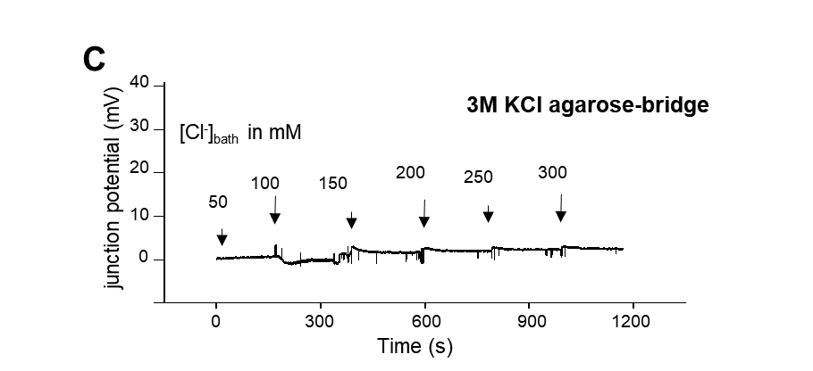

Reviewer #2:
Manuscript Summary:
This manuscript discusses methods for preventing artifacts while studying flow-induced modulation of currents through ion channels. Flow-effect on ion channels has been an area of high-interest for over a decade. Therefore, describing the methodology that will minimize errors in data interpretation and analysis is important. The effect of fluid flow on liquid junction potential was shown by Park et al. in 2007. Park et al also showed that using an agar bridge eliminated the changes in liquid junction potentials with fuid flow. The current manuscript extends on the methodological details from the Park et al manuscript.
Answer) Thank you for the positive general evaluation.
Major Concerns:
The manuscript proposes that convective flow could be a source of variability in interpreting the data on flow-effect on ion channel function. There seems to be an issue with the model diagram used to explain this. The cartoon depicts that K flows in through Kir channels (5.3). At physiological potentials, K should flow from inside to the outside, thereby hyperpolarizing the cell membrane. Influx of K through Kir channels would need hyperpolarized potentials that are not physiological, and are less negative than K equilibrium potential.
Answer) Thank you for the helpful comment. Yes, the comment is correct. The example of inward current was used to ease understanding. The possibility of having an unstirred boundary layer with higher or lower concentrations of ions of interest depends on the direction of ionic current. We believe that the hypothesis stated in the manuscript is applicable both to inward and outward currents.
Minor Concerns:
I recommend that the authors convert at least some of the flow rate numbers to shear stress with the chamber parameters used in the study.
Answer) Thank you for the comment. We have edited the manuscript accordingly:
In REPRESENTATIVE RESULTS:
The voltage-independent facilitation of VDCC_{L} current by fluid flow is a proper response of the VDCC_{L} to the fluid or shear force. The 5 mL/min or approximately 0.004 m/s of fluid flow in the current experimental set up was estimated to represent approximately 0.1 dyn/cm² in terms of shear force (see discussion).

In DISCUSSION:

The shear force in the patch-clamp setting can be estimated from the following relationship¹¹:

τ = (6μQ) / (bh²) (2),

where, τ is the shear stress (N/cm²), μ is the viscosity (0.001 N m/s² for water at 20°C), Q is the fluid flow rate (m³/s), b is the chamber width (m), and h is the chamber height (m). When the fluid flow rate is 30 mL/min, the shear force in the patch-chamber shown in figure 1 is estimated to be ~0.75 dyn/cm² according to the above relation. This is quite a low shear force level compared with the physiological shear force; the endothelial cells in blood vessels can be subjected to shear forces of up to 40 dyn/cm^{2 1, 18, 19}. Therefore, provided that the ion channels are not sensitive to shear force < 0.75 dyn/cm², we can study the fluid flow/shear force sensitivity of ion channels after excluding the unstirred boundary layer effect by setting the control condition to be 0.75 dyn/cm². However, some ion channels, including Kir2.1, seem to be sensitive to shear force < 0.75 dyn/cm² ⁶.

"Fix the mode of the voltage-clamp amplifier to "I=0". Needs more explanation. How was this accomplished? What amplifier was used?
Answer) Thanks for the careful comment. We further explained on it as follows. Amplifier models are shown in the Material list excel file.
3.4. Fix the voltage-clamp amplifier to the current clamp mode (“I=0” or “CC”).
Reviewer #3:
Manuscript Summary:
Review for 'Protocols for fluid shear force-regulation of ion channels in patch clamp recordings' by Jae Gon Kim et al.
The authors describe a clear and concise method, as to the importance of an agar salt bridge to the reference electrode when studying the role of shear stress on ion channel activity. This highlights an important method to reduce a recording artefact which can potentially influence a studies outcome. Below are a couple of minor comments which needs to be addressed before I can recommend this paper for publication.
Answer) Thank you for the positive general evaluation.
Major Concerns:
None
Minor Concerns:
1. In the 'static' conditions, how long was the solution static for? Do the authors have an idea on how fast the decrease in Cl- ion occurs around the reference electrode?
Answer) The time course of changes in junction potential (and thus the decrease of [Cl⁻]) are detailed in Figure 3A. It is composed of fast and slow components. After the junction potential reaches a steady static condition, it may be maintained for a considerably long time (more than 30 min).

2. The authors could further explain the method to verify that the changes in voltage are liquid/metal junction potential, for those who are less experienced in electrophysiology set up. This however maybe clearer in the video recording
Answer) The revised manuscript has been largely edited including the title. We hope that the concerns expressed in the comment have been largely addressed in the revised manuscript.
3. Greater detail is needed in the representative results section, as to which cells are used to record the currents show.
Answer) Thank you for the helpful comment. The revised manuscript has been largely edited including the title. We believe that the concerns raised in the comment have been addressed in the revised manuscript.
4. The results in Figure 4 are not discussed or mentioned in the paper. A short rationale to why you are showing that data is all that is needed.
Answer) We thank you for the comment and apologize for the mistake. We have further clarified this issue in the revised manuscript and Figure 4d has been deleted.
5. The important topic raised in figure 5 needs more explanation to highlight the importance of flow when recording ion channel regulation. I.e. what could be seen as rundown could just be reduction in driving force.
Answer) Thank you for the critical comment. Based on this comment as well as comments of other reviewers, we have deleted Figure 5 in the revised manuscript. Instead, we added a discussion on the simulation study of ion concentrations in the unstirred boundary layer as follows:
Besides emphasizing the importance of using agar or agarose salt-bridge, another application of the method for estimating real ion concentration in the unstirred boundary layer is as follows: because plasmalemmal ion channels can function as ion-selective electrodes, just as the Ag/AgCl electrode functions like a Cl⁻ electrode, the real ion concentration in the unstirred boundary layer adjacent to the channel inlet at the cell membrane surface can be different from the average concentration of the bulk fluid. This difference in ion concentration between the bulk fluid and unstirred layer adjacent to cell membrane is the actual situation under clinical settings, and should be distinguished from the biological modulation of channel gating by fluid flow/shear force. Unfortunately, unlike the unstirred layer effect between the Ag/AgCl reference electrode and bathing fluid, we cannot fix the unstirred layer effect adjacent to the cell membrane surface in studying the regulation of ion channels by fluid flow/shear force. However, considering the observation that real ion concentration in the unstirred layer is approximately 70 % of that in bulk fluid (Fig. 3), we can make some amendments in the experimental data to distinguish the biological modulation of ion channels from the electrochemical phenomenon of unstirred layer effect. The real ion concentration in the unstirred layer at cell membrane surface was also expected to be approximately 70 % of the average concentration of the bulk bathing solution in our recent experimental and simulation study¹⁰. Since fluid flow restored the decreased ion concentration, it facilitated the Kir2.1 current, independent of cellular signaling ¹⁰. In our previous study, current density was considerably high (2.5 A/m²) with a high extracellular K⁺ concentration and a high expression of Kir2.1 in RBL cells ¹⁰. However, in the case of real cell membranes with various ion channel current density amplitudes, the unstirred layer effect at the cell membrane surface may depend greatly on the amplitude of ion channel current density. Besides, this may cause some ion channel currents, especially those with relatively lower current densities, to be insensitive to fluid-flow regulation, although the unstirred layer effect is regulated electrochemically and not biologically. This may affect the technique described in this study. Therefore, the possibility of developing a quantitative method that is adequate for correcting experimental results should be investigated in future studies.

Reviewer #4:
Manuscript Summary:
The authors describe the use of an agar/KCl bridge to minimize artifactual results arising from changing the flow rate of a superfusing solution. Changing the flow rate is used in the study of flow-mediated changes in ion channel activity. The authors provide both theoretical and experimental evidence supporting their ideas, as well as detailed protocols. By emphasizing the changes in electrode junction potentials that can arise at an Ag/AgCl bath electrode, the authors are making an important contribution towards best practice in electrophysiological experiments. The following issues require some attention.
Answer) Thank you for the positive general evaluation.
Major Concerns:
This manuscript is essentially about unstirred layers, also known as transport number effects, for which there is an important literature, particularly by PH Barry, none of which has been cited by the authors. Some of the earliest detailed studies were by Barry & Hope (1969) Biophys J 9:700-, & 729-, while Barry & Diamond (1984) Physiol Rev 64:763-872 is a major review that includes much original theoretical work by the authors for various experimental situations and therefore it is particularly relevant to the study of Kir channels discussed in this manuscript. Barry (1998) Biophys J 74:2903- provides additional clarification. Due to the much greater theoretical considerations and direct relevance to this manuscript, the authors should cite at least some of this literature.
Answer) Thank you very much for the critical comment. The authors found these references to be very helpful in further supporting our hypothesis. We have added the references to the revised manuscript. Moreover, inspired by the references, the manuscript, including the title, has been largely edited,
Page 1, Introduction, last paragraph: The authors should discuss what causes the depletion of Cl- from around the bath electrode. This is important since some of the membrane currents shown in this manuscript are up to many nA, and therefore much greater than what most experimenters would deal with. Does most of this depletion arise from the holding current? What happens if a cell is held at a positive potential and therefore an opposite holding current? If one records in current-clamp mode with no holding current (Protocol 3.4), why would the Cl- concentration against the bath electrode differ from that of the bulk solution?
Answer) Thank you for the critical comment. In fact, we are not certain whether we have a satisfactory answer for this query. We hypothesized the decrease in Cl⁻ concentration based on the deductions of previous experiments (Ref. 10 & 11) and this data shown in Figure 3 of the present manuscript.
In regard to the question raised in the comment, we tested the effect of fluid flow on the holding current and holding potential with negative, positive, and zero potentials. However, the shift was not dependent on the direction of the current. Rather, the shift was dependent on the condition (chlorination) of the Ag/AgCl electrode. When the reference Ag/AgCl electrode was in perfect condition, the shift of junction potential under I-clamp mode was minimal or negative (or slight outward shift of holding current under voltage-clamp mode). However, when the chlorination of the reference Ag/AgCl electrode was not perfect, the direction of shift in the holding currents was inward at both negative and positive holding potentials (please refer to accompanying additional data). Therefore, we edited the related description in the revised manuscript as follows.
One source of fluid flow-induced artifact in the patch-clamp recording is from the junction potential between the bath fluid and Ag/AgCl reference electrode¹¹. It is generally believed that the liquid/metal junction potential between the bathing fluid and Ag/AgCl electrode is constant when Cl⁻ concentration of the bathing fluid is kept constant, considering the chemical response between the bathing solution and Ag/AgCl electrode to be:

Ag + Cl⁻ ↔ AgCl + electron (e⁻) (1)

However, in the situation where the overall electrochemical reaction between the bathing solution and Ag/AgCl reference electrode (equation 1) proceeds from left to right, the Cl⁻ concentration of the bathing fluid adjacent to the Ag/AgCl reference electrode (unstirred boundary layer ¹²⁻¹⁵) may be much lower than that in the bulk of bathing solution, unless enough convectional transport is ensured. Using an old or non-ideal Ag/AgCl electrode with inadequate chlorination of Ag may increase such a risk. This fluid flow-related artifact at the reference electrode, in fact, can be simply excluded by placing a conventional agarose-salt bridge between the bathing fluid and reference electrode, since the artifact is based on the alteration in real Cl⁻ concentration adjacent to the Ag/AgCl electrode¹¹. The protocol presented in this study shows how to prevent the flow-related junction potential change and measure the real ion concentrations in the unstirred boundary layer.
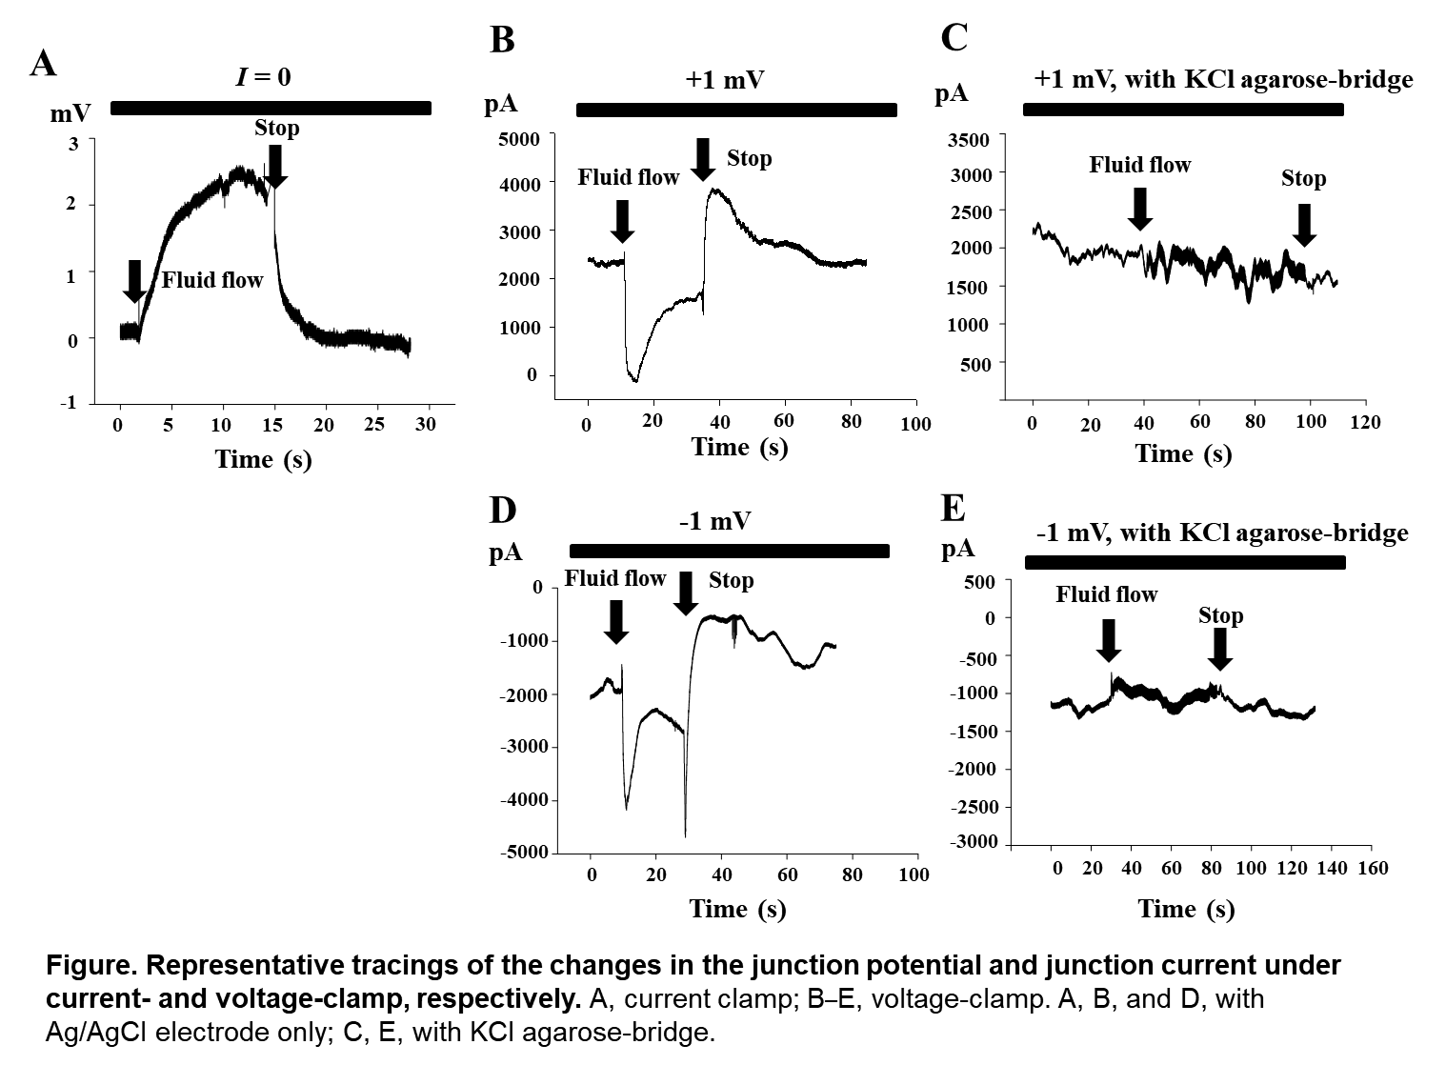
It would be preferable if the order of the figures is closer to the order to which they are referred in the text.
Answer) Thank you. This has been done in the revised manuscript.
The authors refer to flow rates in ml/minute, as is done in most electrophysiological papers. However, the critical parameter for flow-mediated effects is the velocity of the solution (m/s), and this will depend on the geometry of the recording chamber. Therefore, in addition to the flow rate (ml/minute), it would be of use to the reader if the relevant velocities were also included (m/s).
Answer) Thank you. Suggested changes have been made to the revised manuscript.
Minor Concerns:
The list of materials at the end of the manuscript includes agarose. Therefore on page 2, Protocol 1.2.2, agarose should be included in addition to agar, along the lines of: "Weigh 10 g agar or agarose." Also, it would be useful if the % of agar or agarose in solution is given.
Answer) Thank you for the kind comment. In fact, we used agarose instead of agar, although either agar or agarose can be used for generation of the salt bridge, it is conventionally called ‘agar salt-bridge. However, for clarity and accuracy, we have corrected the agar to agarose in the revised manuscript.
Page 3, Protocol 2: Presumably an alternative way to stop and re-start the superfusion would be to use a pump and just it turn it off and on.
Answer) We agree with the comment. In fact, we also used the perfusion pump. We have added the description to the revised manuscript as follows:
  - Alternatively, to control the flow rate (for steps 2.3 – 2.6), use a perfusion pump. In that case, be careful to ensure a constant flow, rather than a pulsatile one.
Page 6, line number 270: Does "best fit by Nernst-equation" mean that the slope was such that the potential changed around 58 mV per ten-fold change in Cl- concentration?
Answer) Thank you for the comment. Basically, the answer is yes. However, the slope was not 58 mV, but 48.7 mV. We believe that, due to the selectivity of Cl⁻ over other ions, the junction potential generated between the Ag/AgCl and bathing fluid is not perfectly dependent on the Cl⁻ concentration. The slope value of 48.7 mV was from the best fit line. The 48.7 mV of slope indicates Cl⁻ dependency (or selectivity) of the Ag/AgCl reference electrode > 95% over other ion (in this case Na+) based on the GHK voltage equation. To make this point clearer, we added the following description in the revised manuscript:
The straight line in red represents the best fit by a modified Nernst-equation for equilibrium potential with a ten-fold slope of 49 mV. Owing to the finite selectivity of Na⁺, compared to that of Cl⁻, for generating the liquid/metal junction potential, the slope value of 49 mV, instead of 58 mV, produced the best fit in the junction potential-[Cl⁻] relation at room temperature. The 49-mV slope indicates the Cl⁻ dependence (or selectivity) of the Ag/AgCl reference electrode > 95 % over the other ion (in this case, Na⁺), according to the Goldman–Hodgkin–Katz voltage equation.
In Figure 3 and its legend, it may be less confusing and it would be more accurate if the total Cl- concentrations were used rather than just the NaCl concentrations.
Answer) Thank you for the careful comment, we have edited the manuscript accordingly.
In Figure 1, is there any advantage in having the accessory chamber for the reference electrode, compared with just inserting an Ag/AgCl wire directly into the agar bridge as is done by some researchers?
Answer) It is much more convenient to preserve the agar salt-bridge. In case the Ag/AgCl wire is directly inserted in the agar salt-bridge, we should be very careful not to create a space between the agar stat and the Ag/AgCl wire. But, in case a separate chamber is used for the bridge and the wire, the agar salt bridge can be just filled with the agar salt which is easy to maintain.
Page 5, line number 260: "pulses" implies a poorly defined time course. It would be better to use "steps".
Answer) Thank you. This has been corrected.
Figure 5A and its legend are a bit too cryptic. What is it trying to show? Why chose 5 mm?
Answer) The authors agree with this comment. Figure 5 has been deleted in the revised manuscript.
Figure 5 B requires some attention. What is it trying to show? What are the units "u" and "r"? The graph would be better if the data were plotted over a shorter x-axis range.
Answer) The authors agree with this comment, Figure 5 has been deleted. in the revised manuscript. This issue is discussed with the relevant citation (reference 10) as follows:
Besides emphasizing the importance of using agar or agarose salt-bridge, another application of the method for estimating real ion concentration in the unstirred boundary layer is as follows: because plasmalemmal ion channels can function as ion-selective electrodes, just as the Ag/AgCl electrode functions like a Cl⁻ electrode, the real ion concentration in the unstirred boundary layer adjacent to the channel inlet at the cell membrane surface can be different from the average concentration of the bulk fluid. This difference in ion concentration between the bulk fluid and unstirred layer adjacent to cell membrane is the actual situation under clinical settings, and should be distinguished from the biological modulation of channel gating by fluid flow/shear force. Unfortunately, unlike the unstirred layer effect between the Ag/AgCl reference electrode and bathing fluid, we cannot fix the unstirred layer effect adjacent to the cell membrane surface in studying the regulation of ion channels by fluid flow/shear force. However, considering the observation that real ion concentration in the unstirred layer is approximately 70 % of that in bulk fluid (Fig. 3), we can make some amendments in the experimental data to distinguish the biological modulation of ion channels from the electrochemical phenomenon of unstirred layer effect. The real ion concentration in the unstirred layer at cell membrane surface was also expected to be approximately 70 % of the average concentration of the bulk bathing solution in our recent experimental and simulation study¹⁰. Since fluid flow restored the decreased ion concentration, it facilitated the Kir2.1 current, independent of cellular signaling ¹⁰. In our previous study, current density was considerably high (2.5 A/m²) with a high extracellular K⁺ concentration and a high expression of Kir2.1 in RBL cells ¹⁰. However, in the case of real cell membranes with various ion channel current density amplitudes, the unstirred layer effect at the cell membrane surface may depend greatly on the amplitude of ion channel current density. Besides, this may cause some ion channel currents, especially those with relatively lower current densities, to be insensitive to fluid-flow regulation, although the unstirred layer effect is regulated electrochemically and not biologically. This may affect the technique described in this study. Therefore, the possibility of developing a quantitative method that is adequate for correcting experimental results should be investigated in future studies.
Page 2, Protocol 1.2.3: "Melt the agar" should be "Dissolve ....". Also, "on a hot plate.", not "in a hot plate."
Answer) Thank you for the comment. These terms have been corrected.
Page 3, Protocol 2.2: This sentence needs re-writing so it is easier to understand.
Answer) Thank you for the comment. The sentence has been re-written.
Page 3, Protocol 3.3: To clarify the situation, insert 'patch" and "electrode" so it reads "Place a patch pipette electrode ...".
Answer) Thank you for the comment. This has been corrected.
Page 3, Protocol 3.4: Include the fact that this is current-clamp mode (perhaps in brackets).
Answer) Thank you for the careful comment. This has been corrected
Page 5, line number 244: "Figure 5C & D" should be "Figure 4C & D".
Answer) Thank you for the kind comment. The related description was corrected and largely edited in the revised manuscript.
Page 5, line number 251: "subjected cell" should be "studied cell".
Answer) Thank you. This has been corrected.
Page 6, line number 284: "diameter = 12.5 µm" should be "radius = 12.5 µm", according to Figure 5.
Answer) Thank you. Figure 5 has been deleted in the revised paper.
Page 6, line number 302: It may be better to use the terms "chambers" instead of "rooms".
Answer) Thank you. The related term has been replaced in the revised manuscript as suggested.
Page 6, line number 304: Perhaps the authors mean "laminar flow" rather than "lamellar flow".
Answer) Thank you for the comment. The related term has been replaced in the revised manuscript.
Page 7, line number 321: "which is practically too fast" would be better phrased as "which, in practise, is too fast".
Answer) Thank you for the comment. The sentence has been edited.
Page 7, line number 331: "should" would be better as "would".
Answer) Thank you. Related sentence has been deleted.
In Figure 3A, it would be more consistent in terms of style, to have the tick marks as being horizontal rather than being angled.
Answer) Thank you for the comment. These have been corrected.
Figure 2B: Typo in "potential" in the label for the x-axis.
Answer) Thank you for the comment. This has been corrected.
In several places, "compared to" is used. Since similar items are being compared, "compared with" should be used.
Answer) Thank you. The manuscript has been edited by a professional English editor.

