Three-Dimensional Printing for Surgical Management of Complex Aortic Anomaly

Xiaoning Sun^{1,2}, Kai Zhu^{1,2,}*, Weijia Zhang^{1,2,3,4}, Hongqiang Zhang^{1,2}, Fazong Hu⁵, Chunsheng Wang^{1,2,}*

Supplementary materials
The user interface of the software for digital reconstruction was presented as below.
Step1. Double click the patient case from case library and open it:
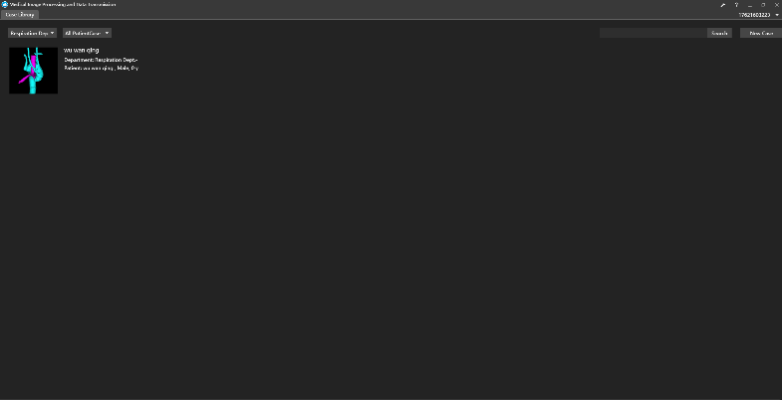
Step2: Select the DICOM series and click “Model Recon” to open the model recon page:
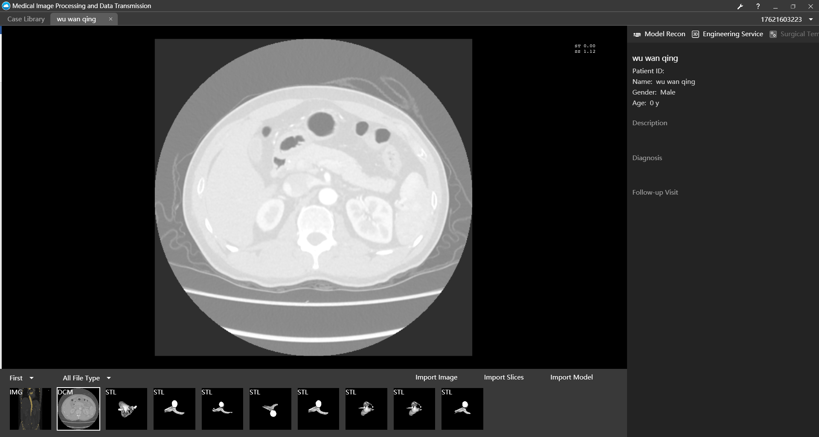
Step 3: Click “Threshold Segmentation” button and adjust the threshold range for vascular:
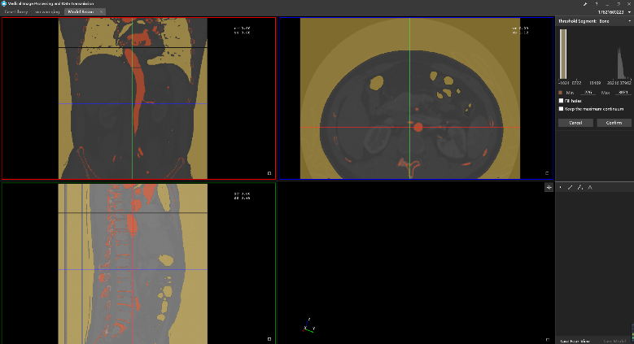
Step 4: Click “Confirm” button for threshold Segmentation, the vascular mask will show in the object list, click “Recon” button from the right of the mask, the 3D vascular will be reconstructed and shows in 3D viewer.
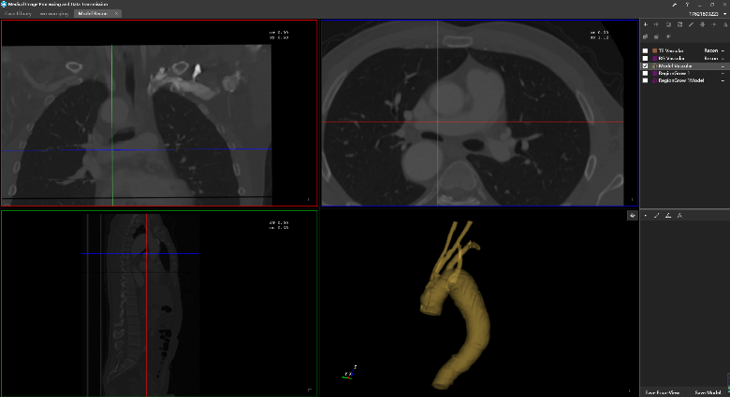
Step 5: Click “Threshold Segmentation” button and adjust the threshold range for trachea, click “Marquee Segmentation” button  to limit the region of interest to mediastinum and lung:
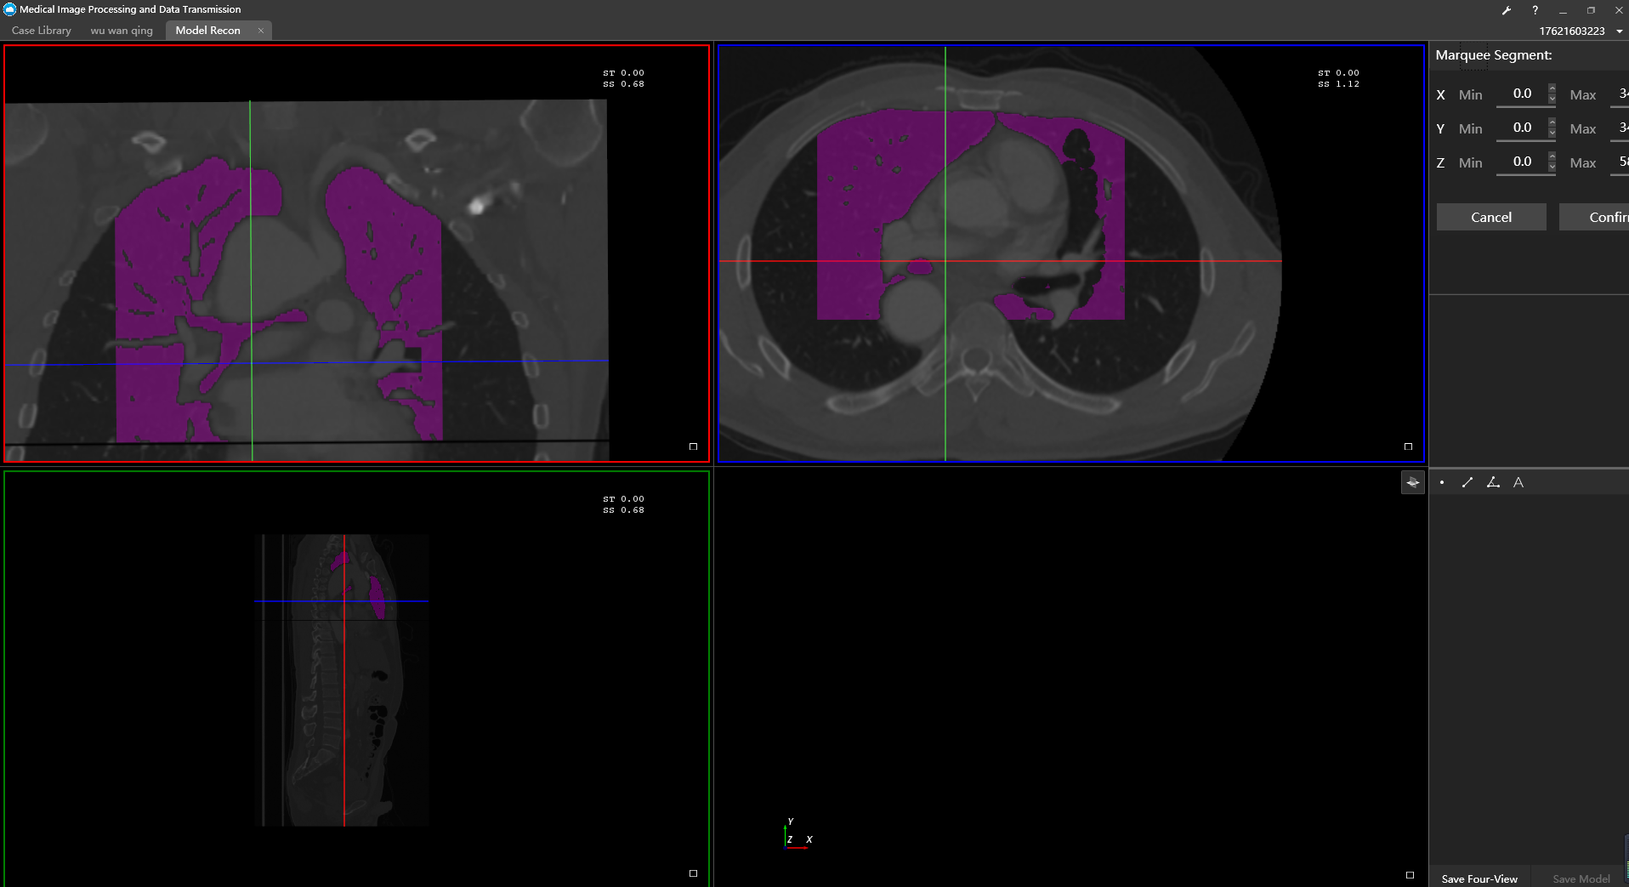
Step 6: Click “Mask Edit” button and erase the connection between trachea lung:
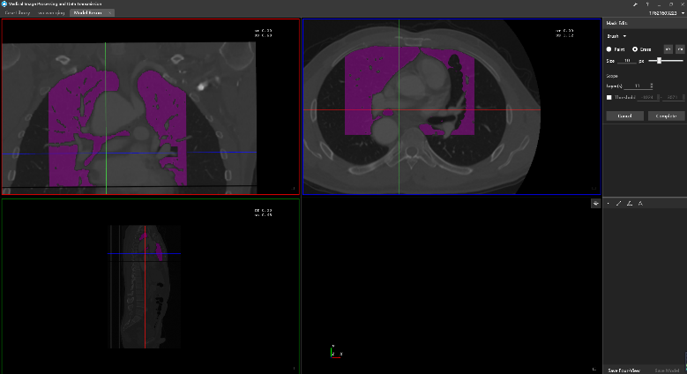
Step7: Click “Region Grow” button and select seeds from the 2D viewers. Check and confirm the region grow result, the trachea mask will show in the object list, click “Recon” button in the right of the mask, the 3D trachea will be reconstructed in 3D viewer.
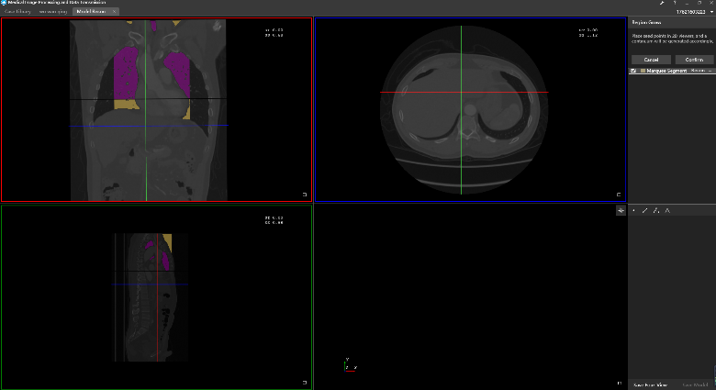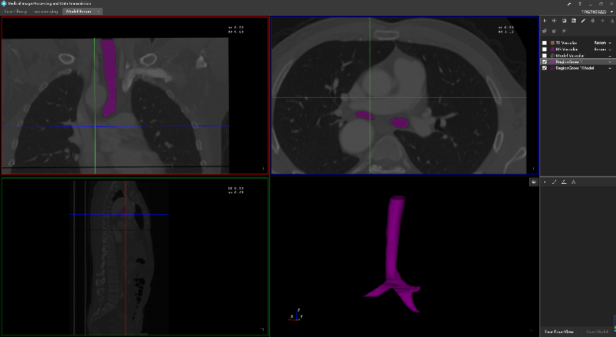
Step8: check the checkbox of vascular and trachea from the object list, both vascular and trachea will show in 3D viewer. Uses can change the color and opacity of the vascular and trachea by click the color icon.
