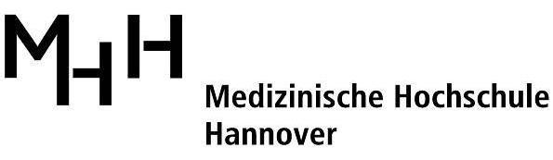

Department of Cardiothoracic, Transplantation, and Vascular Surgery
Hannover Medical School
Carl-Neuberg-Straße 1
30625 Hannover
www.mh-hannover.de

Telephone: +49-511-532-2782
Fax: +49-511-532-5404
E-Mail: Madrahimov.Nodir@mh-hannover.de

July 4, 2018

Dear Editors,

Please find enclosed our revised manuscript, “Technique of veno-venous extracorporeal membrane oxygenation in a mouse” (JoVE58146R2_RE) by Madrahimov et al. originally submitted on March 15, 2018.
We have now addressed all comments of the editor and have provided responses. We hope it is now acceptable for publication in JoVE.

Thank you for considering our manuscript.

Sincerely,

Nodir Madrahimov

