• Protocol:
1) We target 1 page of filmable content in the protocol. This article lacks filmable content as we cannot film section 1. Can steps to perform FAS be shown to demonstrate how the item bank is built? This can be added as a subsection under section 1.
Response: We have added the illustration of the steps of the FAS study to the Supplementary File 1: Appendix 2 as follows: “
Appendix 2. Data retrieval of the CAT-FAS study
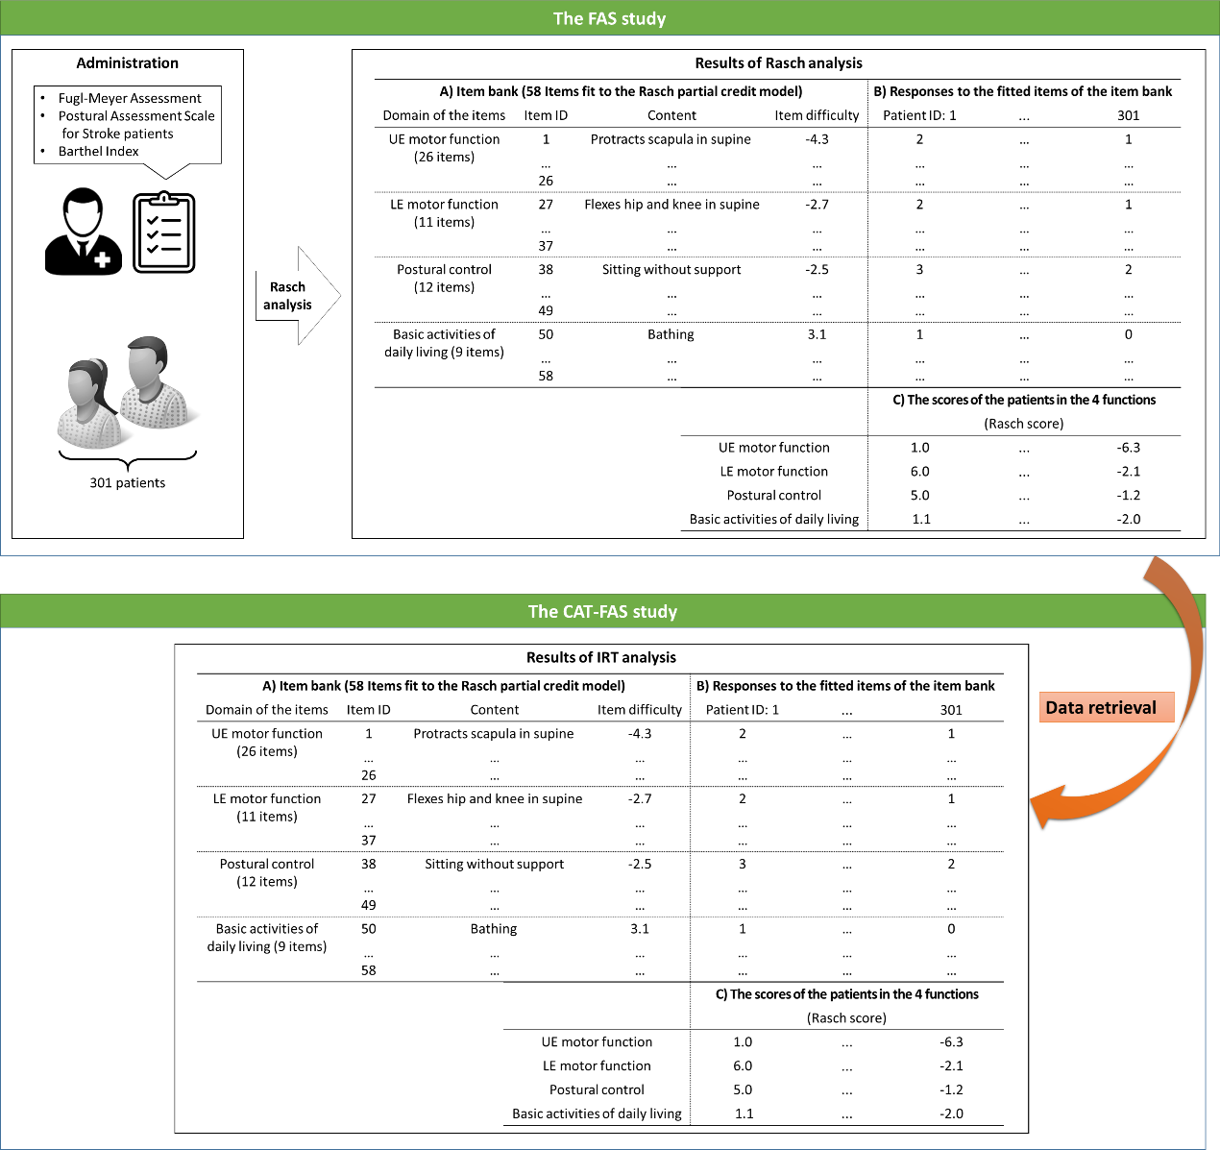
”. (Supplementary File 1: Appendix 2)
2) Several specific comments have been made on your protocol steps in the attached word doc.
Response: We have revised the manuscript according to the specific comments in the word doc. Please find the tracked changes and our responses to the specific comments in the revised manuscript.
• Protocol Highlight: Please highlight ~1-2.5 pages text (which includes headings and spaces) in yellow, to identify which steps should be visualized to tell the most cohesive story of your protocol steps.
1) I have highlighted steps that can be filmed. We ideally need >1-1.5 pages of filmable content in the protocol. Please see the first comment on section 1.
Response: We have highlighted the steps of the Protocol section 1 that can be filmed as follows: “
- Development of the CAT-FAS
  - Retrieve the secondary and encrypted data from the FAS study¹⁴ to conduct simulations (Supplementary File 1: Appendix 2).
    - Establish the item bank of the CAT-FAS by adopting the item bank of the FAS (Supplementary File 1: Appendix 2.A).
    - Retrieve the item difficulties of all items in the item bank from the FAS study (Supplementary File 1: Appendix 2.A. Item difficulty).
    - Retrieve each patient’s responses (e.g., 0, 1, or 2 points) to the items of the item bank of the FAS (Supplementary File 1: Appendix 2.B).
    - Retrieve the ability distribution (i.e., SD of the scores) of the patients in the 4 functions (BADL, postural control, UE/LE motor functions; Supplementary File 1: Appendix 2.C).

  - Determine the operational algorithms of the CAT-FAS (Supplementary File 1: Appendix 4).
    - Adopt the maximum a posteriori (MAP) method for estimating each patient’s scores of the 4 functions with Newton-Raphson iteration.¹⁷
    - Use the criterion of D-optimality for item selection.¹⁸ An item with the maximum determinant of the Fisher information matrix is selected from the item bank for administration.
    - Adopt 10 candidate sets of stopping rules for exploring properties of the CAT-FAS via simulation (Supplementary File 1: Appendix 5).

  - Explore the measurement reliability and efficiency (number of items needed for administration) of the CAT-FAS via steps 1.3.1 to 1.3.11 of simulation (Figure 1).
    - Use a specified set of stopping rules (i.e., from the first to the last candidate sets of stopping rules which are in step 1.2.3, successively) to explore the properties of the CAT-FAS (Figure 1.A).
    - Set initial CAT-FAS scores of the 4 functions (BADL, postural control, UE motor function, and LE motor function) to 0 for specified patients (i.e., from the first to the last patient in the data, successively; Figure 1.B and C).
    - Adaptively select an item with the maximum determinant of the Fisher information matrix (i.e., the criterion of D-optimality) from the item bank for administration (Figure 1.D). The information matrix of each item is calculated based on a patient’s scores of the 4 functions and the item difficulty (from step 1.1.2. To ensure that the CAT-FAS administers at least one item in each function/domain, the first 4 items of the CAT-FAS are selected from the 4 functions.
    - Obtain the patient’s response to the selected item from step 1.1.3 (Figure 1.E).
    - Simultaneously estimate the CAT-FAS scores [and standard errors (SEs) of the scores] of the 4 functions using the MAP method with an iterative Newton-Raphson process (Figure 1.F).¹⁹ During the iterative Newton-Raphson process, renew the scores and SEs of the 4 functions in each iteration until the criterion of convergence is met. Convergence occurs when the differences of scores between two consecutive iterations < 0.001.
    - Count the number of items which are administered, save the latest renewed CAT-FAS scores (and SEs), and calculate the individual-level Rasch reliability of each function using the following formula: 1 - ([SE² of step 1.3.5] / [SD² of the scores of step 1.1.4]) (Figure 1.G).
    - Calculate LRI using the last renewed individual-level Rasch reliability (1.3.6) minus that of the previous estimation (Figure 1.G).
    - Check whether the specified set (e.g., the first candidate set) of stopping rules is met (Figure 1.H). If not, repeat steps 1.3.3 to 1.3.8 until the specified set of stopping rules is met. If so, save the latest renewed CAT-FAS scores (and SEs) as the final CAT-FAS scores (and SEs).
    - Repeat steps 1.3.2 to 1.3.8 until all patients’ administrations are completed (Figure 1.I).
    - Finish the simulation of the CAT-FAS with the specific set of stopping rules and save the results of the simulation (Figure 1.J).
    - Repeat steps 1.3.1 to 1.3.11 to explore the properties of the CAT-FAS with other candidate sets of stopping rules until all candidate sets of stopping rules are explored (Figure 1.K).

  - Select the final set of stopping rules for the CAT-FAS according to the average Rasch reliability ≥ 0.90 in at least 3 functions and the average items of administration ≤ 10.0.

  - Develop an online administration platform of the CAT-FAS by writing a computer program to establish a website (Supplementary File 1: Appendix 7).
” (Lines 90–209, Pages 3–5, Protocol section 1)
2) The highlighted steps should form a cohesive narrative, that is, there must be a logical flow from one highlighted step to the next.
Response: Thank you for your reminder. We have highlighted the steps to form a cohesive narrative.
3) Notes cannot be filmed and should be excluded from highlighting.
Response: We did not highlight the text in the notes.

4) Please bear in mind that software steps without a graphical user interface/calculations/ command line scripting (e.g. section 1) cannot be filmed.
Response: We have added 4 figures to the Supplementary File 1 to illustrate each step of the section 1 of the Protocol as follows: “
  - Retrieve the secondary and encrypted data from the FAS study¹⁴ to conduct simulations (Supplementary File 1: Appendix 2).

Appendix 2. Data retrieval of the CAT-FAS study

    - Establish the item bank of the CAT-FAS by adopting the item bank of the FAS (Supplementary File 1: Appendix 2.A).
    - Retrieve the item difficulties of all items in the item bank from the FAS study (Supplementary File 1: Appendix 2.A. Item difficulty).
    - Retrieve each patient’s responses (e.g., 0, 1, or 2 points) to the items of the item bank of the FAS (Supplementary File 1: Appendix 2.B).
    - Retrieve the ability distribution (i.e., SD of the scores) of the patients in the 4 functions (BADL, postural control, UE/LE motor functions; Supplementary File 1: Appendix 2.C).
  - Determine the operational algorithms of the CAT-FAS (Supplementary File 1: Appendix 4).

Appendix 4. Determination of the operational algorithms of the CAT-FAS
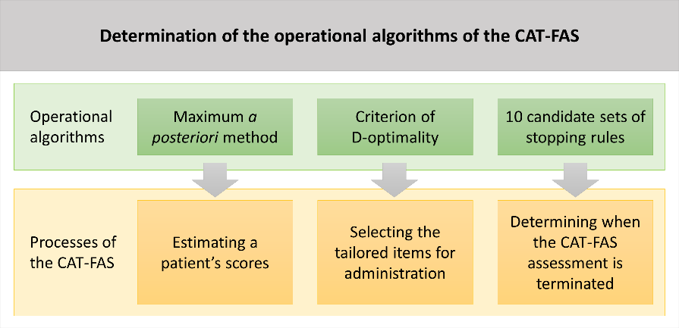
    - Adopt 10 candidate sets of stopping rules for exploring properties of the CAT-FAS via simulation (Supplementary File 1: Appendix 5).
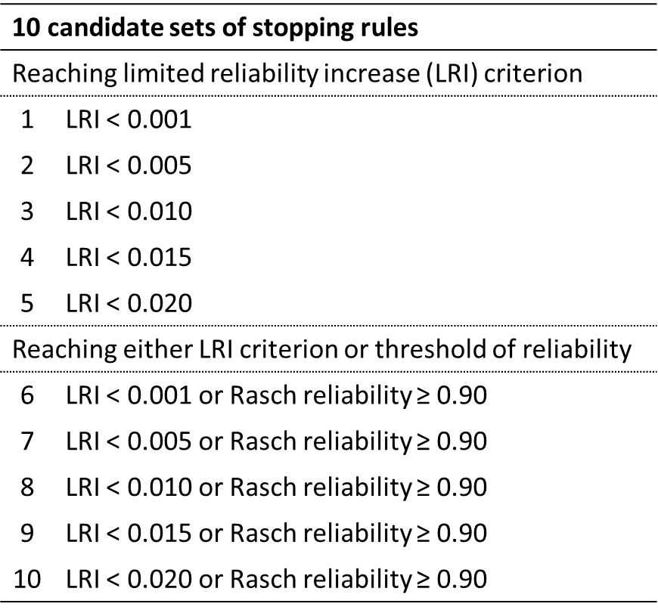
Appendix 5. 10 candidate sets of stopping rules.

  - Develop an online administration platform of the CAT-FAS by writing a computer program to establish a website (Supplementary File 1: Appendix 7).

Appendix 7. Screenshot of the development of the online administration platform of the CAT-FAS
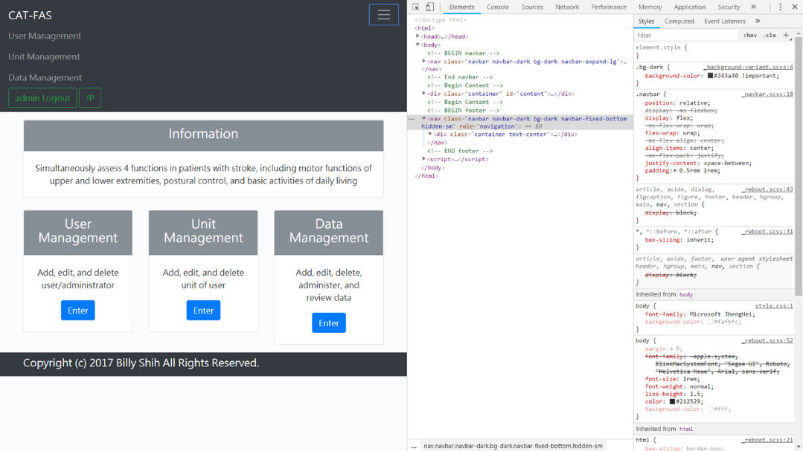
” (Lines 92–209, Pages 3–5, Protocol section 1)
• Figures: Fig 1 needs to be referenced somewhere in your manuscript text.
Response: We have added the reference to Figure 1 in Step 1.3 as follows: “1.3 Explore the measurement reliability and efficiency (number of items needed for administration) of the CAT-FAS via steps 1.3.1 to 1.3.11 of simulation (Figure 1).” (Lines 154–155, Page 4, Protocol section 1)
• Figure/Table Legends: Please expand the legends to adequately describe the figures/tables. Each figure or table must have an accompanying legend including a short title, followed by a short description of each panel and/or a general description.
Response: We have added the general description of each figure and table as follows: “Figure 1: Process of exploring performance of the CAT-FAS via simulation analysis. The process of exploring the measurement reliability and efficiency (number of items needed for administration) of the CAT-FAS with 10 candidate sets of stopping rules.” (Lines 258–260, Page 6, Figure and table legends),
“Table 1: Rasch reliability of the CAT-FAS. For the CAT-FAS, the average Rasch reliability of the 4 functions ranges from 0.88 to 0.93, and individual-level Rasch reliability shows ≥ 70% of participants with Rasch reliability ≥ 0.90.” (Lines 262–264, Page 7, Figure and table legends), and
“Table 2: Efficiency (number of items) of the CAT-FAS. The average number of items needed for administration is 8.5. Most participants (66.4%) were assessed using 5–10 items.” (Lines 266–267, Page 7, Figure and table legends)
• Table of Materials: Please revise the table of the essential supplies, reagents, and equipment. The table should include the name, company, and catalog number of all relevant materials/software in separate columns in an xls/xlsx file. Please include items such as software used.
Response: We have added the information on the software that was used in this study to the table of the essential supplies as follows: “
Name of Material/ Equipment | Company | Catalog Number | Comments/Description
Computer | Any |  | Compatible with software listed below
MATLAB software | The MathWorks Inc. | http://www.mathworks.com/products/matlab/ | Numerical computing software, which is used in the Protocol Section 1 (Step 1.3)
Java Development Kit | Oracle | https://www.oracle.com/java/ | Programming language, which is used in the Protocol Section 1 (Step 1.5)
” (Table of the essential supplies)

