Reply to reviewers regarding the manuscript JoVE58050 entitled: A pulmonary trunk banding model of pressure overload induced right ventricular hypertrophy and failure

The authors gratefully appreciate the thoughtful comments from the editor and reviewers. As requested, we have attached a “marked up” version of the revised manuscript with changes indicated in red. Page and line numbers corresponding to the changes in the revised manuscript are mentioned in the point-by-point responses to editorial and reviewer comments below.

Editorial comments:
Changes to be made by the Author(s):
E1: Please take this opportunity to thoroughly proofread the manuscript to ensure that there are no spelling or grammar issues. The JoVE editor will not copy-edit your manuscript and any errors in the submitted revision may be present in the published version.

Answer E1: The paper has been carefully proofread.

E2: Unfortunately, there are a few sections of the manuscript that show overlap with previously published work. Though there may be a limited number of ways to describe a technique, please use original language throughout the manuscript. Please revise lines: first paragraph of the introduction,

Answer E2: The first paragraph of the introduction has been replaced by:

“The right ventricle (RV) can adapt to a persistent pressure overload. In time, however, adaptive mechanisms fail to sustain cardiac output, the RV dilates and eventually the RV fails. RV function is the main prognostic factor of several cardiopulmonary disorders including pulmonary arterial hypertension (PAH), thromboembolic pulmonary hypertension (CTEPH), and various forms of congenital heart disease with a pressure (or volume) overload of the RV. Despite intense treatment, RV failure remains a predominant cause of death in these conditions.” (p. 1 ll. 46-51).
E3: Please remove trademark (™) and registered (®) symbols from the Table of Equipment and Materials.

Answer E3: Trademark (™) and registered (®) symbols have been removed from the table of equipment and materials.
E4: Please provide an email address for each author.

Answer E4: An e-mail address for each author has been provided in the online submission system. E-mail address for corresponding author is provided in the Author and Affiliations section.
E5: JoVE cannot publish manuscripts containing commercial language. This includes trademark symbols (™), registered symbols (®), and company names before an instrument or reagent. Please remove all commercial language from your manuscript and use generic terms instead. All commercial products should be sufficiently referenced in the Table of Materials and Reagents. Please remove the purchasing links as well.

Answer E5: Commercial names have been removed from the manuscript (long abstract ll. 32-33, p. 2 ll. 96-98, 99-101, and 103-104, p. 3 l. 157, p. 5 ll. 237-238, p. 6 ll. 281-282, and p. 7 ll. 323-324). Links have been removed from the manuscript (p. 2 ll. 97-98 and 99-101). The table of equipment and materials has been updated according to journal guidelines.
E6: Please mention how proper anesthetization is confirmed.

Answer E6: The following passage has been added to the manuscript:

“2.6 Confirm prober anesthetization by checking withdrawal reflexes of the extremities using a forceps to squeeze the paws of the rat.” (p. 2 ll. 125-126).
E7: Please do not abbreviate journal titles.
Answer E7: Abbreviations of journal titles have been replaced by full titles in the reference list.

Reviewers' comments:
Reviewer #1:
Manuscript Summary:
In this manuscript, the authors described a new experimental surgical device and various stages of right heart failure for pulmonary artery banding in order to create a model of right ventricle failure in rats. They compared their results (at 1 and 7 weeks after surgery) of this procedure with those of a sham operated group.
Major Concerns:
C1: The authors should report the number of animals in each group and how they calculated the "sample size". Please describe the number of each section, and the survival data.

Answer C1:
We appreciate the comment and agree that power calculation should be performed when designing studies using the PTB model. The calculated power is dependent on the expected efficacy of the planned intervention. We did not perform power calculation for these data, as they illustrate a model that can be used for future studies and no intervention was introduced in animals subjected to PTB. The data we published can be used for power calculation when planning future studies that involve an intervention.
The number of rats in each group has been specified on the graphs of figure 2, 4, and 5 and indications of group sizes have been deleted from figure legends.

The following passage has been added to the manuscript:

“Perioperative mortality was less than 1 in 6. Seven weeks survival rate was 80% for rats subjected to severe banding and close to 100% in rats subjected to mild or moderate banding or sham surgery.” (p. 4 ll. 186-188).

C2: In the Methods, the paragraph "Echocardiographic measurements" should be made more concise, schematic, and, as a consequence, easily readable. How did the authors calculate the RV EF and RV pressure? Please explain the calculate method.

Answer C2: We appreciate the comment. The methods used for evaluation of hemodynamics (echocardiography, cardiac magnetic resonance imaging and invasive pressure measurements) have been described in detail previously¹, but we have elaborated the section and added the following passage to the manuscript:

“Tricuspid annular plane systolic excursion (TAPSE) was measured as the distance of the tricuspid annular plane with the RV contraction in the apical four-chamber view. An average of three cycles outside respiration was used as a representative value. RV and-diastolic volume (EDV) and end-systolic volume (ESV) was assessed by drawing of the endocardium in a series of short axis images through the RV obtained by MRI for each rat and RV ejection fraction (EF) calculated as EF = (EDV-ESV)/EDV. Cardiac output was measured between the pulmonary valves and the clip using a phase-contrast MRI sequence. Digital recordings of RV pressures was obtained by a micro tip catheter installed in the RV before euthanasia. Further details of the methods have been described previously¹².” (p. 4 ll. 191-200).
Minor Concerns:
C3: In figure 5, there was no description of D.
Answer C3: Figure legend for figure 5 has been updated with the following description of D:

“(D) picrosirius red analyzed under polarized light for fibrosis from sham rats (left) and PTB rats with moderate RV failure (right).” (p. 6 ll. 173-275).
Reviewer #2:
Manuscript Summary:
Andersen S. et al. describe a protocol of pulmonary trunk banding (PTB) operation in rats. Mechanisms of right ventricular hypertrophy and failure remain understudied area and PTB is a technique of choice for its investigations. Detailed description of the technique is of high interest for investigators. The manuscript is well written. The protocol is described in sufficient details.
Major Concerns:
No major concerns
Minor Concerns:
C1: How was sufficient analgesia controlled. Please, provide short description.

Answer C1: Please refer to answer E6.
C2: Fig. 5 D must be picrosirius red staining under polarized light. please, specify this point. Additionally, provide correct labeling of sub-figures in the figure legend.

Answer C2: Text and labelling of subfigures have been corrected. Please refer to answer to comment 3 from reviewer #1.
C3: Throughout the manuscript, the groups of mild, moderate and severe constriction are described. However, data for mild constriction group are shown only of Fig. 5. Please, show data for this group on Figures 2-4.

Answer C3: We appreciate the comment, but unfortunately we do not have data from MRI and invasive in-vivo pressures from our mild PTB operated animals at 1 and 7 weeks. We do however have data from a study published previously illustrating the difference 4 weeks after PTB surgery². We have chosen not to include these data in this study, as we believe it to be confusing having both mild, moderate, and severe and 1, 4 and 7 weeks after surgery included in the paper. We have clarified this in the manuscript accordingly and added the mentioned paper to the reference list:

“Detailed hemodynamic differences between PTB mild rats and PTB severe rats 4 weeks after surgery have been published by our group previousely¹³.” (p. 4 ll. 210-212).
C4: In figure legends, stars for statistical significances are explained as in comparison to sham group only. On the figures, bars indicate significances between banding groups as well. Please, modify correspondingly.

Answer C4: Figure legends of figure 2, 4, and 5 have been updated according to the figures (p. 5 ll. 250-251, and p. 6 ll. 266-267 and ll. 277-278).
Reviewer #3:
Manuscript Summary:
A reliable RV overload model will be valuable for studying RV failure mechanism. Authors improved pulmonary artery banding operations with precise clipping. These improvements established a highly efficient and reliable banding method. With precise constriction, authors demonstrated that different severities of banding will introduce different consequences in RV function. It explains some controversies in the field. The followings are a few questions about results and procedure details.

Major Concerns:
C1: What's the death rate for each banding severity at different time points?
Answer C1: Please refer to answer to comment 1 from reviewer #1.

C2: It will be easier for others to follow if authors could describe the stop mechanism of clip applier in more details.

Answer C2: We appreciate the comments and have sought to clarify how the applier works to make the protocol easier to follow. Figure 1 has been updated to include an enlarged image of the stop mechanism of the ligating clip applier (B) and the figure legend has been changed to provide a more detailed description of the mechanism:

“(A) The surgical instruments used for the PTB procedure including the ligating clip applier (blue arrow). (B) The adjustable stop mechanism of the ligating clip applier. Turning the cogwheel (blue arrow) will adjust the position of the pin (yellow arrow), which stops the closing of the applier when the jaws reach a certain distance from each other. The distance correspond to 2 x the thickness of the legs of the clip plus the inner diameter of the clip, when the clip is compressed, and can be calibrated by using for example a needle with a known outer diameter.” (p. 5 ll. 232-237).

Updated figure 1:
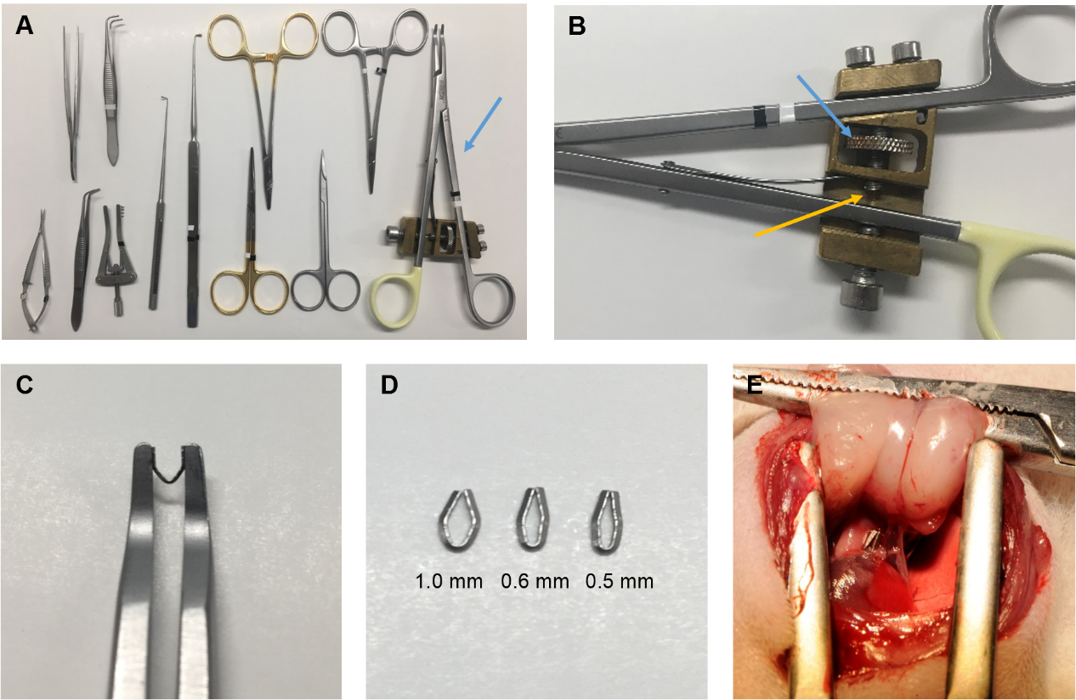
C3: Authors used the diameter of the banding loop to represent the banding severity. However, the area of banding loop will change if a different length of clip is to be used. So, it will be desirable to use the area of banding loop as an indicator of banding severity. It will be easier to compare different studies later.
Answer C3: We appreciate the comment, but as seen in figure 1, E, the pulmonary artery does not completely fill the area of the banding clip. Hence, reporting the area of the banding clip will not be correct either. The correct way would be to measure the area of the pulmonary artery in the banding clip post mortem. Unfortunately, these data are not available.
Minor Concerns:
C4: In the following sentence, "This leaves a lumen of 0.6 mm as the two clip legs have a diameter of 0.2 mm each", the word "diameter" should be replaced by "thickness" to avoid confusion.

Answer C4: The sentence have been updated accordingly (p. 2 l. 104).
C5: All the abbreviations should be explained when it first appears in the main text.
The manuscript has been updated accordingly (p. 4 ll. 191-192 and ll. 194-196).

C6. A neonatal PTB model has recently been published (J Thorac Cardiovasc Surg 2017;154:1734-9). It used a conventional method to perform banding. It should be commented whether the new method can be applicable in neonatal rats.

Answer C1: Thank you for pointing this out. This method could potentially be applied to rat neonates and also mice, but we have no experience in doing so. We have added this to the manuscript:

“The clip model can potentially be used in rat neonates as opposed to the ligating technique previously used¹⁹, but we have no experience with this and the same considerations as mentioned above applies before initiating a study.” (p. 6 ll. 308-310).

Other comments/changes:

This method study is based on data and experiences from previous studies from our group. This have been clarified in the manuscript:

”Here we present our experience using this model based on results from previous studies^{12,13}.” (p. 1 l. 86-87).

”…in previous studies from our group^{12,13}, …” (p. 4 l. 180)

Additionally, the histological images in figure 5 have been updated and minor adjustments have been made to the sentences: “In addition, the MCT model has several extra-cardiac effects” (p. 1 l. 64-65)” and “In experimental pulmonary trunk banding models, the afterload of the RV is fixed due to a mechanical constriction of the pulmonary trunk” (p. 1 l. 67-68).

References

1 Andersen, S. et al. Effects of bisoprolol and losartan treatment in the hypertrophic and failing right heart. Journal of cardiac failure. 20 (11), 864-873, (2014).
2 Andersen, A., Povlsen, J. A., Botker, H. E. & Nielsen-Kudsk, J. E. Right ventricular hypertrophy and failure abolish cardioprotection by ischaemic pre-conditioning. Eur J Heart Fail. 15 (11), 1208-1214, (2013).

