Dr Benye Xi
Ministry of Education Key Laboratory of Silviculture and Conservation, Beijing Forestry University, 35 East Qinghua Road, Beijing 100083, China
Phone number: +86 10 62337055
Fax: +86 10 62337055
Email: benyexi@bjfu.edu.cn

June 26, 2018
Nam Nguyen, Ph.D.
Review Editor,
JoVE58026R2

Title: Assessing the Particulate Matter Removal Abilities of Tree Leaves

Dear Nam Nguyen,

We appreciate the reviewers’ valuable remarks, which considerably contributed to the improvement of our manuscript. According to the suggestions and comments from the reviewers, we have made revisions and corrections in our revised manuscript. Please find our point-to-point responses to the comments as follows. Thank you very much for your consideration and please contact us if you have any queries.

Best regards,
Dr. Benye Xi

Communicating editor and reviewers:

1. Please break up Figure 1 into separate Figures. Please provide a legend for each.

According to the reviewer’s opinions, we have broken up the Figure 1 into a separate Figure. And the legend of it was also provided in a separate document.

2. Please obtain explicit reprint permissions for usage of Figure 1.

Based on the editor’s opinions, we have already obtained explicit reprint permission from Elsevier (Fig. 1). In addition, the pictures of all scanning electron microscope in Figure 1 have been replaced by other similar pictures (we have taken a lot of SEM pictures when we were doing the experiments) in order to avoid repetition with published pictures.

Fig. 1 Explicit reprint permissions for usage of Figure 1

Reviewers' comments:

Reviewer #1:
Manuscript Summary:
Ok
Major Concerns:
No mention of statistical procedures used to compare your data.

According to reviewer’s opinions, the statistical analysis used in our research has been rewritten in the revised manuscript. It has been changed to:
3.3. Conduct all the statistical analyses with SPSS (v. 22.0, SPSS Inc., Chicago IL, USA) software.
3.3.1. Use the Kolmogorov-Smirnov test and the Levene test to verify the ANOVA assumptions of normality and homogeneity of variances, respectively, for the elution percentages of the different-sized particles and the PM retention capacity data.
3.3.2. Apply one-way ANOVA to investigate the effects of the different cleaning steps on the elution percentages of the different-sized particles under various dust retention periods. Use Duncan's test (P = 0.05) to detect the significant differences among different cleaning steps.

Reviewer #2:
Manuscript Summary:
Manuscript entitled "Methodology for assessing the air purification abilities of tree species quantitatively and accurately" assessed three different extraction techniques to evaluate the accuracy of each method in quantifying dust retention capacity of leaves in 5 different tree species exposed to natural particulate matter for short and long duration. The manuscript is sound and relevant but lacks depth and several important information are missing.
Major Concerns:
The title should be changed as tree leaves of the middle canopy is only used in the experiment and not the whole tree is considered. Term "air purification" should be changed to "particulate matter removal".
Suggested title: "Methodology for assessing the particulate matter removal abilities of tree leaves quantitatively and accurately"

We completely agree with the reviewer’s opinions, the term "air purification" in the title has been changed to "particulate matter removal". Thus, the title was changed to “Assessing the Particulate Matter Removal Abilities of Tree Leaves”.

Authors in the long abstract mentioned "Leaf area index is also an important factor for assessing the PM retention efficiency in tree scale" but apart from abstract and final part of discussion section role of Leaf area index (LAI) is not mentioned in the manuscript. If LAI has any relationship with present work it should be measured and discussed if data is not available why to involve LAI at all in the manuscript.

We completely agree with the reviewer’s opinions. Thus, we have deleted all mentions about leaf area index (LAI) in the manuscript. The reason why we refer to the LAI is that the original purpose of our experiment is to assess the particulate matter removal abilities in tree scale. After obtaining the reviewers’ valuable remarks, I realize the innovation point in this manuscript was the elution method and the retention efficiency on leaf surfaces, and the LAI is only a further way to calculate the particulate matter removal abilities in tree scale. After careful consideration, we decided to deleted relevant parts of LAI in manuscript and it has already been modified in the manuscript.

Introduction: Introduction part is well structured with relevant information on the concerned topic.
Protocol:
Where is this experiment performed and what is the ambient level of PM in this area? Are all the trees are sampled from one location and exposed to similar PM?

- Our experiment (leaf sampling) was conducted in the Xitucheng Park (39.97° N, 116.36° E), which is near the three ring road (Fig. 1) and thus a very heavily polluted area in Beijing, China (Fig. 2). The average levels of PM under the short and long dust retention period (i.e. the duration between the last rainfall and the leaf sampling time) in our experiment were 26 (PM_{2.5}), 57 (PM₁₀), and 111 (PM_{2.5}), 160 μg/m³ (PM₁₀), respectively. We have already added this information in revised manuscript.
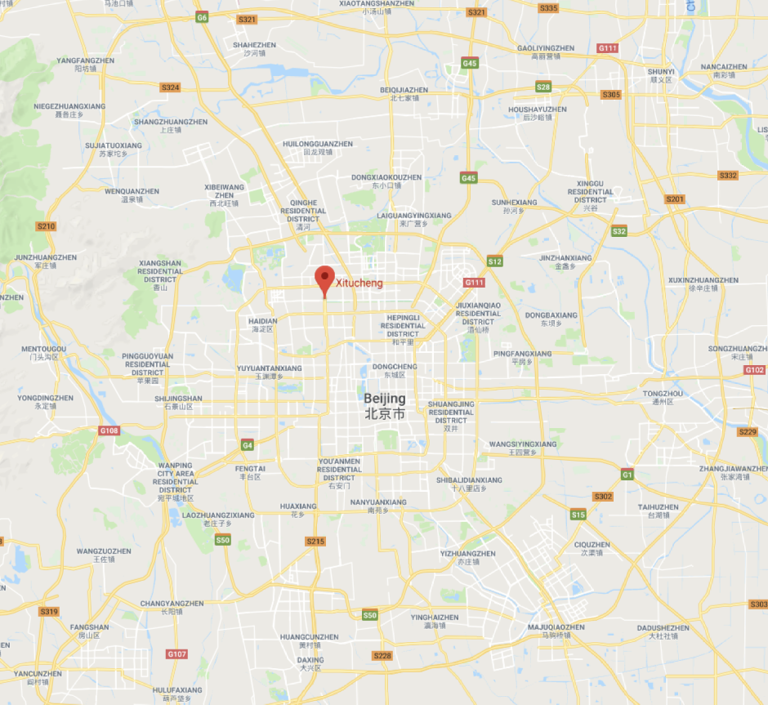
Xitucheng Park
Fig.1 The location of Xitucheng Park
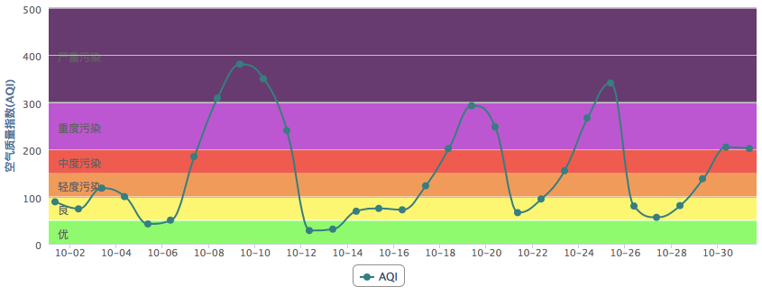
Fig.2 The AQI (Air Quality Index) during sampling period in Beijing at Oct, 2014.

- All the trees for leaf sampling are located closely in a greening strip with length and width of about 250 and 60 m, respectively. So, the environment conditions (wind, light, and rain) of these trees were similar. The distances between sampling trees and the pollution source (road) are similar (about 10-20 m). We have already added this information in the revised manuscript.

Lines 98-99. Why authors collected leaf from the middle of the canopy, it is known that outer canopy leaves are more exposed to air pollutants. The authors should also mention how many leaves were collected for each plant species.

We completely agree the review’s opinion that outer canopy leaves are more exposed to air pollutants. And actually the leaves sampled in our experiments were from the outer canopies. The middle of the canopy in manuscript refers to the sampling height above the ground. The reviewers may produce misunderstanding because of our inaccurate expression in this manuscript. So “the middle of the canopy” has been changed to “the outer canopy in the middle canopy layer” in the manuscript so that it could be understand clearly. And it has been modified in the manuscript.

On what basis authors selected dust accumulation period of 14 days for long dust retention? Is dust accumulation after this period is constant?

The “long” dust retention (14 days after rainfall) was just an expression relative to the “short” dust retention period (4 days after rainfall) used in our experiment. It does not mean “14 days” is definitely a “long time” for leaves to retain dust. The sampling time in our experiments (4 or 14 days after rainfall) was determined according to the weather and the air quality. Due to the air pollution in the sampling area (near a very busy ring road in Beijing) is very heavy and in order to avoid the influence of rainfall and obtain a dust retention duration gradient, we have to arbitrarily determine when we should go to sample the leaves according to the weather forecast.

Lines 114. Authors mentioned that "Randomly select a certain amount of leaves (the leaf area is about 2000 cm²) from leaf samples". Why authors selected 2000 cm² leaf area for different plants. As the weight of leaves will also influence the sonication process. Authors should give rational reasons for such selection for other workers to repeat the experiment for other plants in same and different regions of the world.

When determining the PM quantity on leaf surface, the size of a replicated leaf sample of each tree species was to guarantee the total leaf sample area was about 2000 cm², which was determined according to our preliminary experiment (Liu et al., 2016). The 2000 cm² leaf area selected in present study was due to two reasons:
1) According to the volume of the 1000 ml beaker and 270 ml water we used, the leaves can be immersed in water exactly when the leaf area was about 2000 cm². If the leaf area was larger than 2000 cm², it could not be immersed in the water completely, and the elution effect will be bad.
2) Under the short and long dust retention period, the mass of particles could be measured accurately when the leaves area was about 2000 cm². If the leaf sample area was smaller than 2000 cm², the dust eluted from leaf surface will be so light that we could not weigh it accurately.
Based on the above two points, about 2000 cm² leaf area was selected in this research. We have added the reason for this in the revised manuscript, i.e. “Randomly select a certain amount of leaves (the leaf area is about 2000 cm², which can guarantee all the leaves can be immersed in the water completely and the eluted dust has enough weight so that we can weigh it accurately) from leaf samples”.
References:
Liu, H.H., Cao, Z.G., Jia, L.M., Li, X.Z., Hao, L.F., Liu, J.Q., Wang, H., Xi, B.Y. Analysis of the role of ultrasonic cleaning in quantitative evaluation of the retention of tree leaves to atmospheric particles: a case study with Ginkgo biloba. Sci. Silvae Sin. 52 (12), 133–140 (2016).

Most important factor that determines particulate matter accumulation is surface characteristics of leaves. Are all the trees selected for the study have similar or different surface characteristics? I have one query hear that all the three methods used in this experiment for extraction have any influence of leaf surface characteristics.

Consistent with the reviewer’s opinion, we also agree that leaf surface characteristic plays an important factor in determining particulate matter accumulation. From the observation by scanning electron microscope, the leaf surface microstructures of different tree species in this study are very different (Fig. S1-5, attached at the end of the response letter). The methods used in this study did not have influence on the leaf surface characteristics, and this has also been investigated in detail in our previous study (Liu et al., 2016). From the Fig. S1-5 at the end of the response letter, it can also been that the leaf surfaces microstructures were not destroyed by our cleaning methods.
References:
Liu, H.H., Cao, Z.G., Jia, L.M., Li, X.Z., Hao, L.F., Liu, J.Q., Wang, H., Xi, B.Y. Analysis of the role of ultrasonic cleaning in quantitative evaluation of the retention of tree leaves to atmospheric particles: a case study with Ginkgo biloba. Sci. Silvae Sin. 52 (12), 133–140 (2016).

Line 138-139. How author determines the ultrasonic time of 3 and 10 min. What was the frequency of ultrasonic pulse? Is it same for both species or different? Have authors tried to vary the pulse rate?

1. The ultrasonic time of 3 and 10 min was determined based on our preliminary study (Liu et al., 2016).
2. The power of ultrasonic pulse was 500 W.
3. And for different tree species, the power of ultrasonic pulse was same, all of it was 500 W
4. In order to obtain the optimal ultrasonic cleaning parameters, taking Ginkgo biloba as examples, after the leaves were cleaned by soak, stirring and scrubbing, we set 24 ultrasonic cleaning treatments which were a factorial combination of six ultrasonic cleaning time (1, 2, 3, 5, 10, 20 min) and four ultrasonic power [200(40%), 300(60%), 400(80%), 500(100%) W]. Then, it was sequentially conducted to leaf samples to collect particles retained on leaves. 1). The initial ultrasonic time (T₁) was determined by the time before chlorophyll a could be observed obviously (the concentration of the chlorophyll a and the color of eluent) (Fig. 3&4). And different T₁ could be considered as the optimal ultrasonic cleaning time without damaging the leaf microstructure under different ultrasonic powers, respectively. 2). Taking the mass of particulate matter elution as the mass of total particulate matter till the ultrasonic cleaning time (T₁), then, the eluting portion of particulate matter retained on leaves in different eluting steps (water cleaning, brush cleaning, and ultrasonic cleaning) was calculated (Fig. 5). 3). Comparing the eluting portion of different ultrasonic powers under the optimum ultrasonic cleaning duration (T₁), the final optimal ultrasonic cleaning time (T₂) and ultrasonic cleaning power were determined comprehensively. 4). The Scanning Electron Microscope was used to observe the particulate residue on leaf surface in order to examine the elution effect of the optimal ultrasonic parameters.
The result showed that after conventional cleaning procedures, further cleaning with ultrasonic under power of 500 W could make the leaves more clean, and wash off at the maximum about 27% of the particles retained on leaves. Meanwhile, the parameter (500 W for 3 min) could avoid the exudation of chlorophyll a from leaves obviously.
The ultrasonic time of the other tree species was also determined by this method, but its stability and general applicability to different plant species under different dust retention period should be further investigated when it was applied to use in similar studies.
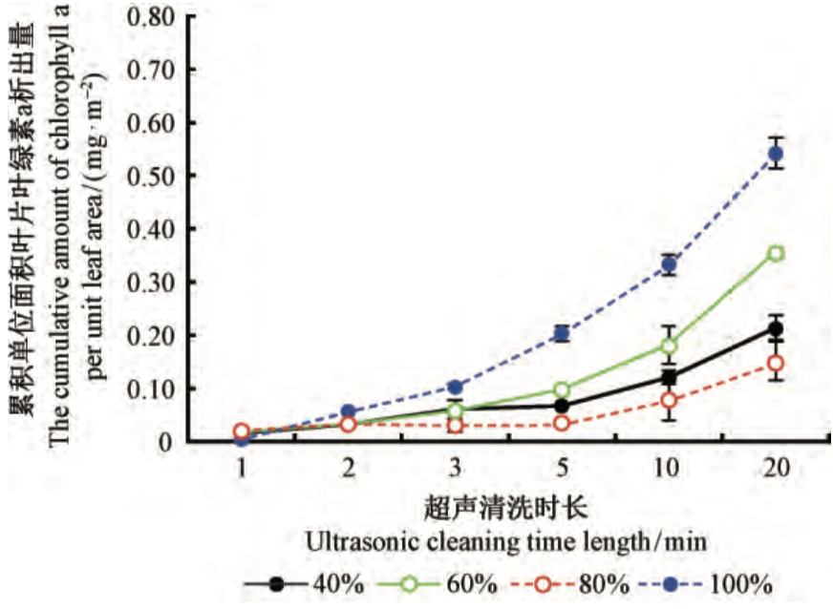

Fig.3 The cumulative amount of chlorophyll a exuded from leaves of G. biloba under different combinations of ultrasonic cleaning power and time length 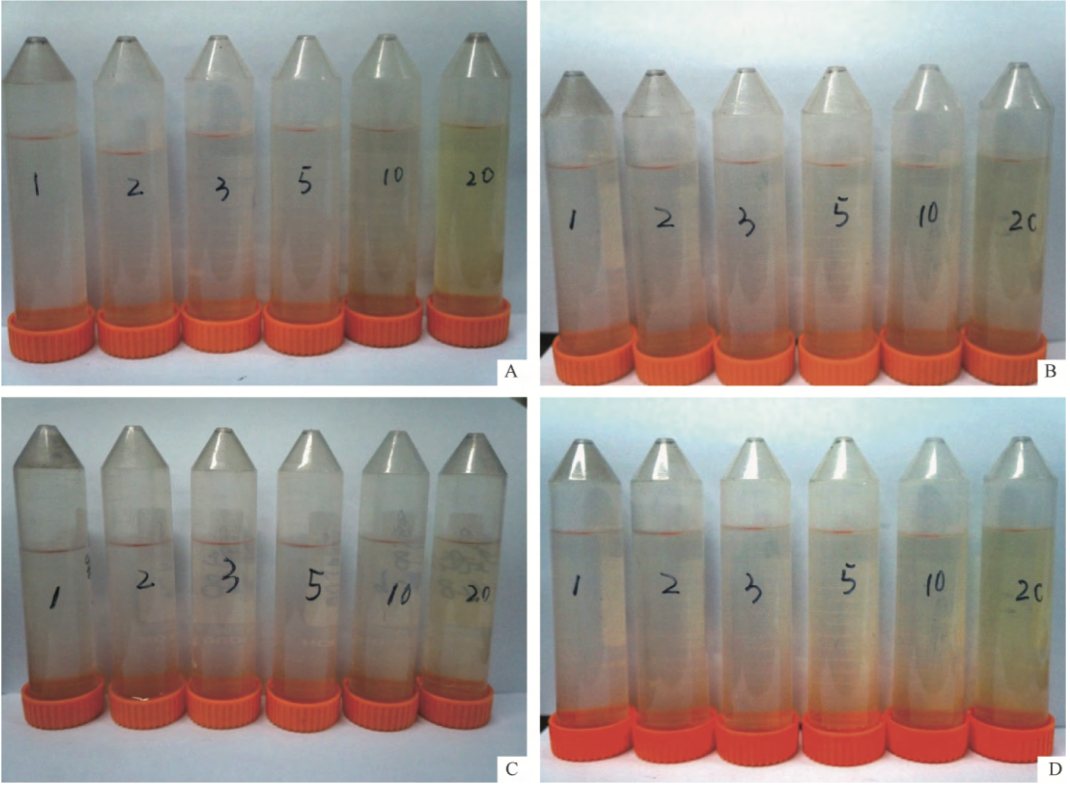
Fig. 4 Color variation of leaf eluent under different ultrasonic cleaning time length and power for G. biloba. (A: 200 W; B:300 W; C:400 W; D: 500 W). The number written on the centrifuge tubes in each picture is the ultrasonic cleaning time (min).
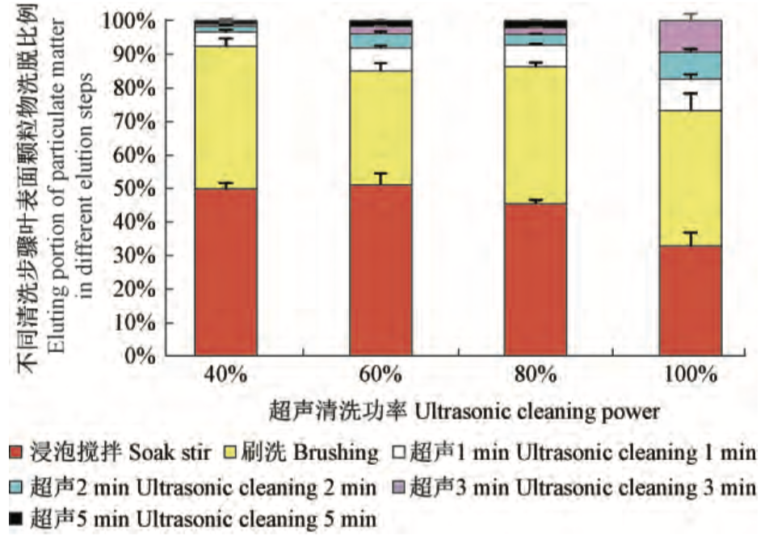
Fig.5 The eluting porting of particulate matter retained on leaves of G. biloba in different eluting steps
References:
Liu, H.H., Cao, Z.G., Jia, L.M., Li, X.Z., Hao, L.F., Liu, J.Q., Wang, H., Xi, B.Y. 2016. Analysis of the role of ultrasonic cleaning in quantitative evaluation of the retention of tree leaves to atmospheric particles: a case study with Ginkgo biloba. Sci. Silvae Sin. 52 (12), 133–140.

Authors did not perform any statistical analysis of the observed data. It will be better if statistical significance of observed methods were performed. How many times did authors repeat the experiment?

Based on reviewer’s opinion, the data analysis was added in revised manuscript. And we set 5 replicates for each tree species in order to guarantee the precision of experiment.

Minor Concerns:
Abstract: Abbreviations must be defined first. In long abstract WC, BC and PM are not defined.

Based on reviewer’s opinion, the WC, BC and PM has been defined in long abstract. And it has been modified in the manuscript.

Reviewer #3:
Manuscript Summary:
Accept.

Reviewer #4:
Manuscript Summary:
Although the manuscript focuses on an important topic, there is not a sufficient introduction for the protocol, furthermore, it needs major rewriting for sense and flow.

According to reviewer’s opinion, the introduction for the protocol has already been rewritten in manuscript.

Major Concerns:
Insert data analysis
Page 6 line 199: The statistical significance of findings is not stated.

According to review’s opinions, the statistical significance of findings was stated at the part of data presentation and analysis in the revised manuscript.

Page 4 line 114: sample size?

When determining the PM quantity on leaf surface, the size of a replicated leaf sample of each tree species was to guarantee the total leaf sample area was about 2000 cm², which was determined according to our preliminary experiment (Liu et al., 2016). The 2000 cm² leaf area was selected in present study might be due to two reasons:
1) According to the volume of the 1000 ml beaker and 270 ml water we used, the leaves were immersed in water exactly when the leaf area was 2000 cm². If the leaf area was larger than 2000 cm², it could not be immersed completely under the surface of water. So it might not have a good elution effect that was limited by experimental instrument.
2) Under the short and long dust retention period, the mass of particles could be measured accurately when the leaves area was about 2000 cm². In other words, only the leaf area about 2000 cm² that we could guarantee that enough PM could be eluted under this dust retention period. Thus, we selected enough leaves (the leaf area is about 2000 cm²) to reduce experimental errors as much as possible.
Based on above two points, about 2000 cm² leaf area was selected in this research.
References:
Liu, H.H., Cao, Z.G., Jia, L.M., Li, X.Z., Hao, L.F., Liu, J.Q., Wang, H., Xi, B.Y. Analysis of the role of ultrasonic cleaning in quantitative evaluation of the retention of tree leaves to atmospheric particles: a case study with Ginkgo biloba. Sci. Silvae Sin. 52 (12), 133–140 (2016).

major rewriting

According to reviewer’s opinions, the relevant part has been rewritten in manuscript.

Minor Concerns:
Title: rephrase your title; I would suggest to add air pollution removal and urban tree species.

We completely agree with the reviewer’s opinions, considering the proposal of the editor and other reviewers simultaneously, the title has been changed to “Assessing the Particulate Matter Removal Abilities of Tree Leaves”.

Page 3 line 53: add particulate matter (PM)

Based on reviewer’s opinions, the particulate matter has been added in manuscript.

Page 3 line 54: delete greening

The word of “greening” has been deleted in manuscript.

Page 4 line 101: did you collect the samples from urban trees? Please describe the site.

Yes, I did.
- Our experiment (leaf sampling) was conducted in the Xitucheng Park (39.97° N, 116.36° E), which is
near the three ring road (Fig. 1) and thus a very heavily polluted area in Beijing, China (Fig. 2). The average levels of PM under the short and long dust retention period (i.e. the duration between the last rainfall and the leaf sampling time) in our experiment were 26 (PM_{2.5}), 57 (PM₁₀), and 111 (PM_{2.5}), 160 μg/m³ (PM₁₀), respectively.
- All the trees for leaf sampling are located closely in a greening strip with length and width of about 250
and 60 m, respectively. So, the environment conditions (wind, light, and rain) of these trees were similar. The distances between sampling trees and the pollution source (road) are similar (about 10-20 m). We have already added this information in the revised manuscript.
Xitucheng Park
Fig.1 The location of Xitucheng Park
Fig.2 The AQI (Air Quality Index) during sampling period in Beijing

B1
A1
B2
A3
A2
B3
B4
A4
Fig. S1 The upper (A) and lower sides (B) of a Ginkgo biloba leaf subjected to different cleaning steps (1: without cleaning; 2: single water cleaning; 3: water cleaning + brush cleaning; 4. water cleaning + brush cleaning + ultrasonic cleaning).
A2
B1
A1
B3
B2
B4
A4
A3
Fig. S2 The concave (A) and convex sides (B) of a Pinus tabuliformis leaf subjected to different cleaning steps (1: without cleaning; 2: single water cleaning; 3: water cleaning + brush cleaning; 4. water cleaning + brush cleaning + ultrasonic cleaning).
B2
B1
A2
A1
B3
A4
A3
B4
Fig. S3 The upper (A) and lower sides (B) of a Sophora japonica leaf subjected to different cleaning steps (1: without cleaning; 2: single water cleaning; 3: water cleaning + brush cleaning; 4. water cleaning + brush cleaning + ultrasonic cleaning).
B2
B1
A1
B3
A3
A2
A4
B4
Fig. S4 The upper (A) and lower sides (B) of a Salix babylonica leaf subjected to different cleaning steps (1: without cleaning; 2: single water cleaning; 3: water cleaning + brush cleaning; 4. water cleaning + brush cleaning + ultrasonic cleaning).
B2
B1
A2
A1
B4
B3
A4
A3
Fig. S5 The conical (A) and scale-form (B) leaves of Sabina chinensis subjected to different cleaning steps (1: without cleaning; 2: single water cleaning; 3: water cleaning + brush cleaning; 4. water cleaning + brush cleaning + ultrasonic cleaning).

