

April 6, 2018

Editorial board of JoVE

Please consider the revised version of the manuscript entitled " A Versatile Model Of Hard Tick Infestation On Laboratory Rabbits ", by Almazan, C., et al., for publication in the Journal of Visualized Experiments (JoVE). In our revised manuscript we have improved the quality of the proposed manuscript dealing with the development of a simple, fast and very effective method for the feeding of the hard ticks on the laboratory rabbits. The most significant change/improvement to the first submission is the Velcro-based openable capsule allowing convenient monitoring and sampling of the ticks during the feeding on the rabbits. In addition based on the reviewers recommendation we focused on emphasizing the technique itself by highlighting its simplicity and versatility and not the experimental animal welfare as was the case in the initial submission. This simple method using easily accessible materials may be used for a variety of different experimental settings when studying tick biology, and is expected to be adapted for use at tick research centers around the world.

Reviewers’ constructive criticisms were greatly appreciated. Our manuscript word file document contains the "clean" (no tracking changes) version, followed by the "tracking changes version" in the same document. Also all our point by point answers to reviewers specific comments are in the separate file (Rebuttal document).

Please let me know if you have any questions.
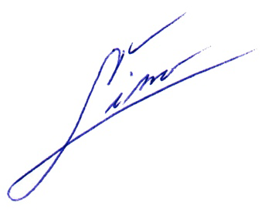
Sincerely,

-------------------------------------------
Dr. Ladislav Simo
Chargé de recherche de 1ère classe
L'Institut national de la recherche agronomique (INRA)
UMR BIPAR Anses, ENVA, INRA
22 rue Pierre et Marie Curie
94700 Maisons-Alfort
France
Tel: +33 1 49 77 46 52
Fax: +33 1 49 77 28 28



