Dear Editor,

I am submitting a revised copy of our manuscript “Laboratory and field protocol for estimating sheet erosion rates from dendrogeomorphology” (REF.: JoVE57987) by Bodoque et al. We are most grateful to you for the helpful comments to our manuscript. To facilitate the new review, we have modified the document highlighting the changes carried out in blue. Regarding requests carried for you, we have:

- Reviewed the following lines to avoid previously published text: 54-55, 316-317, 352-355, 439-442, 452-455, 457-461, 488-493, 521-523.

We thank you for the opportunity to resubmit our manuscript to JoVE and hope that it is now suitable for publication. We look forward to hearing from you at your earliest convenience.

At Toledo (Spain), on May 31, 2018

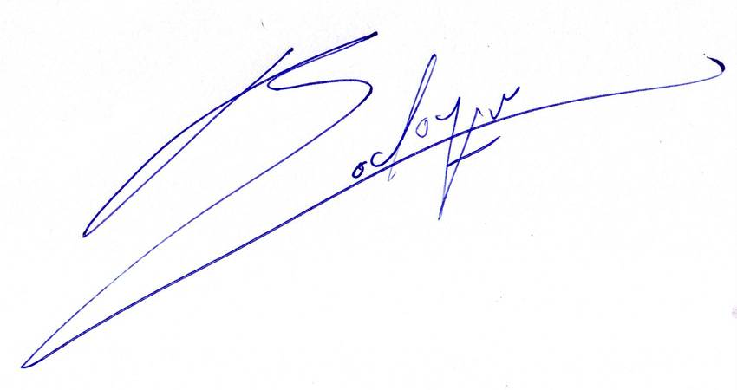

José María Bodoque del Pozo

