
Kazuaki Takabe, MD, PhD, FACS
Professor and Alfiero Foundation Chair of Breast Oncology, Clinical Chief of Breast Surgery
Roswell Park Cancer Institute
Ph: 716-845-5540, Fax: 716-845-5705, Kazuaki.Takabe@RoswellPark.org

Professor of Surgery, University at Buffalo the State University of New York
Affiliated Professor, Tokyo Medical University and Yokohama City University
Liaison Professor, Niigata University Graduate School of Medicine and Dentistry
Aug 10, 2018

Dr. Alisha DSouza
Senior Review Editor
Journal of Visualized Experiments (JoVE)

Dear Dr.DSouza,

Thank you for the comprehensive and helpful review of our manuscript entitled “How to generate murine orthotopic metastatic breast cancer model and perform murine radical mastectomy.” Please find the point-by-point response to the Editorial comments below. We have revised the manuscript accordingly.

We hope that these revisions are satisfactory and that the manuscript is now acceptable for publication in Journal of Visualized Experiments (JoVE).

Sincerely,

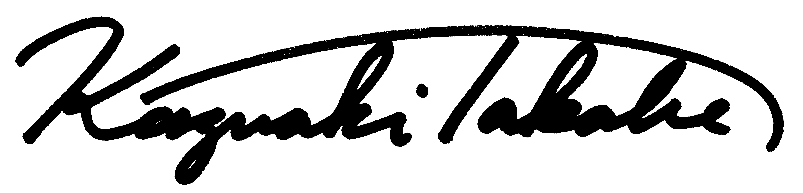
Kazuaki Takabe, M.D., Ph.D., FACS
Professor, Alfiero Foundation Chair and Clinical Chief of Breast Surgery
Roswell Park Cancer Institute

