Supplementary File 1. Built Test function of the battery cycler where the executable cycling protocol is programmed.
a). Display of the build Test screen
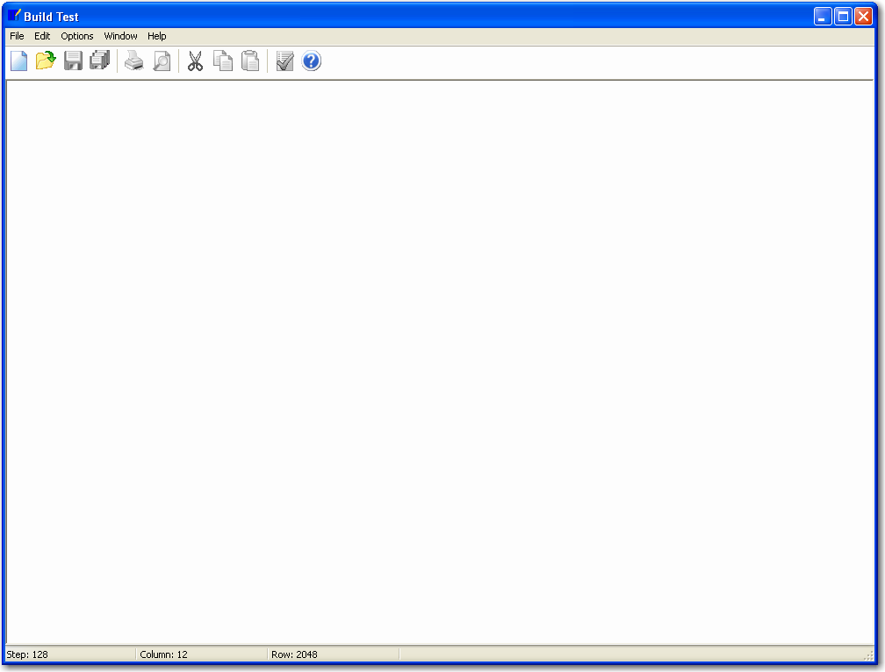

b). Display of the protocol definition screen
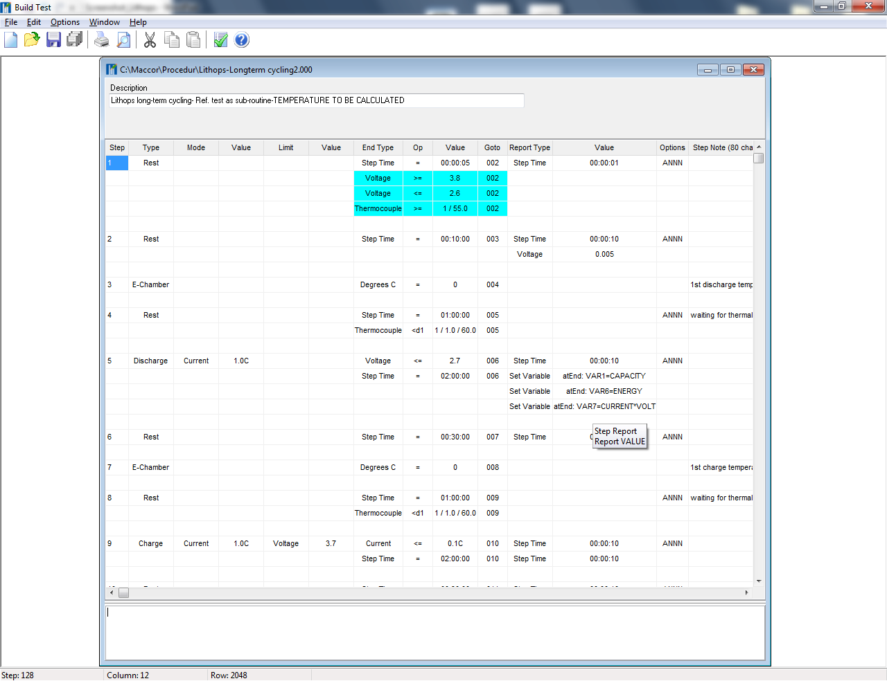

Supplementary File 2. Battery cycler software: overall status page and selection of channels.
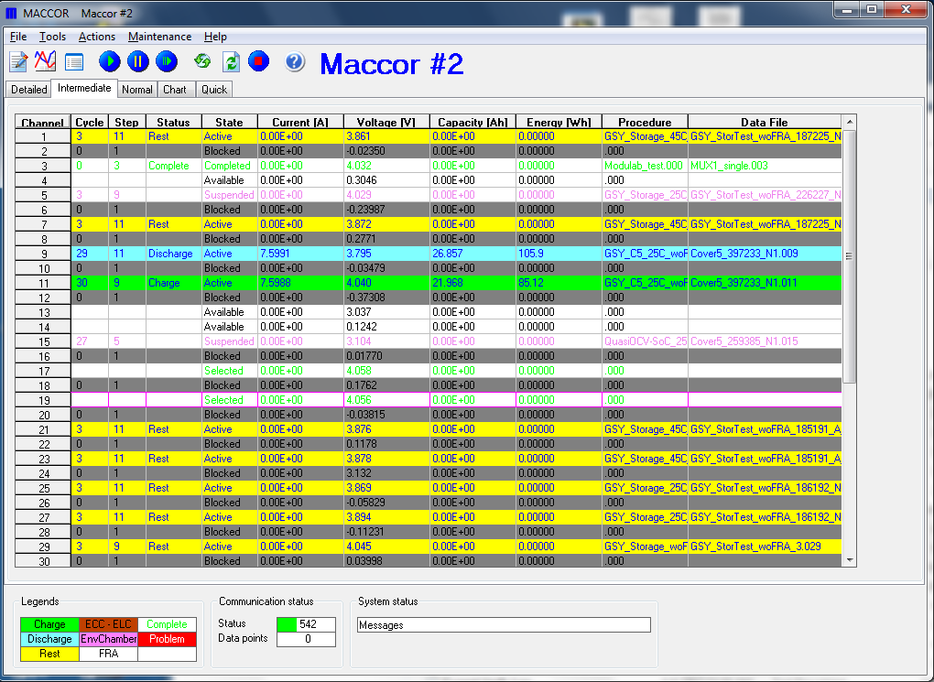
2

1

Supplementary File 3. Starting a test in battery cycler, selection of protocol and file name definition.
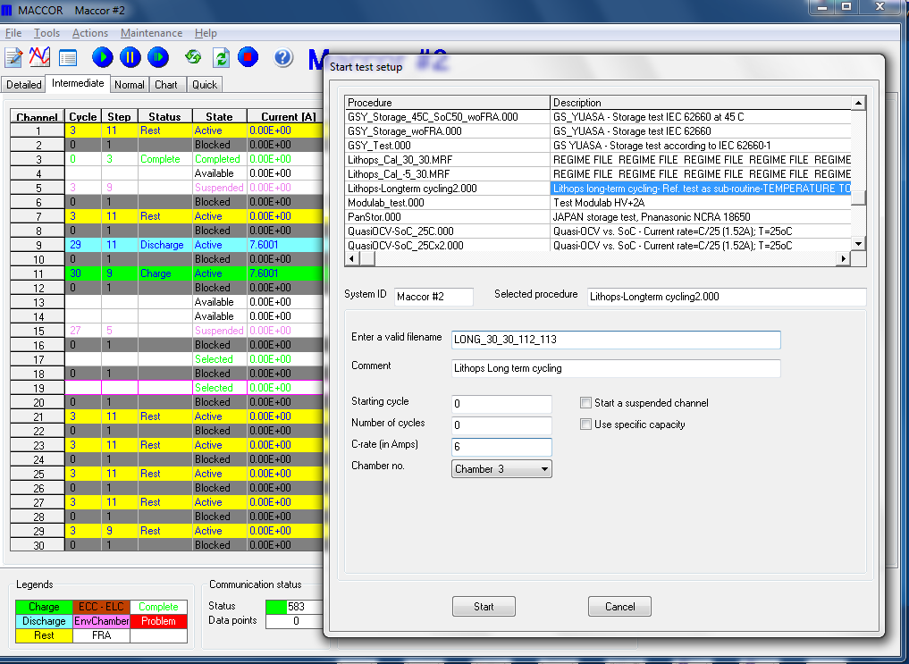
3

2

1

Supplementary File 4. Selection of the appropriate built-in template for visualization of the cycling data.
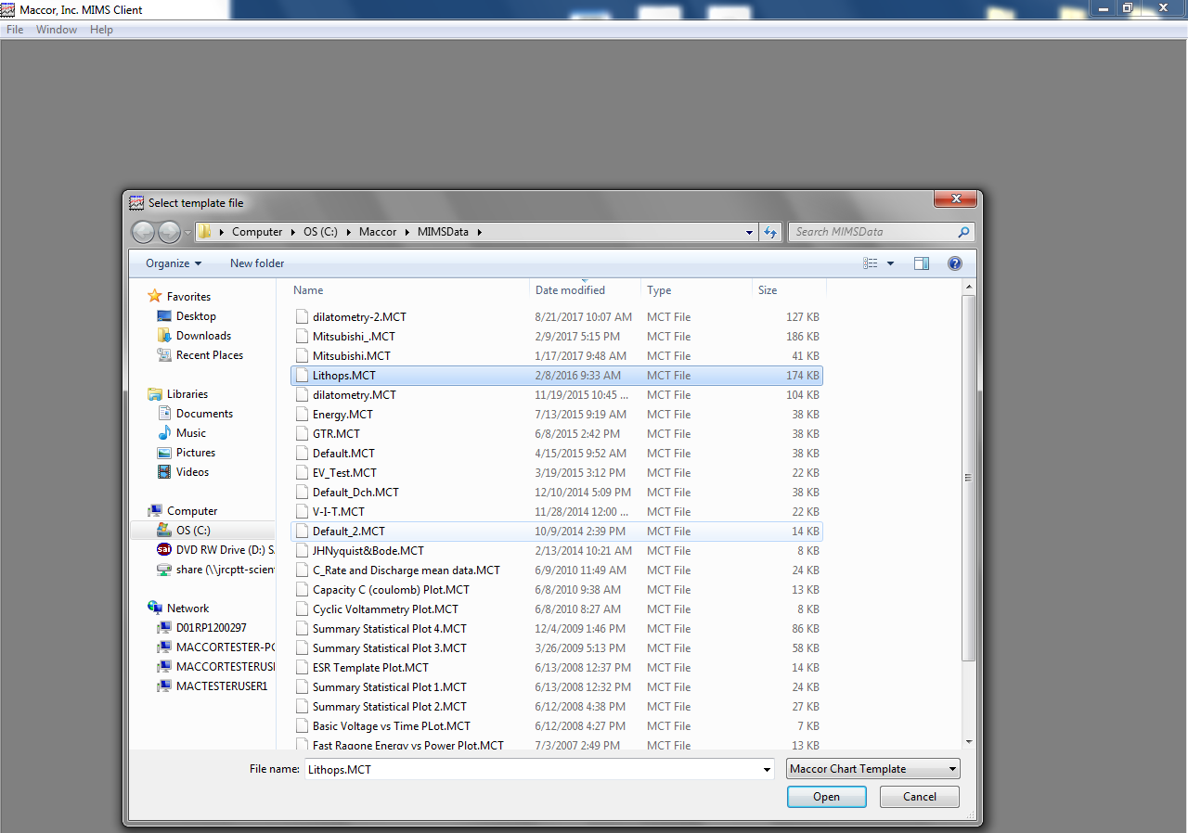

Supplementary File 5. Evaluation of cycling data. Top plot shows capacity retention vs. cycle number and bottom plot shows the variation of potential, current and temperature in time.

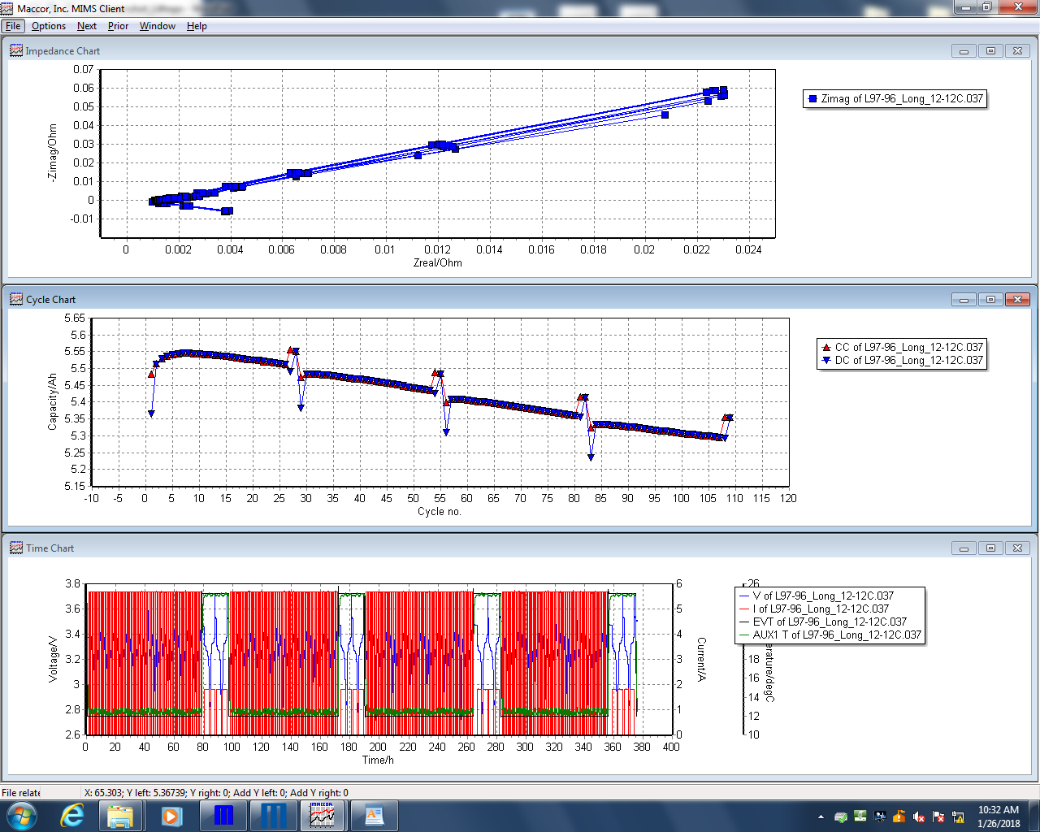

Supplementary File 6. Initiation of data fitting in JMP software
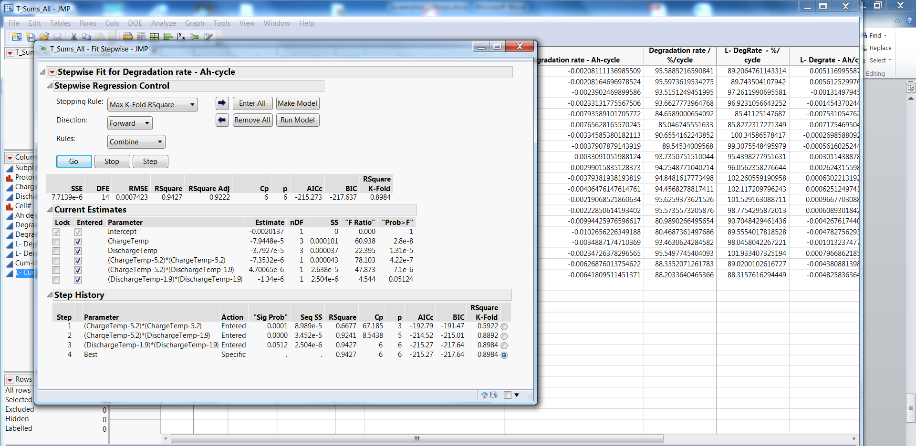
2

1

Supplementary File 7. Selecting the most significant parameters by using ANOVA
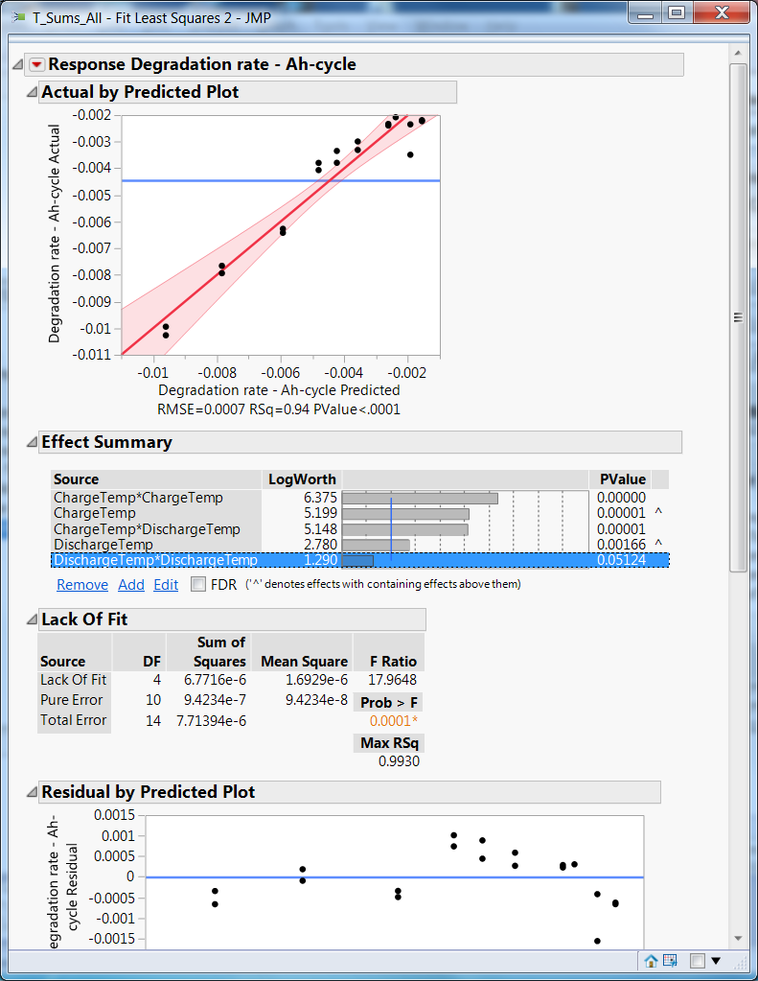

Supplementary File 8. Visual validation of the results
