Submission ID #: 57225

Editor Name: Maja Fiket
Videographer name: Douglas L Smith

Film Date: Jan 30. 2018
Link: http://www.jove.com/files_upload.php?src=17453673

Authors and Affiliations:

Joshua T. Maxwell¹, Chin-Hsien Tsai¹, Tahmina A. Mohiuddin², Jennifer Q. Kwong¹

¹Department of Pediatrics, Emory University School of Medicine, Atlanta, GA, USA

²Emory College of Arts and Sciences, Emory University, Atlanta, GA, USA

Title: Analyses of Mitochondrial Calcium Influx in Isolated Mitochondria and Cultured Cells

Corresponding Author:
Jennifer Q. Kwong

jennifer.kwong@emory.edu

Co-authors:
Joshua T. Maxwell
joshua.t.maxwell@emory.edu
Chin-Hsien Tsai
chinhsien.tsai@emory.edu
Tahmina A. Mohiuddin
tahmina.mohiuddin@emory.edu

A. Microscopy: Does your protocol involve video microscopy, such as filming a complex dissection or microinjection technique? (Y/N)___Y______
Can you record movies/images using your own microscope camera? (Y/N)____Y_____
If no, JoVE will need to record the microscope images using our scope kit (through a camera port or one of the oculars). Please list the make and model of your microscope: _____________________________________________
B. Software Usage: Does your protocol include detailed, step-by-step, descriptions of software usage? (Y/N)___N_____
C. Which steps of your protocol will viewers benefit most from having filmed? Please list 4-6 individual steps using the step numbers listed in this document. (Please do not list entire sections.)
Plate reader protocol: #2.1-2.4, 2.8-2.10
Confocal microscope protocol: #3.1-3.9
Authors, please answer this question with the steps listed here in the protocol section for use by the videographer.
D. What is the single most difficult aspect of this procedure and what do you do to ensure success? Please list 1-2 individual steps using the step numbers listed in this document. (Please do not list entire sections.) ___________________________
Plate reader protocol: #2.2- homogenization of heart. Since the heart cannot be over-homogenized for the successful isolation of functional mitochondria, we ensure success by carefully monitoring the homogenization and counting the number of strokes required to ensure the heart is homogenized just until the point where no large tissue pieces are visible.
Confocal microscope protocol: #3.5-3.6, 3.9-3.10 For this protocol permeabilization of cells is critical (steps 3.5-3.6) and the way that we ensure success is monitoring cell morphology during the process.

Authors, please answer this question with the steps listed here in the protocol section for use by the videographer.
E. Will the filming need to take place in multiple locations? (Y/N) ___Y____ If yes, how far apart are the locations? __ Within the same main lab, but the microscope is in its own separate room.__
1. Introduction (Experimental Goal and Author Interviews) – As the beginning of your video, the introduction should clearly present the goal of your method to the viewer and its significance. Other information can be provided according to the various statements below, but the total introduction should not exceed 150 words.
Authors, please try to memorize your interview statements prior to the shoot.

A. Experimental Goal: (read by voice talent at JoVE)

The overall goal of this procedure is to measure mitochondrial calcium influx in isolated mitochondria and cultured cells. (Intro)

B. Required Interview Statements: (Said by you on camera. Don’t forget to smile!)
  - Jennifer Kwong: This method can help answer key questions in the calcium signaling field, such as how mitochondria help to shape the cytosolic calcium landscape and the role of mitochondrial calcium dynamics in disease conditions. [1-MED]
    - Interview style: Jennifer saying the above
  - Jennifer Kwong: The main advantage of this technique is that our protocols can be adapted to a variety of model systems to assess mitochondrial calcium influx capacity. [1-MED]
    - Interview style: Jennifer saying the above

D. Introduction of Demonstrator: (Said by you on camera. Don’t forget to smile!)
  - ** Jennifer Kwong: I will be demonstrating the plate-reader based mitochondrial calcium uptake procedure, [1-MED] and Dr. Joshua Maxwell, an Instructor in the Department of Pediatrics, will be demonstrating the confocal microscope-based procedure for measure mitochondrial calcium influx. [2-MED] Authors: This statement is used ONLY if the demonstrator has not given an interview statement before. If you would like to completely omit this part, it is fine too, since Joshua Maxwell will speak in the conclusion. Reply: I would like to keep this statement in.
    - Interview style: Jennifer saying the above
    - Dr. Joshua Maxwell looks up and acknowledges the camera.

*Note to the Authors: Goal and interview statements have been edited to conform to the specified number and length restrictions. I am happy to help if you have any questions.

E. Ethics title card: (for human subjects or animal work, does not count toward word length total)

  - All methods described in this protocol have been approved by the Institutional Animal Care and Use Committee of Emory University.

Protocol: (read by voice talent at JoVE)

- Mitochondrial Calcium Uptake Measurement in Isolated Cardiac Mitochondria Using a Plate Reader
  - Start this experiment by thoroughly rinsing previously isolated heart in 25 milliliters of ice-cold 1X PBS, [1-MED-TXT] making sure that blood is completely squeezed out of ventricles. [2-CU] In 5 milliliters ice-cold 1X PBS [3-CU], using a pair of sharp scissors, mince the heart tissue into small pieces. [4-CU]
    - Talent adds PBS and rinses the heart. TEXT: Isolate the heart according to the text protocol.
    - Talent rinses the heart - zoom to show the heart with no blood.
    - Talent adds PBS to the heart tissue.
    - Talent uses scissors to mince the tissue.
  - Carefully discard the PBS [1-ECU] and transfer the tissue to a pre-chilled 7-milliliter glass-teflon dounce (pronounce: down’s) homogenizer. [2-CU-TXT] Then add 5 milliliters of ice-cold MS-EGTA buffer, [3-MED-TXT] and homogenize until there are no visible tissue pieces. [4-CU-TXT]
    - Talent discards of PBS.
    - Talent transfers the tissue to a homogenizer. TEXT: Homogenizer clearance: 0.10 – 0.15 mm
    - Talent adds MS-EGTA buffer. TEXT: See the text protocol for all buffers and solution.
    - Talent starts homogenizing. TEXT: Approximately 11 strokes
  - Transfer the homogenate to a 15-milliliter tube, [1-CU] and then centrifuge at 600 x g at 4 degrees Celsius for 5 minutes to pellet unwanted nuclei and unbroken cells. [2-MED-over the shoulder]
    - Talent transfers the homogenate to a 15-mL tube.
    - Talent places the tube in the centrifuge, closes the lid, starts the centrifuge. Film the settings if possible.
  - Transfer the supernatant to a fresh 15-milliliter tube [1-CU] and centrifuge at 10.000 x g at 4 degrees Celsius for 10 minutes. [2-MED-over the shoulder] After discarding the supernatant, keep the mitochondrial pellet on ice. [3-CU]
    - Talent transfers the supernatant to a new tube.
    - Talent places the tube in the centrifuge, closes the lid, starts the centrifuge. Film the settings if possible.
    - Talent discards the supernatant and places the pellet on ice.
  - To wash the pellet, add 5 milliliters ice-cold MS-EGTA buffer to it, resuspend, [1-MED-TXT] and then centrifuge at 10.000 x g at 4 degrees Celesius for 10 minutes. [2-MED-over the shoulder] After discarding supernatant repeat the wash… [3] and keep the pellet on ice. [4-MED]
    - Talent adds MS-EGTA to the pellet and starts resuspending. Film multiple usable takes, as shot will be repeated later. TEXT: Mitochondria should be used within 1 h.
    - Talent places the tube in the centrifuge, closes the lid, starts the centrifuge. Film the settings if possible.
    - *Use 2.6.1.
    - Talent places the tube on ice.
  - To start mitochondrial calcium uptake measurement using a plate reader, [1-MED] program the reader to perform a kinetic read of calcium green-5N fluorescence every second for a total time of 1000 seconds. [2-MED-over the shoulder-TXT]
    - Talent standing by the plate reader.
    - Talent starts programming the reader. TEXT: Programming depends on the type of plate reader.
  - Program the reagent injectors to dispense 5 microliters of Calcium Chloride solution at various time points. [1-MED-over the shoulder-TXT] Then prime the injectors with the Calcium Chloride solution that will be used. [2-MED]
    - Talent programs the injectors. TEXT: 30, 150, 300, 480 and 690 s.
    - Talent uses CaCl₂ solution to prime the injectors.
  - Next, add 200 micrograms of isolated mitochondria to one well of a 96 well plate, [1-ECU] and add the appropriate volume of potassium chloride buffer to achieve a total volume of 197 microliters. [2-ECU]
    - Talent pipettes the mitochondria to a well of a 96-well plate
    - Talent pipettes KCl to the well.
  - Then add 1 microliter of 1-molar pyruvate… and 1 microliter of 500-millimolar malate… and 1 microliter of 1-millimolar calcium green-5N stock, and mix gently by pipetting. [1-CU] Incubate protected from light at room temperature for 2 minutes, for mitochondria to become energized. [2-MED] Finally, start the pre-programmed kinetic protocol and monitor calcium green-5N fluorescence. [3]
    - Talent pipettes buffers into the well and then starts pipetting.
    - Talent places the plate into the plate reader to protect from light leaves the plate on bench and starts the timer. Timer in shot if possible.
    - Talent at the plate reader starting the protocol. Shot moved from 2.10.2.
  - Add 1 microliter of 1-millimolar calcium green-5N stock, and pipette gently to mix. [1-CU] Finally, start the pre-programmed kinetic protocol and monitor calcium green-5N fluorescence. [2-MED-over the shoulder]
    - Talent adds calcium green-5N and starts pipetting.
    - Talent at the plate reader starting the protocol.

- Mitochondrial Calcium Measurement Using Confocal Imaging in Cultured Cells
  - For this part of the protocol, prepare Rhod-2/AM-MitoTracker (Road two A M- My-toe-tracker) green working solution, by mixing 20 microliters Rhod-2/AM, 0.2 microliters MitoTracker green… 2.5 microliters 20% pluronic F-127 (plu-ro-nic F-1-2-7)… and 1 milliliter Tyrode’s solution. [1-MED-TXT]
    - Talent starts pipetting solutions. Labels should be in shot if possible. TEXT: 1 mM Rhod-2/AM stock, 1 mM MitoTracker green stock; Final concentration of Rhod-2 is 20 μM, MitoTracker green 200 nM.
  - Onto a previously prepared coverslip plated with NIH 3T3 cells, add the Rhod-2/AM-MitoTracker green solution dropwise until covered. [1-CU-TXT] For the cells to load with the dyes, incubate the coverslip protected from light for 30 minutes at room temperature. [2-MED]
    - Coverslip in shot and then talent starts adding drops of the solution to it. TEXT: 3-4 drops.
    - Talent covers the coverslip to protect it from light and starts the timer. Timer in shot if possible. Film multiple usable takes, as shot will be repeated later.
  - To de-esterify Rhod-2/AM, gently remove the Rhod-2/AM-MitoTracker green solution, [1-CU] and replace it with approximately 300 microliters fresh Tyrode’s solution to cover the cells. [2-CU] Finally, incubate the coverslip protected from light for 30 minutes at room temperature. [3]
    - Talent removes the solution from the coverslip with a pipette.
    - Talent adds Tyrode’s solution.
    - *Use shot 3.2.2.
  - Now, transfer the coverslip to the microscope imaging chamber, [1-MED] and fill the chamber with Wash Solution. [2-MED-over the shoulder] Adjust focus to observe the cells in phase contrast at 40X magnification. [3-MED-over the shoulder]
    - Talent transfers the coverslip to the microscope.
    - Talent starts filling the chamber.
    - Talent by the microscope adjusting magnification.
  - To permeabilize plasma membrane of Rhod-2/AM-MitoTracker green loaded cells, remove the Wash Solution from the coverslip [1-CU] and replace it with approximately 300 microliters Permeabilization Solution to cover the cells. [2-CU]
    - Talent uses a pipette to remove the wash solution from the coverslip.
    - Talent adds permeabilization solution. Label in shot if possible
  - Monitor the plasma membrane morphology during this process. [1-MED-over the shoulder] When permeabilized, cells will develop a roughened surface. [2-LM-TXT] Remove the Permeabilization Solution immediately after complete permeabilization, [3-CU] and replace it with 0 (read: zero) Calcium Internal Solution. [4-CU]
    - Talent sitting at the microscope observing the cells.
    - Image of permeabilized cells to be provided by the authors. TEXT: Approximately 1 min.

NOTE by Jennifer Kwong: We will send you pictures of unpermeabilized cells loaded with rhod2, and cells that have been permeabilized.
    - Talent removes the solution.
    - Talent adds new solution. Label in shot if possible.
  - Next, focus on permeabilized cells displaying a clear co-localization of Rhod-2 and MitoTracker green to image Rhod-2 and MitoTracker green fluorescence simultaneously. [1- LM-TXT]
    - 57225_Kwong_Fig 2A Permeabilized cells displaying colocalization of dyes. TEXT: For excitation and emission wavelength see the text protocol. Video Editors: When the VO says: “displaying a clear co-localization of Rhod-2 and MitoTracker green to image Rhod-2 and MitoTracker green fluorescence simultaneously” show just the third panel, “merged”.
  - Next, decrease the microscope laser and gain settings to make the mitochondrial Rhod-2 fluorescence dim and barely visible. [1- MED-over the shoulder-TXT] To capture the kinetics of mitochondrial Calcium changes, select microscope settings to acquire 2-dimensional scans at an appropriate frame rate and time course. [2- MED-over the shoulder-TXT]
    - Talent decreases laser and gain settings to make the mitochondrial Rhod-2 fluorescence dim and barely visible. TEXT: Specific settings depend on the microscope available.
    - Talent selects settings to acquire 2-dimensional scans at an appropriate frame rate and time course. TEXT: Recommended: ≥30 frames/s.
  - Remove the 0 (read: zero) Calcium Internal Solution, making sure not to disturb the cells and microscope focus, [1-ECU] and then start image acquisition. [2-MED-over the shoulder]
    - Talent carefully removes the solution.
    - Talent starts image acquisition.
  - Using a syringe, manually add Calcium-replete Internal Solution at the 10-seconds time point. [1-CU] Finally, in the image acquisition software select regions of interest to encompass regions of co-localization of Rhod-2 and MitoTracker green signal. [2-MED-over the shoulder]
    - Talent manually adds Calcium-replete Internal Solution using a syringe.
    - Talent selects ROIs to encompass regions of co-localization of Rhod-2 and MitoTracker green signal. NOTE by Jennifer Kwong: We can show selection of the ROI from an over the shoulder video. No screen shots.
- Results: Mitochondrial Calcium Analysis in Isolated Mitochondria and in Cultured Cells
  - When Calcium Chloride is added to isolated cardiac mitochondria, fluorescence from the calcium dye increases. As mitochondria uptake Calcium from the buffer, fluorescence decreases. [1-LM]
    - 57225_Kwong_Fig 1A Video Editors: When the VO says first sentence, slowly highlight first 2 parts of the graph where the curve is going up, parts circled on the left image (see below). When the VO says second sentence, slowly highlight first 2 parts of the graph going down, parts circled on the right image (see below).

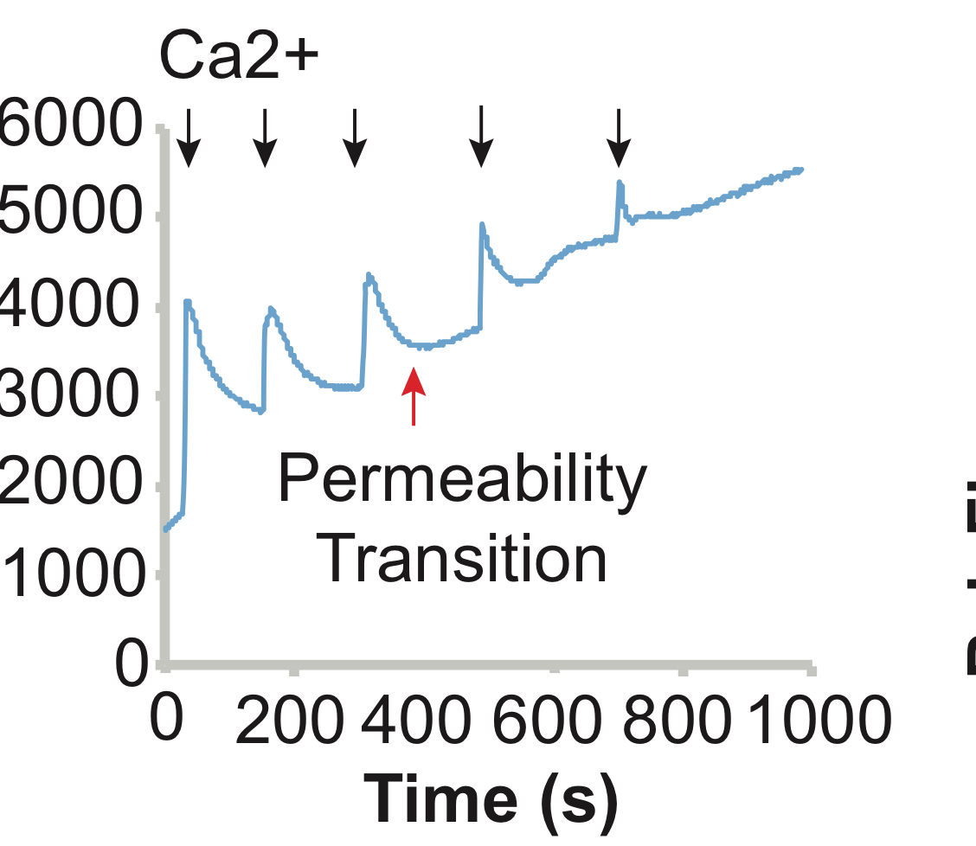

  - However, at the third addition of calcium, fluorescence suddenly starts increasing after a drop, indicating mitochondrial Calcium overload and mitochondrial permeability transition pore opening, which can lead to mitochondrial inner membrane permeabilization. [1-LM]
    - 57225_Kwong_Fig 1A Video Editors: When the VO says: “at the third addition of calcium”, highlight or circle the third arrow above the graph, and when they say: “fluorescence suddenly starts increasing after a drop” highlight part of the graph between the third and fourth arrow, part circled here:

  - On the other hand, when mitochondria are pre-treated with an inhibitor of mitochondrial Calcium uptake, there is an increase in fluorescence following each Calcium addition. [1-LM]
    - 57225_Kwong_Fig 1B Video Editors: Slowly highlight the whole graph starting from left and ending at the very right of the graph.
  - In cultured NIH 3T3 cells mitochondrial network is stained with MitoTracker green dye. Cells are also stained with Rhod-2 dye, and after saponin-permeabilization, cytosolic Rhod-2 is washed away, leaving just mitochondrial staining, which co-localizes with the MitoTracker. [1-LM]
    - 57225_Kwong_Fig 2A Video Editors: First show whole Fig 2 A, then when the VO says first sentence, zoom into first panel. When they say: “Cells are also stained with Rhod-2 dye and after saponin-permeabilization, cytosolic Rhod-2 is washed away, leaving just mitochondrial staining” zoom into second panel. When they say: “which co-localizes with the MitoTracker” zoom into third panel.
  - Since Rhod-2 can accumulate in non-mitochondrial structures, the analysis should focus only on regions where MitoTracker and Rhod-2 co-localize. [1-LM] The addition of Calcium causes an increase in Rhod-2 fluorescence in control cells, whereas in cells treated with the inhibitor of mitochondrial Calcium uptake there is no change in fluorescence. [2-LM]
    - 57225_Kwong_Fig 2A Video Editor: Show just third panel here.
    - 57225_Kwong_Fig 2B Video Editor: When the VO says: “The addition of Calcium” circle the black arrow and 2 µM Ca²⁺ written above it, and when they say: “causes an increase in Rhod-2 fluorescence in control cells”, highlight the part of the black graph after the arrow. When they say: “in cells treated with the inhibitor of mitochondrial Calcium uptake there is no change in fluorescence”, highlight the part of the red graph after the arrow.

RESULTS INSTRUCTIONS FOR AUTHORS:
Please ensure that the representative results narration is appropriate and correctly describes your images, movies, or figures. Our editors will ensure that the results are written in our format.

We consider this section a critical aspect of the video, because here is where you provide validation for your experiments. For example, if this is a cell culture preparation, this section is where the video will show your cells at various time points following culturing. If this is an imaging prep, then this part is where you will show examples of your imaging experiments.

Please limit the extent of narration to no more than 2-3 lines of text per image or movie file being described. The results section is limited to 200 words total. If your results section contains more than 3-4 figures, please choose the most important figures to illustrate your results. Figures with multiple panels submitted with the original protocol should be broken up so that each panel is a separate image. Each image or movie file supplied for the video results section should be referenced by its specific file name.

Below is an example of results text:

EXAMPLE REPRESENTATIVE RESULTS

5. Evaluation of Morpholino Injection and Knockdown
5.1 Representative results of both morpholino injection and mRNA injection are shown here. The
uninjected control at 48 hours post fertilization looks normal, as expected
-LAB MEDIA: 0123_PIname_Figure1.tif (Replace 0123 with your jove video #)

5.2 However, embryos injected with the morpholino heg_e3i3_egfr1, which knocks down Heg isoforms
containing the first of two EGF-like repeats, exhibit brain edema.
-LAB MEDIA: 0123_PIname_Figure2.tif

5.3 Injection of heart of glass mRNA also produced an obvious phenotype. At 24 hours post fertilization,
the heads of the uninjected controls look normal
-LAB MEDIA: 0123_PIname_Figure3.tif

5.4 Conversely, some of the embryos injected with the mRNA exhibit cyclopia
-LAB MEDIA: 0123_PIname_Figure4.jpg

Please visit the following URL to see an example of how the results will look when complete:

http://www.jove.com/video/1597/results-example-mably?status=a3603k

- Conclusion (said by authors on camera)

  - Josh Maxwell: These protocols can be applied to measure mitochondrial Ca²⁺ uptake in many cell types including primary cells such as cardiac myocytes and neurons, and immortalized cell lines, as well as isolated mitochondria from many tissue types including heart, liver and brain. [1-MED]
    - Interview style: Josh saying the above
  - Josh Maxwell: Ca²⁺ handling by mitochondria is a critical function regulating both physiological and pathophysiological processes in different cells. The ability to accurately measure the influx of Ca²⁺ from mitochondria is an important part of determining the role of mitochondrial Ca²⁺ handling in these processes. [1-MED]
    - Interview style: Josh saying the above
  - Josh Maxwell: After watching this video, you should have a good understanding of how to measure mitochondrial calcium influx in isolated mitochondria and cultured cells. [1-MED]
    - Interview style: Josh saying the above

*Note to the Authors: Interview statements have been edited to conform to the length restrictions. I am happy to help if you have any questions.

Provided Media

Authors, Please list all images, movie files, or 3-D rendered animations that can be included in the video per editor’s request. The step in the script/video where these images will be inserted should be specified. For example:

6.2 – 0123_PIname_Figure1.tif - dual color imaging of tumor angiogenesis at 40X
6.2 – 0123_PIname_Figure2.tif - dual color imaging of tumor angiogenesis at 100X

Formats: For static images we prefer .tiff, .eps, Illustrator, Powerpoint or Photoshop files at dimensions of at least 720X480 pixels and 300 dpi. The higher resolution, the better. Likewise any exported movie files should have at minimum these dimensions and be rendered to .mov, .mp4, or .avi files.

Insert your media filenames here.

Authors: Please provide pictures of unpermeabilized cells loaded with rhod2, and cells that have been permeabilized, as indicated above.

Also, please provide unflattened, layered images 1 and 2.

General Preparation

It’s critical for a smooth and organized shoot that all reagents are accounted for, in advance.

Any overnight or long incubation steps should be recognized and specimens/samples be prepared in advance so that prior steps can be recorded and shooting can continue with pre-prepared specimens/samples.

All tubes/flasks should be pre-labeled neatly before we arrive.

Ex. Luciferase assay done in 96 well plates should be labeled with negative/positive control wells and experimental samples are labeled accordingly.

You will receive more detailed preparation instructions are included in the email accompanying the finalized script.

