Dear Dr. Bajaj, January 24, 2018

Concerning revised submission 57163_R2_RE_jwb2 , I have made the following corrections per your request:

- Reference to ASTM D7084-04 in the abstract has been omitted and is changed to standard methods.
- Reference to ASTM D7084-04 in the introduction has been fully cited.
- All references have been corrected to include full titles of manuscripts/books. Volumes and page numbers have been included where available.
- The paper submitted to CET in reference 19 has been e-mailed separately and below is a snip-copy of the submission to CET. I have added the reference number to the citation. Please delete/destroy the pdf after consulting.
- Legends for Figures 1 through 5 and Table 1 have been corrected per your recommendation.
- The figures without legends have been sent separately in an earlier email.

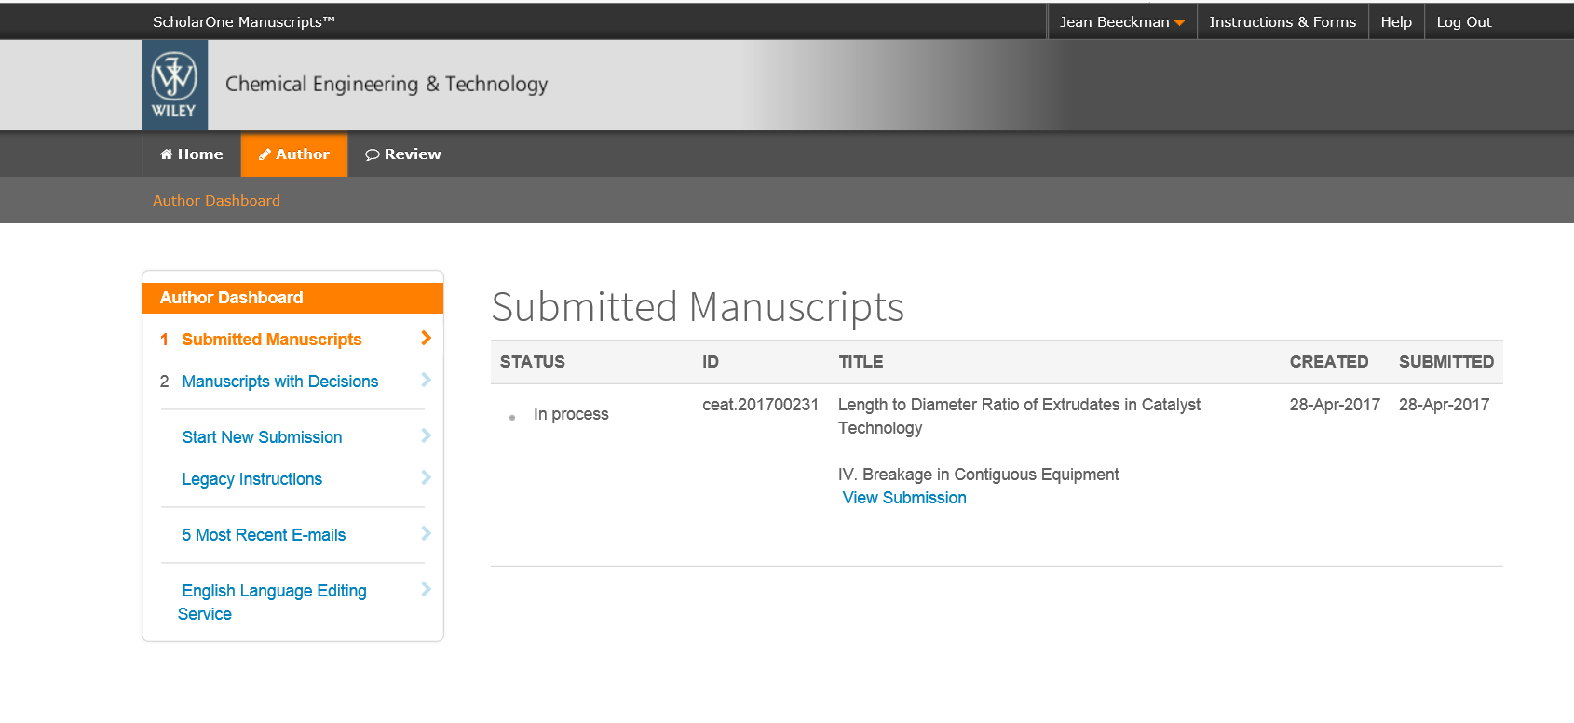
Best Regards,



Jean W. L. Beeckman
ExxonMobil Research and Engineering
PTD/Catalyst Technology Division
Catalyst Scale-up
1545 Route 22 East
Annandale, NJ 08801
(908) 335 2870 Tel

