Pronunciation Guide: Please contact us if you need help

fascia pronunciation: https://www.youtube.com/watch?v=jBGSCCW5dXo

laparotomy: https://www.youtube.com/watch?v=JUWpvn0spTM

Cannulator: say kan-yuh-laytor

Cephalad: https://www.youtube.com/watch?v=2-E4S6jy1Pk

Caudal: https://www.youtube.com/watch?v=zEdZav3DYEQ

dermotomy: say der-mo-tomey

myofascial: https://www.youtube.com/watch?v=9DC_-eFwdZU

pericolic: https://www.youtube.com/watch?v=gbkwAZlYB1w

hemostat: https://www.youtube.com/watch?v=hciReXIB8o4

visceral: https://www.youtube.com/watch?v=wZJwwkUk2ok

Chlorohexidine: https://www.youtube.com/watch?v=Eg5K5VhYaCQ

gluconate: https://www.youtube.com/watch?v=9NN9CbgZyV8

Paracentesis: https://www.youtube.com/watch?v=XuIpSFXfDeo

loban: say low-ban

ABRA: say A-brah

rectus: https://www.youtube.com/watch?v=l97cnn0NJmE

TRAC: say track

VAC: say vac as in vacuum

Maceration: https://www.youtube.com/watch?v=2g2FQwbwyWE

mmHg: millimeters of mercury

Authors: Please edit to read as follows:
Yana Puckett, Beatrice Caballero, Virginia Tran, Michelle Estrada, Shirley McReynolds, Robyn E. Richmond, Catherine A. Ronaghan

II: Installation

@1:00
Patient is widely prepped from nipple area to upper thighs, entire anterior and lateral abdominal area to where the body meets the bed.
Notice the KCI ABThera plastic visceral protector is left in place for the prep, only the outer blue sponge and VAC drape tape are removed.
Also notice wide towel draping with clips followed by narrow 4 towel drape around incision. This is to insure the Ioban is applied on skin. The goal is to have every element of the ABRA DTS system on the Ioban and not directly on the patient’s skin. Initially, do not remove adhesive backing from laparotomy drape.

@1:07
Remove plastic visceral protector. Proceed with thorough exploration and large volume paracentesis with heated 0.9% normal saline *
*To be added as text on the screen*: Volume depends on degree of contamination, minimum 2 liters
REMOVE TEXT ABOUT ANESTHESIA @
Be very respectful of the visceral mass. If visceral mass is fused to itself as seen in this video, do not attempt to separate bowel loops. It is important to be sure the visceral mass is not fused to the posterior fascia, otherwise there is risk of injury from the silicone visceral protector.

@1:13
If patient is deemed an ABRA DTS candidate, obtain baseline measurements:
MFG (MyoFascialGap): Distance (in centimeters) between medial edges of rectus muscles
VE (Visceral Extrusion): Protrusion of viscera (in centimeters) above the posterior fascia
L (Length): Length of incision (in centimeters)

@1:30
Cut the drapes to widely expose anterior and lateral abdomen. The goal is to apply the Ioban widely, such that every element of the ABRA DTS is on the Ioban and NOT directly on patient skin. Protect the visceral mass with a laparotomy sponge, which should not directly contact the skin.

@1:35
Always double glove, and change as needed throughout the procedure.
Generously spritz the skin with Hollister spray, to insure durable adhesion of the Ioban to skin for duration of installation. This Ioban sheet will remain in place until the device is de-installed and primary myofascial closure is achieved.

@1:41
The application of the Ioban should start on the side of the operative surgeon. The assistant across from surgeon holds opposite end of Ioban and follows the operative surgeon’s lead for placement. A third person removes the backing at the direction of the operative surgeon.
Notice the large area of skin covered by the Ioban. It is important to apply slowly and smoothly. Also, note there was no excessive tension as the Ioban is applied to avoid skin shear injury.

@1:52
The Ioban is cut around the laparotomy sponge, which is removed from the field. Notice how adherent the Ioban is to the skin edge, in some areas actually overlapping, which can be trimmed later as needed. The important point is the Ioban is densely adherent to the skin edge which prevents fluid from tracking between Ioban and skin thus causing a maceration skin injury.

@2:11
Elements of the ABRA DTS are shown. These are the main components of the ABRA DTS system.
@2:20
PLEASE ADD NEW TEXT AS SHOWN HERE
@2:28
Measure 5 cm lateral to each myofascial edge. To insure the distance is actually 5 cm from the myofascial edge and not the skin edge, it is recommended the operative surgeon grasp the myofascial unit and measure from the deep myofascial edge. The operative surgeon places a 15 cm ruler at end of middle finger and palpates through the abdominal wall. The area is marked, ultimately creating the ellipse seen here (@2:38).

@2:41
The elastomers should be positioned every 3 cm along the myofascial gap. Do not place elastomers under intact abdominal wall, so be aware of the cephalad and caudal aspects of the myofascial gap.
Fortuitously, the button is 3 cm in width, so if no ostomies are present, place buttons side by side and mark the bottom of the slit (base of the U-shaped slit), intersecting the ellipse.

ADD @ 2:49-2:50
If possible, from raw video footage, find clip of elastomer placed at cephalad-most mark…
Match the side opposite elastomer insertion sites by initially placing an elastomer across the myofascial gap at the cephalad-most mark. Then proceed with side by side button placement to symmetrize elastomer insertion sites on contralateral side.
@2:50
This is the cannulator. It is a device meant to bluntly dissect though the abdominal wall, but could definitely injure viscera, so use caution.

@2:56 – 3:00 REMOVE
@3:01
Use a #11 knife blade to make superficial, but full thickness dermotomies on one side only. Be sure the dermotomy is large enough for the cannulator.
ADD AS TEXT ON SCREEN: The intersection of the hashmark with the ellipse should be the center of the dermotomy.

Bleeding is minimized if deep, stab incisions are avoided and is easily controlled with bimanual pressure, if encountered. Note the parallel position of the blade to the skin.

@3:10
The cannulator is placed through the abdominal wall at an ABSOLUTE 90 degree angle.
Protect the visceral mass with the Yellow Surgifish. Apply A LOT of counter traction with other hand. This allows for a safe and controlled cannulation.
REMOVE TEXT THAT READS “Do not injure abdominal viscera” and replace with “Cannulator is placed at an absolute 90 degree angle through the entire abdominal wall”

@3:15
Insert elastomer, slide toward end of cannulator to secure elastomer as cannulator is withdrawn through abdominal wall. Secure both ends of elastomer with a small hemostat.
On opposite side, repeat each step starting with superficial dermotomies. Remember to apply hemostat to the other end of the elastomer once positioned across myofascial gap.
@3:25
Always orient the silicone visceral protector in the long axis of the abdomen as demonstrated. Scroll it, place under the elastomers, carefully unroll and cover the visceral mass. It is rarely necessary to trim the silicone visceral protector but rather fold it on itself as needed in the paracolic gutters and pelvic brim.

@3:39
Secure elastomers with the buttons and remove hemostats. Do not tension elastomers across the myofascial gap yet. Pinch the elastomer at the button base, stretch elastomer distally to lock into the cleat.
Insert still shot of following picture:
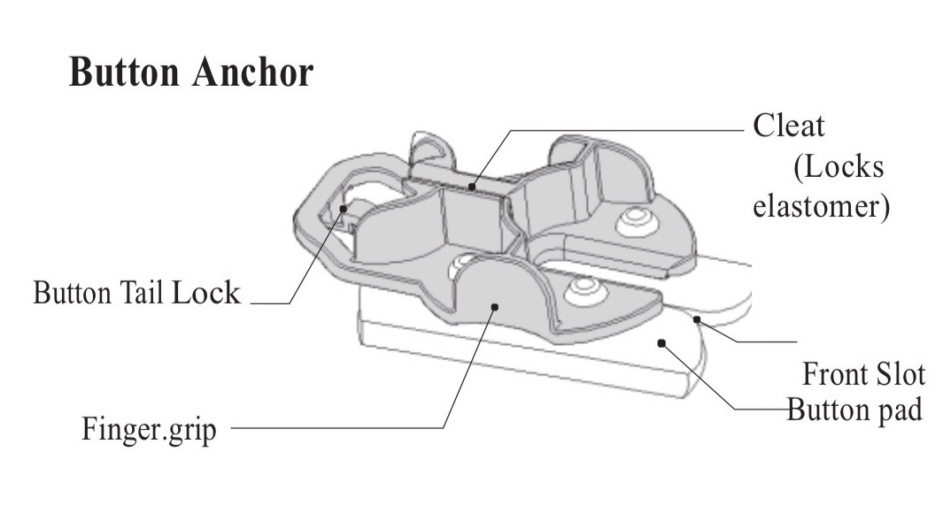
@3:54
Orient elastomers so black tension markings are visible.
@4:04
At this point, begin 2 region osteopathic maneuvers* and continue intermittently for the remainder of the case. Each move should last about 60 seconds. You cannot do too many moves.
Notice lateral position of hands, lateral to all elements of ABRA DTS. Continue this Move at least 3 times per day, while device is in place and at least 5 days after de-installation.
INSERT AS TEXT*: The Move: Myofascial release of lateral/flank muscles (obliques and transversus abdominus), for at least 60 seconds with slow release.

@4:20
Trim the elastomer retainer to slightly less than the length of the incision. Place elastomers into the appropriate slot. It is perfectly acceptable to have 2 elastomers in one slot, if needed.
Begin elastomer adjustments interspersed with osteopathic maneuvers until proper dynamic tension is achieved across the myofascial gap. That is defined as 1.5 – 2 times stretch of the black tension markings across the myofascial gap.
@4:36
Record the progress for operative note documentation.

4:52 – 5:04 needs to be moved to just after 4:41
Narration for button tail application (4:52 – 5:04).
@4:40 – 4:41
Spray the Ioban with Hollister spray.
@4:52 – 5:04
Gently lift the back of the button. Fold backing of button tail exposing metal hanger. Place metal hanger at right angle to button tail lock and be sure hanger is placed within narrow slot to lock. Insert zoomed in picture of button here.
Once all button tails are in place, trim the excess elastomer length. Note the elastomer trim mark on the button tail.

@5:05
Cut KCI black sponge into long thin piece and apply as shown.

@5:11
Generously apply additional Hollister spray to Ioban, medial to buttons.
Cut VAC drape tape sheets into strips. (@5:16).

@5:22
Apply overlapping VAC drape tape strips lateral to medial, as goal is medialization of all elements of the abdominal wall.

@5:37
Apply TRAC pad in the standard fashion, set negative pressure to between 25 and 75 mmHg, continuous, high intensity. Use as low a negative pressure as possible to control drainage.
@5:52
Excess VAC drape tape should be rolled under buttons. Apply double layer of Interdry as demonstrated such that the button completely sits on the Interdry and completely surrounds the elastomer as it exits the skin. This will capture any moisture from within the abdominal cavity tracking along the elastomer, thus avoiding a maceration, pressure injury from the button.

Part III: Elastomer Adjustment

@6:46

Leave patient on hospital bed. Do not move to OR table.

The operative surgeon should carefully remove the black sponge. Notice a minimal amount of VAC drape tape is removed. If the Ioban is adherent to the medial skin edges, do not disrupt. Only trim Ioban in areas where it has separated from medial skin edges. Any exposed skin will be covered at the end of the procedure with VAC drape tape. It is common to have layers of VAC drape tape over intact Ioban.
@7:01 CHANGE TEXT ON SCREEN FOR MFA to read:
MyoFascial Apposition (MFA): Caudal and cephalad areas where myofascial edges are in contact

Obtain new baseline measurements. Typically the cephalad and caudal myofascial edges move to midline first, so document length of MFA as well.

@7:04

Operative surgeon should prep the patient using chlorhexidine gluconate. Avoid a sloppy wet prep.

@7:10

Throughout the adjustment procedure, perform 2 region osteopathic maneuvers. You cannot perform too many!!

@7:14- 7:17 this moves to 7:30-7:31
Narration for 7:18
Complete a thorough re-exploration with large volume paracentesis. No need to remove the silicone visceral protector or release the elastomers. Be sure visceral protector hasn’t slipped, impinged on hollow or solid viscera and most importantly, that elastomers are never in direct contact with the viscera once device is completely installed and elastomers are tensioned.
@7:27
Once these steps are completed, if appropriate, adjust elastomers based on elastomer tension markings across the myofascial gap. Do so in a bidirectional fashion such that the middle elastomers are always tensioned last. DO NOT OVER TENSION.
Typically, adjustments are made when tension markings are at 1.5 times stretch. Be very sensitive to the feel of the elastomer and terminate the adjustment as soon as resistance is felt, regardless of the tension markings across the myofascial gap.
Typically, microadjustments interspersed with osteopathic maneuvers work best.
NEVER adjust elastomers with the KCI negative pressure wound therapy device in place. Why?
Because you cannot see the tension markings across the myofascial gap.
After new segment has been moved to 7:30-731…
Obtain measurements at completion of adjustment procedure and record in operative note. Apply KCI black sponge device as demonstrated.

Part IV: De-Installation
The patient is moved to the OR table with risers to accommodate an x-ray cassette. Again, the operative surgeon should remove the KCI negative pressure wound therapy device sponge and complete the skin prep with chlorhexidine gluconate. This should be a non- sloppy wide prep. The wide and narrow 4 towel drape configuration described for installation is used here as well.
It is important to raise subcutaneous flaps at least 2cm back from myofascial edges to completely and precisely delineate the myofascia.
Obtain a baseline peak inspiratory pressure reading, and this should be monitored throughout the primary myofascial closure.
The device is removed in stages, beginning with the elastomer retainer. Standard exploration and large volume paracentesis is completed.
X-rays are obtained to exclude retained foreign objects.
The primary myofascial closure is completed in a bidirectional fashion with #2 vicryl on a TP1 needle using a far-near-near-far (Smead Jones) technique.
The sutures are tied in place, again in a bidirectional fashion. Then elastomers are cut as demonstrated. This allows for continued dynamic tension during the closure.
Eventually, once the elastomers in the mid portion of the incision are cut, the silicone visceral protector is carefully removed from the abdominal cavity and remaining sutures are tied in place, completing the primary myofascial closure.
Include as text on screen: Note: Leaving the visceral protector in place until near the end of myofascial closure controls and protects the visceral mass

Around 8:40 insert following text: Note how well myofascial is delineated with subcutaneous flap elevation.
Note the drapes have now been cut to expose the entire ABRA DTS system. The Ioban, buttons, button tails, and cut elastomers are carefully removed from the skin to avoid epidermal shear injury. The circulating nurse examines and counts all elements of ABRA DTS system.
Typical xenograft requirements: Micromatrix 1 gram and a 10 x 15 cm Cytal 2 layer wound sheet. Hydrate the wound sheet in its original packaging with sterile irrigation fluid as demonstrated for at least 3-5 minutes.
Prior to implantation of the porcine urinary bladder matrix, the elastomer exit sites are covered with Aquacel AG-Hydrofiber Extra after the surrounding skin is generously spritzed with Hollister spray. These are secured in place with strips of VAC drape tape.
The Micromatrix is sprinkled on the myofascial closure. The delaminated 2 layer Cytal wound sheet is positioned in the wound such that the myofascia and subcutaneous tissue are exposed to the xenograft.
The skin edges are apposed with strips of VAC drape tape after liberal spritzing of skin with Hollister spray.

V: Results: Examples of Completely Healed Open Abdomen Patients
Insert following pictures (two pictures should appear side by side, with some space in between, at the same time) with Narration

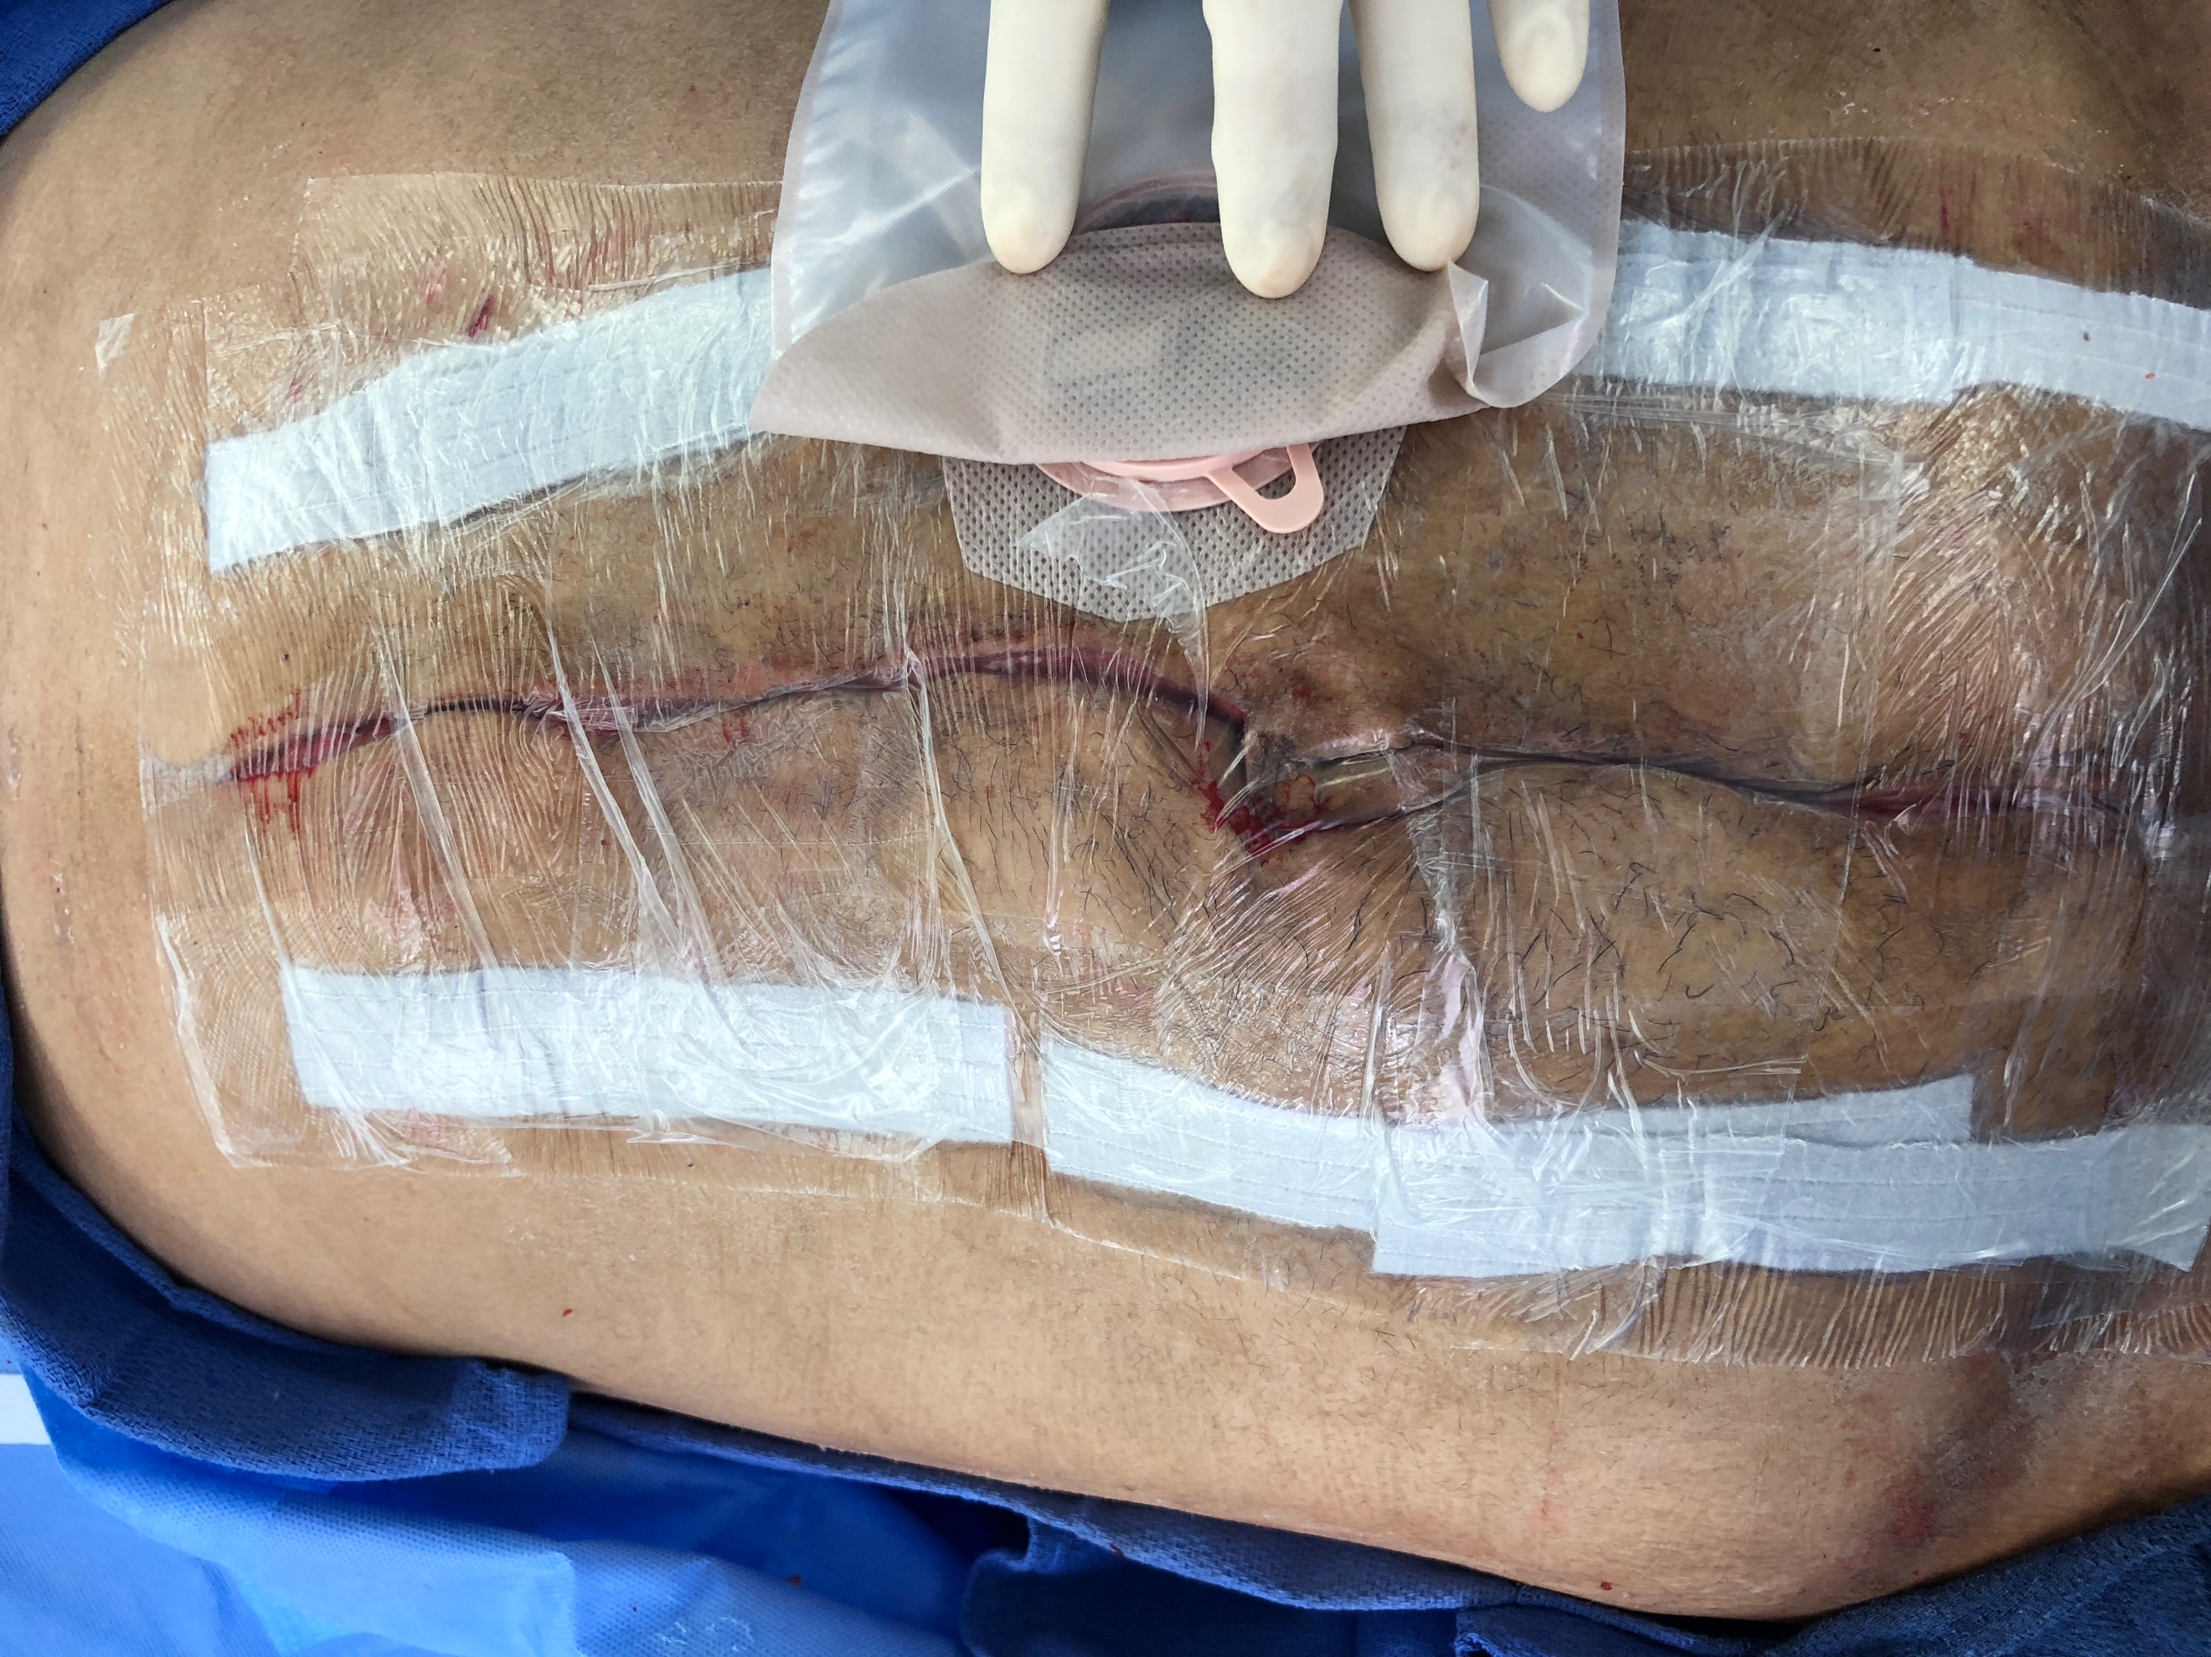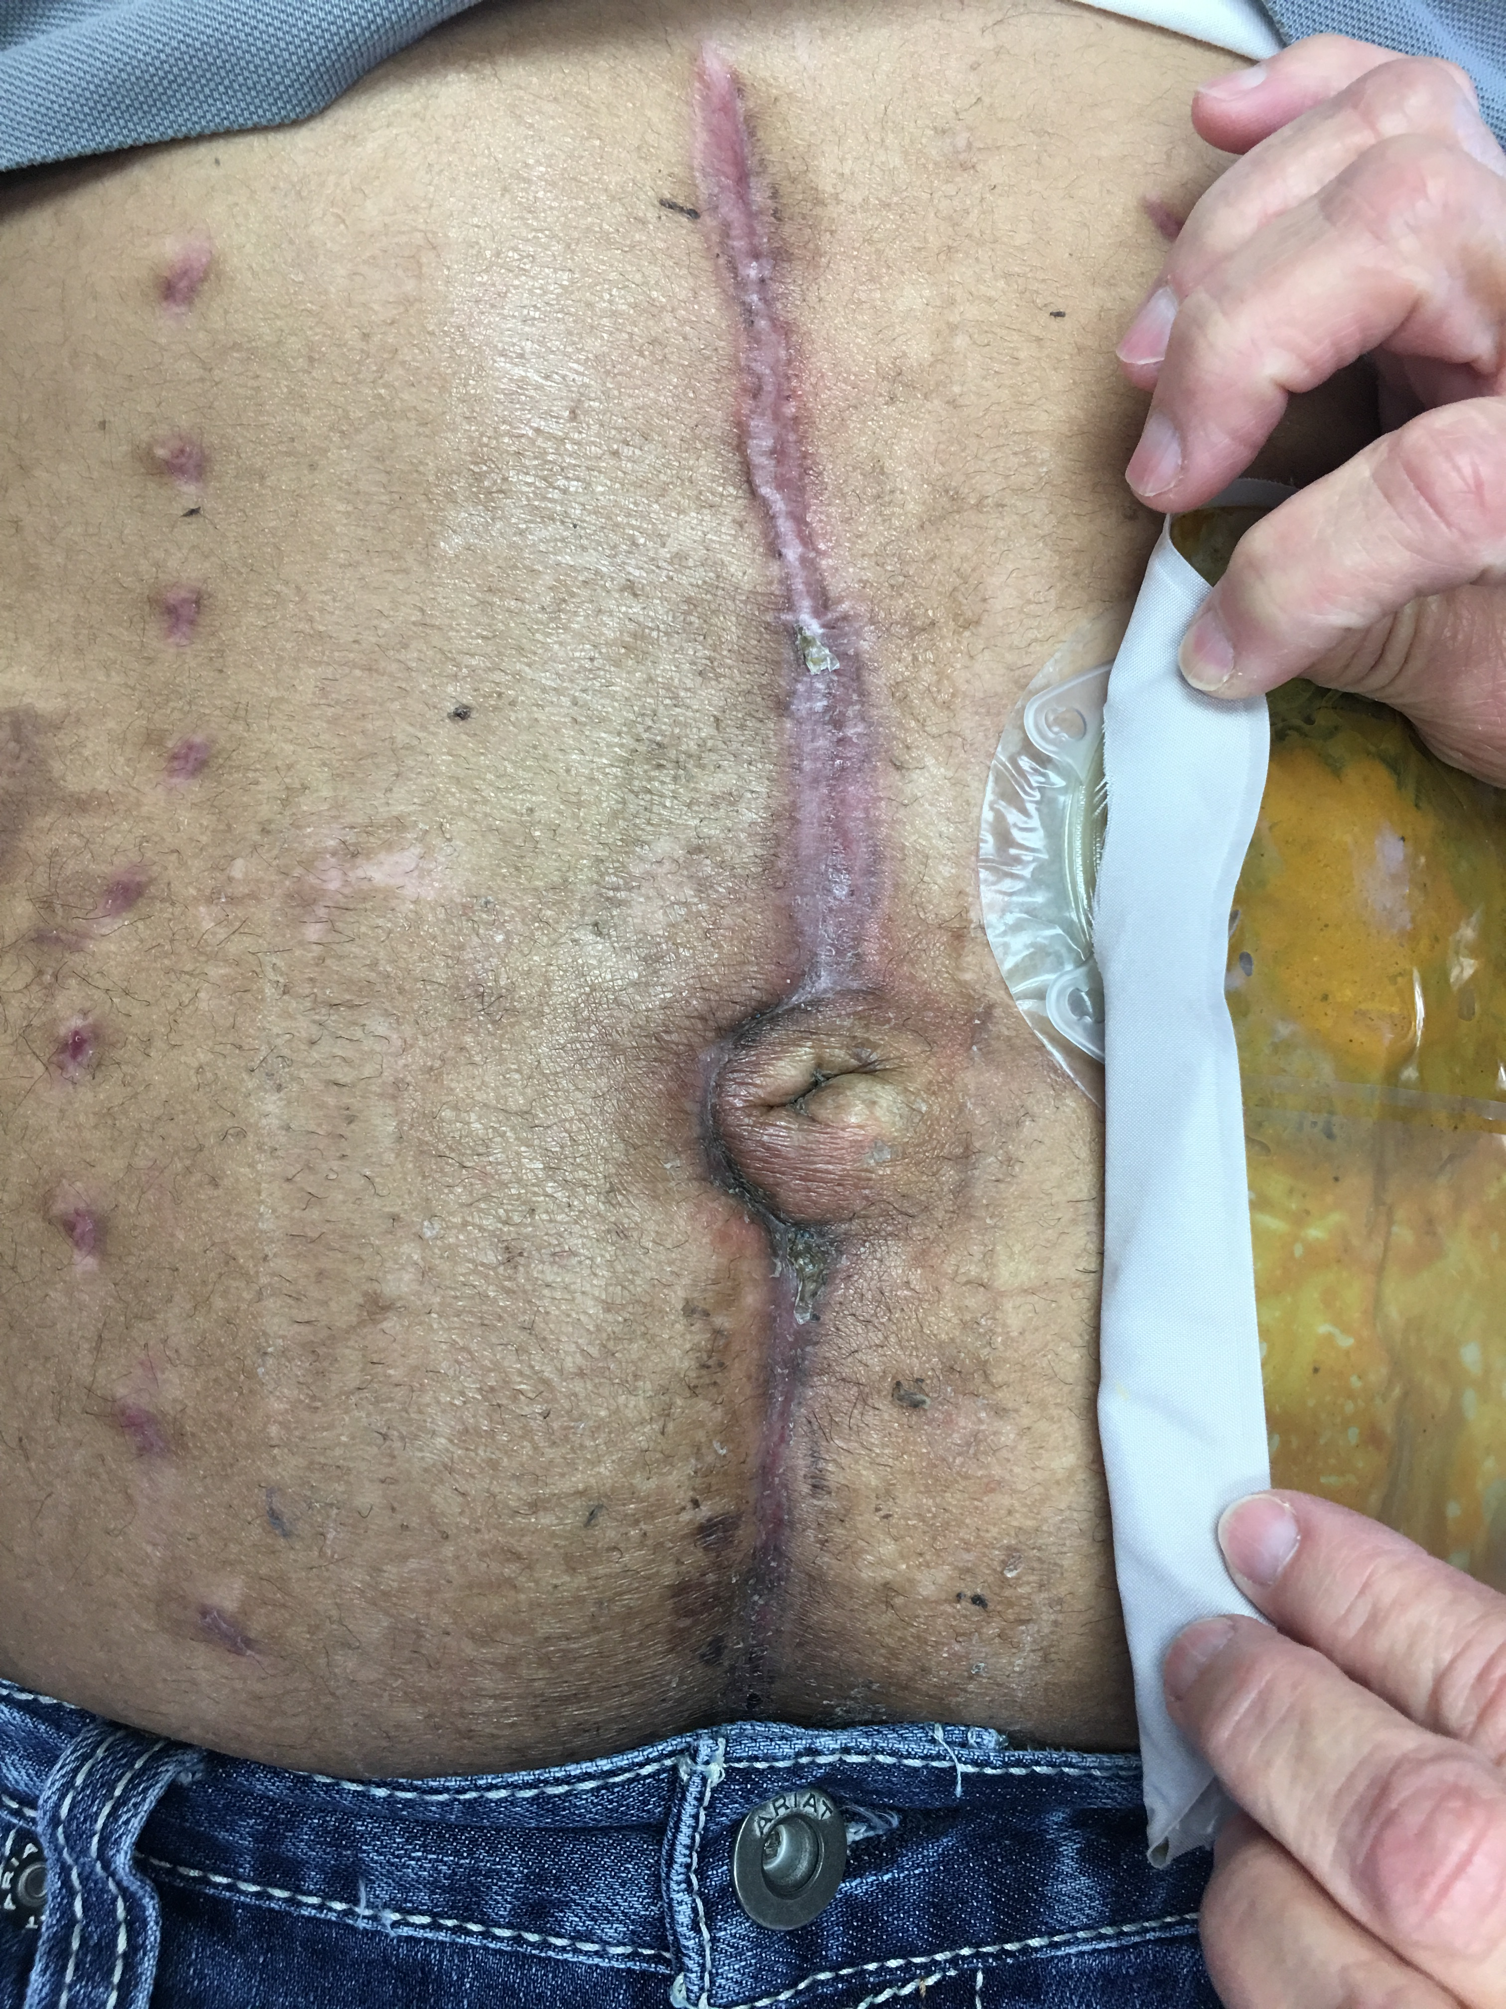
This is an example of the sutureless skin closure where the skin edges are apposed with strips of VAC drape tape.

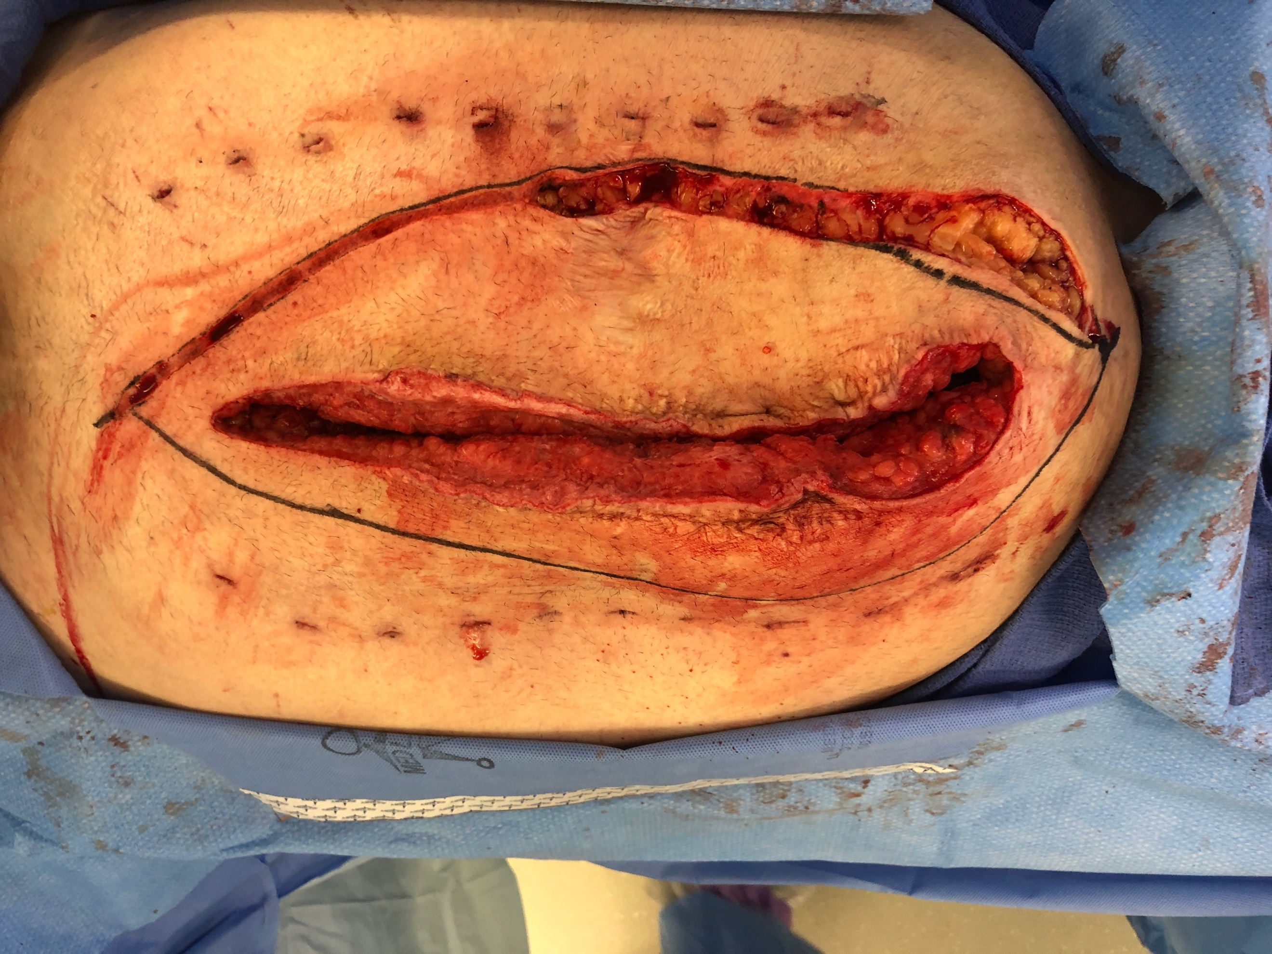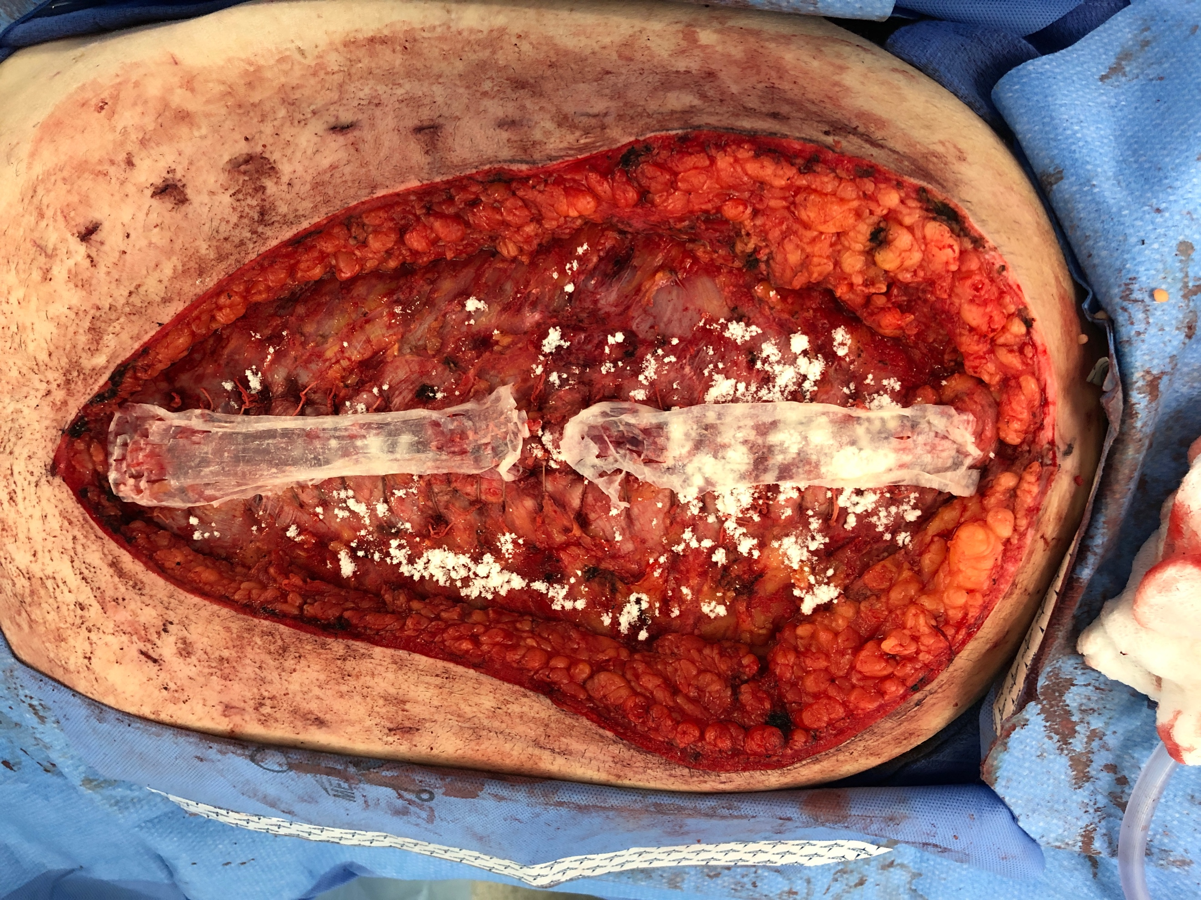
This example combines a vertical panniculectomy with the de-installation, primary myofascial closure and PUBM implantation.

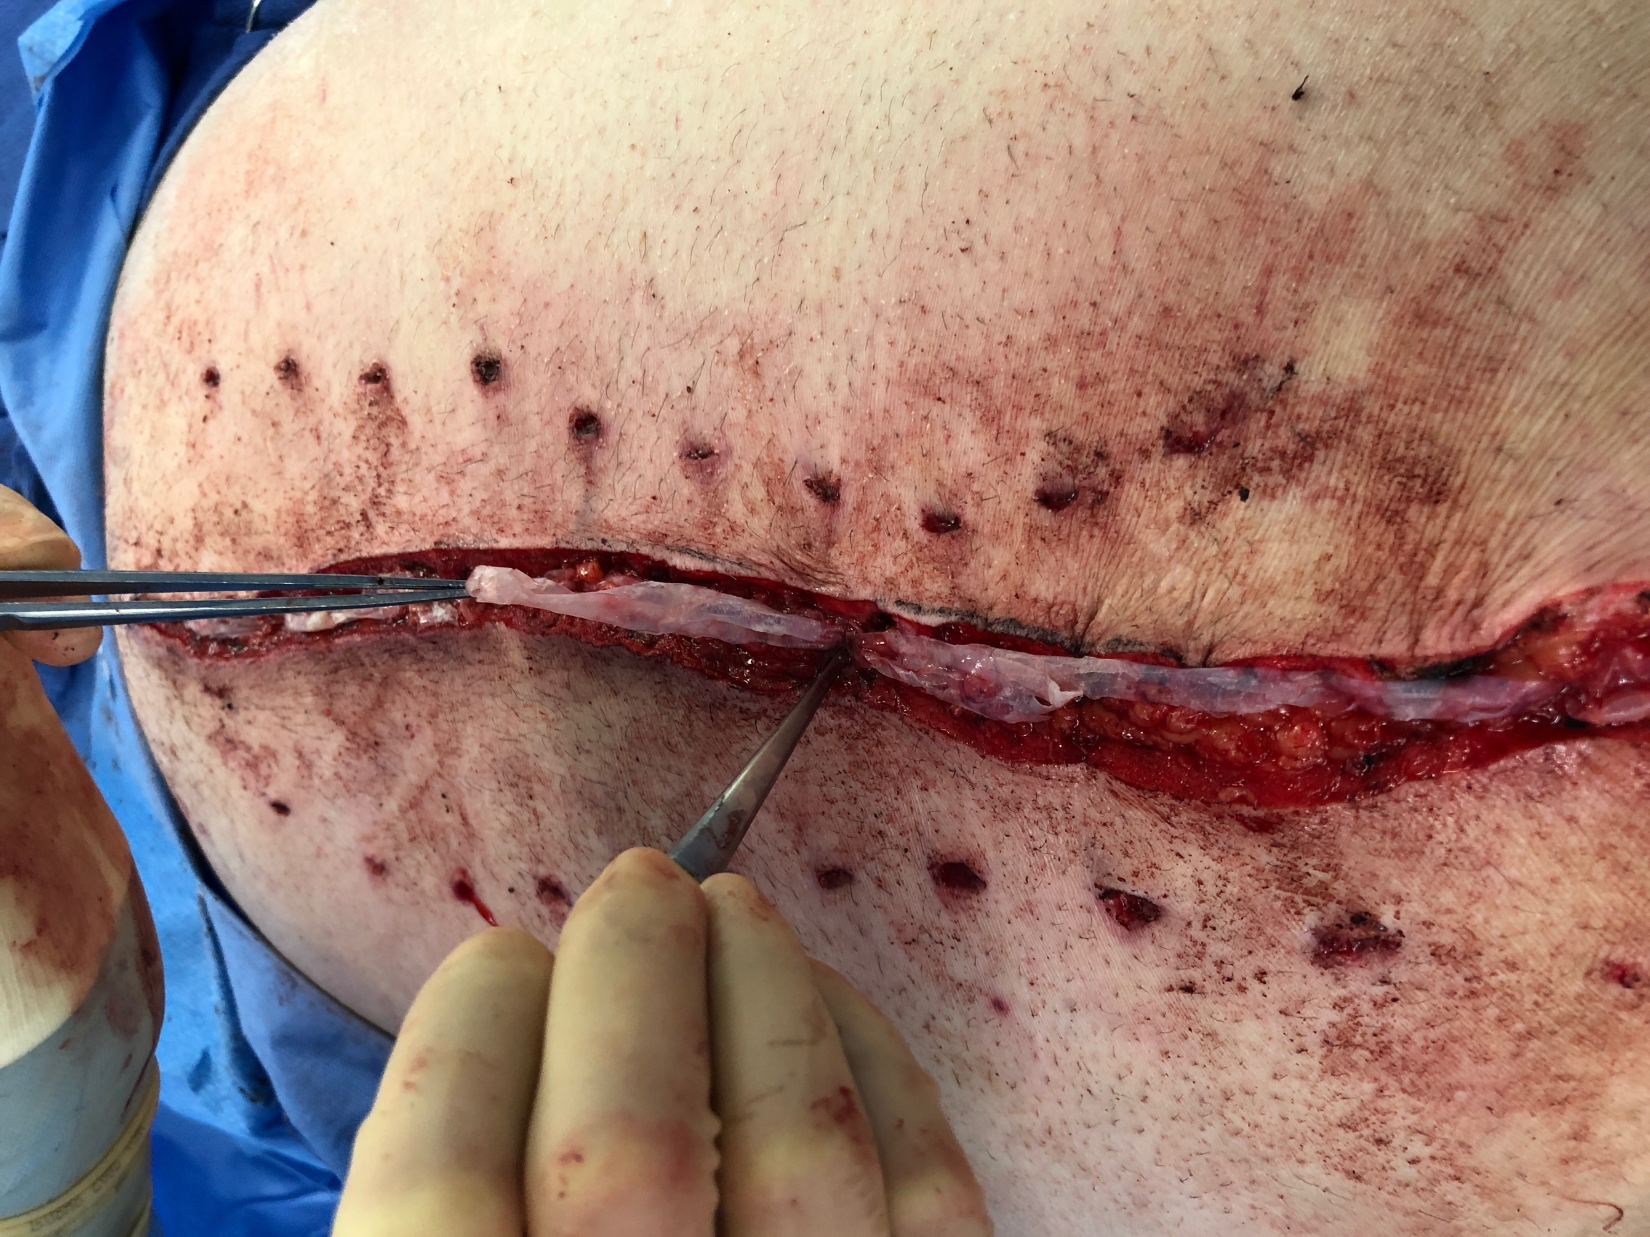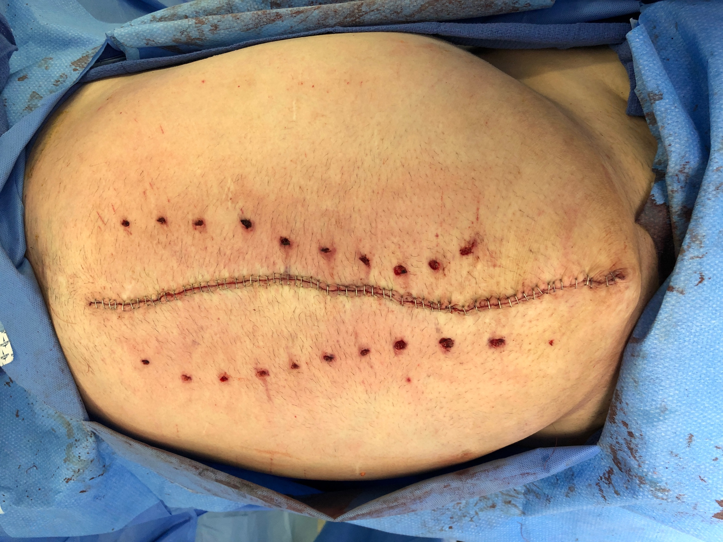
This is a layered sutured closure after the vertical panniculectomy and subcutaneous flap elevation. Note the PUBM is implanted as each layer is closed.

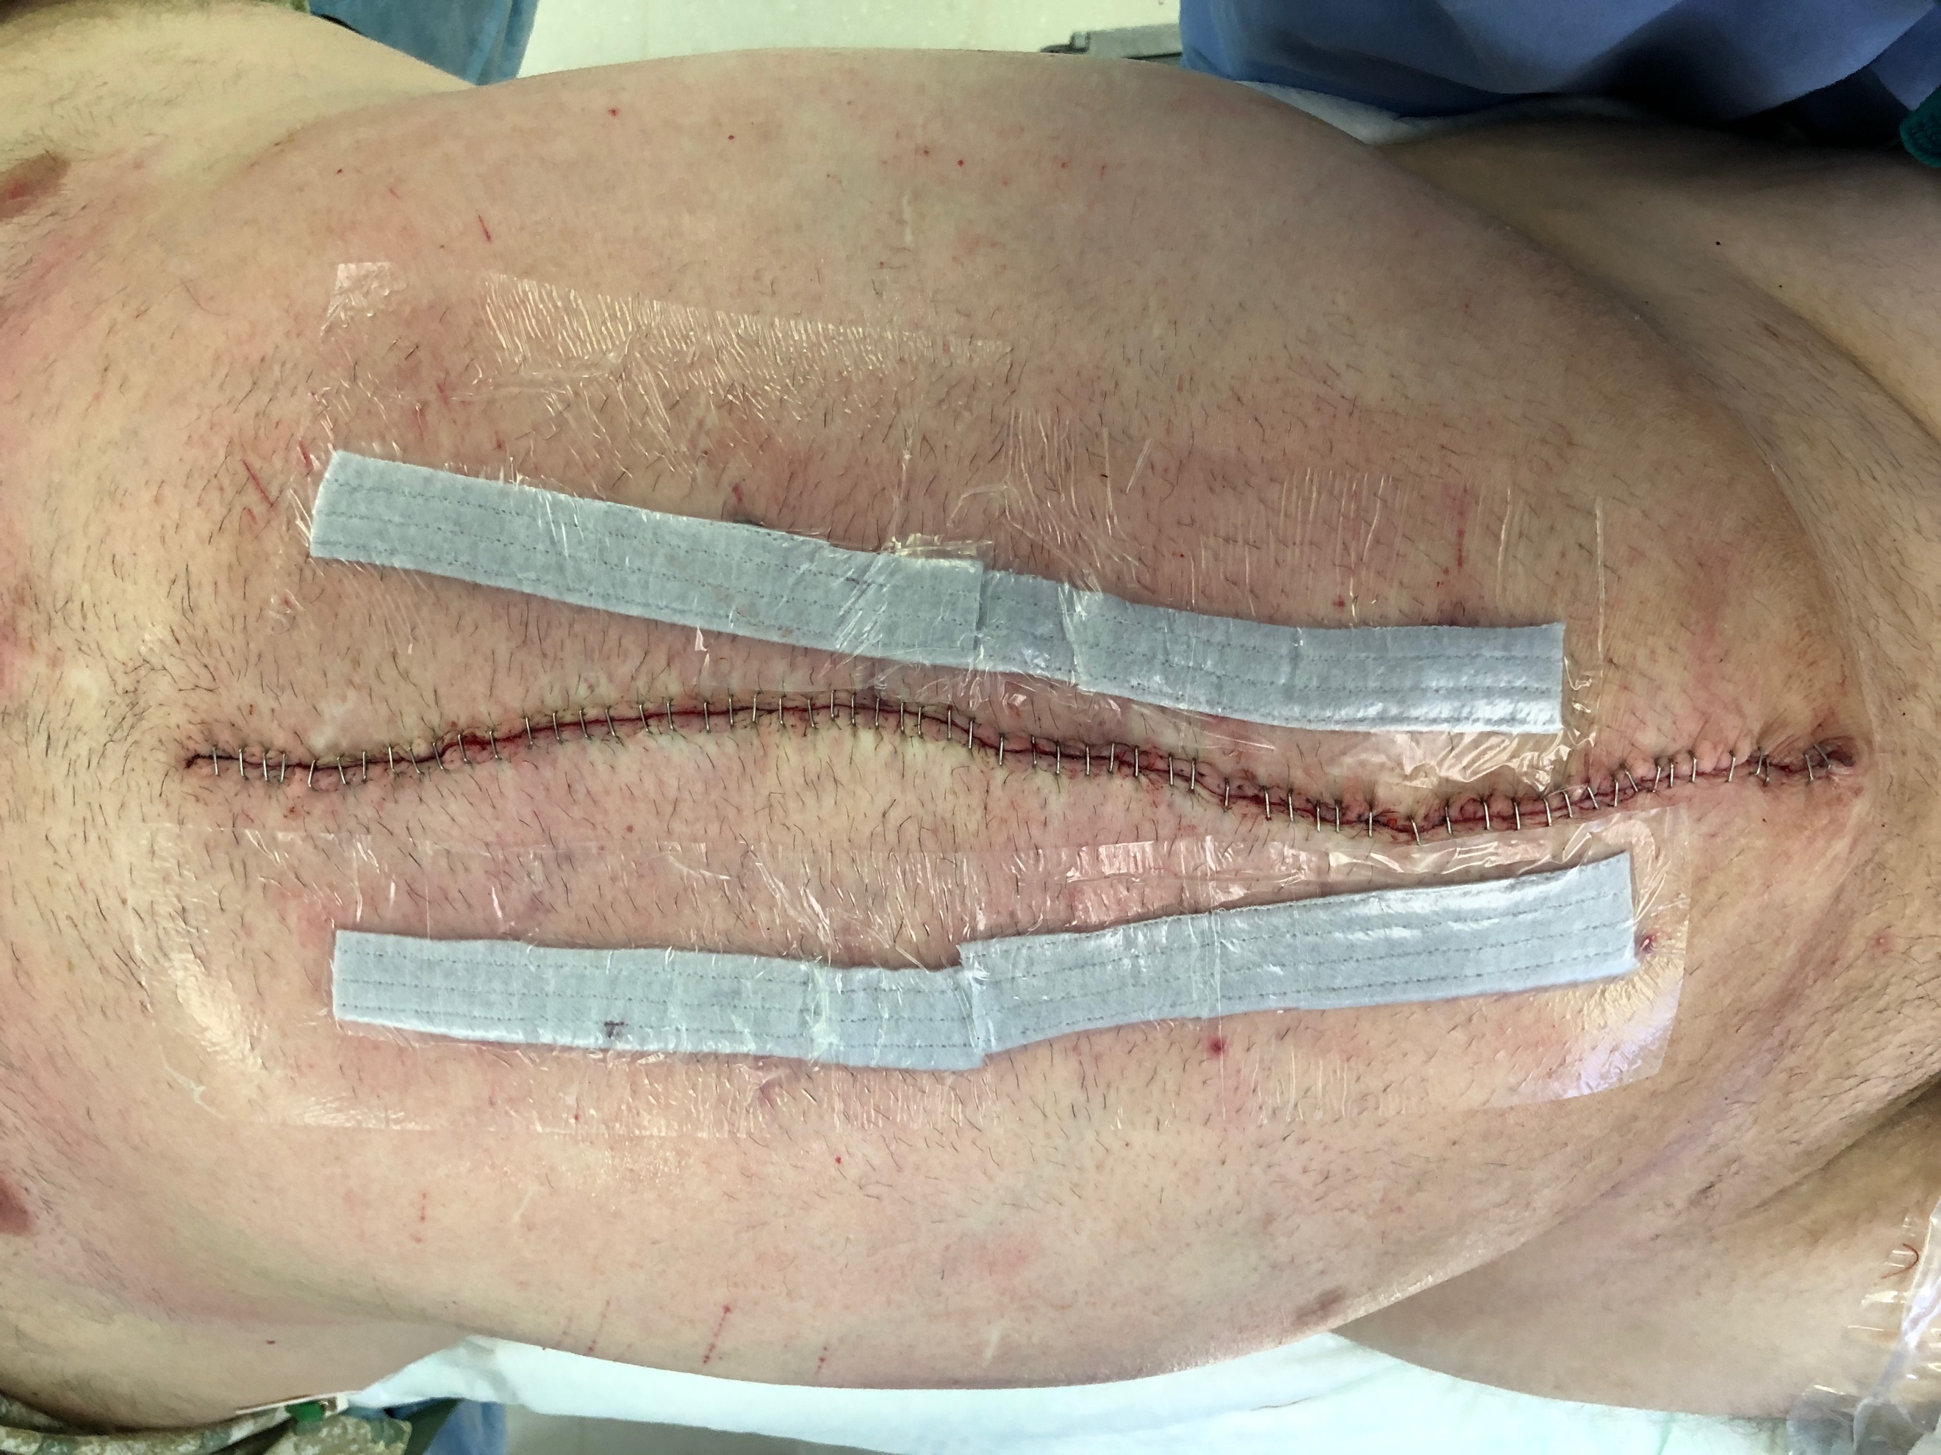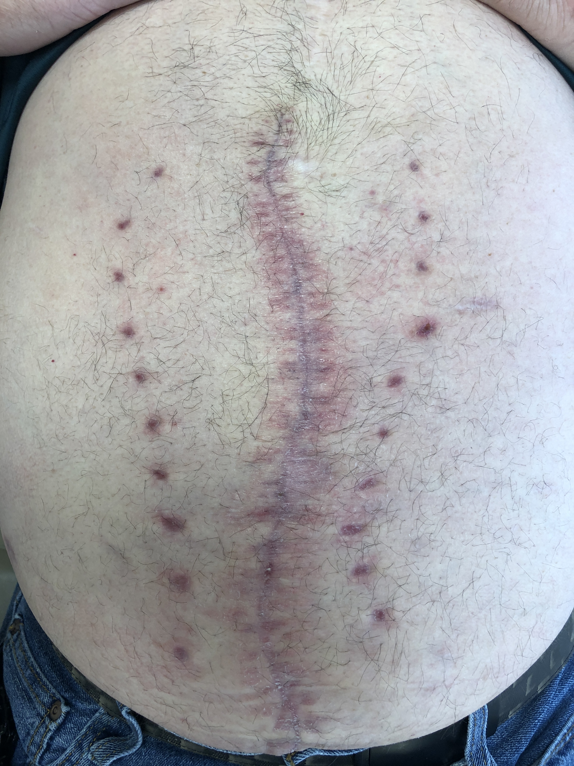
Appearance of abdominal closure approximately 3 weeks post-op.

